WebDesign Assignment

Gustavo Modena Sirtolli

Full Stack Software Development
UCD, 27 September 2025

Table of Content
Planning Analysis Sheet - Legendary Dragon 2
Website Goal 2
Working Titles of Pages 2
List of sources 3
Site MAP 5
Github Link 5

Planning Analysis Sheet - Legendary Dragon

Website Goal
The goal of the Legendary Dragon website is to showcase and celebrate how the history of the football is reflected on the classic football shirts from around the world, including clubs and national teams. The desired result is to engage football fans by providing a vintage visually appealing, informative, and memorable experience that highlights the history and culture of iconic jerseys.

Working Titles of Pages
Pages:
- Index page: introduction to the site, logo, tagline, and main navigation.
- Stories in Every Jersey – explain and exemplify why the football shirts are important for the sport.
  - Discover the stories behind every jersey
  - From Triumphs to Timeless Symbols - Use of picture and video to show case eternalised jerseys

- History_kits:
- The Global History of Football Shirts – give an overview of what marked every decade on the football shirt history, using pictures of the time mentioned.
  - 19th and Early 20th Century - The First Steps
  - 20th Century - Cotton and Consolidation
  - The 1980s and 1990s - Polyester and Sponsorship Revolution
  - The New Millennium - Technology and Style

- Classic_shirts:
- World History of Football Shirts – a selection of iconic shirts throughout time.
  - 19th Century and Early 20th Century - The Beginnings
  - 70's and 80's - Professionalization and Historic Icons
  - 90's - Creativity, Sponsorships, and Iconic Kits
  - 2000's - Technology, Fashion, and New Icons

List of sources
Facts & Text: Historical information about football shirts (official club and federation websites, football history articles).
Graphics: Images of classic shirts (own photos, official websites pictures).
Video: Optional highlights or historical clips embedded from YouTube.

Sites used for the content development and images:
Mantos do futebol - https://mantosdofutebol.com.br/
Skysports.com - https://www.skysports.com/more-sports/news/4787842/2005-liverpool-win-champions-league
The guardian - https://www.theguardian.com/football/2017/sep/13/what-formation-did-hollands-total-football-side-actually-play
Juventude - https://www.juventude.com.br/
Satirella - https://www.santirella.com.br/post/os-uniformes-no-futebol-historia-e-evolucao/?utm_source=chatgpt.com
Ludopedio - https://ludopedio.org.br/biblioteca/a-historia-das-camisas-de-todos-os-jogos-das-copas-do-mundo/?srsltid=AfmBOoq8Y18ZcuR3DOoqzWQBsqUVxf_ij0yFnQ6s3rqG77ijvjCjk3Dw&utm_source=chatgpt.com
Exame - https://exame.com/esporte/por-que-algumas-selecoes-de-futebol-adotam-cores-diferentes-de-suas-bandeiras-nas-camisas/?utm_source=chatgpt.com
Boteco dos Boleiros - https://botecodosboleiros.com.br/camisas-iconicas-no-futebol-a-historia-por-tras-dos-mantos-que-marcaram-geracoes/?utm_source=chatgpt.com
Olympics.com - https://www.olympics.com/pt/noticias/selecao-brasileira-cor-uniforme-amarela-historico-camisas?utm_source=chatgpt.com

Site MAP
Linear flow with bidirectional linkage

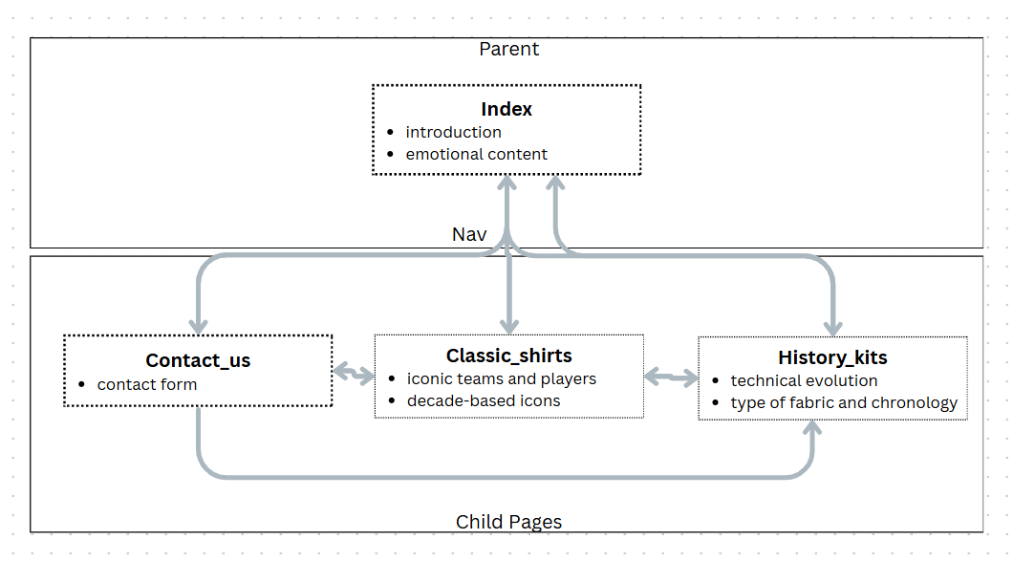

GitHub Link
GitHub repository for the website - https://github.com/gustavo8modena/UCD_project/tree/main
GitHub website page : https://gustavo8modena.github.io/UCD_project/index.html

