Project: AM Receiver System Design

ENEL 469

**Objectives:**

1. To analyze and understand different system design perspectives of an amplitude modulation (AM) receiver.
2. To design and implement an AM receiver system.
3. To test and evaluate the performances of the developed AM receiver system
   1. To probe different signals at different points of the circuit.
   2. To receive and listen to a real-time AM broadcast channel.

**Overview of an AM Receiver System:**

Amplitude modulation (AM) refers to modifying the amplitude of a carrier signal to convey information in a wireless system. For example, the amplitude of a radio carrier is varied in Figure 1 according to the audio signal, which gives the amplitude-modulated signal. Generally, AM signals are transmitted from a broadcast station, and an AM receiver system is required to listen to that particular station.

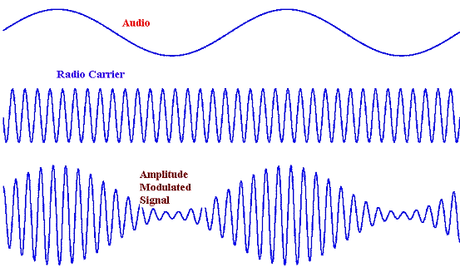

Figure : Amplitude modulation

A block diagram of an AM receiver system is shown in Figure 2.



Figure : AM receiver system.

The antenna in Figure 2 mainly acts as a transducer to convert the radio signal to an electrical one. However, when receiving the signal by the antenna, it is essential to filter out the unnecessary out-of-band signals. A band pass filter is required to select the specific band of interest. For example, if we want to receive the AM 660 kHz channel, the antenna and the filter should be tuned at this 660 kHz. To boost the received signal, an amplifier can be used. To perform both filtering and amplification, active filters are the first choice.

Now to hear back the audio signal, which was amplitude modulated earlier, it is now time to demodulate. For this purpose, an envelop detector circuit can be used. The concept of envelop detection is shown in Figure 3, where a diode first rectifies the signal, and the RC circuit acts as a low pass filter to sense the envelop of the AM signal, which is the desired audio signal. As you can see, this simple circuit is the key to the whole receiver system. To get it working, ensure that the RC time constant of the envelop detector circuit is appropriately selected to detect the envelop and follow it properly. Also, ensure the chosen diode can operate at a high carrier frequency.

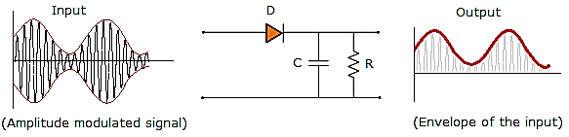

Figure : Envelop detection.

Once the audio signal is detected, note that the signal frequency is now down-converted from carrier (high frequency) to the audio signal (low frequency in the order of 150-300 Hz). This low frequency is sometimes called a baseband signal. This detected audio signal/baseband signal is amplified and fed to the speaker with an output stage/buffer stage to hear the AM station. As you already know, the buffer/output stage is necessary to avoid the loading effect.

A common emitter stage can be used as a baseband amplifier, whereas a common collector stage can be used for the buffer/output driver stage. It is important to properly select the coupling and bypass capacitors to design these amplifier and output stages so that the desired signal gets amplified and passed to the speaker.

**AM Receiver Circuit:**



Figure : AM receiver circuit.

An example of AM receiver circuit is shown in Figure 4. Different blocks of the AM receiver system shown in Figure 2 are implemented in the AM receiver circuit shown in Figure 4, and the blocks are marked from 1-6.

**Part A:**

The response of an LC tank circuit is shown in Figure 6. As you can see, such a circuit generally passes the particular frequency band centered at *f0,* which is determined by:



$$f_{0}= \frac{1}{2π√(LC)}$$

Figure 5: LC circuit response.

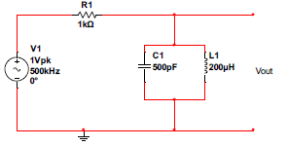

Figure 6: Detection circuit response analysis

1. Observe the band-pass filter response of the Antenna + LC circuit.
2. Calculate the resonance frequency of the following circuit shown in Figure 6. What should be the output voltage at the resonant frequency, and why?
3. Simulate the circuit in Figure 6 using AC analysis to get the response over the frequency range from 1 Hz-100 MHz (choose a linear scaled frequency axis and around 100 points per decade). Add your simulated results plot below and save your simulation filed as “Proj-A-1b. ms14”.



1. Redo the simulation in part 1a while doing a parametric sweep and change the capacitor value C1 from 100 pf to 1 nf with 10 points. Add your simulated results plot below and save your simulation filed as “Proj-A-1c. ms14”.



1. Explain the results obtained above; what does changing the capacitor affect the circuit?
2. Simulate the circuit in Figure 6 using AC analysis again with a parallel resistor to the LC, to get the response over the frequency range from 100 kHz-10 MHz (choose linear scaled frequency axis). Add your simulated results plot below and save your simulation filed as “Proj-A-1e. ms14”.



1. Explain the results obtained above; what is the effect of this resistor on the circuit?
2. What are we changing now if we move the resistor to be in series with the inductor? Do you observe the same behavior, and why?
3. Develop the active filter circuit with the antenna shown in Figure 7.
4. Perform a DC and small signal analysis of the circuit shown below in Figure 6 and find the value of the parameters listed in the Table below at **resonance frequency.**

***Hints****: For DC, capacitors are open, and the inductor is short. For small signal analysis, consider R1, L1, R7 and C2 as a high-impedance ≈ R1. Use C1 and C3 as 100 nF, and during analysis consider that they will remain short-circuited.]*

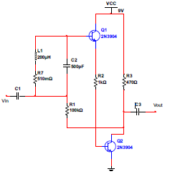

**20 $Ω$**

|  |  |  |
| --- | --- | --- |
| Parameter | Hand Calculation | Simulation |
| VCE1 | 8.2 V | 8.15738 V |
| VCE2 | 1.56 V | 1.54121 V |
| IC1 | 98.3 µA | 98.65541 µA |
| IC2 | 15.8 mA | 15.86881 mA |
| Small signal Gain | 237.7 | 30.4 |

Figure 7: Receiving amplifier circuit.

1. Simulate the circuit in Figure 7 to verify the results you got from your calculations and add them to the same table. Take a screenshot of the simulation with the results of the DC simulations and add it below. Finally, add your simulated results plot below and save your simulation filed as “Proj-A-2b. ms14”.

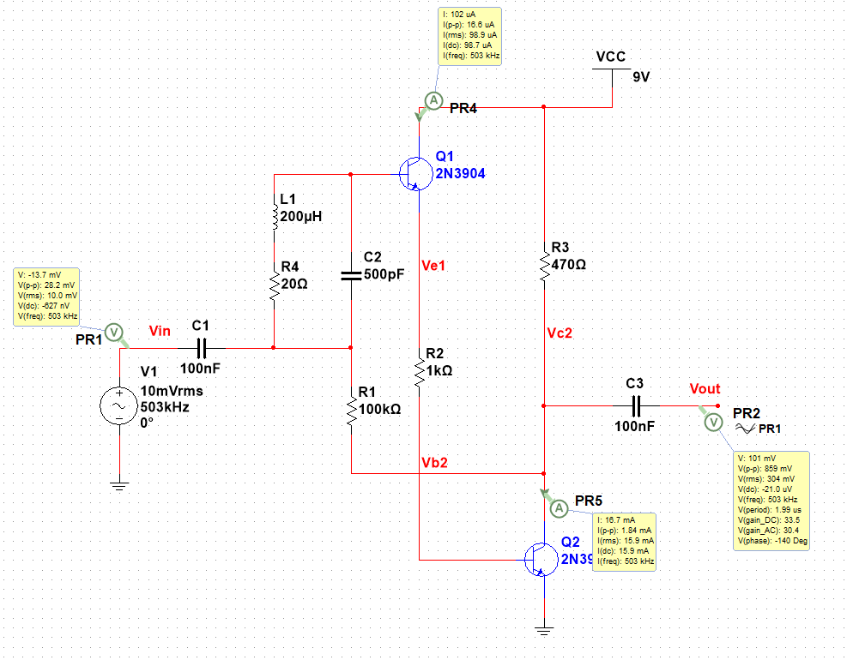

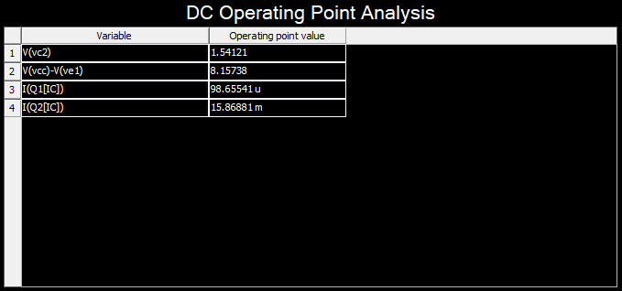

1. Is there a difference between the calculated and simulated values? If so, why?

* There is a slight difference in the collector’s currents and the common-emitter voltages calculated in the DC analysis. This may be due to the collector gain approximation (β). A β value of 160 was used in the calculation, however this is not representative of the collector current gain of Q1 in the simulation, which is closer to 100. The difference the small signal voltage gain is due to the clipping effect that occurs when the quiescent point of the transistor is at the extremes of the DC and AC load lines.

1. Apply an AC signal to the input of the active filter in Figure 7, and Set the amplitude to about 10 mV peak. Using AC analysis, plot the small signal gain of the circuit. Add your simulated results plot below and save your simulation filed as “Proj-A-2d. ms14

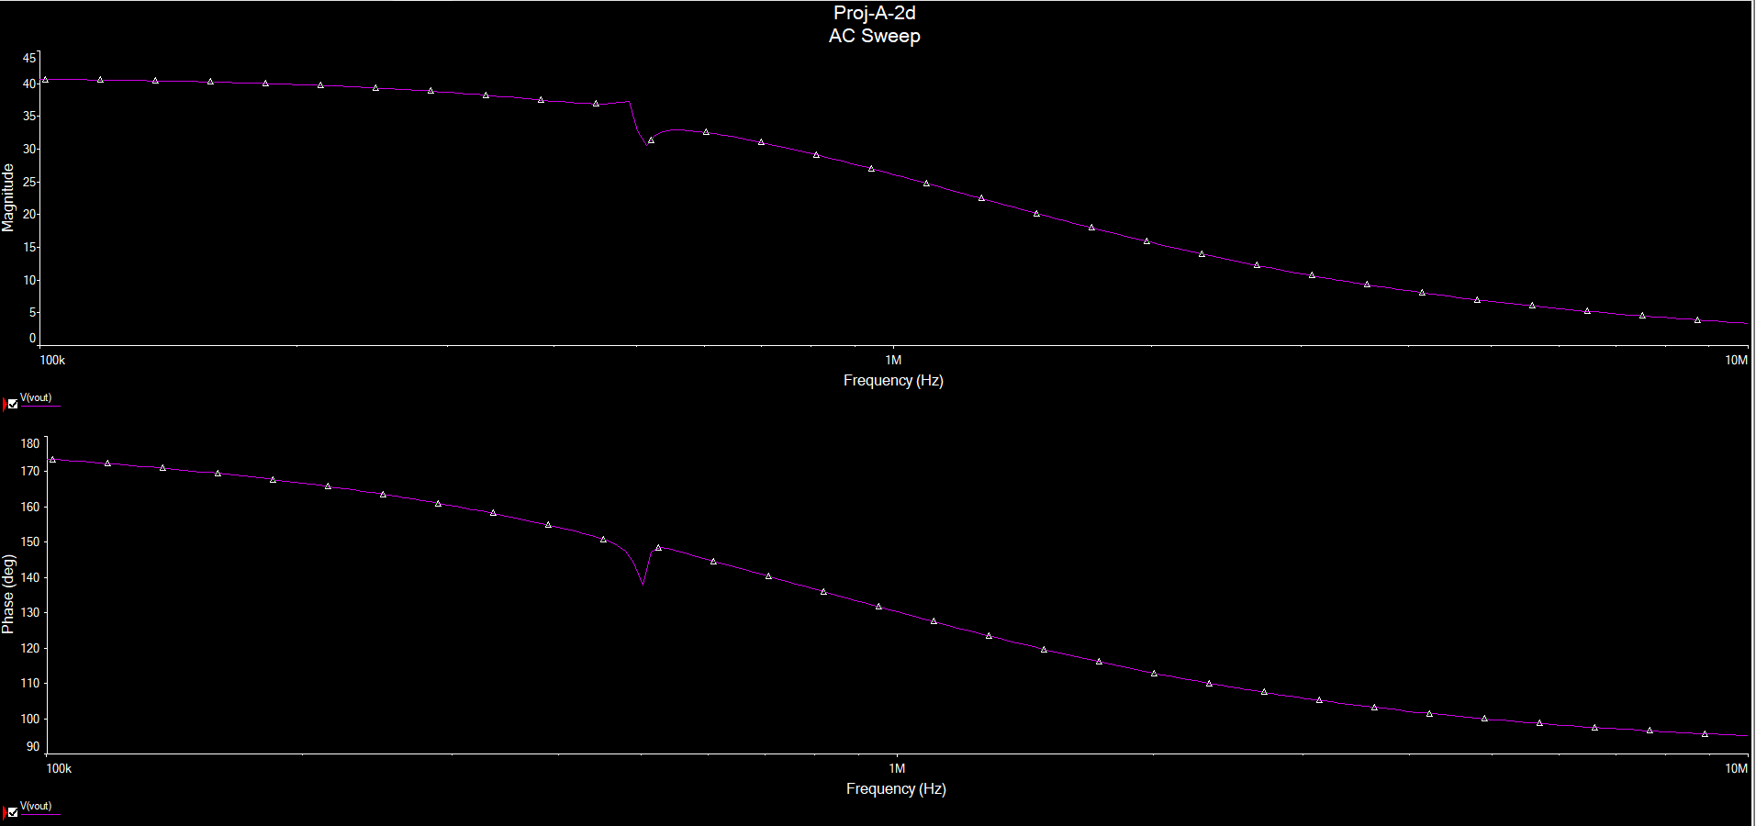

1. Explain why there is a glitch in the resonance frequency.

* At very high frequencies, impedances diminish and circuit components such as capacitor and inductors become shorted. Therefore, at the resonance frequency, which is also referred to the cutoff frequency of the of the active filter, the gain of the circuit also begins to diminish. Since this is the point where L1 and C2 in the circuit become shorted, there is a slight glitch in the resonance frequency.

1. Apply amplitude modulated signal to the input of the active filter in Figure 10 with a carrier frequency of 500 kHz and modulating frequency of 5 kHz. Set the amplitude to about 1mV peak. Plot the input and output waveform in an oscilloscope. Add your simulated results plot below and save your simulation filed as “Proj-A-2f. ms14”.

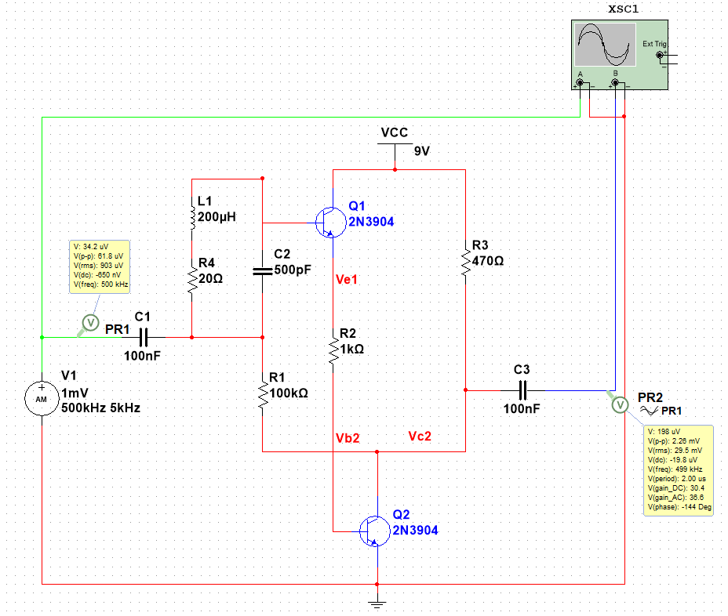

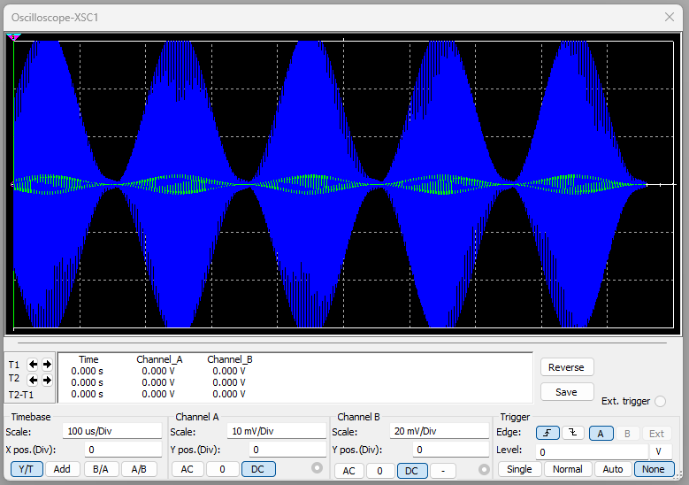

1. What is the gain of the circuit?

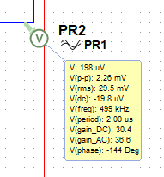

* The gain of the circuit fluctuates depending on the amplitude of the AM modulated signal, however the gain averaged at around 36.

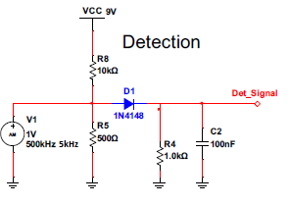

Figure 8: Detection Circuit

1. Observe and test the response of the detection circuit shown in Figure 1. Connect the circuit shown in Figure 7 at the output of the active filter circuit shown in Figure 8. Observe the detected signal in an oscilloscope. Plot the input and output waveform in an oscilloscope. Add your simulated results plot below and save your simulation filed as “Proj-A-2h. ms14”.

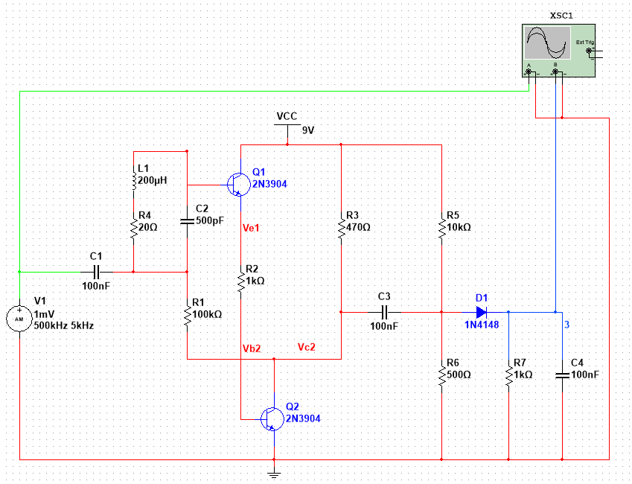

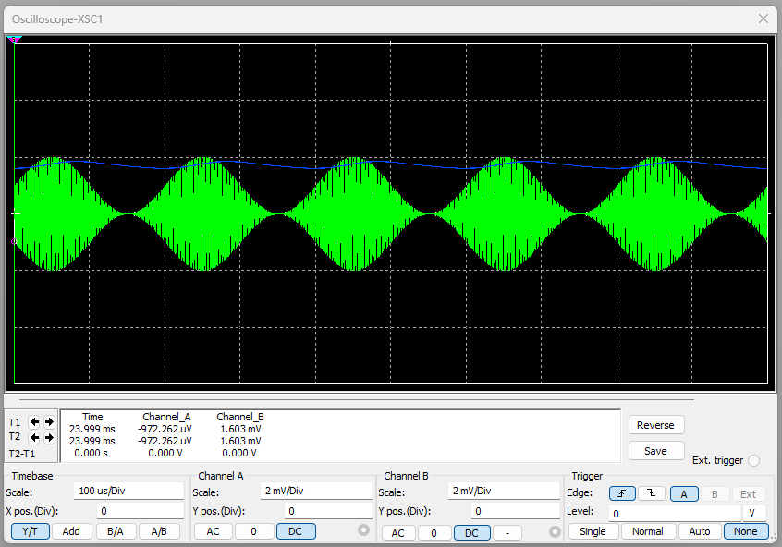

**Part B:**

**Hints:**

1. Be careful when designing sub-systems, so they don’t face the loading effect.
2. In the detection circuit, the diode should be properly biased to rectify the modulated signal!
3. Design and simulate the base-band amplifier shown in Figure 9 with a small signal gain of about 20 and of quiescent point of about (6 V, 1.5 mA). Present both simulated input and output signal.

**[Hints: Consider an input sinusoidal signal of several kHz to perform the analysis and simulation.]**

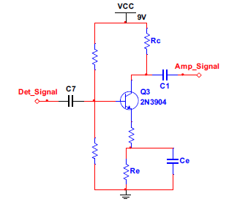

Figure 9: Baseband Amplifier

1. Show your design procedure and record your values below.

|  |  |
| --- | --- |
| Parameter | Value |
| R1 |  |
| R2 |  |
| Re |  |
| RE2 |  |
| R­c |  |
| Ce |  |
| C7 |  |
| C1 |  |

1. Simulate the circuit in Figure 9 to verify the results you got from your calculations and add them to the same table. Take a screenshot for the simulation with the results of the DC simulations and add it below. Add your simulated results plot below and save your simulation filed as “Proj-B-1b. ms14”.



1. Is there a difference between the calculated and simulated values? If so, why?
2. Apply an input signal to the input of the Baseband Amplifier in Figure 9. Set the signal Frequency to around 5 kHz and the amplitude to about 10 mV peak. Plot the input and output waveform in an oscilloscope. Add your simulated results plot below and save your simulation filed as “Proj-B-1d. ms14”.



1. Perform an AC analysis on your design and show the response over the frequency range from 1 Hz-100 MHz (choose log scaled frequency axis and around 100 points per decade). Add your simulated results plot below and save your simulation filed as “Proj-B-1e. ms14”.



1. Design and simulate the output buffer amplifier shown in Figure 9 with a speaker resistance of 8-16 Ω. Present both simulated input and output signal.

**[Hints: Consider an input sinusoidal signal of several kHz to perform the analysis and simulation. Also, consider quiescent point of Q4 as (7.8V, 40 uA) and Q5 as (8.5 V, 6.5 mA)]**

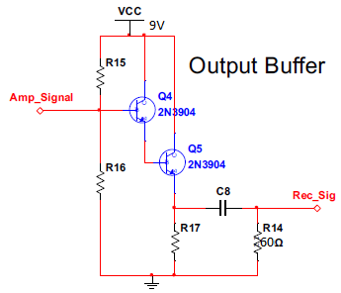

Figure 9: Output Buffer

1. Show your design procedure and your values below.

|  |  |
| --- | --- |
| Parameter | Value |
| R15 |  |
| R16 |  |
| R17 |  |
| C8 |  |

1. Simulate the circuit in Figure 9 to verify the results you got from your calculations and add them to the same table. Take a screenshot of the simulation with the results of the DC simulations and add it below. Finally, add your simulated results plot below and save your simulation filed as “Proj-B-2b. ms14”.



1. Is there a difference between the calculated and simulated values? If so, why?
2. Apply an input signal to the input of the output buffer in Figure 9. Set the signal Frequency to around 5 kHz and the amplitude to 1 mV peak. Plot the input and output waveform in an oscilloscope. Add your simulated results plot below and save your simulation filed as “Proj-B-2d. ms14”.



1. Perform an AC analysis on your output buffer design and show the response over the frequency range from 1 Hz-100 MHz (choose log scaled frequency axis and around 100 points per decade). Add your simulated results plot below and save your simulation filed as “Proj-B-2e. ms14”.



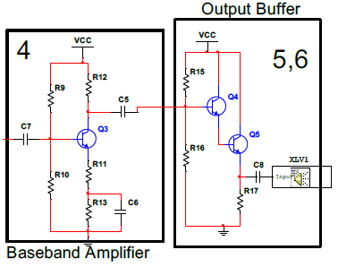

Figure : AM receiver sub-circuits.

1. Construct the circuit shown in Figure 14 by connecting individual circuits simulated in 1-2. Present both input and output voltage waveforms. Add your simulated results plot below and save your simulation filed as “Proj-B-3. ms14”.

[You should see a sinusoidal voltage at the output.]



**Part C:**

1. **Implement an AM receiver circuit shown in Figure 5: AM receiver circuit.** Apply an AM-modulated signal and observe the response of your receiver circuit. Add your simulated results plot below and save your simulation filed as “Proj-C-1.ms14”.

