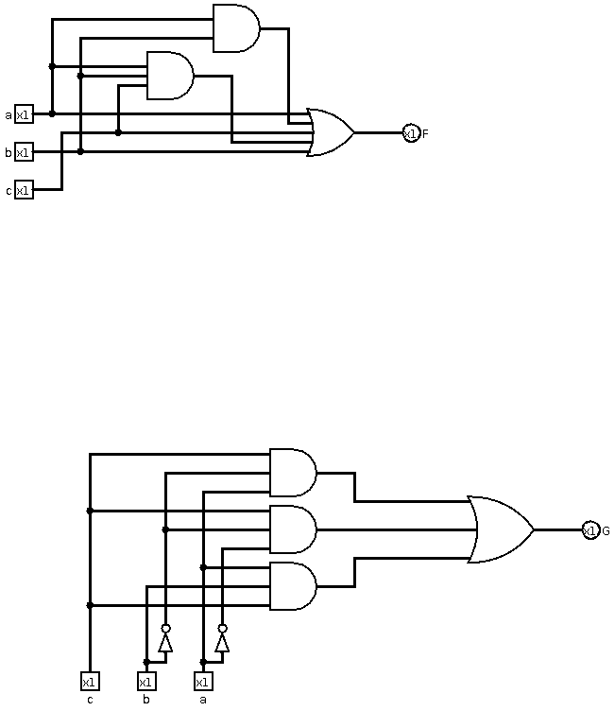
CSCE 312 Computer Organization 09/27/2015
Gustavo Estrela de Matos 925003559

Problem 1
1.

2. 7408 AND gate; 7404 hex inverter and 7432 quad 2-input OR gate

3. a) 2 AND gates (20ns each) and 4 OR gates (14ns each) results in 96ns of delay
b) 1 NOT gate (15ns), 2 AND gates and 2 OR gates resulting in 83ns of delay

4. I used the one that had biggest delay, because I believe that verifying the delay of a circuit has a lot to do with being able to say that the circuit is able to give an answer in a determined time, and, if we don't take the biggest delay we can't guarantee a maximum response time.

Problem 2
1.

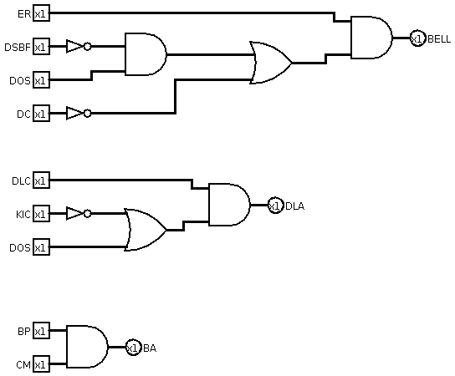

2. 74F04 Hex inverter for the NOT gates, 74F08 for the AND gates and 74F32 for the OR gate

3. The delay for each gates are: 7.0ns for the NOT gate, 7.5ns for the AND gate and 7.5ns for the OR gate, which gives us the delay for each circuit:
- BELL circuit: 29.5ns
- DLA circuit: 22.0ns
- BA circuit: 7.5ns

Problem 3
1. It will be necessary to have 6 switches, one for each car. Since we have 6 wires, our encoder will be a 6x3 encoder (8x3 encoder with the last two bit always 0). The decoder will be 3x6 (3x8). The bus will be formed by 3 wires.

2. I would use a common anode, because it would imply that the current flows from the switcher to display, which is how I designed my circuit.

3.

4.

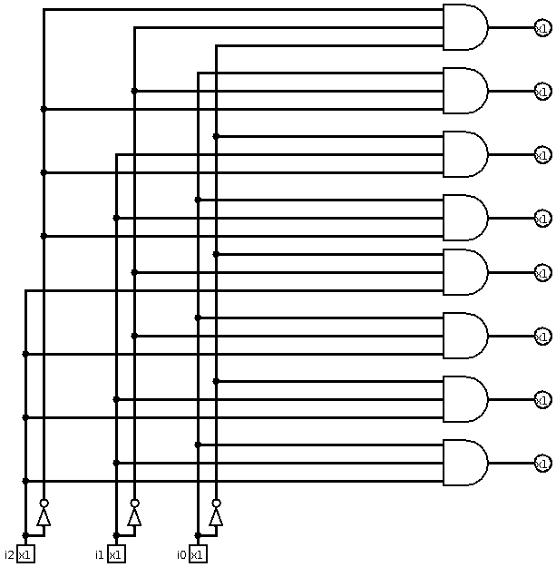

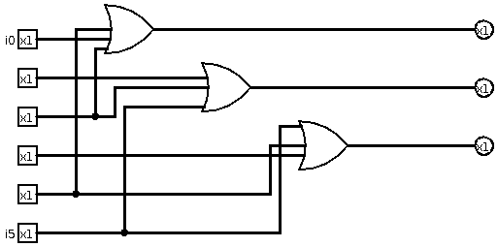

5. The developed circuit has 6 switches, from C1 to C6, each one of those represents a car in the locomotive. If one of the cars have its switches switched to one, than a circuit made with a encoder and a decoder gets the information to number display which displays the car who had sent the signal. If the car Ci have its switch switched to 1 the display will show the number i. This system doesn't guarantee anything when more then one switch is on.

6. All kind of weird things can happen, like display the sum of the car numbers with switch on, or displaying only the one who has higher number, or even not showing anything. To solve this, I would use a. To solve this problem I would transform this system, from a combinational circuit to a finite state machine, creating a state when a switch is turned on, making the display show only this switch, and a reset button to make the machine go to the initial state.

