CSCE 312 Computer Organization 10/05/2015
Gustavo Estrela de Matos 925003559
Problem 1
1 -
2 - 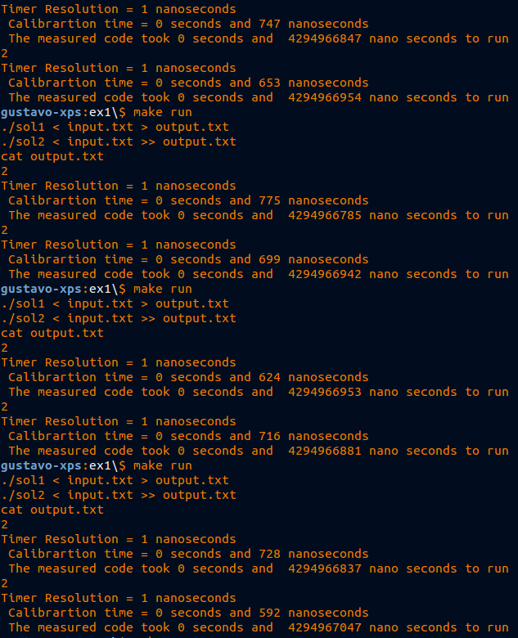
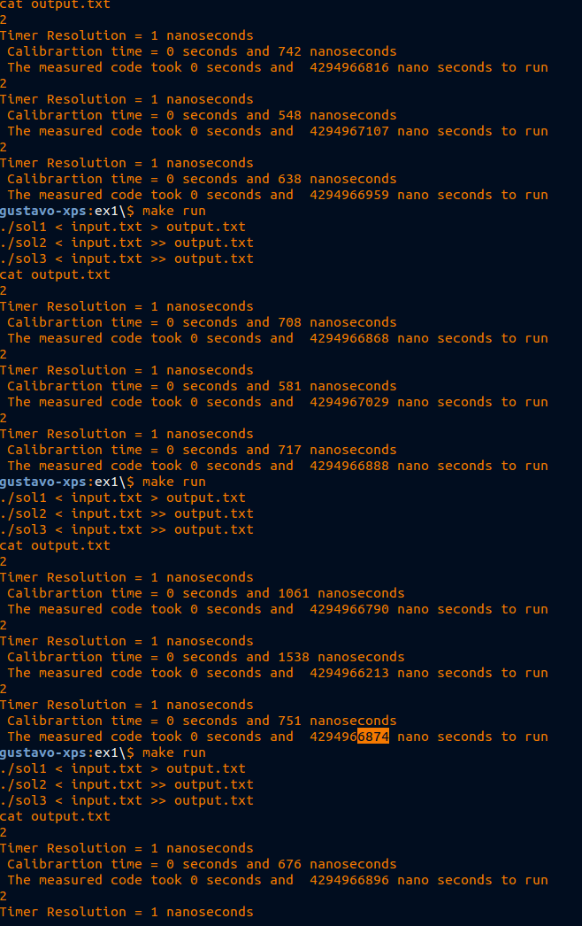
3-

The performance of the algorithms were similar, but it was possible to see that solution 1 was the fastest and the solution 2 was the slowest.

4 – Solution 1 was the fastest because it has the fewest number of conditions and applications of masks. The solution from lab1 has a similar number of conditions, but applies masks more than the solution 1, which probably was the reason this solution was slower than the fastest. Solution 2 was the slowest, probably because it has too many conditions, because in the worst case it can verify all the possible input values.

5 – The problem in my solution is that it applies masks too many times in the input variable. Possible solutions could be changing the way the conditions are verified, to something similar to solution 1, or using variables to keep the result of masks (it wouldn't be a good solution because it would cause waste of memory).

