Critical digital literacy in formal education, 2016–2026: A scoping review of research growth, objects of critique and the rise of generative artificial intelligence

Abstract
Critical digital literacy (CDL) asks learners to read digital technologies as sites of power and not only as tools. This scoping review maps research on CDL in formal education published in English and Spanish between 2016 and 2026. Reported according to PRISMA-ScR, it screened 469 Scopus records in two independent passes, on titles and on abstracts and keywords, and resolved disagreements with an explicit rule; a second reviewer verified 169 decisions. The 135 included studies were charted with term dictionaries, which were then checked against the full texts of 38 open-access studies. Output grew by an estimated 21% a year between 2016 and 2025, and 52 studies appeared in 2026 alone. Artificial intelligence, absent before 2020, appears in 43% of the studies of 2024–2026, and algorithms, data and platforms rose from 6% to 32%. Research concentrates on higher education and teacher education; early childhood and primary education account for 7%. The full texts qualify this picture. Only 25 of the 38 studies made CDL a central concern, including 5 of the 11 coded for AI, and the dictionaries were accurate for AI but missed most work on disinformation and privacy. Of the 25, 16 did not evaluate outcomes, none used a comparison group, and 14 examined the infrastructures behind digital texts. The field responds quickly to each new technology, but part of its growth is nominal, and it has yet to reach young children or show what learners gain.
Keywords: critical digital literacy; generative artificial intelligence; scoping review; teacher education

Context and implications
Rationale for this study. Schools teach through platforms and AI systems they do not control. Earlier reviews covered one level or country and mostly predate generative AI.
Why the new findings matter. The field grows fast and follows each new technology, but a third of the studies sampled treat CDL only in passing, and few test what learners gain.
Implications for researchers, practitioners and policy makers. Researchers need intervention studies in primary schools, shared instruments and screening on full texts, because titles and abstracts overstate the field. Teacher educators can build on practices that recur across the corpus, such as virtual exchange and student media production. Digital competence frameworks such as DigComp and DigCompEdu could move questions of platform ownership, data and interests from illustrative examples into the competences themselves.

Introduction
A secondary student today may draft an essay with a chatbot, submit it through a learning platform that records every click, and discuss the grade with classmates on a messaging app owned by an advertising company. Each of these technologies shapes what counts as knowledge, whose work becomes visible and what happens to the data that learning leaves behind. None of them was designed by the school.
Research on the platform society has shown that such infrastructures are not neutral conduits. They organise attention, extract data and answer to business models that can pull against public values, including educational ones (van Dijck et al., 2018). In education, the same process takes the form of datafication: learners and teachers become streams of data that are measured, compared and acted upon, often by actors outside the school (Williamson, 2017). The question for educators is no longer whether technology works, but for whom, and at what cost (Selwyn, 2016).
Policy has answered mostly with competence frameworks. DigComp 2.2 sets out what citizens should be able to do with digital technologies (Vuorikari et al., 2022), and DigCompEdu does the same for educators (Redecker, 2017). Both include critical elements: the critical evaluation of information and sources, citizenship through digital technologies and the protection of personal data. DigComp 2.2 also added examples on datafication and on citizens' interaction with AI systems, including the controversy over who owns the data those systems collect. These elements appear mostly as illustrative examples of knowledge and attitudes, however, while the competences and their proficiency levels remain framed around what an individual can do. A growing body of work argues that this keeps at the margins the political question of who designs digital technologies, in whose interest and with what effects on inequality and democracy (Pangrazio, 2016; Pötzsch, 2019). Critical digital literacy (CDL) is the name that research has given to the attempt to bring that question into classrooms.
The literature on CDL has been reviewed before, but always in part. Ilomäki et al. (2023) reviewed critical digital literacies at school level. Villar-Onrubia et al. (2022) examined how teacher competence frameworks around the world deal with critical digital literacy. Creely et al. (2026) reviewed critical literacies in the upper years of primary school in Australia. Other syntheses have approached the topic sideways, through critical thinking and social media (Escribano-Muñoz et al., 2024) or the educational uses of TikTok in South America (Rodas-Coloma et al., 2026). None of these covers all levels of formal education at once. Research written in Spanish, which has grown quickly in Spain and Latin America, is seldom brought together with research in English, and the reviews published before 2023 could not take account of generative AI, which has since become a central object of critical work. There is also a problem of boundaries. Telling CDL apart from generic critical thinking is difficult, and when the decision is left implicit at the selection stage, the scope of a review is hard to reproduce.
This article addresses those gaps with a scoping review of research on CDL in formal education published in English and Spanish between 2016 and 2026. A scoping review suits the purpose because the aim is to chart the extent, character and direction of a heterogeneous field rather than to estimate the effect of an intervention (Arksey & O'Malley, 2005). The review asks four questions:
- RQ1. How has research on CDL in formal education grown since 2016, and how is it distributed across languages, countries, educational levels and research designs?
- RQ2. Which theoretical traditions does it draw on, and have they changed over time?
- RQ3. Which digital phenomena does it take as objects of critique, and how have these shifted?
- RQ4. What pedagogical practices does it describe, and what place do teachers occupy in it?

Conceptual framework

Three traditions
CDL did not begin with the internet. It inherits three traditions that were concerned with power in texts long before screens.
The first is critical literacy. Freire (1970) treated learning to read as inseparable from becoming aware of the social relations that oppress the reader. Later work turned that insight into a classroom practice: asking who speaks in a text, whose interests it serves and how it could be written otherwise (Janks, 2010; Luke, 2012). The second is the pedagogy of multiliteracies, which moved attention from reading to design (The New London Group, 1996). Learners are not only decoders of meaning but makers of it, working across modes and media. The third is critical media literacy, which adds the analysis of representation, ideology and the political economy of the media industries (Kellner & Share, 2007).
The three traditions overlap, and much of the work reviewed here draws on more than one. What they share is the claim that literacy is never only a technical skill. To read and write is always to take part in a social order, and education can either reproduce that order or help learners question it.

From competence to critique
Digital competence frameworks cover more of this ground than is often acknowledged, but they place it differently. In DigComp 2.2 the competence that names critique, evaluating data, information and digital content, concerns the credibility and reliability of sources (Vuorikari et al., 2022). Ownership, business models and collective action do appear, as examples in the annex on citizens interacting with AI systems: citizens should be aware that the ownership of personal data in AI systems is contested and that the business models of many AI companies depend on collating that data (example AI 54), and willing to join citizen-led collective action to change AI services and their business models (example AI 69). DigCompEdu, the framework for educators, does not take up these questions (Redecker, 2017). CDL differs less in the topics it names than in where it puts them. It treats the way the information environment is built and governed as the core of the literacy, not as an example attached to individual competences.
Pangrazio (2016) argued that work in this area had focused too much on deciphering the ideology of digital texts, and proposed joining that analysis with reflection on learners' own digital practices and with attention to the political economy of digital media. Pötzsch (2019) defined CDL explicitly against an education in technology organised around user competence and the needs of the labour market. Both positions share a concern that has become more pressing since: the most consequential digital texts that learners meet today are not authored by identifiable people at all. They are ranked feeds, recommendation systems and, increasingly, outputs generated by language models. A literacy limited to reading texts would miss the systems that produce them.

Working definition
For this review, CDL is the knowledge and practice that allow people to (a) analyse how digital texts and artefacts construct representations and relations of power; (b) understand the infrastructures behind them, including platforms, data, algorithms and AI systems, and the economic and political interests they serve; and (c) intervene in those infrastructures through production and collective action. I call these the textual, infrastructural and transformative dimensions.
A study was treated as CDL research if it addressed at least the textual dimension in terms of power, or the infrastructural dimension. Studies in which "critical" meant only checking the reliability of a source, or critical thinking in a general sense, fell outside the definition. Drawing that line is the main methodological difficulty of the field, and the next section explains how it was done.

Method

Design
The review follows the framework of Arksey and O'Malley (2005) and is reported according to the PRISMA extension for scoping reviews (PRISMA-ScR; Tricco et al., 2018). The flow of records is reported with the PRISMA 2020 diagram (Page et al., 2021). The review departs from JBI guidance in one respect. JBI recommends assessing the full texts of potentially eligible studies (Peters et al., 2024), but the access available returned neither the text of abstracts nor the full texts of subscription articles. Eligibility was therefore assessed on titles and on searches inside abstracts and keywords, verified by a second reviewer, and both eligibility and coding were checked against the full texts of a random sample of open-access studies, 38 of which could be read. No protocol was registered in advance. To compensate, every decision in the review was made reproducible: the search string, the 469 records, both screening passes, the adjudication rule, the coding dictionaries and the code that applies them are archived as an open data set (Author, 2026).

Information source and search
The search was run in Scopus on 27 October 2026 through the Scopus Search API. Scopus was chosen because its coverage of education and social science journals is broader than that of Web of Science (Mongeon & Paul-Hus, 2016) and because its API allows every step of selection and coding to be scripted. The string combined two blocks applied to titles, abstracts and keywords. The first captured CDL with English and Spanish terms, using the proximity operator W/3 to catch variants such as critical and digital literacies or alfabetización crítica digital. The second restricted results to educational settings. Limits were publication years 2016–2026, English or Spanish, and the document types article and review. The full string is given in Appendix A.

Eligibility criteria
Table 1 sets out the criteria. The concept criterion applies the working definition given above.
Table 1. Eligibility criteria
Criterion | Included | Excluded
Concept | CDL as defined in this review is a central focus of the study | CDL is mentioned in passing; "critical" means only checking sources or generic critical thinking
Context | Formal education: early childhood, primary, secondary, higher education, initial and in-service teacher education | Families, public libraries, communities or organisations with no link to an educational institution; informal learning
Source | Peer-reviewed journal articles and reviews | Book reviews, editorials, conference proceedings
Period and language | 2016–2026; English or Spanish | Other periods and languages

Selection of sources
Records were screened in two independent passes.
Pass 1: titles. A single reviewer, assisted by a large language model (Claude, Anthropic; see the AI use declaration), screened the title and journal of each record against Table 1 and recorded a reason for every exclusion.
Pass 2: abstracts and keywords. The Scopus access available for the review did not return the text of abstracts, but Scopus can search inside them. Pass 2 used that capacity. For each record, three indicators were obtained through queries of the form EID(...) AND KEY(...) or ABS(...): whether the author keywords named a critical literacy of the digital (K), whether the abstract named one (A), and whether the abstract or keywords used terms of the sociopolitical dimension of the working definition, such as power, ideology, inequality, platformisation, surveillance or decoloniality (P). The term lists are given in Appendix A. A record was included in pass 2 if K was present, or if A and P were both present. Pass 2 did not look at titles, so it is independent of pass 1.
Agreement and adjudication. The two passes agreed on 375 of the 469 records (80.0%), with a Cohen's κ of 0.51, which is usually read as moderate agreement (Table 2). Agreements were accepted as they stood. The 94 disagreements were resolved by a decision rule that was fixed after the distribution of disagreements had been inspected and before any of them was decided, and that was then applied to all of them without exception. A disputed record was included if its title named a critical literacy of the digital, or if its title referred to a digital technology and at least two of the three indicators K, A and P were present. Exclusions made in pass 1 because of context or document type were kept. Of the 94 disagreements, 50 were included (22 because the title named the construct and 28 on two indicators) and 44 were excluded (38 for lack of evidence and 6 for context or document type).
Table 2. Agreement between the two screening passes and outcome of adjudication
 | Pass 2: include | Pass 2: exclude | Total
Pass 1: include | 85 | 44 | 129
Pass 1: exclude | 50 | 290 | 340
Total | 135 | 334 | 469

Outcome | Records | Final decision
Both passes include | 85 | Included
Both passes exclude | 290 | Excluded
Disagreement; title names CDL | 22 | Included
Disagreement; title refers to a digital technology and at least two of K, A, P | 28 | Included
Disagreement; insufficient evidence | 38 | Excluded
Disagreement; excluded in pass 1 for context or document type | 6 | Excluded
Note. K: author keywords name a critical literacy of the digital. A: the abstract names one. P: the abstract or keywords use terms of the sociopolitical dimension. κ = 0.51; observed agreement 80.0%. Pass 2 and the final selection both contain 135 records, but not the same ones: adjudication excluded 22 records that pass 2 had included and included 22 that it had excluded.
Verification by a second reviewer. A second reviewer read the abstracts of all 94 disputed records and of a random sample of 75 of the 375 records on which the two passes agreed (20%), 169 records in all, and checked each final decision against the criteria in Table 1. The second reviewer agreed with all 169 decisions, and none was changed.

Charting the data
Each included study was charted on six variables: language, country of author affiliation, educational level, research design, theoretical tradition and object of critique. Language came from the Scopus LANGUAGE field and countries from author affiliations. The other four variables were coded deductively with term dictionaries. For each category, Scopus was asked which included studies contain the terms in their title, abstract or keywords, through queries of the form EID(...) AND TITLE-ABS-KEY(...). Categories are not mutually exclusive, and a study can carry several codes within one variable or none. The dictionaries are listed in Appendix A. Bibliographic details were retrieved from the Abstract Retrieval API.
Because term-based coding depends on the terms chosen, the main trends were re-estimated with strict dictionaries that keep only the least ambiguous terms of each category. The comparison is reported in the results.

Validation on full texts
To check whether the selection and the dictionaries identify what they claim to identify, the full texts of a random sample of included studies were read and coded with a codebook (Supplementary file S4). Because the review had no institutional access to subscription journals, the sample was drawn from the 77 open-access studies. It was stratified by period in proportion to the whole corpus rather than to the open-access subset, which is weighted towards 2024–2026: all 4 open-access studies from 2016–2019, 10 of 14 from 2020–2023 and 26 of 59 from 2024–2026, taken in a random order with a fixed seed. The remaining open-access studies of each period were listed in random order as replacements.
An open-access flag in the bibliographic record did not always lead to a text. Full texts were sought at the open-access locations recorded by OpenAlex and Semantic Scholar and on the publishers' own pages, without bypassing any access control, and were obtained for 22 of the 40 sampled studies. The 16 missing studies from 2020–2023 and 2024–2026 were replaced by the next replacements of the same period with a retrievable text. The 2 missing studies from 2016–2019 could not be replaced, because the sample already contained every open-access study of that period. In all, 38 full texts were read: 2 from 2016–2019, 10 from 2020–2023 and 26 from 2024–2026. For one study a repository served a different article under the right record, and the journal's own text was used instead.
For each study the coder recorded whether it met the eligibility criteria; its level, design, theoretical tradition and objects of critique, coded by what the study does rather than by the words it uses (a tradition, for example, only when the study adopts it as its framework); whether and how it evaluates outcomes, distinguishing qualitative evidence of learning, quantitative measures without a comparison and comparative designs; and whether it addresses each of the three dimensions of the working definition. Each dimension coded as present was recorded with a supporting quotation and its page, and borderline decisions were explained in a note (Supplementary file S5).
The full texts were coded by one coder, a large language model (Claude, Anthropic) applying the codebook, so no agreement between coders can be reported; the quotations allow each code to be checked against its source. For the eligible studies, the full-text codes were compared with the dictionary codes. Precision is the share of a dictionary's codes that the full text confirms, sensitivity is the share of full-text codes that the dictionary finds, and Cohen's κ summarises agreement. Proportions are given with Wilson 95% confidence intervals.

Analysis
The analysis is descriptive. To examine change over time, the studies were grouped into three periods: 2016–2019, before the pandemic; 2020–2023, the years of emergency remote teaching and the release of ChatGPT in late 2022; and 2024–2026, when research on generative AI began to reach print. Changes in the share of studies carrying each code were tested with the Cochran–Armitage test for trend across the three periods. Annual growth was estimated with a Poisson regression of yearly counts for 2016–2025; 2026 was left out because it was incomplete at the time of the search. The dispersion of the model was 1.04, so no correction for overdispersion was needed.
The narrative synthesis describes what the studies set out to do: their aims, settings and pedagogical approaches. It does not report their findings, because most full texts were not read. As is usual in scoping reviews, the methodological quality of the studies was not assessed (Tricco et al., 2018).
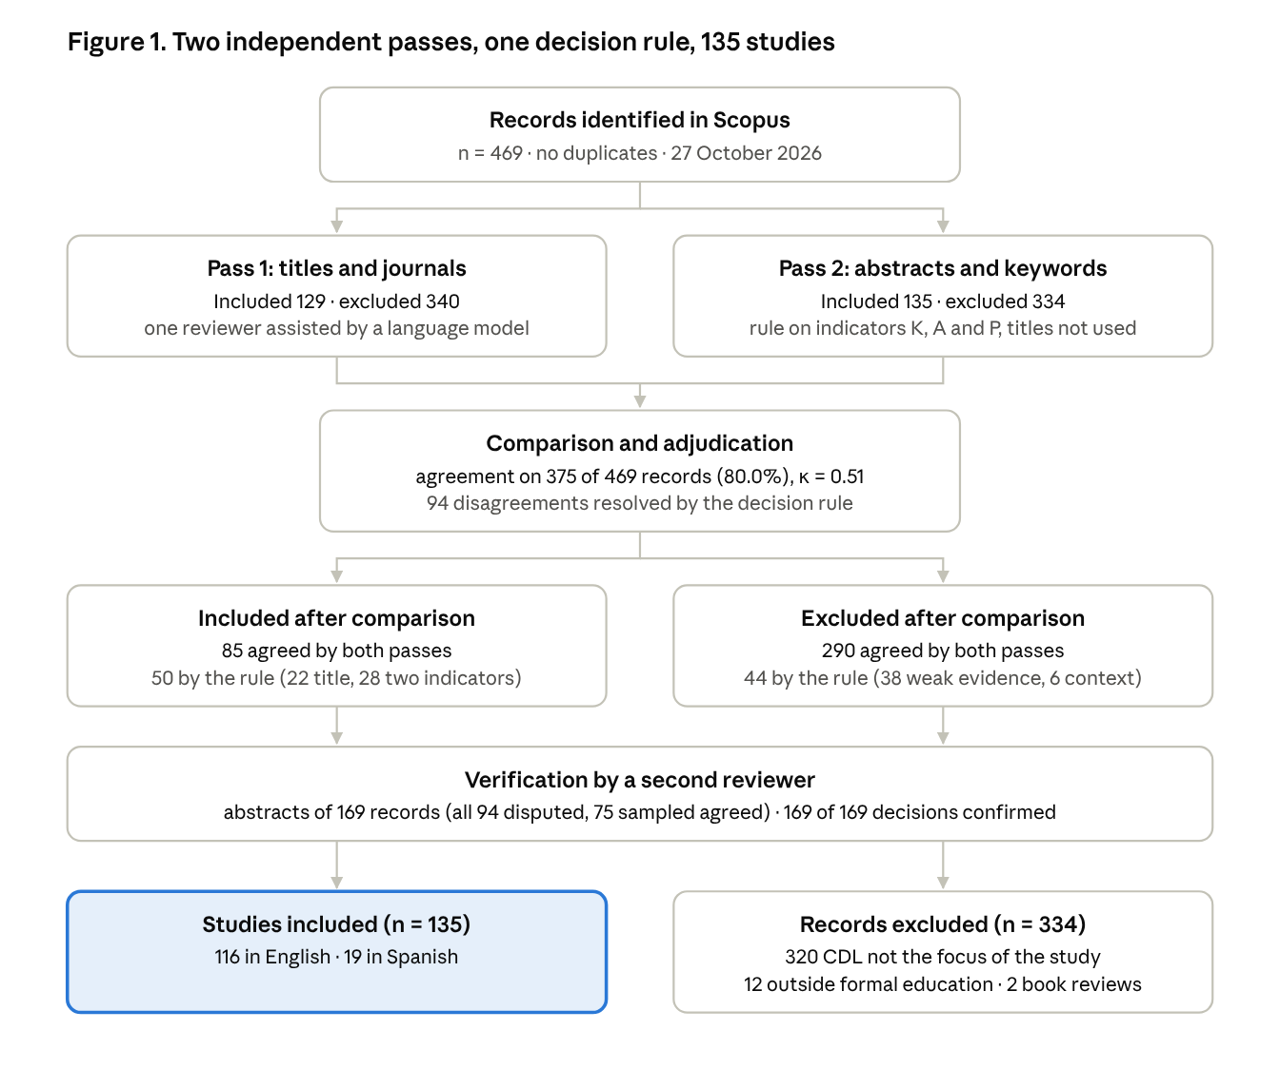
Figure 1 · adapted from the PRISMA 2020 flow diagram (Page et al., 2021) · Scopus, 27 October 2026
Note. K: author keywords name CDL; A: the abstract names CDL; P: the abstract or keywords address a sociopolitical dimension. The rule for disagreements is described in the Method section.

Results

Selection
The search returned 469 records and no duplicates. After the two screening passes, adjudication and the check by a second reviewer, 135 studies were included (Figure 1). Most exclusions (320) were studies in which critical and digital literacy appeared close together without a CDL approach: work on generic critical thinking, technology acceptance or the digital skills of health science students. A further 12 records were set outside formal education and 2 were book reviews. A reading of full texts for a sample of these studies, reported at the end of this section, suggests that about two thirds of them make CDL a central concern; the figures that follow describe the 135 studies as selected.

Growth and characteristics of the field (RQ1)
The field has grown fast. It went from 2 studies in 2016 to 22 in 2025, and the 52 studies published in 2026 up to the date of the search already more than double the previous year (Figure 2). Over 2016–2025 the Poisson model estimates annual growth of 20.6% (95% CI 11.0–31.1%, p < .001). Most of the field is very recent: 82 of the 135 studies (60.7%) appeared in 2024–2026. Growth here means growth in studies indexed under CDL. In the full-text sample, the share that made CDL a central concern was lowest in 2024–2026, so the recent rise of the field is probably overstated.
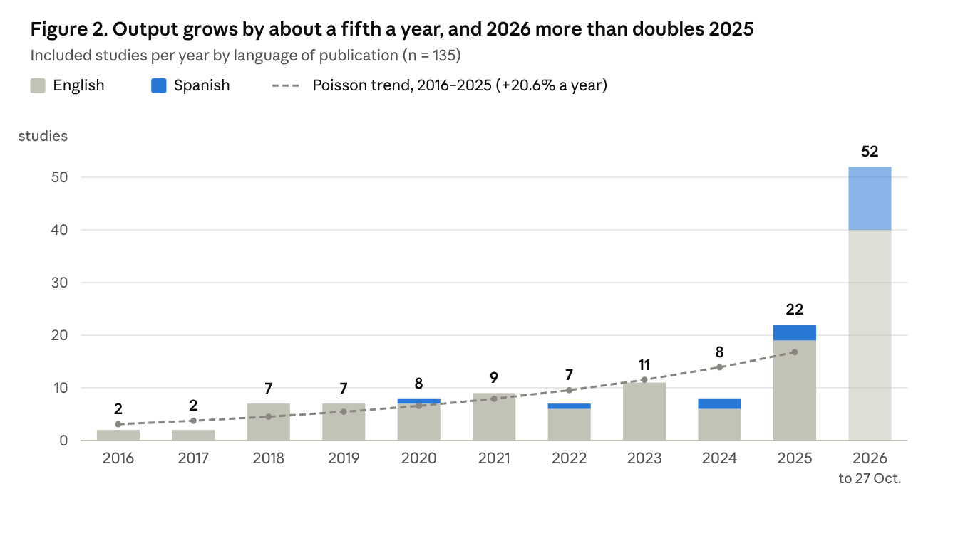
Figure 2 · Scopus, 135 included studies, 2016–2026 · 2026 covers 1 January to 27 October
Note. The dashed line is the Poisson regression of yearly counts for 2016–2025 (annual growth 20.6%, 95% CI 11.0–31.1%). The 2026 bar, shown lighter, covers the year only up to the date of the search.
Of the 135 studies, 116 were written in English and 19 (14.1%) in Spanish. Spanish-language work was absent before 2020 and accounts for 17 studies in 2024–2026, a fifth of that period (z = 2.75, p = .006). Three journals publish 8 of the 19: Digital Education Review, Edutec and Aula Abierta.
Authors were affiliated with institutions in 35 countries (Figure 3). The United States (32 studies) and Spain (27) lead by a wide margin, and at least one of them appears in 59 studies (43.7%), followed by Canada and the United Kingdom (8 each), Hong Kong (7) and Australia (5). By region, at least one author was based in Europe in 48 studies, North America in 40, Asia in 33, Latin America in 7, Oceania in 5 and Africa in 2. Of the 27 studies with an author in Spain, 13 were written in Spanish. The journals with most studies were System (8), Journal of Adolescent & Adult Literacy (7), Computers and Composition (6) and Pedagogies (5). The 135 studies had received 1,646 citations in Scopus at the time of the search (median 4), and 77 (57.0%) were open access.
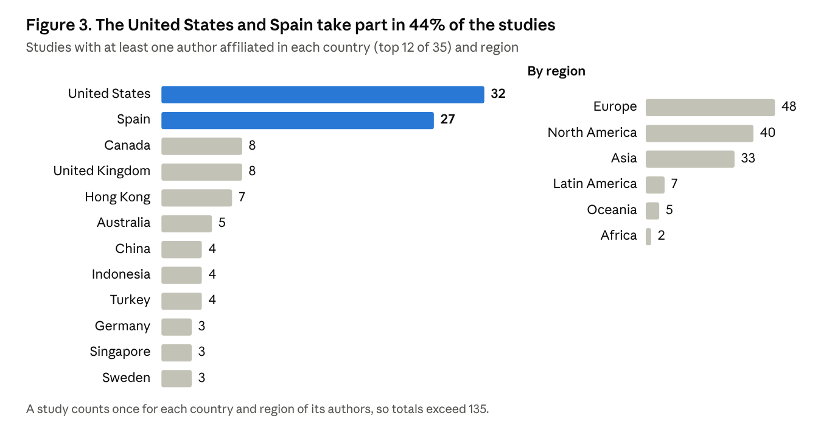
Figure 3 · author affiliations recorded in Scopus · 135 included studies
Table 3 shows how the corpus is distributed by educational level and design. Higher education is the most studied level (40.7%), followed by teacher education (28.9%) and secondary education (21.5%). Early childhood and primary education account for only 10 studies (7.4%), and their share did not grow. If anything, the code overstates them: four of the five sampled studies coded for this level were set at another level. The apparent fall of secondary education, from 44.4% to 17.1%, should be read with caution: it rests on broad terms such as adolescents, and it disappears with the strict dictionary (Table 5). Qualitative designs became more frequent, rising from a third of the studies in the first period to 58.5% in the last, and so did quantitative designs and literature reviews. The share of studies coded as describing an intervention or a designed sequence of teaching did not increase, although this code found only half of the interventions in the full-text sample.
Table 3. Educational level, design and language by period, n (%)
Category | 2016–2019 (n = 18) | 2020–2023 (n = 35) | 2024–2026 (n = 82) | Total (n = 135) | Trend z | p
Educational level
Early childhood and primary | 2 (11.1) | 3 (8.6) | 5 (6.1) | 10 (7.4) | −0.80 | .426
Secondary | 8 (44.4) | 7 (20.0) | 14 (17.1) | 29 (21.5) | −2.26 | .024
Higher education | 6 (33.3) | 11 (31.4) | 38 (46.3) | 55 (40.7) | 1.45 | .149
Teacher education | 5 (27.8) | 14 (40.0) | 20 (24.4) | 39 (28.9) | −0.92 | .356
Design
Qualitative | 6 (33.3) | 9 (25.7) | 48 (58.5) | 63 (46.7) | 2.91 | .004
Quantitative | 1 (5.6) | 7 (20.0) | 23 (28.0) | 31 (23.0) | 2.08 | .038
Conceptual or theoretical | 3 (16.7) | 6 (17.1) | 18 (22.0) | 27 (20.0) | 0.66 | .510
Intervention or designed teaching | 4 (22.2) | 9 (25.7) | 13 (15.9) | 26 (19.3) | −1.01 | .312
Literature review | 0 (0.0) | 1 (2.9) | 11 (13.4) | 12 (8.9) | 2.24 | .025
Language
Spanish | 0 (0.0) | 2 (5.7) | 17 (20.7) | 19 (14.1) | 2.75 | .006
Note. Codes are not mutually exclusive. No level code was assigned to 30 studies and no design code to 34. Trend: Cochran–Armitage test across the three periods.
The Spanish-language studies are distributed somewhat differently. Half of them (10 of 19) are set in higher education, and only 3 (15.8%) in teacher education, against 31.0% of the studies in English.

Theoretical traditions (RQ2)
The vocabulary of the theoretical traditions changed as the field grew (Table 4). The codes record whether a study uses the terms of a tradition in its title, abstract or keywords, not whether it adopts that tradition: a study that mentions multimodality is not thereby a multiliteracies study, and one that mentions gender or race is not thereby feminist or decolonial. With 54 studies (40.0%) using none of the terms, the trends below are trends in visible vocabulary, which may also reflect changes in how authors describe their work. In 2016–2019, nine of the 18 studies used the vocabulary of media literacy and nine that of multiliteracies or the New Literacy Studies, often in combination. That weight owes much to a single journal: 7 of the 18 studies from the period, including 7 of the 9 coded for media literacy, appeared in the Journal of Adolescent & Adult Literacy, a journal written largely for literacy teachers (Harrison, 2018; McArthur, 2019; Saunders et al., 2017). Both traditions fell to under a fifth of the studies in later periods, and both declines are significant. The full-text check supports reading these codes as vocabulary. In the sample, the dictionaries found 2 of the 6 studies that adopt Freirean critical pedagogy as their framework, and they agreed only in part with the full texts on media literacy and multiliteracies (κ = .46 and .62).
Table 4. Theoretical traditions by period, n (%)
Tradition | 2016–2019 (n = 18) | 2020–2023 (n = 35) | 2024–2026 (n = 82) | Total (n = 135) | Trend z | p
Media literacy and educommunication | 9 (50.0) | 5 (14.3) | 11 (13.4) | 25 (18.5) | −3.04 | .002
Multiliteracies and New Literacy Studies | 9 (50.0) | 6 (17.1) | 15 (18.3) | 30 (22.2) | −2.37 | .018
Digital citizenship | 1 (5.6) | 12 (34.3) | 8 (9.8) | 21 (15.6) | −0.98 | .329
Race, gender and decolonial perspectives | 2 (11.1) | 4 (11.4) | 14 (17.1) | 20 (14.8) | 0.85 | .396
Critical pedagogy (Freirean) | 1 (5.6) | 3 (8.6) | 12 (14.6) | 16 (11.9) | 1.27 | .206
Note. Codes are not mutually exclusive; 54 studies (40.0%) carried no tradition code. Trend: Cochran–Armitage test.
Digital citizenship peaked in 2020–2023, when a third of the studies used it. This was the period of reviews of teacher competence frameworks (Villar-Onrubia et al., 2022), of projects linking CDL with active citizenship in schools (Maiorana et al., 2023) and of a group of articles published together in Pedagogies on the civic and imaginative dimensions of CDL (Lewis et al., 2021). The pattern is not monotonic, so the trend test does not capture it.
Two traditions gained ground without reaching significance. Freirean critical pedagogy rose from one study to 14.6% of the last period. It appears in proposals for a pedagogy of the "digitally oppressed" (Farag et al., 2022), in calls for an emancipatory critical digital pedagogy in universities (Gutiérrez-Ujaque, 2024) and in a translation workshop on a cyberbullying campaign (Damaskinidis et al., 2026). Race, gender and decolonial perspectives appear across the whole period and cluster in recent work on AI. Examples include the critical race algorithmic literacies that Black students used to resist AI-mediated racism at school (Tanksley, 2024), a survey of U.S. adolescents' critical race digital literacy skills (McGee et al., 2026), language decolonisation among Arab bilingual learners writing with AI (Alhabbash et al., 2026) and the gendered self-surveillance of adolescents on platforms (Regueira et al., 2026).

Objects of critique (RQ3)
What the field asks learners to read critically has followed the dominant technology of each period (Figure 4). Social media is the one stable object, present in about a fifth of the studies throughout (z = 0.06, p = .952). Algorithms, data and platforms rose from one study in 2016–2019 to 31.7% of the studies in 2024–2026 (z = 2.61, p = .009). Artificial intelligence did not appear at all before 2020, appeared in two studies in 2020–2023 and is present in 42.7% of the most recent studies, most of them on generative AI (z = 4.69, p < .001). Disinformation and post-truth (8 studies), privacy and surveillance (8) and hate speech and radicalisation (3) are smaller and stable lines of work. These counts are probably too low: in the full-text sample, the dictionaries found 1 of the 6 studies that critique disinformation and 1 of the 7 on privacy and surveillance.
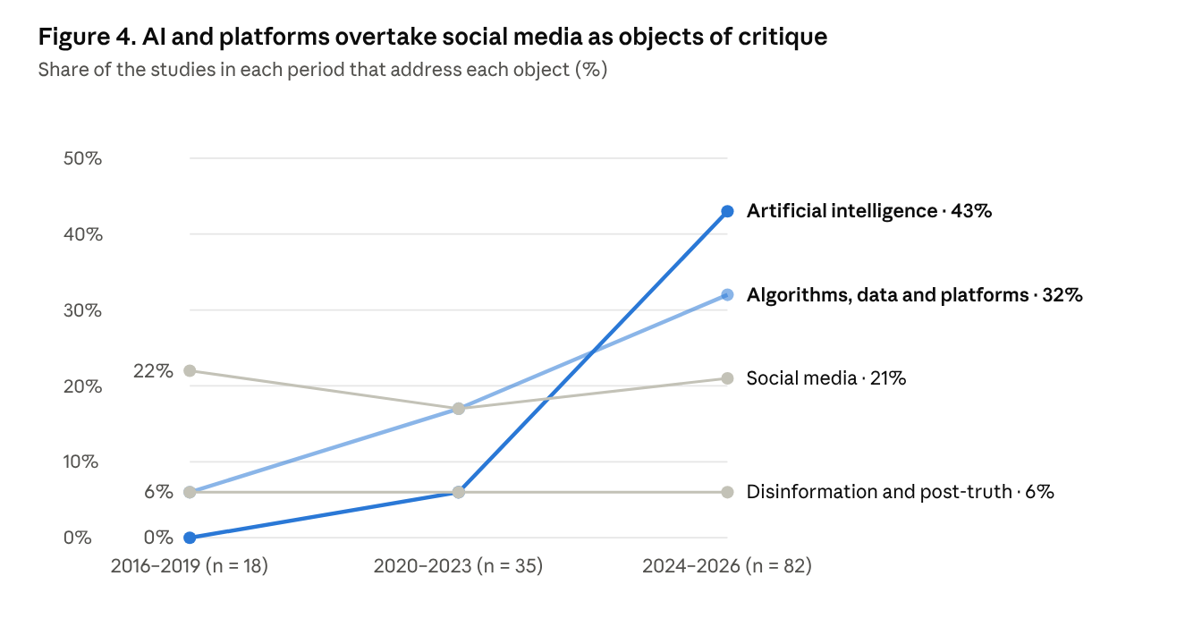
Figure 4 · codes from titles, abstracts and keywords (broad dictionaries, Appendix A3) · 135 included studies
Note. A study can address more than one object. Trend tests and the strict-dictionary check are reported in Table 5.
Studies of social media analyse political memes with middle school students (Elmore & Coleman, 2019), use social media as a site for multimodal critical digital literacy in higher education (Talib, 2018), or follow how adolescents negotiate privacy on Instagram (González-Villa & Gewerc, 2026). Work on platforms and data includes critical data literacy for academic development (Atenas et al., 2023), the experiences of primary school pupils in platformised schools (Moreno-González et al., 2026), algorithm-aware writing pedagogies in English for academic purposes (Wang & Xu, 2026), and CDL as a response to neofascism among young people in the platform era (Herrera Urízar, 2026). Research on AI is the most recent strand, and it includes the most cited study in the corpus, which argues that second language writing mediated by generative AI needs critical digital literacies (Darvin, 2025). Others examine ideological bias in chatbot interactions (Van Poucke, 2024), visual bias in AI-generated images (Weninger & Xu, 2026) and bias in AI-supported lesson planning (Zagami, 2026), or propose frameworks and scales for critical AI literacy (Bozkurt et al., 2026; Stewart & Rodgers, 2025). More than a third of the studies on AI come from language education and academic writing.
Objects and traditions are not independent (Figure 5). Algorithms and platforms are the object most often addressed within the digital citizenship tradition (8 of 21 studies) and within race, gender and decolonial perspectives (8 of 20), which also carry the highest share of work on AI (7 of 20). Social media, by contrast, is more often read through media literacy and multiliteracies, the older traditions of the field.
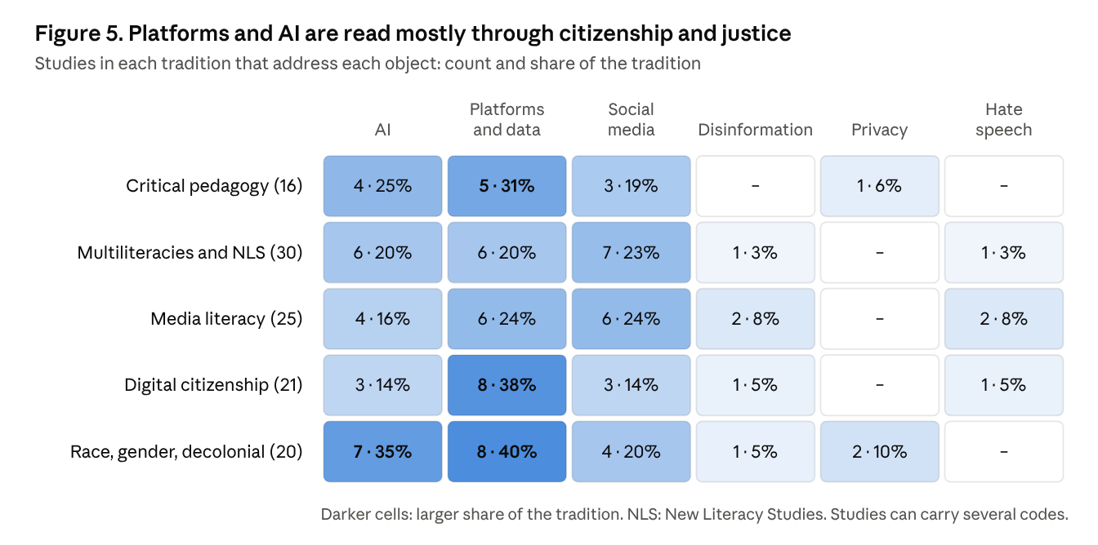
Figure 5 · co-occurrence of tradition and object codes · 135 included studies
The main trends hold when the coding is repeated with strict dictionaries (Table 5). The rise of AI and of platforms remains significant; the strict AI dictionary, which counts only generative AI, still finds it in 26.8% of the latest studies. Social media stays flat under both dictionaries. The changes by educational level are not robust: the fall of secondary education disappears with the strict dictionary, and under that dictionary no level shows a significant trend. The full-text check adds a different caveat. The AI dictionary was the most accurate of all, so the rise of AI as a code is not an artefact of the terms chosen; but only 5 of the 11 sampled studies coded for AI made CDL a central concern.
Table 5. Robustness of the main trends to the coding dictionary, n (%) by period
Category | Dictionary | 2016–2019 (n = 18) | 2020–2023 (n = 35) | 2024–2026 (n = 82) | Trend z | p
Artificial intelligence | Broad | 0 (0.0) | 2 (5.7) | 35 (42.7) | 4.69 | < .001
 | Strict | 0 (0.0) | 0 (0.0) | 22 (26.8) | 3.75 | < .001
Algorithms, data and platforms | Broad | 1 (5.6) | 6 (17.1) | 26 (31.7) | 2.61 | .009
 | Strict | 1 (5.6) | 3 (8.6) | 26 (31.7) | 3.11 | .002
Social media | Broad | 4 (22.2) | 6 (17.1) | 17 (20.7) | 0.06 | .952
 | Strict | 4 (22.2) | 2 (5.7) | 12 (14.6) | −0.19 | .851
Early childhood and primary | Broad | 2 (11.1) | 3 (8.6) | 5 (6.1) | −0.80 | .426
 | Strict | 1 (5.6) | 3 (8.6) | 3 (3.7) | −0.71 | .476
Secondary | Broad | 8 (44.4) | 7 (20.0) | 14 (17.1) | −2.26 | .024
 | Strict | 1 (5.6) | 7 (20.0) | 8 (9.8) | −0.22 | .828
Higher education | Broad | 6 (33.3) | 11 (31.4) | 38 (46.3) | 1.45 | .149
 | Strict | 4 (22.2) | 9 (25.7) | 28 (34.1) | 1.19 | .235
Teacher education | Broad | 5 (27.8) | 14 (40.0) | 20 (24.4) | −0.92 | .356
 | Strict | 5 (27.8) | 9 (25.7) | 13 (15.9) | −1.44 | .151
Note. Strict dictionaries keep only the least ambiguous terms of each category, for example generative AI, ChatGPT or large language model for AI, and higher education, university students or undergraduate for higher education (Appendix A). Trend: Cochran–Armitage test.

Pedagogical practices and teachers (RQ4)
Five kinds of practice recur across the corpus (Table 6). They differ in what learners do with the digital: analyse it, make it, exchange across borders through it, work through a designed sequence about it, or act on it. The typology is drawn from the aims and settings that the studies describe, and it is illustrative rather than exhaustive.
Table 6. Pedagogical practices described in the corpus
Practice | What learners do | Examples
Critical analysis of digital texts | Read memes, videos, teaching materials or AI outputs for representation, bias and ideology | Political memes in middle school (Elmore & Coleman, 2019); diversity in airline safety videos (Ho & Hafner, 2025); ideological bias in chatbot answers (Van Poucke, 2024); visual bias in AI images (Weninger & Xu, 2026)
Media production and multimodal composing | Produce video, stories, posters or multimodal texts that answer dominant narratives | Video production in elementary teacher education (Watt, 2019); digital storytelling on District Six (Noble & Gachago, 2022); bilingual Vine making (de los Ríos, 2018); translating a poster campaign on cyberbullying (Damaskinidis et al., 2026)
Virtual exchange | Work with peers in other countries and examine how platforms shape the exchange | Hauck (2019); ELT teacher education (Bilki et al., 2023); multimodal representation (Satar et al., 2023); a COIL project with pre-service teachers (Ketzer-Nöltge & Markovic, 2022)
Designed modules and inquiry | Follow a sequence built around a game, a controversy or a writing task | Co-designing a module with indie video games (Jiménez Torras et al., 2026); conspiracy theories in English classes (Gerlach et al., 2025); reflection notebooks on misinformation (Spracklin & Espina, 2025); rating classroom tools for privacy with future primary teachers (Castañeda & Villar-Onrubia, 2023)
Civic action | Use digital tools to investigate and act on local or political issues | Civic interrogation in a ninth-grade ethnic studies course (Kwon & de los Ríos, 2019); student activism after the Parkland shooting (Abowitz & Mamlok, 2020); university digital activism in Peru (Fernández, 2026); Black students resisting AI-mediated racism (Tanksley, 2024)
Studies that describe an intervention or a designed teaching sequence are a minority: 26 of the 135, and 8 of them also mention quantitative measures. Outcome evaluation, quantitative measurement and causal inference should not be confused. Qualitative studies of an intervention can document learning, changes in practice or agency, and a quantitative measure does not by itself show that a practice caused a change. The dictionaries show which studies describe an intervention and which mention quantitative measures, but not which evaluate outcomes; the full-text sample, reported below, answers that question for 25 studies. Quantitative work is concentrated in higher education (18 of the 31 quantitative studies), and much of the recent effort goes into building instruments rather than evaluating teaching. Examples are the Comprehensive Digital Literacy Scale (AlGhannama et al., 2025), the Critical 3wAI Literacy Scale (Bozkurt et al., 2026) and a survey of adolescents' critical race digital literacy skills (McGee et al., 2026). In early childhood and primary education, three studies describe an intervention.
Teachers are the focus of 39 studies (28.9%), many of them in initial teacher education. Some ask how teachers understand CDL and how it shows in their practice (Gouseti et al., 2024) or measure the skills and attitudes of future teachers (Castellví et al., 2020; Santisteban et al., 2020). Others study how teacher educators build CDL into their own work, through inquiry groups (Lohnes Watulak, 2016), scalar analyses of teacher education programmes (Stewart et al., 2021) or collaborative autoethnography (Kim et al., 2026). Since 2025 a new strand asks what generative AI means for teacher preparation, from novice teachers planning lessons with ChatGPT (Javahery et al., 2025) to bias in AI-supported differentiation (Zagami, 2026). Several studies question how CDL fits within the use-centred digital competence frameworks that organise teacher education (Castañeda & Villar-Onrubia, 2023) or examine the tensions of teaching digital citizenship in initial teacher education (Salazar-Jiménez et al., 2026), and some propose frameworks of their own, for instance for second-language teacher education in the Global South (Mahapatra & Koltovskaia, 2025).
Citations are concentrated in a few studies (Table 7). The ten most cited account for 593 of the 1,646 citations (36.0%). Four of them come from language education. The highest citation rate belongs to one of the newest studies: Darvin (2025) gathered 98 citations in two years.
Table 7. The ten most cited studies in the corpus
Study | Journal | Citations | Per year | Focus
Darvin (2025) | Journal of Second Language Writing | 98 | 49.0 | CDL for second language writing mediated by generative AI
Ilomäki et al. (2023) | Review of Education | 74 | 18.5 | Systematic review of CDL at school level
Pötzsch (2019) | tripleC | 71 | 8.9 | CDL beyond user competence and labour-market qualifications
Hauck (2019) | European Journal of Language Policy | 68 | 8.5 | Virtual exchange for (critical) digital literacy
Moorhouse et al. (2025) | System | 49 | 24.5 | Generative AI tools and empowerment in L2 academic writing
Castellví et al. (2020) | Social Sciences | 49 | 7.0 | Pre-service teachers' CDL skills and attitudes towards social problems
Talib (2018) | E-Learning and Digital Media | 49 | 5.4 | Social media pedagogy for multimodal CDL
Mesquita-Romero et al. (2022) | Comunicar | 46 | 9.2 | Critical media literacy and students' competences
Gouseti et al. (2024) | Educational Review | 45 | 15.0 | Teachers' perceptions of CDL and their teaching practices
Tagg & Seargeant (2021) | Linguistics and Education | 44 | 7.3 | Context design and critical language and media awareness
Note. Scopus citations on 27 October 2026. Per year: citations divided by the number of calendar years since publication, counting the year of publication.

Validation on full texts
Of the 38 studies read in full, 25 (65.8%, 95% CI 50–79%) met the eligibility criteria. All 13 exclusions had the same reason: CDL was not a central focus. In some, CDL appeared only in a closing recommendation, as in a survey of students' views on regulating ChatGPT (López-Fernández et al., 2026). In others, "critical" meant judging the credibility of sources (Ketzer-Nöltge & Markovic, 2022; Lalira & Warouw, 2026) or holding ethical beliefs about AI (Bozkurt et al., 2026). Fifteen decisions were borderline. Excluding all of them would leave 19 eligible studies (50%); including all of them would give 34 (89%).
Eligibility depended on how a study had entered the review. It was confirmed for 20 of the 25 sampled studies on which both screening passes had agreed, but for only 3 of the 10 admitted under the second branch of the adjudication rule, a title referring to a digital technology and two of the three indicators. It was also lower among studies coded for AI (5 of 11) and in the latest period (16 of 26, against 7 of 10 in 2020–2023 and both studies from 2016–2019). The numbers are small, but they point the same way: much of the recent growth of the corpus, and of its work on AI, consists of studies that mention CDL without making it their concern.
Table 8 compares the dictionary codes with the full-text codes of the 25 eligible studies. The AI dictionary matched the full texts exactly (5 of 5, κ = 1.00), and the codes for secondary education, social media and race, gender and decolonial perspectives came close (κ = .80 to .88). The other dictionaries erred in one of two directions. Some assigned codes that the full text did not support: four of the five studies coded for early childhood and primary education were set at another level, and three of the four coded as conceptual were not conceptual studies. Others missed most of what the full texts contained. They found 1 of the 6 studies that critique disinformation, 1 of the 7 on privacy and surveillance, 1 of the 5 in which learners produce digital content, 2 of the 6 that adopt Freirean critical pedagogy and 5 of the 10 that describe an intervention.
Table 8. Dictionary codes compared with full-text codes in the eligible studies of the validation sample (n = 25)
Category | Full text | Dictionary | Both | Precision | Sensitivity | κ
Educational level
Early childhood and primary | 1 | 5 | 1 | .20 | 1.00 | .29
Secondary | 5 | 6 | 5 | .83 | 1.00 | .88
Higher education | 5 | 8 | 5 | .63 | 1.00 | .69
Teacher education | 10 | 10 | 8 | .80 | .80 | .67
Design
Literature review | 2 | 3 | 1 | .33 | .50 | .34
Conceptual or theoretical | 2 | 4 | 1 | .25 | .50 | .25
Qualitative | 17 | 14 | 13 | .93 | .76 | .58
Quantitative | 7 | 6 | 4 | .67 | .57 | .48
Intervention or designed teaching | 10 | 7 | 5 | .71 | .50 | .39
Theoretical tradition
Critical pedagogy (Freirean) | 6 | 4 | 2 | .50 | .33 | .26
Multiliteracies and New Literacy Studies | 3 | 3 | 2 | .67 | .67 | .62
Media literacy and educommunication | 2 | 2 | 1 | .50 | .50 | .46
Digital citizenship | 3 | 2 | 2 | 1.00 | .67 | .78
Race, gender and decolonial perspectives | 4 | 3 | 3 | 1.00 | .75 | .83
Object of critique, context or practice
Artificial intelligence | 5 | 5 | 5 | 1.00 | 1.00 | 1.00
Disinformation and post-truth | 6 | 1 | 1 | 1.00 | .17 | .23
Social media | 7 | 7 | 6 | .86 | .86 | .80
Algorithms, data and platforms | 11 | 9 | 6 | .67 | .55 | .34
Privacy and surveillance | 7 | 1 | 1 | 1.00 | .14 | .19
Hate speech and radicalisation | 1 | 0 | 0 | — | .00 | .00
Second or foreign language education | 6 | 3 | 3 | 1.00 | .50 | .60
Student media production | 5 | 1 | 1 | 1.00 | .20 | .29
Note. Full text: studies coded in the full-text reading. Dictionary: studies coded by the dictionaries from titles, abstracts and keywords. Both: studies coded by both. Precision = both ÷ dictionary; sensitivity = both ÷ full text; κ: Cohen's kappa. Precision is undefined when a dictionary assigned no code. The full-text codes were assigned by a single coder, a large language model applying the codebook (Supplementary files S4 and S5).
Outcome evaluation was rare. Of the 25 eligible studies, 16 did not examine what participants learned, 5 offered qualitative evidence of learning or change after an intervention, 4 reported quantitative measures before and after without a comparison group, and none used a comparative design. Interventions were more frequent than the dictionaries suggest (10 of the 25), and all but one of them reported some evaluation.
The three dimensions of the working definition were unevenly present. Of the 25 eligible studies, 18 addressed the textual dimension, 14 the infrastructural and 9 the transformative; 9 addressed the textual dimension alone, and 4 all three. The infrastructural dimension was more frequent in the latest period, in 10 of the 16 studies from 2024–2026 against 3 of the 7 from 2020–2023. In five of the nine studies with a transformative dimension, action was proposed or anticipated rather than documented. Four showed participants acting to change a practice or a technology, for example by reporting analyses of open data to public authorities (Atenas et al., 2023) or by redesigning lessons to resist the bias of AI recommendations (Zagami, 2026).

Discussion
Research on CDL in formal education has grown by about a fifth each year and now produces more studies in a year than it did in its first four years together. The review points to three imbalances in that growth. The field follows each new technology closely, it is concentrated at the top of the education system, and it describes far more than it evaluates. A fourth finding concerns the review itself: in this field, titles and abstracts are a poor guide to content, and a third of the studies read in full did not make CDL their concern.

A field that follows the technology
The widening of attention from social media to platforms and then to generative AI shows a field able to respond quickly. Attention to social media did not fall, so the pattern is one of accumulation rather than replacement. Within three years of the release of ChatGPT, AI had become the most frequent object of critique in the corpus. That speed has a cost. Each new technology tends to bring its own literacy, and the corpus already contains data literacy, algorithmic literacy, prompt literacy and critical AI literacy alongside CDL. If every technology gets its own framework, the field will struggle to accumulate knowledge, and teachers will face a new vocabulary every few years. Part of the response is also nominal: fewer than half of the sampled studies coded for AI made CDL a central concern, and the others invoked it in a closing recommendation or reduced it to ethical attitudes or to checking sources.
The working definition used here suggests a way through. Its infrastructural dimension, which asks who owns a technology, what data it collects and whose interests it serves, does not depend on any particular device. It applies to a social network, a learning platform or a language model alike. That is the point Pangrazio (2016) and Pötzsch (2019) made before generative AI existed, and it fits the broader analyses of platformisation and datafication in education (van Dijck et al., 2018; Williamson, 2017). The co-occurrence results point in the same direction. Platforms and AI are most often studied through digital citizenship and through race, gender and decolonial perspectives, which are concerned with governance and justice rather than with reading individual texts. Social media, the older object, is still read mostly through media literacy and multiliteracies. The full texts lend this some direct support, though the numbers are small: the infrastructural dimension appeared in 10 of the 16 eligible studies from 2024–2026 and in 3 of the 7 from 2020–2023. The field seems to be moving from the critique of representation towards the critique of infrastructure, and that move is what can give it continuity.

Where young children are missing
Early childhood and primary education account for 7.4% of the studies, and three of them describe an intervention. The gap is not explained by a lack of digital technology in those years. Pupils in primary schools also learn on platforms, as research on their experience of platformised schooling shows (Moreno-González et al., 2026), and their data can be collected from the moment they log in. One possible reason for the imbalance is access: researchers in faculties of education can study their own university students and pre-service teachers more easily than they can enter primary classrooms. Whatever the cause, the result is that the field knows least about the stage at which children first meet the platforms that will shape their schooling.

From description to evidence
Qualitative and conceptual designs are the most frequent codes, and the share of studies that describe an intervention has not grown. The full texts confirm the gap. Of the 25 eligible studies read, 16 did not examine what participants learned and none compared participants with a group that did not take part; the interventions that were evaluated relied on qualitative evidence or on measures taken before and after. Evidence of what learners gain can come from qualitative as well as quantitative designs, and the field has some of the first kind. What it lacks are designs that allow a change to be attributed to a practice.
The new instruments for CDL and critical AI literacy (AlGhannama et al., 2025; Bozkurt et al., 2026) could support comparative designs, but they bring a risk the field should name. A literacy whose aim is to question how systems sort and score people can be reduced, in turn, to a score, and the one scale read in full here measured ethical beliefs about AI rather than any critique of power (Bozkurt et al., 2026). Evaluation designs that combine measures with analyses of what learners produce and say would be more consistent with what CDL sets out to do.
The transformative dimension, the one that asks learners to act, is the least developed of the three: it appeared in 9 of the 25 eligible studies and was documented as practice in only 4. Evaluating CDL will also mean finding out whether learners can do what that dimension asks.

Geography and language
Authors based in the United States or Spain appear in 44% of the studies, while authors based in Latin America and Africa appear in 7 and 2 studies respectively. Part of the imbalance comes from the database. Scopus, like Web of Science, under-represents the social sciences and journals published in languages other than English (Mongeon & Paul-Hus, 2016). The recent growth of research in Spanish is real, but it is concentrated in three journals and mostly in Spain. Latin America has a long tradition of educommunication and popular education that speaks directly to CDL, and it is very likely under-represented here. A review that added SciELO and Redalyc would probably change the geographical picture more than any other single step.

Implications for policy
Several studies in the corpus question how CDL fits within competence frameworks centred on use. DigComp 2.2 already mentions data ownership, business models and collective action, but only as examples in its annex on AI systems, and DigCompEdu does not develop them for educators. The findings support moving these questions from the examples into the competences themselves, as an infrastructural dimension: knowledge of who owns educational platforms, what data they collect and how their business models work. Without it, digital competence for teachers risks meaning the efficient adoption of tools whose logic is never discussed.

A methodological note
The two screening passes agreed only moderately. Neither pass alone reproduced the final selection. Compared with it, the title pass would have missed 28 of the 135 included studies (20.7%) and kept 22 that were finally excluded; the abstract-and-keyword pass would have missed 22 and kept 22. Because the final selection was built from both passes, these figures show how far each pass departs from it, not independent error rates. Some studies name CDL only in their abstract or keywords, and some titles that sound critical describe something else.
The full texts give a firmer measure, and it is less reassuring than the check on abstracts. The second reviewer, reading abstracts, had confirmed every decision that the rule took on disputed records. Yet only 3 of the 10 sampled studies admitted on two indicators made CDL a central concern, against 20 of the 25 on which both passes had agreed. An abstract can combine the right terms and still describe a study of something else, such as the adoption or regulation of AI or the evaluation of sources. Reviews of CDL, and probably of other critical literacies, should not rely on titles and abstracts. Field-level searches inside abstracts offer a reproducible way to locate candidate studies, but reproducibility is not validity, and only full texts settle what a study is about.

Limitations
The review has six main limitations.
- Full texts read only for a sample. The Scopus access available did not return the text of abstracts, so both screening passes and the charting rest on titles and on term searches in abstracts and keywords. A second reviewer read the abstracts of 169 records, and full texts were read for 38 open-access studies. They show that the corpus is broader than the definition: 25 of the 38 made CDL a central concern (95% CI 50–79%), so the 135 studies are best read as research indexed under CDL, of which perhaps two thirds is CDL research in the sense used here. For the 97 studies not read, codes show that a term appears, not how a study treats it, and the synthesis describes what studies set out to do rather than what they found. Because the sample was drawn from open-access studies only, and two of its four studies from 2016–2019 could not be retrieved, its estimates may not transfer exactly to subscription journals or to the earliest years.
- Screening. Pass 1 was carried out by one reviewer assisted by a large language model and pass 2 by a rule. The adjudication rule was set after the disagreements had been inspected, though before any was decided, and it was not registered in advance. The second reviewer checked every disagreement but only a 20% sample of the agreed records, so errors among the other 300 agreed records cannot be ruled out.
- Term-based coding. Codes depend on the dictionaries, and reproducible coding is not the same as valid coding. The full-text check shows that the dictionaries for AI, secondary education and social media are reliable, but that those for disinformation, privacy, student production, Freirean pedagogy and interventions miss most cases, and that the code for early childhood and primary education is inflated (Table 8). Trends in these categories are trends in vocabulary. The strict dictionaries show that the main trends do not depend on the broader terms; even so, 30 studies received no level code, 34 no design code and 54 no tradition code.
- Full-text coding by a single automated coder. The full texts were coded by a large language model applying the codebook, with no second coder, so the reliability of these codes is unknown. Each code is backed by a quotation and page (Supplementary file S5) and can be audited, but none was checked by a second person. Fifteen eligibility decisions were borderline: under the most restrictive and the most inclusive reading of those cases, between 19 and 34 of the 38 studies would be eligible.
- Coverage. Only Scopus was searched, and only English and Spanish were included. Web of Science, ERIC, SciELO and Redalyc, and research in Portuguese, would broaden the picture, especially for Latin America.
- Time. The year 2026 is covered only up to 27 October, and the citation counts of recent studies are still accumulating.

Conclusion
Between 2016 and 2026, research on critical digital literacy in formal education moved from a small niche, with two studies in 2016, to a fast-growing field, with 52 studies in 2026 alone, although a third of the studies read in full used the term without making CDL their concern. It has widened its attention from social media to platforms, data and artificial intelligence without leaving social media behind, and the vocabulary of media literacy that marked its early years now appears alongside that of critical pedagogy and of race, gender and decolonial perspectives. Research written in Spanish, almost absent before 2020, now makes up a fifth of the newest studies.
Three tasks lie ahead. The first is to reach young children, who make up a small fraction of the research even though platforms reach them early. The second is to find out what learners gain from CDL, with designs that test practices without reducing critique to a score. The third is to settle on a conceptual core that does not have to be rebuilt for each new technology, and the infrastructural questions of ownership, data and interest are the natural candidates.
For policy, the main message is that current frameworks already name some of these questions but treat them as examples rather than as competences. Preparing people to live with platforms they do not control means putting at the centre the questions of who designs those platforms, what data they collect and whom they serve.

Data availability
The search string, the 469 records, the decisions of both screening passes, the adjudication, the coding of the 135 included studies, the full-text validation and the code that produces them are archived as an open data set (Author, 2026) at [repository link removed for anonymous review]. Supplementary file S1 lists the included studies with their codes; supplementary file S2 gives the decisions of both screening passes for all 469 records; supplementary file S3 gives the PRISMA-ScR checklist; supplementary file S4 gives the codebook for the full-text validation; and supplementary file S5 gives the full-text codes with their supporting quotations.

Conflict of interest
The conflict of interest statement is given on the title page, which is withheld from reviewers to keep the review anonymous.

AI use declaration
A large language model (Claude, Anthropic) was used for study design (drafting the search string and the screening and coding procedures), data collection (running the Scopus queries through the Scopus APIs and retrieving the open-access full texts of the validation sample), literature review (proposing the title-screening decisions of pass 1, drafting the dictionaries for pass 2 and for coding, and coding the full texts of the validation sample with the codebook, recording a supporting quotation and page for each code), data analysis (writing the Python code for screening, coding and the statistical tests), figure creation (drawing Figures 1–5 and building the tables) and writing assistance (drafting and revising the manuscript). It was also used to check the references against Crossref, OpenAlex and ORCID records. A second, human reviewer read the abstracts of 169 records to verify the screening (see Method). No second person coded the full texts. The author checked the decisions, the analyses, the references and the text, and takes full responsibility for the content.

References
Abowitz, K. K., & Mamlok, D. (2020). #NeverAgainMSD student activism: Lessons for agonist political education in an age of democratic crisis. Educational Theory, 70(6), 731–748. https://doi.org/10.1111/edth.12451
AlGhannama, B., Alsaber, A., Alkandari, A., & Anbar, A. (2025). Psychometric evaluation of the Comprehensive Digital Literacy Scale (CDLS): A measurement of critical digital literacy and basic operational digital skills. New Review of Information Networking, 30(2), 353–382. https://doi.org/10.1080/13614576.2025.2588758
Alhabbash, M., Al Mohammedi, N., Omar, H., & Alothali, S. (2026). Writing back with AI: A phenomenological study of language decolonization among Arab bilingual learners. Contemporary Educational Technology, 18(2), Article ep651. https://doi.org/10.30935/cedtech/18477
Arksey, H., & O'Malley, L. (2005). Scoping studies: Towards a methodological framework. International Journal of Social Research Methodology, 8(1), 19–32. https://doi.org/10.1080/1364557032000119616
Atenas, J., Havemann, L., Rodés, V., & Podetti, M. (2023). Critical data literacy in praxis: An open education approach for academic development. Edutec, (85), 49–67. https://doi.org/10.21556/edutec.2023.85.2851
Author. (2026). Data and code for a scoping review of critical digital literacy in formal education, 2016–2026 [Data set]. Details omitted for masked review.
Bilki, Z., Satar, M., & Sak, M. (2023). Critical digital literacy in virtual exchange for ELT teacher education: An interpretivist methodology. ReCALL, 35(1), 58–73. https://doi.org/10.1017/S095834402200009X
Bozkurt, A., Ertan, S., & Cömert, Z. (2026). What does it mean to be AI literate? Psychometric validation of the Critical 3wAI Literacy Scale. Open Praxis, 18(4), 655–669. https://doi.org/10.55982/openpraxis.18.4.1451
Castañeda, L., & Villar-Onrubia, D. (2023). Beyond functionality: Building critical digital teaching competence among future primary education teachers. Contemporary Educational Technology, 15(1), Article ep397. https://doi.org/10.30935/cedtech/12599
Castellví, J., Díez-Bedmar, M.-C., & Santisteban, A. (2020). Pre-service teachers' critical digital literacy skills and attitudes to address social problems. Social Sciences, 9(8), Article 134. https://doi.org/10.3390/SOCSCI9080134
Creely, E., Parr, G., Richardson, H., Carabott, K., McLeod, A., & Scull, J. (2026). Critical literacies in upper primary in Australia (2014–2024): A thematic literature review. Australian Journal of Language and Literacy, 49(1), 1–18. https://doi.org/10.1007/s44020-025-00086-w
Damaskinidis, G., Pliogou, V., & Tromara, S. (2026). Intersemiotic translation as a pedagogy for cyberbullying awareness: The One Shot is Enough poster campaign. Public Journal of Semiotics, 12(2), 38–62. https://doi.org/10.37693/pjos.2026.12.29327
Darvin, R. (2025). The need for critical digital literacies in generative AI-mediated L2 writing. Journal of Second Language Writing, 67, Article 101186. https://doi.org/10.1016/j.jslw.2025.101186
de los Ríos, C. V. (2018). Bilingual Vine making: Problematizing oppressive discourses in a secondary Chicanx/Latinx studies course. Learning, Media and Technology, 43(4), 359–373. https://doi.org/10.1080/17439884.2018.1498350
Elmore, P. G., & Coleman, J. M. (2019). Middle school students' analysis of political memes to support critical media literacy. Journal of Adolescent & Adult Literacy, 63(1), 29–40. https://doi.org/10.1002/jaal.948
Escribano-Muñoz, C., Gil-Fernández, R., & Calderón-Garrido, D. (2024). Confluencias entre pensamiento crítico y redes sociales en el ámbito educativo. Mapeo de experiencias y detección de desafíos a través de una revisión sistemática [Confluences between critical thinking and social media in the educational world. Mapping experiences and detecting challenges through a systematic review]. Revista Complutense de Educación, 35(2), 363–379. https://doi.org/10.5209/rced.85615
Farag, A., Greeley, L., & Swindell, A. (2022). Freire 2.0: Pedagogy of the digitally oppressed. Educational Philosophy and Theory, 54(13), 2214–2227. https://doi.org/10.1080/00131857.2021.2010541
Fernández, L. E. (2026). Activismo digital y alfabetización crítica: Agencia universitaria para la justicia sociolingüística en Perú [Digital activism and critical literacy: University agency for sociolinguistic justice in Peru]. Lengua y Sociedad, 25(1), Article e32220. https://doi.org/10.15381/lengsoc.v25i1.32220
Freire, P. (1970). Pedagogy of the oppressed (M. B. Ramos, Trans.). Herder and Herder.
Gerlach, D., Schildhauer, P., & Weiser-Zurmühlen, K. (2025). Developing critical minds: An ethnographic study on the implementation of conspiracy theories to foster critical digital literacy in English language classrooms. System, 135, Article 103871. https://doi.org/10.1016/j.system.2025.103871
González-Villa, Á., & Gewerc, A. (2026). Prácticas adolescentes de negociación de la privacidad en Instagram: La necesidad de alfabetización digital crítica en la escuela [Adolescent practices of privacy negotiation on Instagram: The need for critical digital literacy in schools]. Educar, 62(2), 429–445. https://doi.org/10.5565/rev/educar.2510
Gouseti, A., Lakkala, M., Raffaghelli, J., Ranieri, M., Roffi, A., & Ilomäki, L. (2024). Exploring teachers' perceptions of critical digital literacies and how these are manifested in their teaching practices. Educational Review, 76(7), 1751–1785. https://doi.org/10.1080/00131911.2022.2159933
Gutiérrez-Ujaque, D. (2024). Towards a critical digital literacy and consciousness in higher education: The emancipatory role of critical digital pedagogy. Pedagogies, 19(3), 337–371. https://doi.org/10.1080/1554480X.2024.2379787
Harrison, C. (2018). Critical internet literacy: What is it, and how should we teach it? Journal of Adolescent & Adult Literacy, 61(4), 461–464. https://doi.org/10.1002/jaal.713
Hauck, M. (2019). Virtual exchange for (critical) digital literacy skills development. European Journal of Language Policy, 11(2), 187–210. https://doi.org/10.3828/ejlp.2019.12
Herrera Urízar, G. (2026). Critical digital literacy to confront (neo)fascism among young people in the platform era: A narrative review. Journal for Critical Education Policy Studies, 24(2), 181–206.
Ho, W. Y. J., & Hafner, C. A. (2025). Representations of diversity, equity, and inclusion in airline safety videos: Insights for fostering students' critical digital literacies. System, 135, Article 103867. https://doi.org/10.1016/j.system.2025.103867
Ilomäki, L., Lakkala, M., Kallunki, V., Mundy, D., Romero, M., Romeu, T., & Gouseti, A. (2023). Critical digital literacies at school level: A systematic review. Review of Education, 11(3), Article e3425. https://doi.org/10.1002/rev3.3425
Janks, H. (2010). Literacy and power. Routledge. https://doi.org/10.4324/9780203869956
Javahery, P., Alpat, M. F., & Kamali, J. (2025). Exploring Iranian novice EFL trainees' perceptions of ChatGPT use for lesson planning through a critical digital literacy lens. Discover Computing, 28(1), Article 194. https://doi.org/10.1007/s10791-025-09720-0
Jiménez Torras, D., Noguera Pigem, E., & Lara Blanco, S. (2026). Critical digital literacy for Catalan high school students: Co-design of an educational module around an indie video game. Knowledge Management & E-Learning, 18(2), 216–233. https://doi.org/10.34105/j.kmel.2026.18.010
Kellner, D., & Share, J. (2007). Critical media literacy is not an option. Learning Inquiry, 1(1), 59–69. https://doi.org/10.1007/s11519-007-0004-2
Ketzer-Nöltge, A., & Markovic, M. (2022). Fostering pre-service teachers' information and critical digital literacy skills through a COIL project. International Journal of TESOL Studies, 4(3), 125–142. https://doi.org/10.46451/ijts.2022.03.10
Kim, N., Cheung, M. M., Lee, V. W. Y., & De Costa, P. I. (2026). Centering critical digital literacy in the lives of language teaching professionals: A collaborative autoethnographic exploration. System, 137, Article 103930. https://doi.org/10.1016/j.system.2025.103930
Kwon, L., & de los Ríos, C. V. (2019). "See, click, fix": Civic interrogation and digital tools in a ninth-grade ethnic studies course. Equity & Excellence in Education, 52(2–3), 154–166. https://doi.org/10.1080/10665684.2019.1647809
Lalira, J. E., & Warouw, M. P. (2026). Critical digital literacy enacted by Indonesian first-year undergraduates: A corpus-assisted study. Reading & Writing, 17(1), Article a700. https://doi.org/10.4102/rw.v17i1.700
Lewis, C., Crampton, A., & Scharber, C. (2021). The sociocultural role of imagination in critical digital literacy. Pedagogies, 16(2), 154–172. https://doi.org/10.1080/1554480X.2021.1914056
Lohnes Watulak, S. (2016). Reflection in action: Using inquiry groups to explore critical digital literacy with pre-service teachers. Educational Action Research, 24(4), 503–518. https://doi.org/10.1080/09650792.2015.1106957
López-Fernández, R., George-Reyes, C. E., Sorhegui-Ortega, R. A., & Sandoval-Benítez, L. F. (2026). Inteligencia artificial en la universidad: Análisis de género de las perspectivas éticas y regulatorias en cinco escenarios internacionales [Artificial intelligence in higher education: A gender analysis of ethical and regulatory perspectives across five international scenarios]. Edutec, (96), Article 1. https://doi.org/10.21556/edutec.2026.96.4421
Luke, A. (2012). Critical literacy: Foundational notes. Theory Into Practice, 51(1), 4–11. https://doi.org/10.1080/00405841.2012.636324
Mahapatra, S., & Koltovskaia, S. (2025). A framework for focalising critical digital literacies in second language teacher education in the Global South. Asian-Pacific Journal of Second and Foreign Language Education, 10(1), Article 44. https://doi.org/10.1186/s40862-025-00350-z
Maiorana, F., Altieri, S., Colli, A., Labri, M., Nazzaro, L., Porta, M., Severi, A., & Cristaldi, G. (2023). Critical digital literacy and active citizenship at school: The experience of the Scientix Ambassadors. Italian Journal of Educational Technology, 31(3), 71–79. https://doi.org/10.17471/2499-4324/1301
McArthur, S. A. (2019). Centering student identities in critical media literacy instruction. Journal of Adolescent & Adult Literacy, 62(6), 686–689. https://doi.org/10.1002/jaal.951
McGee, T., Coopilton, M., English, D., Tynes, B. M., Gibson, S. M., Kahne, J., & Willis, H. A. (2026). U.S. adolescents' critical race digital literacy skills: Demographic variables and learning opportunities as contributing factors. Journal of Children and Media. Advance online publication. https://doi.org/10.1080/17482798.2026.2705213
Mesquita-Romero, W.-A., Fernández-Morante, C., & Cebreiro-López, B. (2022). Critical media literacy to improve students' competencies. Comunicar, 30(70), 47–57. https://doi.org/10.3916/C70-2022-04
Mongeon, P., & Paul-Hus, A. (2016). The journal coverage of Web of Science and Scopus: A comparative analysis. Scientometrics, 106(1), 213–228. https://doi.org/10.1007/s11192-015-1765-5
Moorhouse, B. L., Wan, Y., Wu, C., Wu, M., & Ho, T. Y. (2025). Generative AI tools and empowerment in L2 academic writing. System, 133, Article 103779. https://doi.org/10.1016/j.system.2025.103779
Moreno-González, A., Rivera-Vargas, P., Calderón-Garrido, D., & Fardella, C. (2026). Entre la protección y la participación: Experiencias del alumnado de educación primaria en contextos de plataformización escolar [Between protection and participation: Primary school students' experiences in contexts of educational platformization]. Digital Education Review, (48), 69–83. https://doi.org/10.1344/der.2026.48.69-83
The New London Group. (1996). A pedagogy of multiliteracies: Designing social futures. Harvard Educational Review, 66(1), 60–92. https://doi.org/10.17763/haer.66.1.17370n67v22j160u
Noble, A., & Gachago, D. (2022). Developing critical digital literacies through digital storytelling: Student attempts at re-telling the District Six story. International Journal of Mobile and Blended Learning, 14(3), 1–19. https://doi.org/10.4018/IJMBL.312184
Page, M. J., McKenzie, J. E., Bossuyt, P. M., Boutron, I., Hoffmann, T. C., Mulrow, C. D., Shamseer, L., Tetzlaff, J. M., Akl, E. A., Brennan, S. E., Chou, R., Glanville, J., Grimshaw, J. M., Hróbjartsson, A., Lalu, M. M., Li, T., Loder, E. W., Mayo-Wilson, E., McDonald, S., … Moher, D. (2021). The PRISMA 2020 statement: An updated guideline for reporting systematic reviews. BMJ, 372, Article n71. https://doi.org/10.1136/bmj.n71
Pangrazio, L. (2016). Reconceptualising critical digital literacy. Discourse: Studies in the Cultural Politics of Education, 37(2), 163–174. https://doi.org/10.1080/01596306.2014.942836
Peters, M. D. J., Godfrey, C., McInerney, P., Munn, Z., Tricco, A. C., & Khalil, H. (2024). Scoping reviews. In E. Aromataris, C. Lockwood, K. Porritt, B. Pilla, & Z. Jordan (Eds.), JBI manual for evidence synthesis. JBI. https://doi.org/10.46658/JBIMES-24-09
Pötzsch, H. (2019). Critical digital literacy: Technology in education beyond issues of user competence and labour-market qualifications. tripleC: Communication, Capitalism & Critique, 17(2), 221–240. https://doi.org/10.31269/triplec.v17i2.1093
Redecker, C. (2017). European framework for the digital competence of educators: DigCompEdu (Y. Punie, Ed.). Publications Office of the European Union. https://doi.org/10.2760/159770
Regueira, U., González-Villa, Á., Rodríguez-González, C., & Gewerc, A. (2026). Mirarse para ser vistas: Autovigilancia de género y retos de alfabetización digital crítica para una adolescencia plataformizada [Looking to be seen: Gendered self-surveillance and the challenges of critical digital literacy in a platformized adolescence]. Digital Education Review, (48), 84–93. https://doi.org/10.1344/der.2026.48.84-93
Rodas-Coloma, A., Cabezas-González, M., Casillas-Martín, S., & Nevado-Batalla Moreno, P. (2026). From virality to pedagogy: A systematic and comprehensive review of TikTok's educational use in South America. Frontiers in Education, 11, Article 1716735. https://doi.org/10.3389/feduc.2026.1716735
Salazar-Jiménez, R., Orellana Fonseca, C., & Fuentes Rodríguez, C. (2026). Formación inicial docente y ciudadanía digital: Tensiones y desafíos en la enseñanza de las ciencias sociales [Initial teacher education and digital citizenship: Tensions and challenges in social studies education]. Interciencia, 51(6), 313–321.
Santisteban, A., Díez-Bedmar, M.-C., & Castellví, J. (2020). Critical digital literacy of future teachers in the Twitter age. Cultura y Educación, 32(2), 185–212. https://doi.org/10.1080/11356405.2020.1741875
Satar, M., Hauck, M., & Bilki, Z. (2023). Multimodal representation in virtual exchange: A social semiotic approach to critical digital literacy. Language Learning & Technology, 27(2), 72–96.
Saunders, J. M., Ash, G. E., Salazar, I., Pruitt, R., Wallach, D., Breed, E., Saldana, S., & Szachacz, A. (2017). "We're already somebody": High school students practicing critical media literacy IRL (in real life). Journal of Adolescent & Adult Literacy, 60(5), 515–526. https://doi.org/10.1002/jaal.617
Selwyn, N. (2016). Is technology good for education? Polity Press.
Spracklin, E., & Espina, C. R. (2025). SIFTing through misinformation: Reflection notebooks to teach critical digital literacy. Nurse Educator, 50(2), 106–110. https://doi.org/10.1097/NNE.0000000000001760
Stewart, O. G., Hsieh, B., Smith, A., & Pandya, J. Z. (2021). What more can we do? A scalar approach to examining critical digital literacies in teacher education. Pedagogies, 16(2), 125–137. https://doi.org/10.1080/1554480X.2021.1914054
Stewart, O. G., & Rodgers, D. J. (2025). A critical AI media literacy framework: Understanding layered bias and empowerment in artificial intelligence. Learning, Media and Technology. Advance online publication. https://doi.org/10.1080/17439884.2025.2527179
Tagg, C., & Seargeant, P. (2021). Context design and critical language/media awareness: Implications for a social digital literacies education. Linguistics and Education, 62, Article 100776. https://doi.org/10.1016/j.linged.2019.100776
Talib, S. (2018). Social media pedagogy: Applying an interdisciplinary approach to teach multimodal critical digital literacy. E-Learning and Digital Media, 15(2), 55–66. https://doi.org/10.1177/2042753018756904
Tanksley, T. C. (2024). "We're changing the system with this one": Black students using critical race algorithmic literacies to subvert and survive AI-mediated racism in school. English Teaching: Practice & Critique, 23(1), 36–56. https://doi.org/10.1108/ETPC-08-2023-0102
Tricco, A. C., Lillie, E., Zarin, W., O'Brien, K. K., Colquhoun, H., Levac, D., Moher, D., Peters, M. D. J., Horsley, T., Weeks, L., Hempel, S., Akl, E. A., Chang, C., McGowan, J., Stewart, L., Hartling, L., Aldcroft, A., Wilson, M. G., Garritty, C., … Straus, S. E. (2018). PRISMA extension for scoping reviews (PRISMA-ScR): Checklist and explanation. Annals of Internal Medicine, 169(7), 467–473. https://doi.org/10.7326/M18-0850
van Dijck, J., Poell, T., & de Waal, M. (2018). The platform society: Public values in a connective world. Oxford University Press. https://doi.org/10.1093/oso/9780190889760.001.0001
Van Poucke, M. (2024). ChatGPT, the perfect virtual teaching assistant? Ideological bias in learner-chatbot interactions. Computers and Composition, 73, Article 102871. https://doi.org/10.1016/j.compcom.2024.102871
Villar-Onrubia, D., Morini, L., Marín, V. I., & Nascimbeni, F. (2022). Critical digital literacy as a key for (post)digital citizenship: An international review of teacher competence frameworks. Journal of e-Learning and Knowledge Society, 18(3), 128–139. https://doi.org/10.20368/1971-8829/1135697
Vuorikari, R., Kluzer, S., & Punie, Y. (2022). DigComp 2.2: The digital competence framework for citizens. With new examples of knowledge, skills and attitudes. Publications Office of the European Union. https://doi.org/10.2760/115376
Wang, S., & Xu, F. (2026). From scroll to screen: Cultivating critical digital literacy through algorithm-aware writing pedagogies in EAP. Journal of English for Academic Purposes, 81, Article 101676. https://doi.org/10.1016/j.jeap.2026.101676
Watt, D. (2019). Video production in elementary teacher education as a critical digital literacy practice. Media and Communication, 7(2), 82–99. https://doi.org/10.17645/mac.v7i2.1967
Weninger, C., & Xu, H. (2026). AI, representation, and critical digital literacy: Navigating visual bias in the digital age. System, 136, Article 103896. https://doi.org/10.1016/j.system.2025.103896
Williamson, B. (2017). Big data in education: The digital future of learning, policy and practice. SAGE. https://doi.org/10.4135/9781529714920
Zagami, J. (2026). Addressing the dark side of differentiation: Bias and micro-streaming in artificial intelligence facilitated lesson planning. Information, 17(1), Article 12. https://doi.org/10.3390/info17010012

Appendix A. Search string, screening indicators and coding dictionaries

A1. Search string (Scopus, 27 October 2026)
TITLE-ABS-KEY((critical W/3 ("digital literac*" OR "digital media literac*"))
OR "critical digital literac*"
OR ((alfabetización OR alfabetizaciones OR literacidad OR literacidades
OR "competencia digital") W/3 crític*))
AND TITLE-ABS-KEY(school* OR classroom* OR student* OR teacher* OR pupil*
OR "higher education" OR universit* OR college* OR curricul*
OR "teacher education" OR escuela* OR aula* OR estudiant* OR alumn*
OR docente* OR profesor* OR maestr* OR universidad* OR currículo OR curricular)
AND PUBYEAR > 2015 AND PUBYEAR < 2027
AND (LANGUAGE(english) OR LANGUAGE(spanish))
AND (DOCTYPE(ar) OR DOCTYPE(re))

A2. Indicators used in pass 2 and in adjudication
Indicator | Where it is searched | Terms
K: keywords name CDL | Author keywords (KEY) | "critical digital literac*" OR "critical digital media literac*" OR "critical media literac*" OR "critical AI literac*" OR "critical data literac*" OR "critical algorithmic literac*" OR "critical internet literac*" OR "critical information literac*" OR "alfabetización digital crítica" OR "alfabetización crítica digital" OR "literacidad digital crítica" OR "literacidades digitales críticas" OR "competencia digital crítica" OR "alfabetización mediática crítica"
A: abstract names CDL | Abstract (ABS) | The same terms as K
P: sociopolitical dimension | Abstract or author keywords | power OR ideolog* OR hegemon* OR "social justice" OR emancipat* OR oppress* OR inequalit* OR inequit* OR racis* OR sexis* OR capitalis* OR "political economy" OR surveillance OR datafication OR platformi* OR "critical pedagog*" OR "critical literac*" OR democra* OR activis* OR decoloni* OR colonial* OR "critical race" OR resistan* OR justice OR marginali* OR gender OR feminis* OR queer OR poder OR "justicia social" OR desigualdad* OR hegemónic* OR género
Title names CDL | Title (used only in adjudication) | critical digital, critical internet, critical AI, critical data, critical algorithmic or critical race (digital or algorithmic) followed by literacy or competence; critical media literacy; critical and digital; (critical) digital literacy; CDL; and the Spanish equivalents
Title refers to a digital technology | Title (used only in adjudication) | digital, online, internet, web, AI, ChatGPT, GPT, chatbot, social media, platform, names of platforms, video game, cyber-, virtual, algorithm, data, metaverse, technology, hashtags, coding, computer, mobile, wearable, immersive, extended reality

A3. Coding dictionaries
All categories were searched in titles, abstracts and keywords (TITLE-ABS-KEY). Strict dictionaries were used only for the robustness check in Table 5.
Variable | Category | Broad dictionary | Strict dictionary
Level | Early childhood and primary | "early childhood" OR preschool OR kindergarten OR "primary school" OR "primary education" OR "elementary school" OR "elementary classroom" OR "fourth-grade" OR "educación infantil" OR "educación primaria" | "primary school*" OR "primary education" OR "elementary school*" OR "early childhood"
Level | Secondary | "secondary school" OR "secondary education" OR "high school" OR "middle school" OR adolescen* OR teenager* OR "ninth-grade" OR "educación secundaria" OR bachillerato | "secondary school*" OR "secondary education" OR "high school*"
Level | Higher education | "higher education" OR universit* OR undergraduate* OR college OR "graduate students" OR "educación superior" | "higher education" OR "university students" OR undergraduate*
Level | Teacher education | "teacher education" OR "teacher training" OR "pre-service" OR preservice OR "student teachers" OR "future teachers" OR "teacher candidates" OR "initial teacher" OR "formación docente" OR "formación del profesorado" OR "futuros docentes" OR "professional development" | "pre-service teacher*" OR "preservice teacher*" OR "teacher education" OR "initial teacher education"
Design | Literature review | "systematic review" OR "literature review" OR "scoping review" OR "narrative review" OR "revisión sistemática" OR bibliometric
Design | Conceptual or theoretical | theoretical OR "conceptual paper" OR "conceptual article" OR "we argue" OR "this essay" OR "this article argues" OR "this paper argues" OR ensayo OR "reflexión teórica"
Design | Qualitative | qualitative OR "case study" OR ethnograph* OR interview* OR "focus group*" OR "action research" OR narrative OR autoethnograph* OR "discourse analysis" OR cualitativ*
Design | Quantitative | quantitative OR survey OR questionnaire OR "quasi-experimental" OR experiment* OR "pre-test" OR pretest OR scale OR psychometric OR "structural equation" OR cuantitativ* OR cuestionario
Design | Intervention or designed teaching | intervention OR "design-based" OR "co-design" OR workshop* OR "teaching unit" OR module OR "didactic proposal" OR "pedagogical proposal" OR "lesson*" OR "propuesta didáctica" OR "secuencia didáctica"
Tradition | Critical pedagogy (Freirean) | freire* OR "critical pedagogy" OR "pedagogía crítica" OR emancipat* OR conscientiz*
Tradition | Multiliteracies and New Literacy Studies | multiliterac* OR "new literacies" OR "new literacy studies" OR multimodal* OR "social semiotic*" OR multiliteracidades
Tradition | Media literacy and educommunication | "media literacy" OR "media education" OR educommunication OR educomunicación OR "alfabetización mediática" OR "media and information literacy"
Tradition | Digital citizenship | "digital citizenship" OR civic OR citizenship OR ciudadanía
Tradition | Race, gender and decolonial perspectives | race OR racism OR racial OR "critical race" OR gender OR feminis* OR queer OR decoloni* OR género
Object | Artificial intelligence | "artificial intelligence" OR "generative AI" OR genai OR chatgpt OR "large language model*" OR "inteligencia artificial" | "generative AI" OR "generative artificial intelligence" OR chatgpt OR "large language model*" OR genai
Object | Algorithms, data and platforms | algorithm* OR datafication OR "data literacy" OR platform* OR "big data" OR algoritm* OR plataform* | platform* OR algorithm* OR datafication
Object | Social media | "social media" OR "social network*" OR instagram OR tiktok OR twitter OR youtube OR snapchat OR whatsapp OR "redes sociales" | "social media"
Object | Disinformation and post-truth | misinformation OR disinformation OR "fake news" OR "post-truth" OR posverdad OR desinformación OR conspira*
Object | Privacy and surveillance | privacy OR surveillance OR privacidad OR vigilancia
Object | Hate speech and radicalisation | "hate speech" OR radicali* OR extremis* OR "discurso de odio" OR fascis*
Context | Second or foreign language education | EFL OR ESL OR "English language teaching" OR "second language" OR "foreign language" OR L2 OR TESOL OR "lengua extranjera"
Practice | Student media production | "digital storytelling" OR "video production" OR "multimodal composing" OR "digital composing" OR podcast* OR "content creation" OR "media production" OR "relato digital"

