# Lobbyist disclosure system

# RFP response

## December 15, 2011

logo.png

11 East Adams, Suite 900  
Chicago, Illinois 60603  
(312) 469-5444   
paulb@webitects.com

# We propose a new approach to software creation for the City of Chicago

In July 2011, a group of five Chicago designers and developers started work on an open government data project to visualize lobbying activity in the City of Chicago, using data from the city’s data portal. This became ChicagoLobbyists.org.

The project team consists of two designers, Nick Rougeux and Paul Baker, and one developer, Derek Eder, who work at Webitects and two developers, Chad Pry and Ryan Briones, who work at Groupon.

As part of your lobbyist disclosure system project, we propose that our team provide design, design research, usability testing, and web strategy. Of course, we can also adapt our existing ChicagoLobbyist.org design and code under a new URL to fulfill the public facing website requirement.

We would work with whomever the city picks to handle the internal backend development, although the developer members of our group can consult on related issues such as database design, web best practices, business logic, payment integration, etc.

We recognize that our unorthodox structure may be a challenge, so we are in the process of setting up a nonprofit that could become a contractor for the city. Other arrangements could be made based on the city’s feedback.

# ChicagoLobbyists.org has changed the government transparency landscape

We believe that ChicagoLobbyists.org already fulfills the third requirement of your RFP to make data publicly available in easily accessible ways, including showing:

* the amount of money each lobbyist was paid, and from which client
* the number of clients each lobbyist has
* actions taken in front of each city agency and on behalf of which client
* the firm they work for, their address and how far they are from City Hall
* clients of lobbying firms ranked by the amount spent on lobbyists
* lobbyists ranked by amount paid
* city agencies ranked by actions sought by lobbyists
* a global site search (using Google custom search engine)
* each lobbyist action, with an associated client
* every payment to a lobbyist and the client who paid them
* lobbyist expenditures (office expenses, food, travel, education, etc)
* City of Chicago payments data cross-referenced, listing all payments to each client
* ways to sort and search all data on the detail pages
* comments that have been made on each detail page

Below are two screen shots from ChicagoLobbyists.org.

Home page

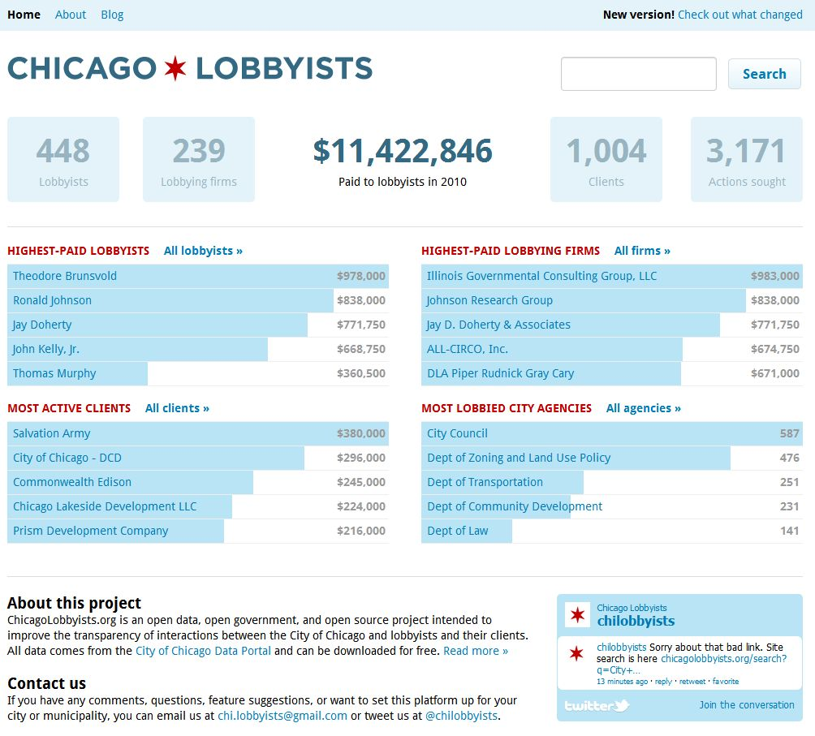

Lobbyist detail page

# chi-lobbyists-2.jpg

# Collaborating with a development contractor

We expect that the city will contract with a firm to provide the backend programming to fulfill the first two technical requirements of the RFP.

We would like to work in collaboration with the above contractor, primarily as designers and analysts, responsible for

* Design research, initially involving interviews with lobbyists entering the data, with the public that views data visualizations, and with city personnel charged with carrying out the ordinance
* User interface design and HTML/CSS
* Usability testing
* Web strategy
* Adapting ChicagoLobbyist.org design and code under a new city-controlled URL to fulfill the public facing website requirement
* Creating an interoperable API for exporting data in a normalized format

Two benefits of such collaboration would be our best in class user interface design and deep experience with the lobbyist data that you are collecting.

We prefer to work in an Agile fashion, releasing software to users in regular iterations,   
testing, making changes based on gathered feedback, releasing again, etc.

Regular interaction with the contracted developers and software audiences would include: usability testing as new iterations are released; making suggestions and answering questions about what is currently being coded; and looking forward in order to anticipate future needs and minimize rework.

We suggest that, whenever possible, the code, data schemas, and designs should be released as open source. Chicago has a unique opportunity to set an open standard for lobbying data structure, collection, and display—so other municipalities can use it. This will also set a good example for government-related projects that it makes sense to share.

Moving from proprietary systems to open source makes collaboration and sharing easier and gives access to a wider pool of highly skilled talent. Examples of successful projects include Open 311, which the city plans to implement in 2012, and Open Street Maps, a viable alternative to Google and Bing Maps.

# Working with CDO Brett Goldstein and DoIT on ChicagoLobbyists.org has been very efficient and productive

About the time of our initial release we discovered that some of the lobbying data had gaps which did not allow us to answer some of the basic questions that we wished to answer. For instance, we couldn’t tell “Which client hired which lobbyist to appear in from of which city agency for what purpose.” We could answer little pieces of that question but couldn’t put them together in a comprehensive story. To improve the site, we asked CDO Brett Goldstein the following questions:

1. Is there a way to determine compensation that comes to a firm versus lobbyist?   
   (We can’t be sure adding up compensation of all lobbyists within a firm is accurate.)
2. Is there a way to determine how much a client paid to a lobbying firm or lobbyist?
3. Related to the question above, can we retrieve the purpose for a client payment?
4. Can we receive data before 2010? If so, what years are available?
5. Is there a way to determine which client requested an action in front of an agency? We only know which lobbyist requested an action.
6. Are street addresses available for lobbying firms (some give political donations from many different addresses)?
7. Do you have a good state contact from which we could request political donation data?
8. Is there a list of all city datasets available (besides those on Socrata)?
9. Is there a schedule of when particular datasets are updated (frequency, time period)?

We met with Brett Goldstein and his team and within a few weeks they had released data that satisfied our requests and allowed us to greatly improve the site.

This is an example of how we like to work—understanding and/or developing goals based on real world feedback, analyzing problems, exploring solutions, creating designs, and iterating, testing, and improving to come up with an evolving, better product.

This is an opportunity for the city to partner with members of the open government community on an important transparency project. We realize that this will require some flexibility on the city’s part in terms of usual contract provisions, etc. We propose, however, that this is the best way for the city to get projects done more quickly with improved quality and reduced costs.

# Other examples of websites involving public data created by members of our team

## Lookatcook.com

Created by designer Nick Rougeux and developer Derek Eder, with design suggestions from Paul Baker, this site presents data from Cook County budgets since 1993.

Visitors can drill down to see every department’s budget, budget trends, overruns, and shortfalls. Also the site is mostly javascript running in a browser, every data view has its own URL, so each can be bookmarked and a link sent via email to anyone who might be interested.

O’Reilly radar, one of the most respected online publications about emerging technologies wrote, “Look at Cook sets a high bar for open government data visualizations.”

See <http://radar.oreilly.com/2011/09/look-at-cook-gov-data-visualization.html> for the full article.

Other cities, including San Francisco, have inquired about taking a similar approach to presenting budget data.

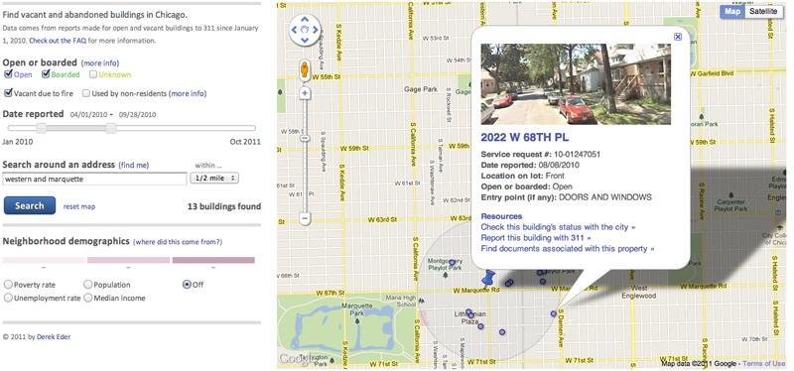  
**Vacant and abandoned building finder**  
<http://chicagobuildings.org>

A tool for helping people and organizations find buildings in Chicago that are not in use and potentially hazardous to the neighborhood   
around them.

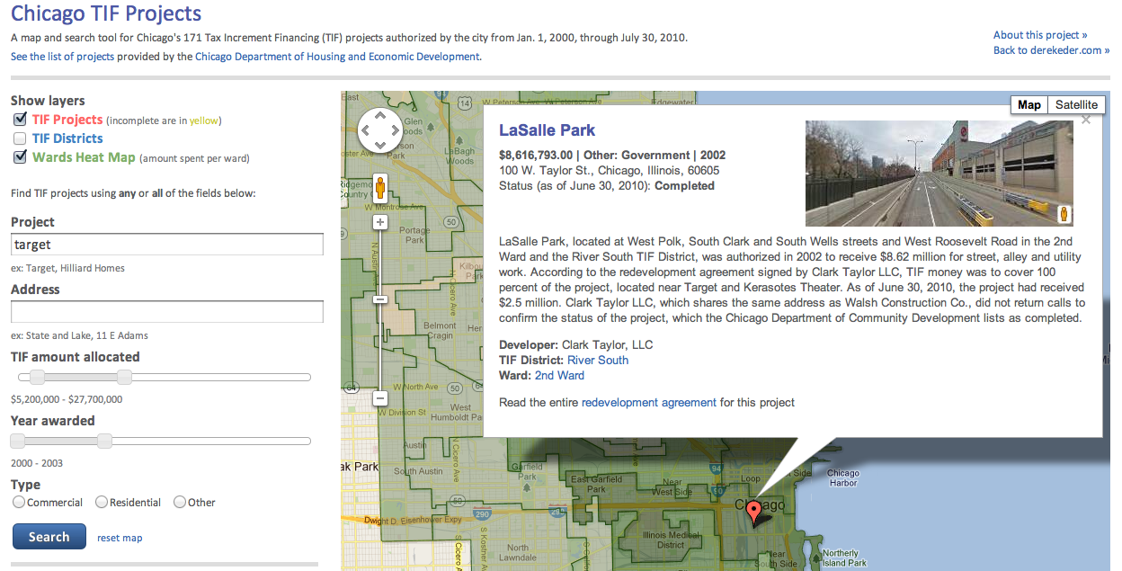**Chicago TIF projects map** <http://derekeder.com/maps/chicago-tif/>  
A map and search tool for Chicago's 171 Tax Increment Financing (TIF) projects authorized by the city from Jan. 1, 2000, through July 30, 2010. Created in collaboration with Columbia College’s journalism class and written about in the New York Times.

# In closing

Please call or write with comments or questions. We would be happy to meet with you to discuss this proposal in more detail.

Best regards,

Baker.png

Paul Baker Derek Eder Chad Pry

Ryan Briones Nick Rougeux