**Title of the game: The hating scale (this needs work)**

**A brief explanation:** The hating scale is nothing more than a score system for what annoys you the most. By ranking two different situations and letting you decide which one is the worst and, after selecting, the game will bring another situation for another voting. Each time you choose a situation it scores one point, the game doesn’t exactly have an ending, it’ll stop when you think you’ve had enough.

Once you’re done voting you can see the score and check how accurate the game scaled your personal hatings.

**How it works:** Once you start the game, the computer will bring two random situations to your screen as shown on this image:

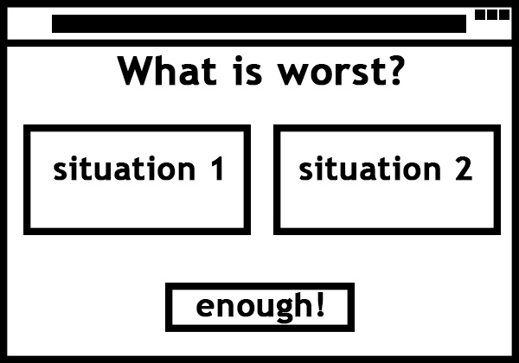

With your cursor, you choose what seems worst for you, once you pick your winner the game will remove the remaining situation and replace for another random situation. Every time you click on a situation the game will give +1 point to the voted situation, once you click on the button “enough!” the game will finally display the final score.

**Explaining the mechanics:** The game will match every possibility among all situations stored on its database, so let’s just say the game contains only 20 different situations, once the game starts it’ll start matching all the situations randomly, for example:

A x A

A x B

A x C

…

Until every possible match is made. So yeah… the game does have an ending, but the more situations we throw on the database the longer it’ll take to reach the end.

In this way every situation will appear the same amount of times in screen than any other situation.

Each vote adds 1 point to the voted situation, so in the end the screen will look like this:

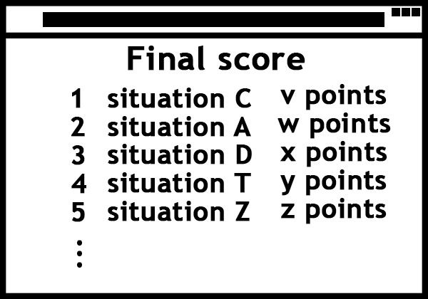

Naturally, the longer the player keeps playing the game, the better the final score will be.

---

**Future adds nº 1:** Every situation will be classified with one “feedback”.

For example: “Car horning”, “someone talking on the phone loudly” and “baby crying” are all related to hearing, so these situations will be classified as auditive situations, other situations like: “Cheetos fingers”, “walking on dirty floor” and “greasy surfaces” are tactile situations.

Along with the final score, the player will be able to see what sort of body feedbacks annoys the most.

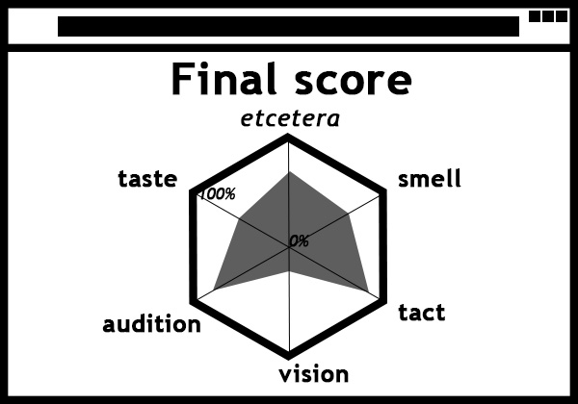

The percentage will be calculated by the sum of all scores and separating how much of the total is related to each feedback.

---

**Future adds nº 2:** The game will save the results and add the recent values to a bigger graph, which will show the global top hated situations and body feedbacks.