Members: ____________________________________________________
Activity 1
Suppose the input neurons should represent a RGB image and the output neurons should represent a gray level image. Specify weights and biases (draw labeled arrows and fill the boxes) that would make the dense layer below implement the gray level conversion we have seen in Class 4. If an arrow is not drawn, it is implied that its corresponding weight is zero. If a box is not filled, it is implied that the bias is zero.
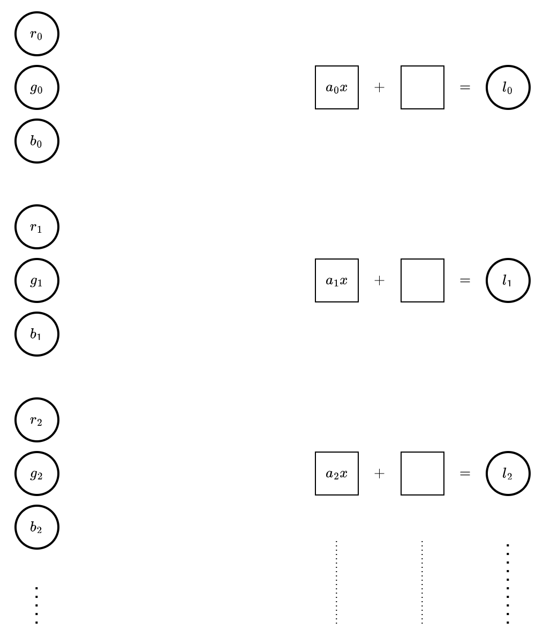
Activity 2
Suppose the input neurons should represent a gray level image and the output neurons should represent another gray level image. Specify weights and biases that would make the dense layer below implement a brightness reduction of 100.

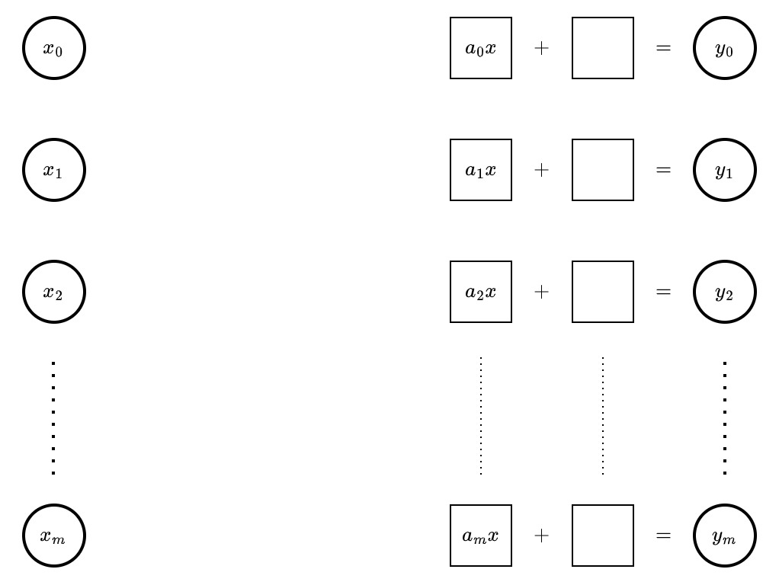

Challenge 1
Suppose the input neurons should represent a gray level image and there are only two output neurons, p_{d} and p_{b}. Specify weights and biases that would make the dense layer below ensure that (a) p_{d} + p_{b} = 1; (b) p_{d} is higher for darker images; and (c) p_{b} is higher for brighter images. In other words: the probabilities of the image being dark or bright.

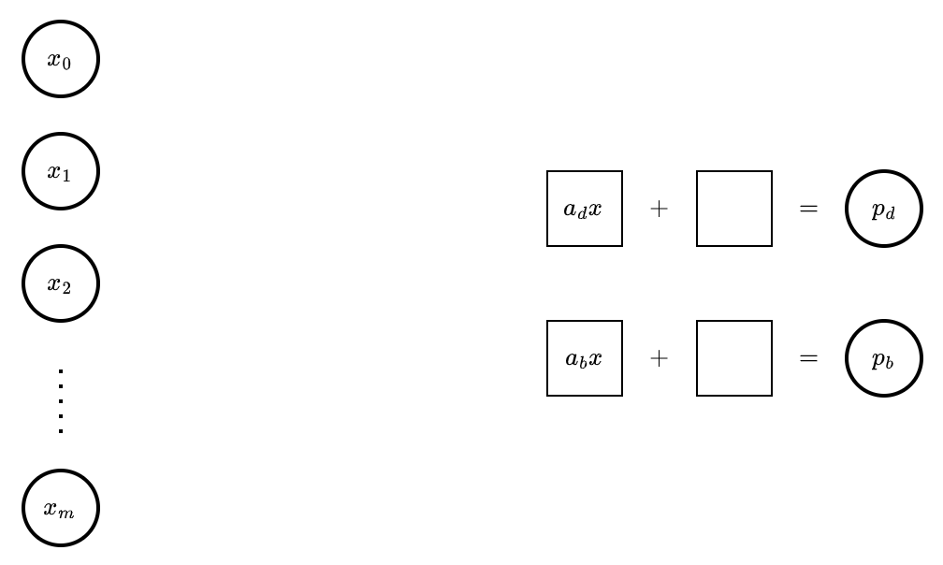

Challenge 2
Suppose the input neurons should represent a gray level image and the output neurons should represent another gray level image. Specify weights and biases that would make the dense layer below implement a contrast reduction of 50%. If you remember what we have seen in Class 5, you know this is not as easy as Activity 2.

