|  |
| --- |
| **Central Wayfinder** |
|  |
| Project Charter |

|  |
| --- |
| **Author** |
|  |
|  |
| Gustavo Tavares Dias |
|  |
| Suruchi Bapat  B Wright |
|  |
| **Date** |
| 06/08/2015 |
|  |
| **Version** |
| 0.3 |

**Table of Contents**

1. Introduction

Version History

2. Scope

3. Project Managers

4. Milestones

5. Feasibility

5.1 Operational Feasibility

5.2 Technical Feasibility

5.3 Schedule Feasibility

5.4 Budget Feasibility

6. Fit

7. System Development Methodologies

8. Initial Resources

8.1 Use Case Diagram (UCD)

8.2 Entity Relationship Diagram (ERD)

8.3 Initial Mockups

9. References

10. Document Acceptance

# 1. Introduction

Central Institute of Technology has a varied student base, students travel from across the world to come and study at Central. As the college grows the campus itself grows, therefore students finding their specific room and building is posing some initial issues. The concept of a Wayfinder application was brought to the programming department as a possible venture to alleviate the student navigation issues. The application concept was researched and decided we will create the application and trial this at the Perth Campus.

The project objective is to develop a quality fully functional Wayfinder application for all Central students to use. The priority of the application is ease of use and clear instruction and direction to the user.

By creating such a product this will give a new student an enhanced experience at Central.

This project development will start on July 28th 2015 and the completed product will be completed by October 30th 2015.

User acceptance testing will take place for a further 4 weeks, where all issues should be reported to developers.

There will be no cost to this project as a group of internal central students will complete this as their final Diploma project.

## Version History

|  |  |  |  |
| --- | --- | --- | --- |
| Date | Authors | Reason | Version |
| 23/07/2015 | Gustavo Tavares Dias | First version | 0.1 |
| 03/08/2015 | Suruchi Bapat, Gustavo Tavares Dias | Edits, Scope Update | 0.2 |
| 06/08/2015 | B Wright, Gustavo Tavares Dias | ERD, UML, Mocks | 0.3 |

# 2. Scope

The goal of the Central Wayfinder application is to assist directing new students/staff in getting to their classes on time. This will be especially important to students speaking english as a second language, as the app will focus on using maps and visual cues, instead of spoken/written directions. There will also be an accessible option, which shows a path using lifts and ramps.

The program will be made available on both Android and IOS platforms (depending on approval from App Stores). There also will be two options to find your location one using GPS/location data and the other a search option.

Initially we are targeting students and only the Perth campus will be mapped, however there is room for expansion in the future. The program will be up and running by the 30th of October 2015, with several weeks after set aside for testing/troubleshooting and the launch.

# 

# 

# 3. Project Managers

The project managers, Suruchi Mandar Bapat and James McNeil, are authorized to interact with management as required, delegate responsibilities within the framework of the project, be of assistance whenever necessary, to communicate with the project supervisor and the project sponsor as required to ensure the successful and timely completion of the project. The project manager is responsible for monitoring the schedule and scope of the project during the development as well as organizing any meetings with the team, project supervisor and project sponsor.

# 

# 

# 4. Milestones

The Wayfinder project milestones are outlined in the table below:

|  |  |  |
| --- | --- | --- |
| Milestone | | Estimated Date of Accomplishment |
| Documentation | |  |
| Project Charter | | **31/07/2015** |
| Project Schedule | | **31/07/2015** |
| Document Sign Off | |  |
|  | |  |
| Design | |  |
| Design Complete | | **TBD** |
| Design Sign Off | | **TBD** |
|  |  |
| Software Development | |  |
| Software Coding Complete | | **28/07/2015** |
| Software Development Sign Off | | **30/10/2015** |
| Software Testing | | **13/11/2015** |
|  |  |
| Web Development | |  |
| Web Coding Complete | | **TBD** |
| Web Testing | | **TBD** |
| Web Development Sign Off | | **TBD** |
|  |  |
| User Acceptance Testing | | **27/11/2015** |
|  | | **04/12/2015** |
| Project Sign Off | |  |

# 

# 

# 

# 5. Feasibility

## 5.1 Operational Feasibility

The Wayfinder application will be freely available for use by students, staff, tradespeople and visitors.

The application was previously developed successfully for the Windows environment, and a new and improved version for Android will be more widely accessible and easier to use.

## 5.2 Technical Feasibility

The Wayfinder application will be developed for Android and iOS platform simultaneously.

The development of the application in the Android environment is going to be in Android Studio and iOS development will be done using Xcode. An internet connection will be required to synchronize the app data with the website.

## 5.3 Schedule Feasibility

The Wayfinder project is expected to be finished by the 30th of November, 2015, allowing enough time for the design, development and testing of the application on both platforms, and the website.

## 5.4 Budget Feasibility

This is a non-funded project, developed by students from Central Institute of Technology, supervised by Nichola Kerr, for Neil Fernandes and Anne Davis without any monetary investment.

# 6. Fit

The Central Wayfinder application will be programmed to run on both the IOS and Android operating systems. This allows the Wayfinder app to reach the majority of potential users.

There is also going to be a website to support the application, a landing page explaining its features, and a link to both the App Store (™?) (Apple) and the Play Store (Android) making it so that the application reaches a bigger number of people.

# 

# 

# 7. System Development Methodologies

A few methodologies were researched by the group from both Traditional and Agile types, the selected method was SCRUM based on the following facts:

* It is more flexible than traditional methodologies. The developers are not restricted to an exact area of the project and are able to have a better view of the entire lifecycle and where they currently are in its development;
* All the tasks can be performed in sprints, giving a better view of the current status and allowing more important parts to be completed sooner; and
* Effective monitoring and adjustments in the schedule can be made easily through the sprints.

## 

## 

# 8. Initial Resources

## 

## 8.1 Use Case Diagram (UCD)

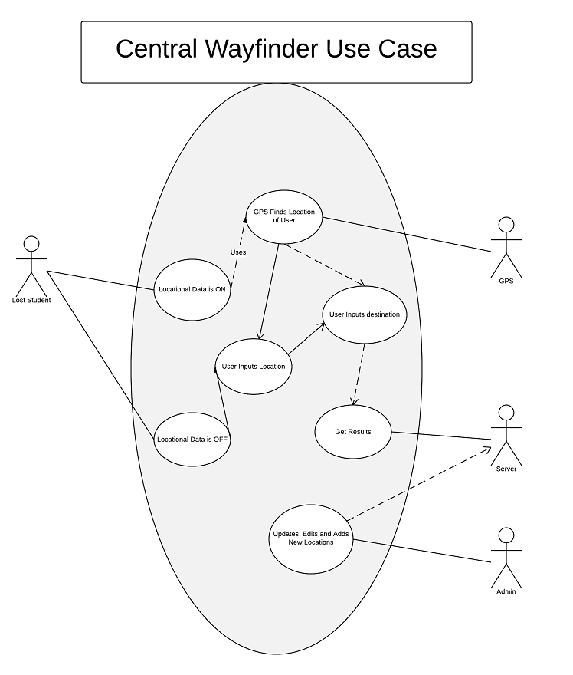

## 8.2 Entity Relationship Diagram (ERD)

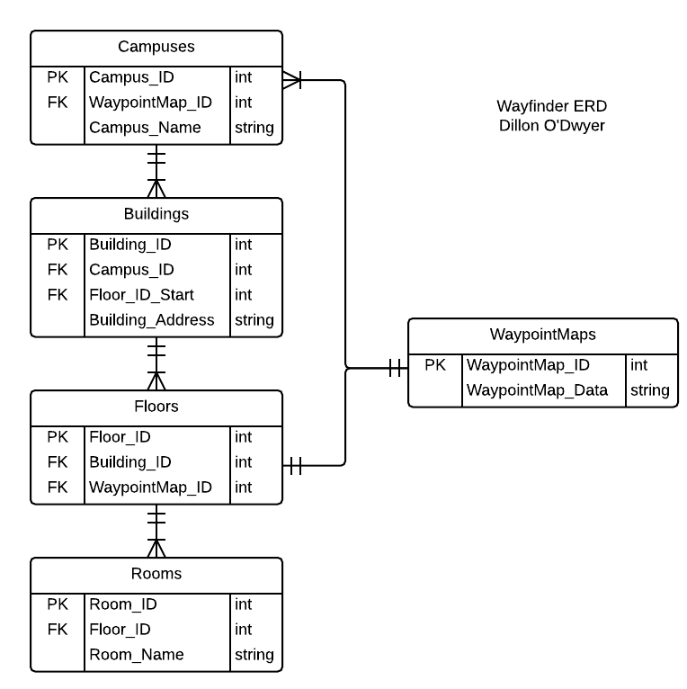

## 8.3 Initial Mockups

## 

## 

# 9. References

# 10. Document Acceptance

|  |  |  |  |  |  |  |  |  |  |  |  |  |  |  |  |  |  |  |  |  |  |  |  |  |  |  |  |  |  |  |  |  |  |  |
| --- | --- | --- | --- | --- | --- | --- | --- | --- | --- | --- | --- | --- | --- | --- | --- | --- | --- | --- | --- | --- | --- | --- | --- | --- | --- | --- | --- | --- | --- | --- | --- | --- | --- | --- |
| **Approvals**  This document requires the following approvals. A signed copy should be placed in the project files.   |  |  |  |  |  | | --- | --- | --- | --- | --- | | **Name** | **Signature** | **Title** | **Date of Issue** | **Version** | | Nichola Kerr |  | Owner |  | 0.1 | | Neil Fernandes |  | Client |  | 0.1 | |  |  |  |  |  |   **Distribution**  This document has been distributed to:   |  |  |  |  | | --- | --- | --- | --- | | **Name** | **Title** | **Date of Issue** | **Version** | |  |  |  |  | |  |  |  |  | |  |  |