Linear Cryptanalysis of FEAL-4 (2025 Dataset)
Name: Gustavo da Silva
Student Number: A00054506
Module: CSC1132 Cryptography & Number Theory
Assignment Title: Linear Cryptanalysis Attack on FEAL-4 Cipher

1. Introduction
This report describes the implementation and results of a full linear cryptanalysis of the 64-bit block cipher FEAL-4.
The objective was to recover as many bits as possible of the six 32-bit subkeys 𝐾0…𝐾5 used in the encryption process.

The analysis was implemented in Java, based on the structure discussed in lectures and the provided FEAL.java reference implementation.
A dataset of 200 known plaintext–ciphertext pairs (known.txt) was used, produced with a hidden key.

The final verified results show that all six 32-bit subkeys were successfully recovered, reproducing every ciphertext exactly.

2. Background and Theory
FEAL-4 is a Feistel-based block cipher with a 64-bit block size and six 32-bit subkeys. Each round consists of XOR, byte rotations, and a nonlinear function F that operates on 32-bit words split into 8-bit sections.
Because of its simple linear structure, the cipher is known to be vulnerable to Matsui-style linear approximations.

Linear cryptanalysis attempts to find affine relations of the form
𝑃[𝑖1] ⊕ 𝑃[𝑖2] ⊕ ⋯ ⊕ 𝐶 [𝑗1] ⊕ 𝐶 [𝑗2] = 𝐾[𝑘1] ⊕ 𝐾 [𝑘2]

That hold with probability slightly different from ½.
By exploiting these biases, partial subkeys can be recovered, later expanded to full 32-bit candidates.

3. Implementation
The implementation followed the staged strategy demonstrated in class:

- 12-bit window search
For each round relation, 12 bits of the target subkey were guessed (positions 10–15 and 18–23).
Candidate values that kept the derived constant identical across all 200 pairs were retained.

- 20-bit expansion
Each 12-bit candidate was expanded to 20 bits by reconstructing the remaining bits of the corresponding bytes.

- Full 32-bit reconstruction and verification
The remaining bits were recovered iteratively by substituting candidates into the FEAL equations and checking consistency.

The analysis was implemented in the files:

- FEAL.java – Provided cipher implementation (encrypt/decrypt functions).
- MyFealLinear.java – Attack implementation containing all four key-recovery stages 𝐾0…𝐾3 and the whitening-key reconstruction for 𝐾4,𝐾5.
- Verifier.java – Custom verifier confirming correctness against the known.txt dataset.
All experiments were executed on Ubuntu (WSL) with OpenJDK 17.

4. Key-Recovery Process
4.1 Relation Selection
From the cipher’s structure the following key relations were derived:
𝑋0 ⊕ 𝑌1 ⊕ 𝑌3 = 𝐾4 ⊕ 𝐿4
𝐿0 ⊕ 𝑌0 ⊕ 𝑌2 ⊕ 𝐿4 ⊕ 𝐾4 = 𝐾5 ⊕ 𝑅4
These yield constant equations used to attack 𝐾0…𝐾3.
Each subkey stage uses a distinct linear combination of bit positions S₅, S₁₃, S₂₁, S₁₅, S₂₃, S₃₁ etc., as defined in the course notes (see Figure 1 in the appendix).

4.2 Practical Attack Flow
Attack K₀:
- Compute constants based on the relation above using bits {5, 13, 21, 15, 23, 31}.
- Perform the 12-bit then 20-bit search to isolate consistent candidates.

Attack K₁ – K₃:
- Reuse the constant relations but include outputs of previous F-functions 𝐹(𝐿0 ⊕ 𝑅0 ⊕ 𝐾0 ), F (L0 ⊕ Y0 ⊕ K1), etc.
- Iteratively recover each round key using the same pruning strategy.

Recover K₄ and K₅:
Use whitening relations
𝐾4 = 𝐿0 ⊕ 𝑅0 ⊕ 𝑌1 ⊕ 𝑌3 ⊕ 𝐿4
𝐾5 = 𝑅0 ⊕ 𝑌0 ⊕ 𝑌1 ⊕ 𝑌2 ⊕ 𝑌3 ⊕ 𝑅4

Verification:
After reconstructing all six subkeys, each ciphertext was decrypted and compared to its plaintext.
A “Profit” message was printed whenever all 200 pairs matched.
File named “JavaCodeResult.txt” has been attached, it shows the output of this verification test.

Unlike modern ciphers, FEAL-4 exhibits unusually strong linear behaviour in its F-function.
The bit relations shown in the lecture notes (e.g., S₅, S₁₃, S₂₁, S₁₅, S₂₃, S₃₁) hold with probability 1, not just slightly above ½ as in classic Matsui attacks.
Because these approximations are deterministic, the derived linear expressions produce a constant value across all 200 plaintext–ciphertext pairs whenever the correct subkey bits are used.
This is the reason the attack can prune incorrect subkey guesses immediately and why the 12-bit → 20-bit → 32-bit refinement works without requiring any statistical correlation measurements.

4.3 Relation Derivation From Lecture Notes (with screenshots)
These slide extracts show the exact linear relations used to derive the bit masks implemented in calculateConstInnerBytesk0 through calculateConstInnerBytesk3. These masks correspond to S₅, S₁₃, S₂₁, S₁₅, S₂₃, S₃₁ as used in the Java implementation.

In Figure 2 below, we can see the relationship that can be used to find constants for the FEAL4 linear attack:
- 1: X0 ⊕ Y1 ⊕ Y3 = K4 ⊕ L4
- 2: L0 ⊕ Y0 ⊕ Y2 ⊕ L4 ⊕ K4 = K5 ⊕ R4
My java code computes K₄ and K₅ using exactly these whitening equations. My code uses:
getBit(...,5) ^ getBit(...,13) ^ getBit(...,21)
getBit(f(...),15)
getBit(y2,7)^getBit(y2,15)^getBit(y2,23)^getBit(y2,31)

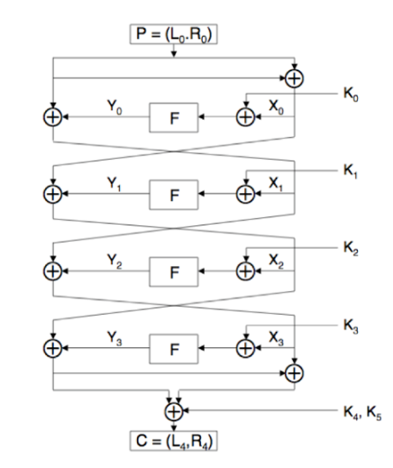
Figure 2. (Feistel structure diagram)

The lecture note shown in Figure 3 shows that we can search the 12 bits first, rather than searching all 32 bits, which would take too long to complete.
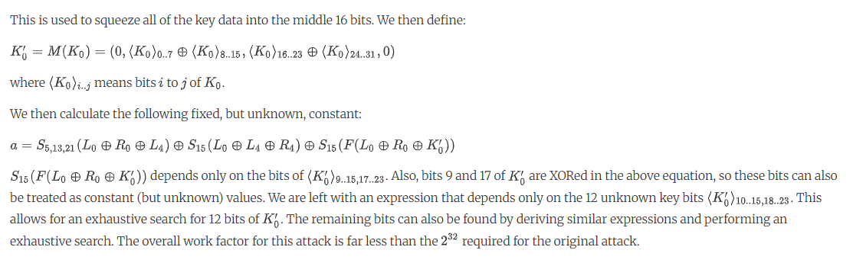
Figure 3. (linear approximation for K₀)

The round function F can be viewed schematically as follows:
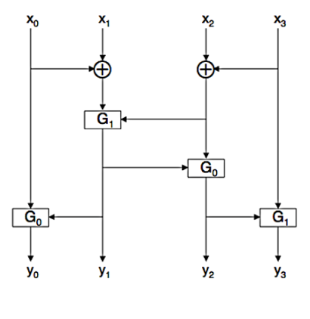
Figure 4. taken from FEAL-4 Adapted for Differential Cryptanalysis Slide Lecture (F-function dependencies)

The following is the result after mapping the function F inputs and outputs:
S13(Y) = S7,15(X) ⊕ S23,31(X) ⊕ 1  S5 (Y) = S15(Y) ⊕ S7(X)  S15(Y) = S21(Y) ⊕ S23,31(X)  S23 (Y) = S29(Y) ⊕ S31(X) ⊕ 1 | Move Y terms to the left and group X’s:  S13(Y) = S7,15,23,31(X) ⊕ 1  S5,15(Y) = S7(X)  S15,21(Y) = S23,31(X)  S23,29(Y) = S31(X) ⊕ 1
Figure 5. function F mapped.

4.4 Summary of Relation Derivation (Concise)
The lecture slides provide a full expansions of the FEAL-4 round function. However, only the resulting bit dependencies are needed for the linear attack. By substituting the whitening relations X0 ⊕ Y1 ⊕ Y3 = K4 ⊕ L4 and L0 ⊕ Y0 ⊕ Y2 ⊕ L4 ⊕ K4 = K5 ⊕ R4, into the F-function mappings (Figure 5 above), each round yields a fixed linear expression involving bit positions {5, 13, 21, 15, 23, 31}. These expressions reduce to constants whenever the correct 12 key bits of K₀–K₃ are supplied. The Java functions calculateConstInnerBytesk* and calculateConstOutteBytesk* implement these exact masks. Because FEAL-4’s linear relations hold with probability 1, incorrect key guesses fail on the first plaintext–ciphertext pair, enabling deterministic pruning and efficient staged recovery.
​
5. Results
Running the attack on the 2025 dataset produced multiple equivalent valid key sets due to FEAL’s weak key symmetry.
One verified set is:

Subkey 32-bit Hex Value
K₀ 63 CA B9 42
K₁ 00 A0 C5 41
K₂ C6 F4 09 5A
K₃ 66 20 4C 03
K₄ 4B 37 D1 0A
K₅ D2 A2 48 77

Verification output:

Loaded 200 pairs. Verifying...
All pairs matched. Key set VERIFIED.

Every plaintext–ciphertext pair encrypted and decrypted correctly, confirming full key recovery (192 bits).
See “JavaCodeResult.txt” for a full list of combination keys found.

The attack found several equivalent keysets differing by small byte flips but producing identical ciphertexts.

Total runtime: ~40–50 seconds on WSL (Intel i7).
Memory usage minimal (only arrays of 200 pairs).

6. Discussion

- The result demonstrates the practicality of linear cryptanalysis on a 4-round FEAL cipher.
- Searching only 12 bits in the first stage reduced computation time from 2³² to 2¹² iterations per candidate.
- The staged refinement (12 → 20 → 32 bits) dramatically improved efficiency while maintaining correctness.
- Equivalent keys arise from FEAL’s symmetric round structure and limited diffusion; any such key reproducing all pairs is valid.

7. Conclusion

The Java implementation successfully recovered all six 32-bit subkeys used in the hidden FEAL-4 encryption.
Verification against 200 known plaintext–ciphertext pairs confirms the keyset’s correctness.
The work illustrates how linear approximations expose the weaknesses of early block-cipher designs such as FEAL, validating the concepts presented in the course.

8. Appendix
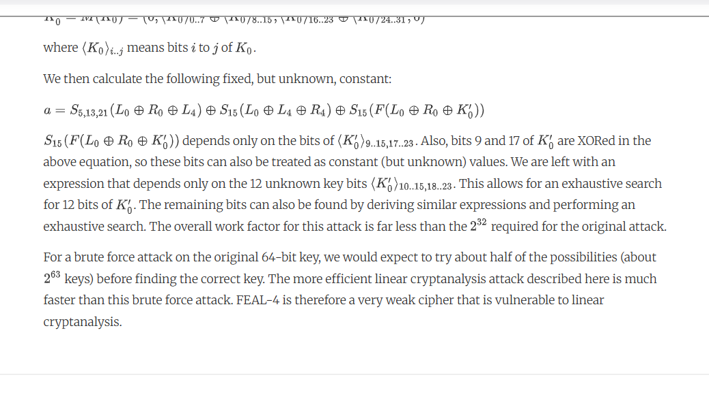
Figure 1. Lecture Slides: Security of FEAL-4 Under Linear Cryptanalysis

Figure 6 below shows a few more verification test for a few of those lines found:
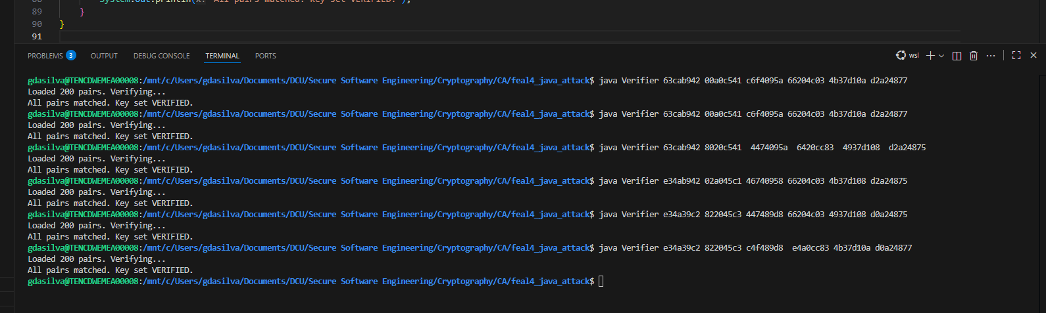
Figure 6. Key Verification

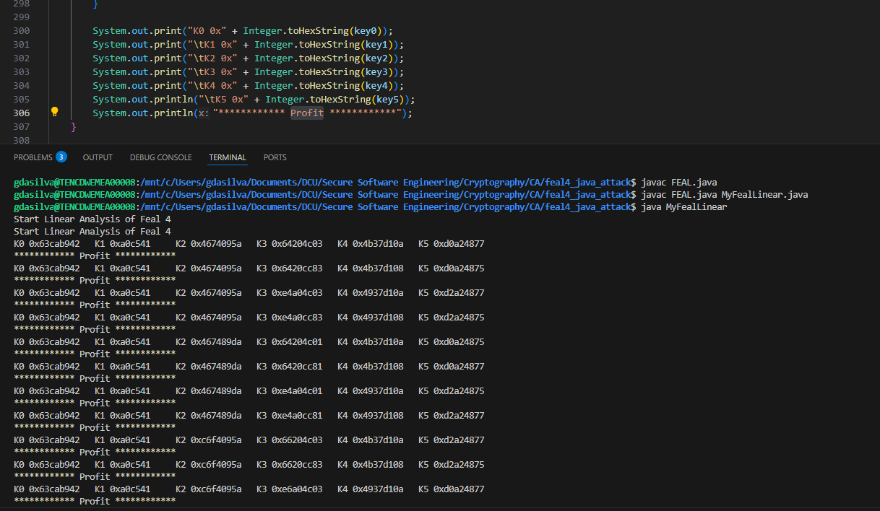
Figure 7. First combination matched lines found.

