 |  |  | 

Training Workshop on NOwcasting TEchniques: T-NOTE
Facultad de Ciencias Exactas y Naturales
Buenos Aires, Argentina
5-16 August 2013

QPE Laboratory
Wednesday, Second Session Afternoon.
Trainer: Isztar Zawadzki and Paola Salio

Material for lab:

- Program "Profilers"
To open the program open a terminal window and write
./profile

- Radar Information from Parana at March 18, 2009

Exercise 1: Explore the variables
- Open the program profilers and explore the available information.
- Load available data from March 18, 2009 at 3:50, 5:10, 10:20
- Evaluate with trainers different variables available with the right mouse bottom. Explore differences between raw PHIDP and KDP data and corrected variables.

Exercise 2: Correction by attenuation.
- Visually explore differences between the variable Reflectivity and Corrected Reflectivity using the methodology proposed by Bringhi et al 2001, to correct the C- Band attenuation.
-Using the MATLAB program compara_reflectividad.m evaluate difference between both variables

Exercise 3: Calibration by polarimetric variables
- Using Profilers you can evaluate a calibration by polarimetric variables. The corrected reflectivity Zk is calculated using the Z-ZDR relationship calculated by a large number of drop size distribution samples around the globe. The relationship is showed in figure 1.
- The variable Zk-Z shows the difference between the relefectivity observed and calculated by Z-ZDR relationship.
- Visually explore differences between the variables and the possible dBZ off set to apply to correct the calibration.

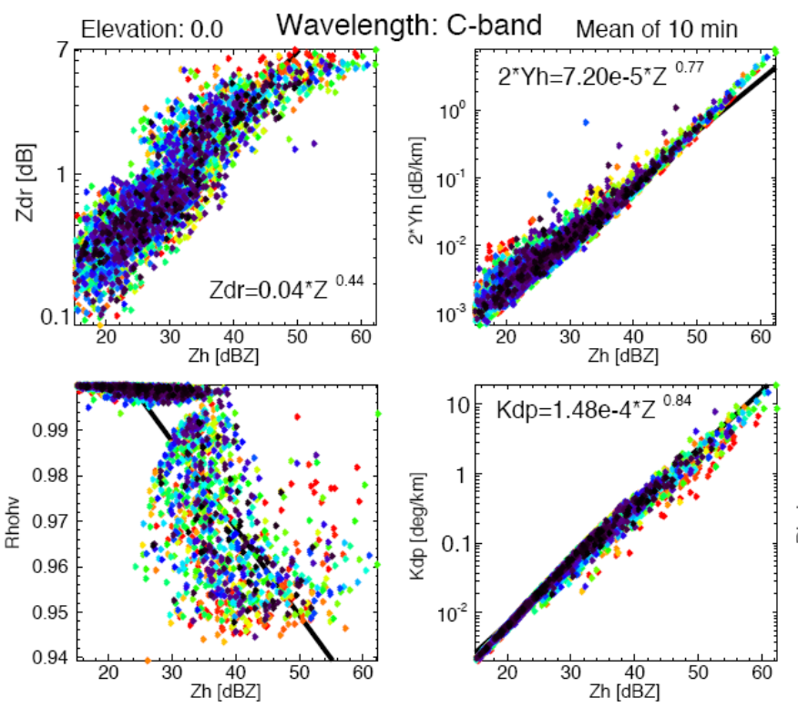
Figure 1: Relationship between polarimetric variables and reflectivity calculated for multiple DSD around the globe.

Exercise 4
-Using the MATLAB program compara_reflectividad_YTT.m evaluate difference between Reflectivity corrected using the attenuation correction using the relationship Ytt-Zh in Figure 1 and Corrected Reflectivity analyzed in exercise 2.
-Evaluate the RMSE and BIAS in each case.

Exercise 5
- The MATLAB program compara_precip.m you can calculate the precipitation rate using corrected and uncorrected precipitation using a Z-R relationship that you select.
- Evaluate differences using the climatological Z-R relationship Z=300R^{1.5}
- From disdrometer information located at Diamante (Figure 2) it is possible to calculate stratiform and convective Z-R relationship. Also you can evaluate the impact of using different filter methods to calculate Z-R relationship for the present case. Evaluate differences in each case.
- Figure 3 shows more cases under different stratiform events. Evaluate differences in each case.
-Evaluate the RMSE and BIAS in each case.

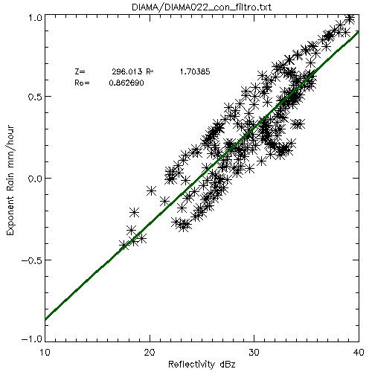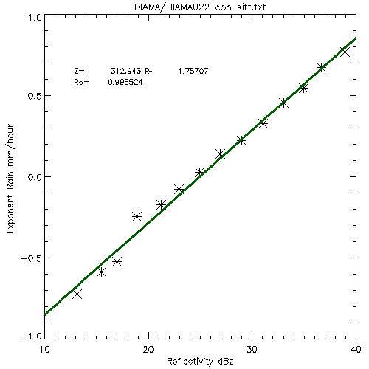
10 min filter SIFT filter
Figure 1: Reflectivity and Rainfall calculated from disdrometer information at Diamante during Nov, 18 2009.

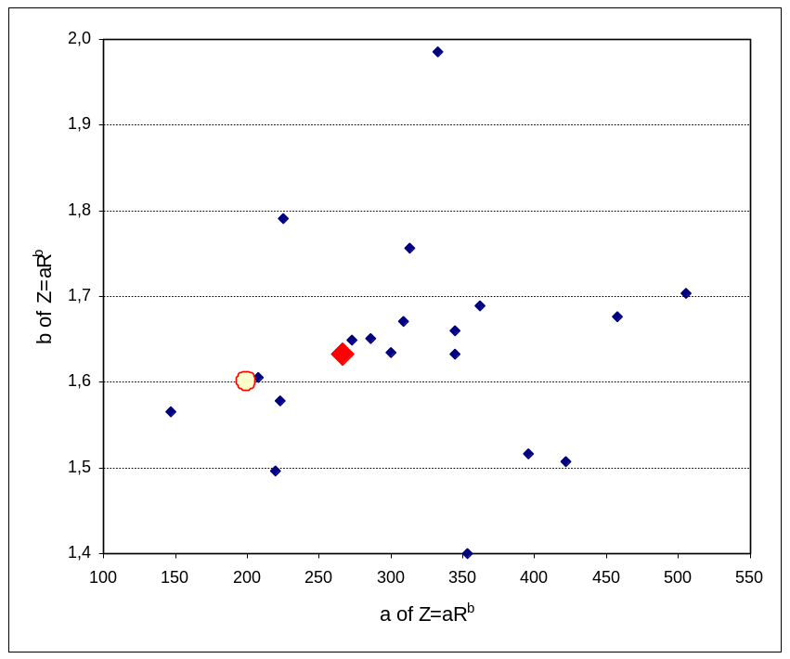
Figura 2: Constants a and b from the relationship Z-R during the cases registered with a disdrometer located al Diamante during Nov 2009 to Jan 2010.

References:
Bringhi at al 2001, Correcting C-Band Radar Reflectivity and Differential Reflectivity Data for Rain Attenuation:A Self-Consistent Method With Constraints. IEEE TRANSACTIONS ON GEOSCIENCE AND REMOTE SENSING, VOL. 39, NO. 9, SEPTEMBER 2001.

Lee and Zawadzki, 2006, Radar calibration by gage, disdrometer, and polarimetry: Theoretical limit caused by the variability of drop size distribution and application to fast scanning operational radar data Journal of Hydrology, 328, 83– 97

