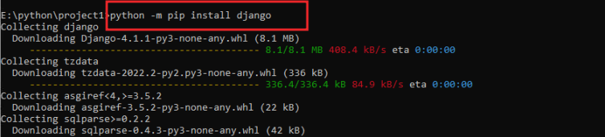

python -m pip install django

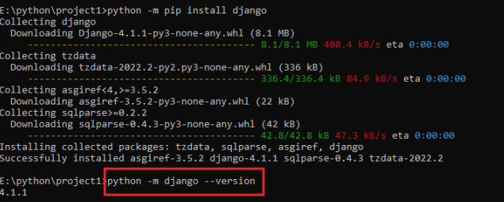

python -m django –version



django-admin startproject my_app

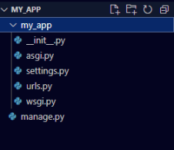

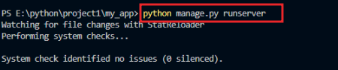

python manage.py runserver

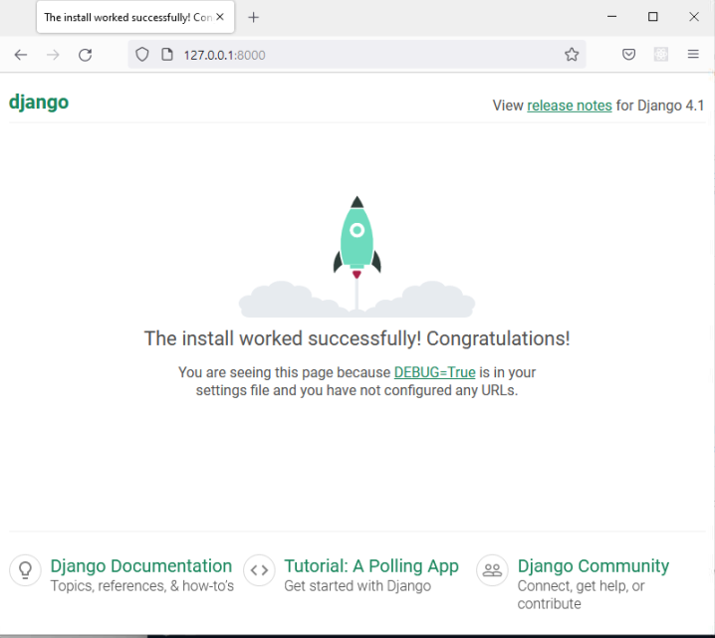



python manage.py startapp my_oke