Nama: Gusti Fahmi Fadhila

Kode Peserta: JVSB001ONL012

**Requirement 1**

Berikut ini adalah ERD dari database untuk pengerjaan requirement 1: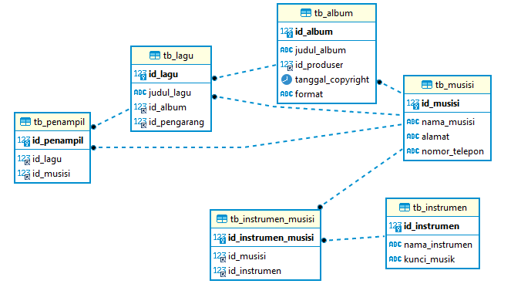

Terdapat 6 tabel, yaitu:

1. tb_musisi

* id_musisi int -> Primary Key
* nama_musisi VARCHAR
* alamat VARCHAR
* nomor_telepon VARCHAR

1. tb_instrumen

* id_instrumen int -> Primary Key
* nama_instrumen VARCHAR
* kunci_musik VARCHAR

1. tb_album

* id_album int -> Primary Key
* judul_album VARCHAR
* id_produser int -> Foreign Key ke tabel tb_musisi
* tanggal_copyright DATE
* format VARCHAR

1. tb_lagu

* id_lagu int -> Primary Key
* judul_album VARCHAR
* id_album int -> Foreign Key ke tabel tb_album
* id_pengarang -> Foreign Key ke tabel tb_musisi

1. tb_instrumen_musisi (tabel yang menhubungkan relasi many to many dari tabel tb_instrumen dan tabel tb_musisi)

* id_instrumen_musisi int -> Primary Key
* id_instrumen int -> Foreign Key ke tabel tb_instrumen
* id_musisi int -> Foreign Key ke tabel tb_musisi

1. tb_penampil (tabel yang menhubungkan relasi many to many dari tabel tb_lagu dan tabel tb_musisi)

* id_penampil int -> Primary Key
* id_lagu int -> Foreign Key ke tabel tb_lagu
* id_pengarang int -> Foreign Key ke tabel tb_musisi

1. Buat tabel menggunakan CREATE TABLE
2. tb_musisi

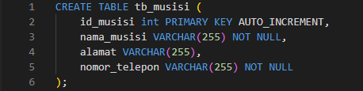

1. tb_instrumen

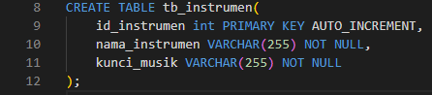

1. tb_album

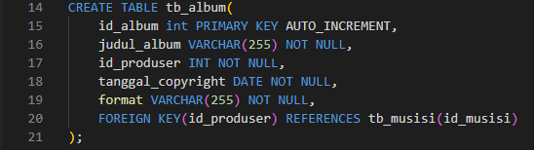

1. tb_lagu

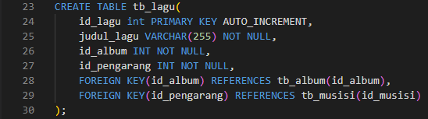

1. tb_instrumen_musisi

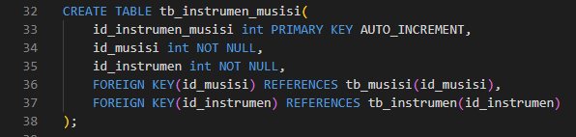

1. tb_penampil

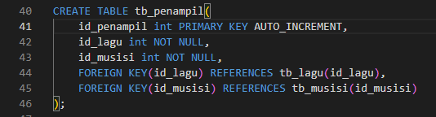

1. Lalu, tambahkan data, di masing-masing tabel. Saya menggunakan DBeaver untuk menambahkan data.
2. tb_musisi

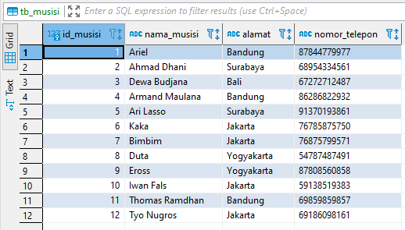

1. tb_instrumen

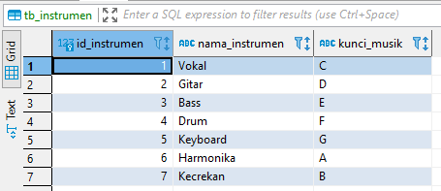

1. tb_album

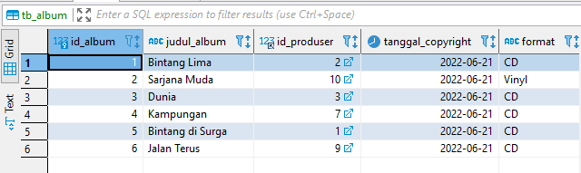

1. tb_lagu

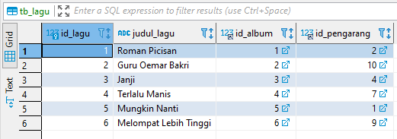

1. tb_instrumen_musisi

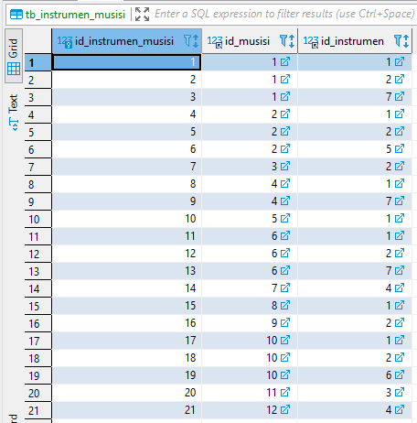

1. tb_penampil

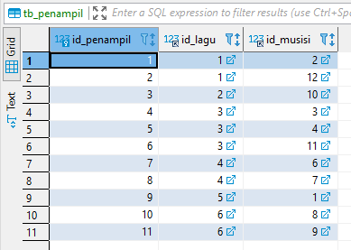

**Requirement 2**

1. Berikut ini adalah ERD dari database untuk pengerjaan requirement 2:

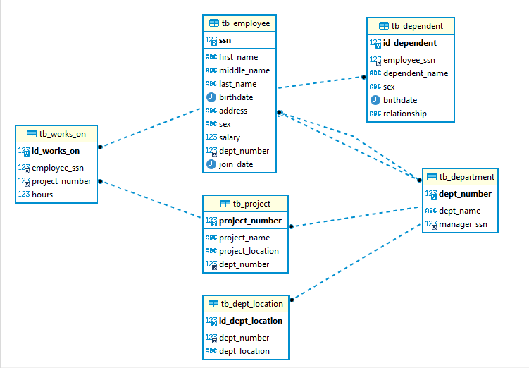

Terdapat 6 tabel yaitu

1. tb_employee (saya menambahkan column join_date karena digunakan di soal view nomor n)

* ssn int -> Primary Key
* first_name VARCHAR
* middle_name VARCHAR
* last_name VARCHAR
* birthdate DATE
* join_date DATE
* address VARCHAR
* sex VARCHAR
* salary int
* dept_number int -> Foreign Key ke tabel tb­_department

1. tb_department

* dept_number int -> Primary Key
* dept_name VARCHAR
* manager_ssn int -> Foreign Key ke tabel tb_employee

1. tb_dept_location

* id_dept_location int -> Primary Key
* dept_number int -> Foreign Key ke tabel tb_department
* dept_location VARCHAR

1. tb_project

* project_number int -> Primary Key
* project_name VARCHAR
* project_location VARCHAR
* dept_number int -> Foreign Key ke tabel tb_department

1. tb_works_on

* id_works_on int -> Primary Key
* employee_ssn int -> Foreign Key ke tabel tb_employee
* project_number int -> Foreign Key ke tabel tb_project

1. tb_dependent

* id_dependent int -> Primary Key
* employee_ssn -> Foreign Key ke tabel tb_employee
* dependent_name VARCHAR
* sex VARCHAR
* birthdate DATE
* relationship VARCHAR

1. Buat tabel dengan CREATE TABLE
2. tb_employee

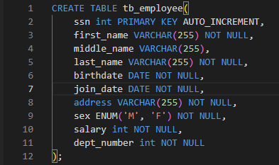

1. tb_department

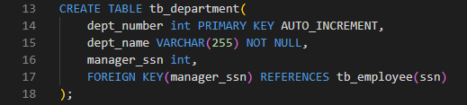

Lalu kita perlu menambahkan foreign key untuk column dept_number di tb_employee. Walaupun tb_employee dibuat pertama kali, tapi kita baru bias menambahkan foreign key tersebut setelah membuat tb_department.



1. tb_dept_location

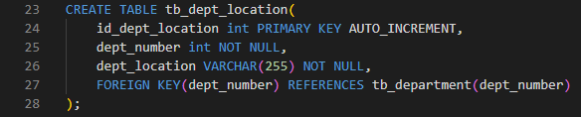

1. tb_project

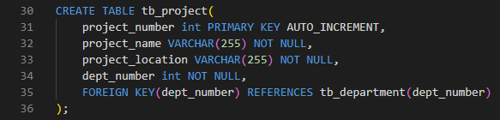

1. tb_works_on

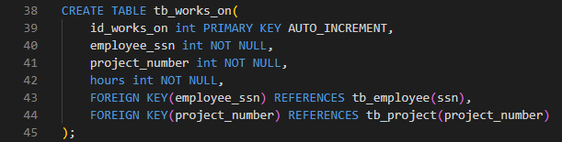

1. tb_dependent

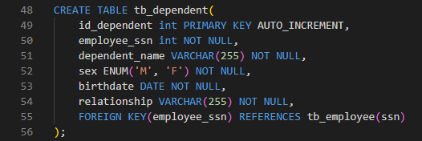

1. Tambahkan data ke masing-masing table melalui DBeaver
2. tb_employee

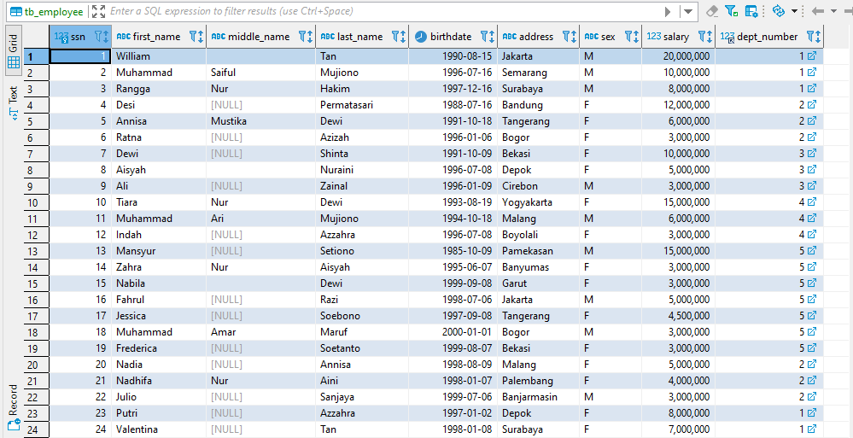

1. tb_department

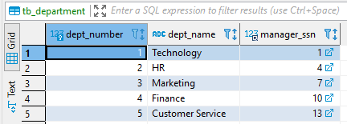

1. tb_dept_location

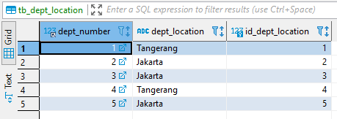

1. tb_project

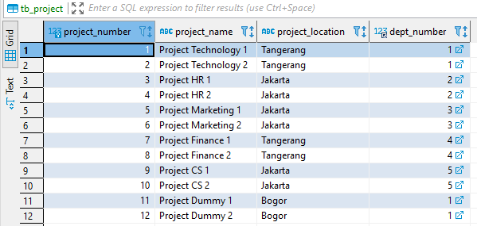

1. tb_works_on

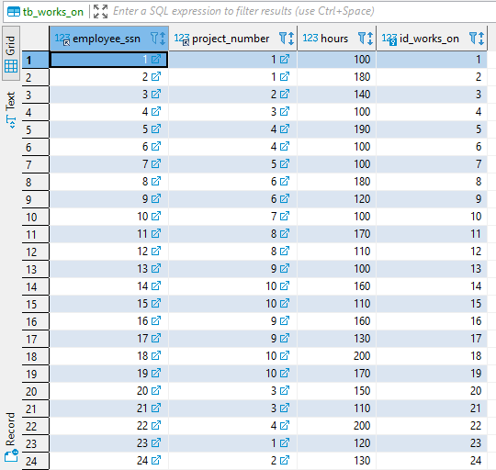

1. tb_dependent

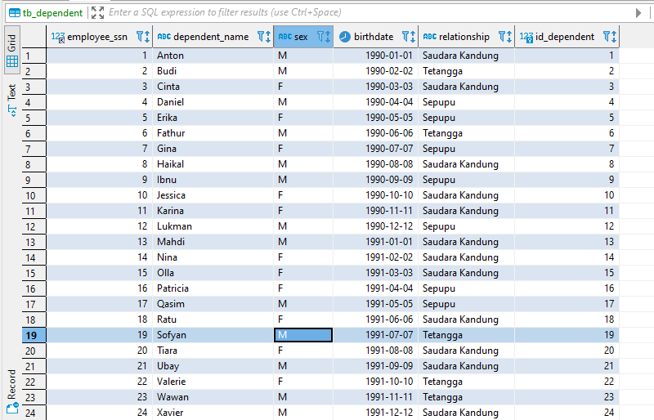

1. Buat view sesuai soal
2. View a (employee_r)

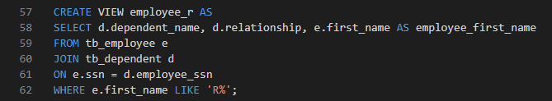

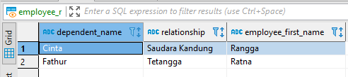

1. View b (employee_pnum_1)

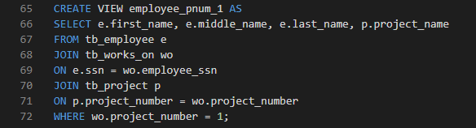

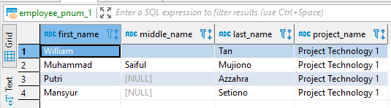

1. View c (number of employee_salary_3500000)

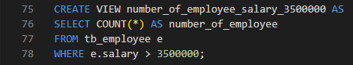

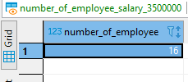

1. View d (number_of_project_dnum_2)

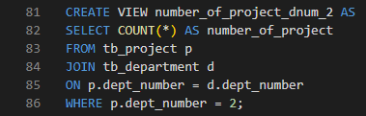

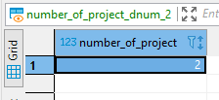

1. View e (salary_per_department)

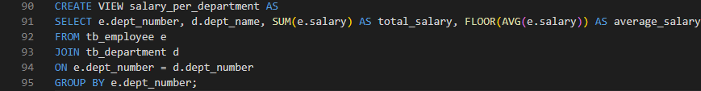

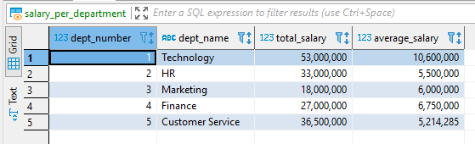

1. View f (number_of_employee_per_department)

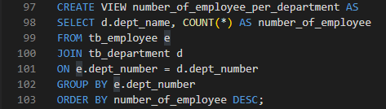

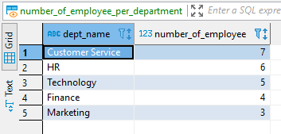

1. View g (total_hours_per_project)

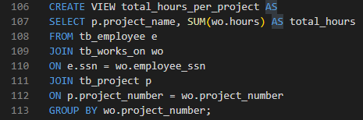

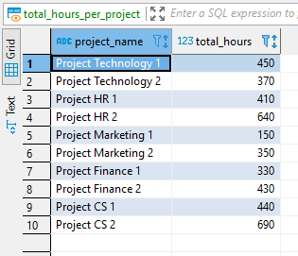

1. View h (140_hours_per_week)

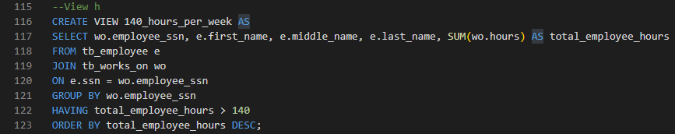

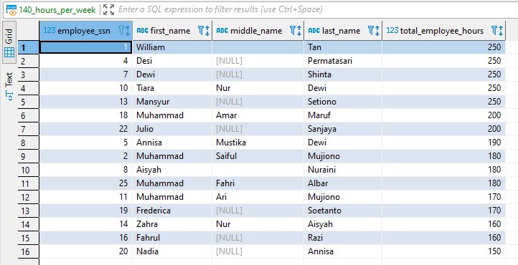

1. View I (employee_bonus)

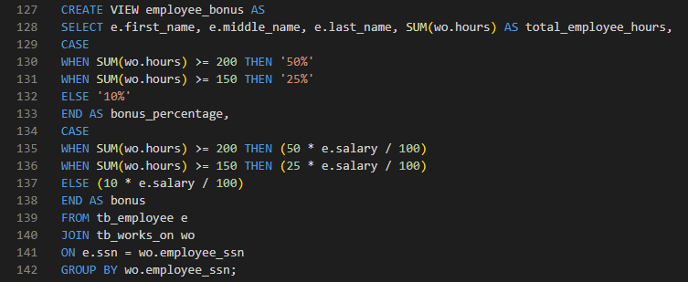

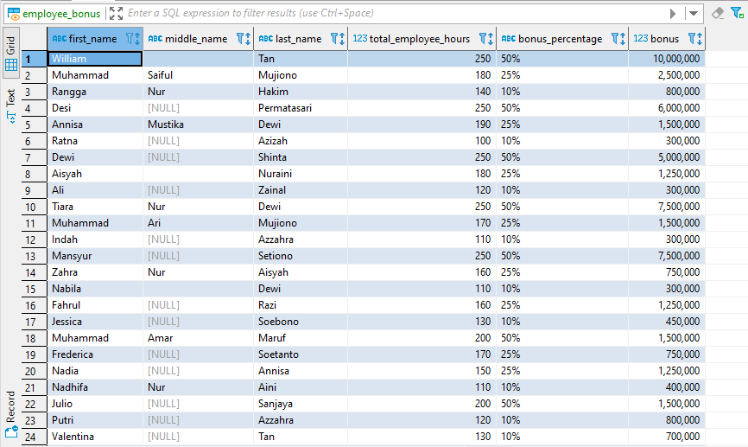

1. View j (number_of_project_per_employee)

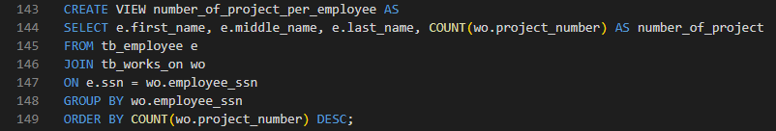

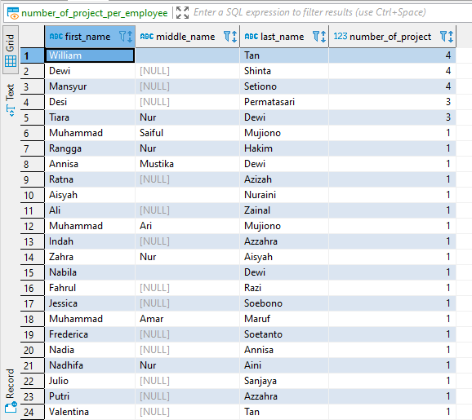

1. View k (employee_with_4_projects)

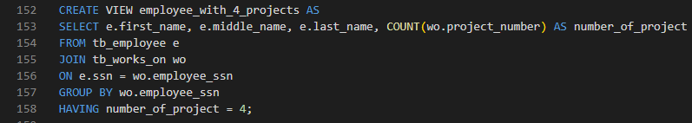

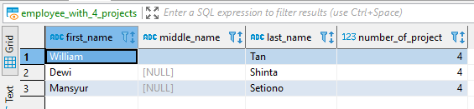

1. View l
2. View m (number_of_relationship)

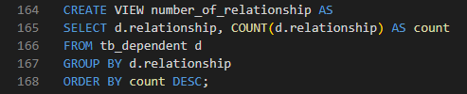

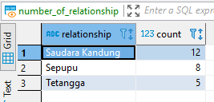

1. View n (manager_joined_since)

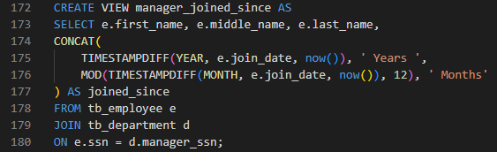

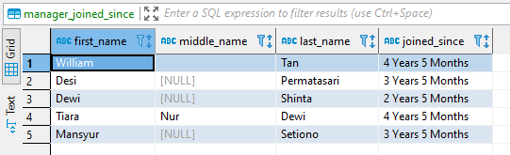

1. View o (project_location_with_multiple_department)

