Decision Tree Model

Gus Vu

2023-05-22

# Fitting a Decision Tree Model

A decision tree works by classifying an observation into categories in multiple steps, or branches of a tree. The tree will choose a variable and a threshold for that variable. If the observation is over/ under the threshold then the tree decides it is more or less likely to fit in one category. This will make more sense once I plot the tree.

library(rpart)

## Warning: package 'rpart' was built under R version 4.2.2

library(rpart.plot)

## Warning: package 'rpart.plot' was built under R version 4.2.2

decisionTree_model <- rpart(Class ~ . , creditcard, method = 'class')  
predicted_val <- predict(decisionTree_model, creditcard, type = 'class')  
probability <- predict(decisionTree_model, creditcard, type = 'prob')  
rpart.plot(decisionTree_model)

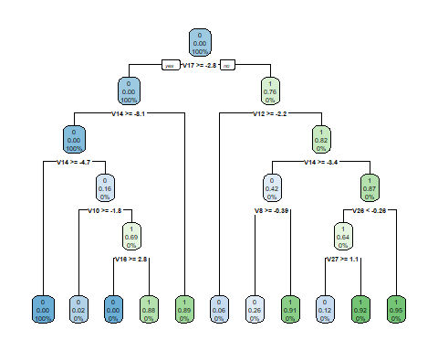

The nodes on the bottom represent the probabilities of 1 or 0 (fraud or not), given that the predicter variables meet the conditions of that branch.

mean(predicted_val == creditcard$Class)

## [1] 0.9995471

We see that our acuracy is 0.9995471, and our decision tree model is highly effective.