Equipment Room (MDF) Location:
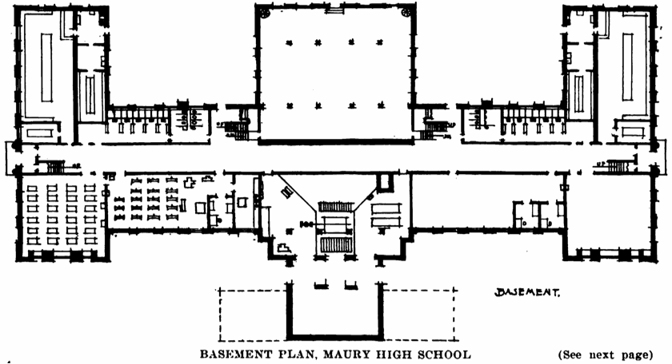
Telecommunications Closet 1 (IDF1) Location:
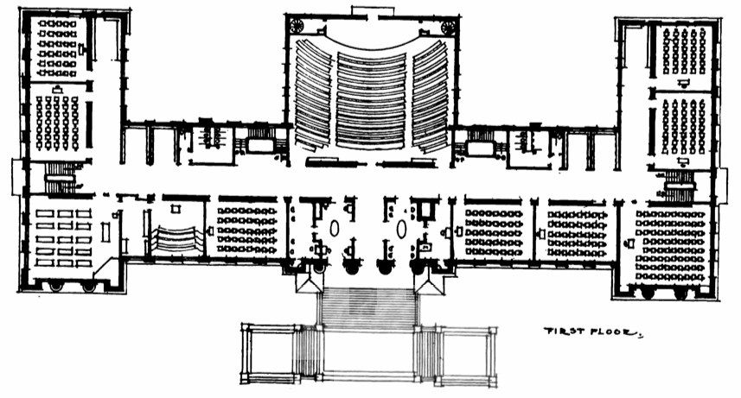
Telecommunications Closet 2 (IDF2) Location:
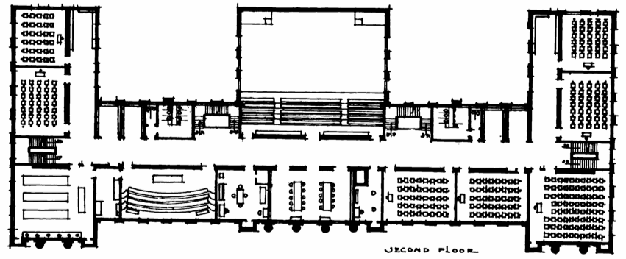
Telecommunications Closet 3 (IDF3) Location:
