Olivia Guswiler

Lab Assignment 3

2024-10-08

This study used camera traps to capture bobcat use/unuse of 102 sites across Illinois. Cameras were deployed for five weeks between the 1st of October and 14th of November, the days within this timespan were assigned a day-of-year, where 1 = 1 Oct and 120 = 14 Nov. At each site, forest and grass land cover percentage estimates were recorded for a 500-m radius around the camera. Day-of-year and forest and grass land cover percentages were z-score standardized to allow for easier comparison. To estimate bobcat use and detection probability at our sites, I fit several models using a single-season occupancy model as described by MacKenzie et al. (2002) using the *unmarked* package in R (version 2023.06.1, build 524). Models were compared for best fit by computing second-order Akaike’s information criterion using the *AICcmodavg* package in R.

Fitting an intercept-only model, assuming constant rate of use and detection, resulted in a naïve use estimate of 39.2% (SE = 4.8%, 95% CIs: 30.2 to 49.0%, *p* = 0.0307, AICc = 163.1), or the proportion of sites where bobcats were detected. As detection was assumed to be constant, the probability of detection was estimated at 99.0% (SE = 0.7%, 95% CIs: 96.1 to 99.7%, *p* < 0.0001). For all following models, detection was set to vary as a function of day-of-year. With the inclusion of this covariate, there was no change in the probability of bobcat use around the camera sites (AICc = 150.4). Accounting for forest cover, probability of use was 86.2% (SE = 60.0%, 95% CIs: 73.8 to 93.2%, *p* < 0.0001, AICc = 118.9). Probability of use was not found to differ in the presence or absence of grass cover at camera sites (*ψ* = 43.1%, SE = 55.1%, 95% CIs: 33.6% to 53.1%, *p* = 0.175, AICc = 150.6). Therefore, the probability of bobcat use, when accounting for forest (*ψ* = 85%, SE = 60.1%, 95% CIs: 73.1 to 93.1%, *p* < 0.0001) and grass cover (*ψ* = 47.8%, SE = 56.2%, 95% CIs: 36.0 to 50.0%, *p* = 0.729), was driven by the presence of forest cover alone (AICc = 121.0).

Forest cover had a strong positive influence on bobcat use across the sites, while grass cover was not an accurate predictor (see Figure 1). At sites with forest cover one magnitude below average, probability of use is predicted to be ~13.0% and rise sharply as forest cover increases until reaching a threshold past one magnitude above average forest cover, where predicted probability of use is ~87.5% and slowly increases from there. There is a slight negative trend in the predicted probability of bobcat site use as grass cover increases but is not a reliable inference due to varying levels of uncertainty in this estimate. Day-of-year did not affect the probability of bobcat detection across the sites (see Figure 2). This predicted estimate has too much uncertainty to allow for inferences to be made, however there is a trend of increasing probability of detection within the first ~2 weeks of the survey period. This could indicate that bobcats are less likely to be detected immediately following deployment of camera traps but requires further investigation to confirm.

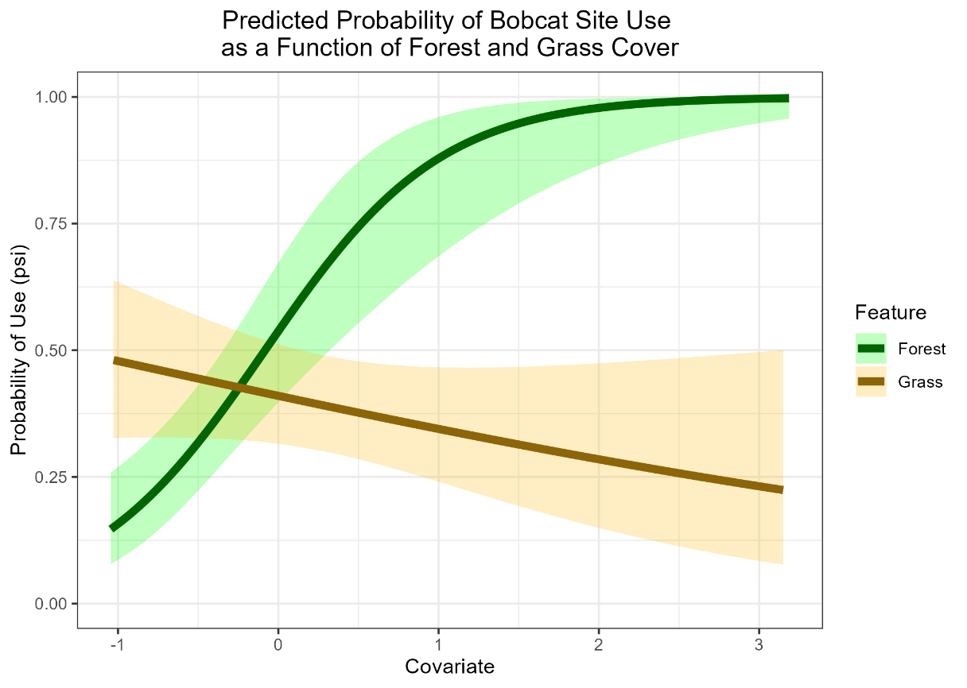

Figure 1. Predicted probability of camera trap site use by bobcats as percentages of forest and grass cover increase independently.

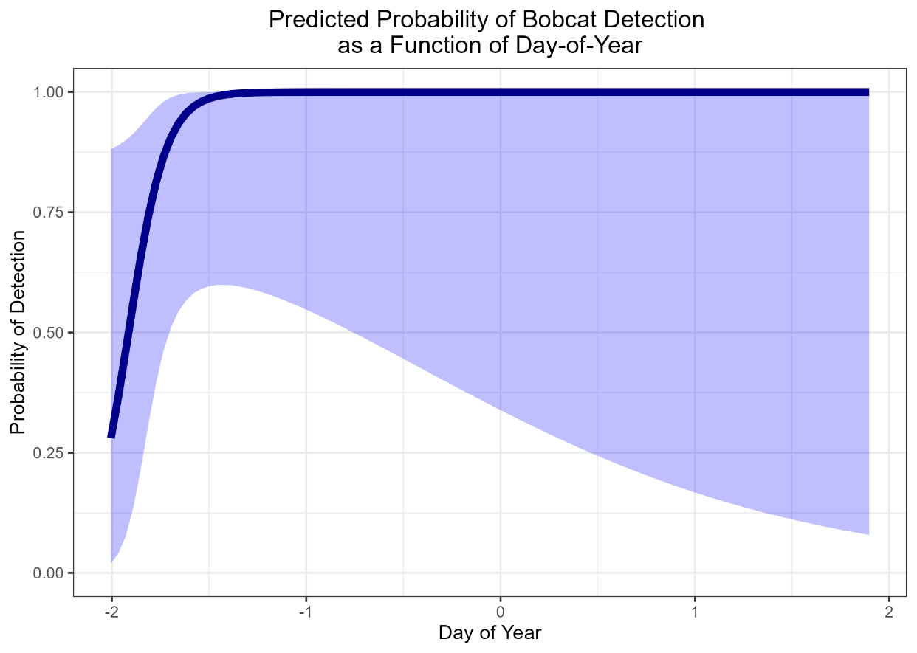

Figure 2. Predicted probability of bobcat detection across the survey period.