Tuesday Lab

2024-09-24

**Analysis of used vs unused (presence vs absence) data: Occupancy Modeling**

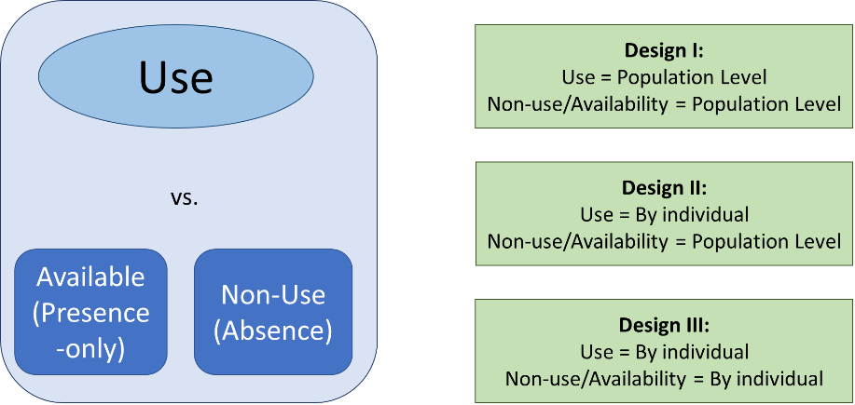

Measure where an animal is present or using features, as well as where the animal is absent or not using features.

* Collecting binary data, 1 = present, 0 = absent
* Modelling probability, our y axis is constrained to 0 to 1. Our slope lines are all curved because of the logit link function that allows us to observe our probabilities as continuous.

**Review of Generalized Linear Models**

3 components of a GLM

1. Deterministic function (the linear predictor) aka y = β0 + β0 * X1
   1. Deterministic function gives us our expected value (y)
   2. β0: slope
   3. β1: intercept, effect size. How much y changes per one unit change in x
2. Stochastic distribution (the error distribution)
   1. Variation of data around expected values (can think of expected value as mean)
   2. When we assume residuals have gaussian (normal) distribution, we assume deviations remain constant magnitude across x
      1. You can’t observe negative individuals, need an error distribution that can only be positive and can change its spread as expected value changes.
      2. For binomial models, we will always use binomial error distributions
3. Link function
   1. In a binomial GLM, the link function maps the linear predictor to a probability bounded between zero and one
   2. *logit(pi)* = *β0 +* *β1* * X1,*i*
   3. Parameter estimates that you’re seeing on your model is going to correspond on the logit scale. When you observe then on the probability scale (using plogis()), they will be remapped using that plogis() transformation.
   4. See Javan’s slides about this for graph images that relate linear predictor to original scale

Binomial GLM or Logistic Regression : *yi* ~ Binomial*(β0 + β1* * X1,*i)*

* *y*: your 0s and 1s
* *n*: trial size (always 1 with binary response) so *y* ~ Binomial(*p*)
* *p*: probability of being a 1

**Imperfect Detection**

**ACCOUNTING FOR IMPERFECT DETECTION MATTERS IN YOUR ANALYSES!!!!!**

The solution for imperfect detection? Hierarchical Occupancy Models!

* Probability that Chiricahua leopard frogs are present at a site during the study period
  + If all we have is one site visit, we cannot determine detection rate
* *y:* what we observe, *z*: true state of the site, whether or not it is truly occupied
  + *Two binomial GLMs estimated simultaneously*
  + If *z* = 0, *y* = 0
  + If *z* = 1, *y* = 0 or 1
* State model (occupancy): probability of site being occupied
* Observation model (detection): probability of species being detected

How do we get this information to determine detection and occupancy?

* Multiple site visits, we will get some 0s and some 1s for same site depending on visit. Can determine true state of site.
* *ψi* = probability of occupancy (# sites with detection at any visit/total sites)
* *pi* = probability of detection (detections/site visits)

Design of occupancy models, assumptions

* see slides

Camera trap models need to modify assumption of closed system for species occupancy

* random movement in and out of study site, determined as probability of use for area around camera
* blue boxes are flipped on this slide with gray fox

For occupancy models, see McKenzie et al. 2002