Mars Craters Research Report

|  |  |  |
| --- | --- | --- |
| Sławomir Figiel *Space and Satellite Technologies, ETI Faculty Gdańsk University of Technology* [fivitti@gmail.com](mailto:fivitti@gmail.com) index no. 12345 | Tomasz Mrugalski *Space and Satellite Technologies, ETI Faculty Gdańsk University of Technology* [tomasz.mrugalski@eti.pg.edu.pl](mailto:tomasz.mrugalski@eti.pg.edu.pl) index no. 75751 | Ewelina Omernik  *Space and Satellite Technologies, ETI Faculty Gdańsk University of Technology* [ewelina.omernik@gm](mailto:ewelina.omernik@gm)ail.com index no. 12345 |

*Abstract* — The following report provides an overview of the research being conducted within the Mars Craters Research as part of the Remote Earth Observation Sensing class, held at ETI Faculty of Gdańsk University of Technology. This report covers an overview of the craters phenomena, their origins and creation process. The primary goal of the project was to identify satellite photos of Mars surface and identify craters on them. This report provides description of the methods used. A discussion about strong and weak points of various approaches applied conclude this paper.

Keywords —mars, craters, satellite, observation, opencv.

# Introduction

Mars is the most similar planet to Earth in our Solar System. Its sidereal day is 24h 37min, which is roughly 40 minutes longer than Earth’s. Mars gravity is weaker and equals to 37% of Earth’s gravity. Its atmosphere is probably the most distinct feature that sets Mars and Earth apart. Its average density (11.55 hPa) is around 0.6% of Earth’s (101.3 hPa). The atmosphere consists of 96% of carbon dioxide, 1.93% of argon and 1.89% of nitrogen. Oxygen is present only in trace amounts (0.174%). For more details, see [2].

Asteroids occupy various orbits throughout the whole Solar System, but the area behind Mars orbit has the highest concentration. Therefore it often nicknamed “an asteroid belt”. As of Nov. 2019 there are over 851.000 minor bodies known in the Solar System [3]. Earth is naturally protected from incoming minor bodies by its thick atmosphere and a large Moon that can alter the trajectory of incoming objects. Neither of those mechanisms as present on Mars. Also, the close proximity to main asteroid belt contributes significantly to the amount of surface impacts. As such, Mars is a very attractive place for meteorite research.

The goal of the research conducted was to study evidence of incoming bodies. Since the Mars’ atmosphere is so thin, most of the incoming meteors end up hitting the surface and becoming a meteorite. The primary goal of this research was to study the data available, experiment with various techniques and come up with the most reliable method for detecting craters.

# Methodology

There are currently 6 orbiters providing orbital photos from Mars: 2001 Mars Oddysey (2001), Mars Express (2003), Mars Reconnaissance Orbiter (2006), Mars Orbiter Mission (2014), MAVEN (2014) and ExoMars orbiter (2016). Year of reaching Mars orbit specified in parentheses.

Several imagers are particularly useful:

**THEMIS -** precision better than 10m on India territory and 20m on surrounding sea.

# Results

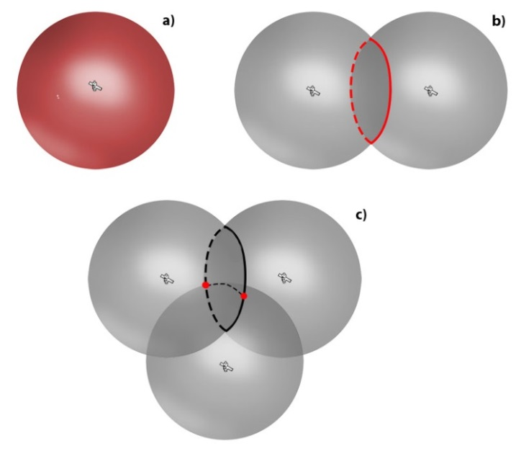

*Fig. 1: Solving the distance problem with n satellites*Possible locations denoted with red color. a) one satellite signal,   
b) two satellite signals; c) three satellite signals.

HiRISE – describe HiRISE here.

## Initial data selection

During our research we noticed that some impact craters have very bright edges on images from infrared sensor at night from THEMIS mission. NASA provide the global mosaic from these images in resolution 100m. Several experiments proved that it’s a good source data for craters recognition. Using this data has one limitation, however. Not every crater has a bright edge. Crater must to have a specific depth (at least 0.4-0.5 km). The radius cannot be too big (< 15km).

We noticed that not only craters have a bright edge on images. Other terrain forms may to have similar behavior. It is problematic and we determined it needs to be filtered.

In filtration stage we based on shape. We assume that impact crater have rounded shape. We use a circle recognition algorithm (for example Hough Circle Transform with Hough Gradient detection method).

During filtration you should remember that not whole edge will be bright for each crater. For old crater edge may be incomplete or edge may to have different structure and some parts are dark.

# Strong and weak points

There are many phenomena that impact accuracy of a GNSS system. The first and foremost is the number of visible satellites. As discussed in previous section, the minimum is 4. Each additional visible satellite improves accuracy. However, this relationship is not linear.

**Geometry of the constellation** of visible satellites play a significant role. The farther out the satellites are spread across the sky the better.

**Orbit uncertainty.** Each satellite has its orbit determined with certain precision. Uncertainty of the orbit parameters usually results in 1 to 2 m precision inaccuracy.

**Clock precision.** Although atomic clocks present onboard the satellites are very stable, they do have a non-zero bias. While that bias is being corrected for, the correction is never perfect.

**Ionosphere model.** The signal emitted by satellites has to traverse through all layers of the atmosphere before reaching a receiver. The air is mostly transparent for radio signals, however ionosphere has some small, but measureable impact. The models used are not a perfect representation of the actual ionosphere. A ionosphere model is considered good if it results in 1-2 m error. Improving our understanding of ionosphere is one of the driving factors that improve GPS accuracy over time.

**Current ionosphere state**. Due to Sun, the local state of a ionosphere may vary wildly. Although in year 2019 the sun is going through a period of low activity in its 11 year cycle, there are occasional magnetic storms and Coronal Mass Ejection (CME) events that, if the hit Earth, may have a major impact. An example is shown on Fig.2 below.

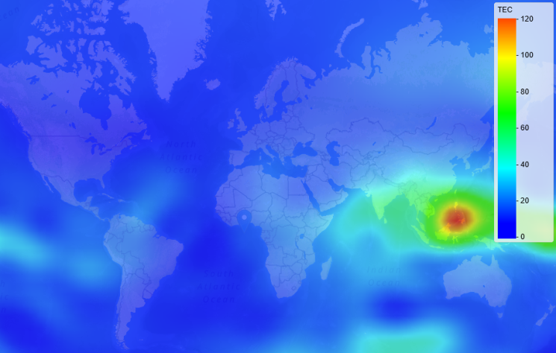

*Fig. 2: Ionosphere state as of 2019-03-20  
Source: Trimble Inc., www.gnssplanning.com*

**Multi-path.** In an ideal world, there is always line of sight and the signal travels from the satellite to the receiver directly. However, in real world that is often not true and signals may reach the receiver indirectly, by bouncing off various obstacles, such as tall buildings or mountains. This impacts the signal reception in at least two ways. First, it is possible to receive a signal bounced off from a distant object, thus increasing the path traversed. Second, multiple bounced signals will be received multiple times and in slightly different phase. This can cause another 1-2 meters error.

**Outdated orbital parameters**. The orbital parameters change slightly over time. Some satellites are experiencing technical difficulties, are put out of commission occasionally and their replacements are being launched. Those changes are being tracked and updated orbital parameters are being published as so called Almanacs. Each published almanac is considered to be valid for 50 days since publication. Using outdated almanac may impact accuracy. Almanac format including detailed analysis of its parameters will be described in upcoming Space Missions Exercise report 1.

**Selective Availability**. GPS used to have two modes: public (civilian) and military. The ability to encrypt part of the signal thus providing better accuracy only to selected users (military) was called selective availability. This used to be the greatest source of positioning errors. This capability has been disabled on May 2000, so it is no longer a factor.

**Engineering choices**, such a computational capabilities of the receiver and optimizing for certain types of information. The calculations required to determine accurate location are computationally intensive which, given that most GPS receivers are battery operated, creates a set of conflicting requirements. The problem can be solved with approximate solutions of lesser complexity (and thus providing better battery life) or more precise, but requiring more computation. Furthermore, the solution can be optimized to more precisely calculate some components, such as X, Y position, while neglecting Z. This is a rational choice for land vehicles for example. The opposite is true for aircrafts, where calculating altitude is of utmost importance.

For further discussion of those factors, see [5] and [6].

# Quantitative approach

The following parameters are commonly used to describe positioning accuracy:

MRSE (Mean Radial Spherical Error) is a single number that describes accuracy in 3D space. is a standard error in a direction *w*. It represents a root square of the average of square errors in each dimension.

For 2D the component can be neglected and the parameter is then called DRMS (Distance Root Mean Squared):

This parameters gives 65% probability of the actual location to be within a circle of MRSE meters diameter. A slightly more practical estimate is 2DRMS, defined as doubles DRMS:

2

The major benefit of this parameter, compared to DRMS, is that it gives 95% confidence, which is considered sufficient for most applications. More formal definition of those parameters can be found in [3]. A nice overview of those aforementioned as well as additional parameters, such as CEP, can be found in [4].

The user’s position error can be logically represented as being a function of two parameters: a pseudorange error called User Equivalent Range Error (UERE) and user/satellite geometry expressed by Dilution of Precision (DOP). The UERE parameter can be further specified as being a compound of User Range Error (URE), which accounts for all errors coming from the space related aspects and User Equipment Error (UEE), which covers errors coming from signal propagation and receiver processing. This relation can be expressed as:

There are various versions of DOP parameters specified: GDOP (geometric DOP), PDOP (Position DOP), HDOP (Horizontal DOP), VDOP (vertical DOP).

All of those parameters can be tied together using the following equation:

# Definining obstuctions

Real world measurements are often affected by obstacles that prevent line of sight between a satellite and an observer. Trimble Planning software has a mechanism to define such obstacles. It allows the user to define direction of an obstacle and its height. Unfortunately, the interface provided is very imprecise and relies on accurate mouse movements. This approach is very error prone. Fortunately, it’s possible to write the obstacles definition to a file, edit it as needed and then load the data back.

The file syntax is very simple plain text file. Each line has an integer (expressing azimuth in degrees, between 0 and 359) followed by a floating point number (expressing height of an obstacle in said direction, expressed in degrees; allowed values are 0..90). Lines that are empty or start with semicolon are ignored.

The laboratory instruction specified the obstacles to be used as Az: ; Az: and . The author of this report developed simple editing tool called obstacles-edit that is able to generate and edit obstacles files. The tool requires python. It takes two arguments. The first one denotes a name of a file. The second one specifies min-max,h parameters that define starting and ending of an obstacle, h is obstacle height. An example execution of the script looks as follows:

python obstacles-edit.py obs.txt 160-250,60

python obstacles-edit.py obs.txt 300-355,70

python obstacles-edit.py obs.txt 45-50,55

After loading the file into Trimble Planning, the obstacles were visualized as presented on Fig.2. The software has been released under GPL v3 license and is available in [1].



*Fig. 4: Visualizing obstacles*Graphical representation of the obstacles generated with obstacles-edit.py tool

# Conclusions

The inverse correlation between number of visible satellites and the GNSS accuracy has been clearly proven. Furthermore, another often neglected aspect – the satellites geometry on the sky – has been studied and was determined to have significant effect. Another important factor is the sky visibility and obstacles that can obstruct the line of sight. This problem, however, can be alleviated to a large degree by using more satellites.

##### Bibliography

1. S. Figiel, T.Mrugalski, E.Omernik “mars-obs”, open source project, <https://gitlab.klub.com.pl;3000/astro/mars-obs>, retrieved Nov. 2019
2. Wikimedia Foundation, Wikipedia page on Atmosphere of Mars, https://en.wikipedia.org/wiki/Atmosphere_of_Mars , Wikimedia, retrieved Nov 2019.
3. Minor Planet Center, <https://minorplanetcenter.net/about>,, Smithsonian Astrophysical Observatory, retrieved Nov. 2019
4. Novatel, „GPS Positon Accuracy Measures”, Novatel, 2003
5. I. Kanpur, “Modern Surveying Techniques, module 2, lecture 9: GPS Errors and accuracy”, <https://nptel.ac.in/courses/105104100/9>, NPTEL, 2009
6. I.Kanpur, “Modern Surveying Techniques, module 2, lecture 10: Error source in GPS observations”, <https://nptel.ac.in/courses/105104100/10>, NPTEL, 2009
7. J.Januszewski, “Sources of Error in Satellite Navigation Positioning”, TransNav, the Intl. Journal on Maritime Navigation and Safety of Sea Transportation, 2017
8. R.Bate, D.Mueller, J.White, “Fundamentals of astrodynamics”, Dover Publications, 1971
9. H.Curtis, “Orbital Mechanics for Engineering Students”, Elsevier, Oxford, 2014
10. R. Langley, “Dilution of Precision”, GPS World, <http://gauss.gge.unb.ca/papers.pdf/gpsworld.may99.pdf>, retrieved Mar 2019, May 1999
11. Wikipedia articles on Navstar GPS, Glonass, Galileo, BeiDou, QZSS, IRNSS, Dilution of Precision, tundra orbits, <http://en.wikipedia.org>