MIU Schedule Vision
By Guta Fida

1. Introduction

MIUSched will be a schedule builder application for MUM’s Computer Professionals program. Many years ago, scheduling of classes and faculty was done with comparably easy excel spreadsheet since there were probably 20-40 students per three entries every year. The student registration part be kept simple tool for this project. It is added for the purposes of having a separate student register subsystem which will be explained later.

2. Positioning

This tool will be useful to any university that uses the block system for offering classes. With small modifications it could also be used for Semester based programs.

2.1 | Problem Statement
 | The problem of | managing the Compro schedule and allowing
 |  | students to register for classes
 | affects | administrators, faculty, and students.
 | The impact is that | scheduling is complex, must be manually
 |  | maintained, and changed frequently.
 | A successful solution | one tool which builds a Compro schedule that
 | would be | integrates the business rules for faculty availability
 |  | and courses needed by students per entry. This
 |  | tool will provide a Database and a user interface
 |  | that is easy to use for faculty, staff, and students.
2.2 | Product Position Statement
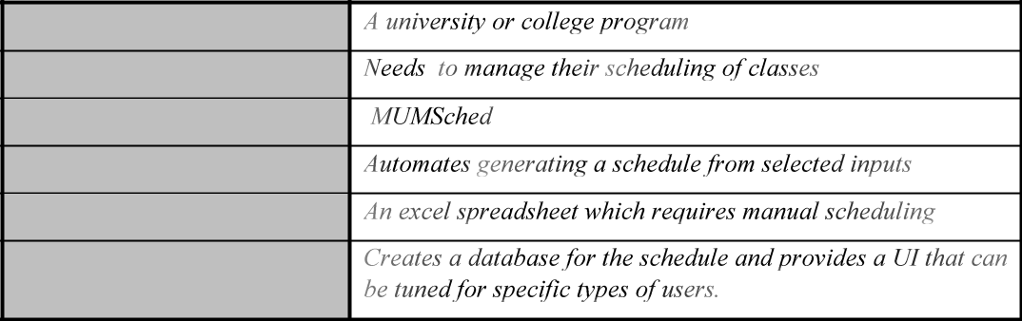

For

That

The

That

Unlike

Our product

- Stakeholder Descriptions
3.1 Stakeholder Summary
Name | Description | Responsibilities
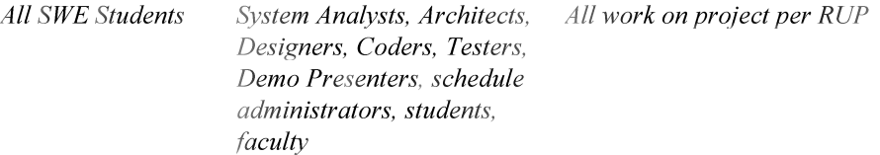

3.2 User Environment
- Product Overview

4.1 Product Perspective

See the problem statement from Assignment 1 on the SWE sakai site for CS425-2017-04A-04D

4.2 Assumptions and Dependencies

This project only provide a very simple student registration interface since the student registration system has already been developed and is deployed on the Infosys system here:

http://register.cs.mum.edu/register/

4.3 | Problems, Needs and Features
 | Problem |  |  | Need |  | Feature
 | 1. | Each Compro entry |  | Compro entries must |  | Schedule Admin must
 |  | has a projected |  | be sized by number of |  | be able to add or delete
 |  | number of students |  | students and entered |  | entries to the schedule
 |  | entering in the FPP |  | into the schedule. |  | and enter a projection
 |  | and MPP track. |  |  |  | for the number of
 |  |  |  |  |  | students in the MPP
 |  |  |  |  |  | and FPP tracks.
 | 2. An entry will have a |  |  | Blocks must be |  | Schedule Admin must
 |  | set of blocks with |  | created for each entry |  | be able to add or delete
 |  | classes that are |  | and have a sequence |  | blocks to the schedule
 |  | targeted for the MPP |  | number per entry track. |  | and enter one or more
 |  | track and the FPP |  |  |  | sequence numbers for
 |  | track. |  |  |  | the block based on
 |  |  |  |  |  | entry and track.
 | 3. Each block will have a |  |  | Based on entry student |  | The schedule builder
 |  | number of students |  | number projections |  | must calculate the
 |  | that are projected to |  | and entry sequence the |  | number of FPP, MPP,
 |  | be in FPP, MPP, and |  | number of students |  | and elective courses
 |  | elective courses. |  | and the sections |  | required for each block
 |  |  |  | required must be |  | based on each entry’s
 |  |  |  | computed. |  | projected number of
 |  |  |  |  |  | students.
 | 4. | Some U.S. resident |  | Need to be able to |  | Schedule Admin must
 |  | students may take 9 |  | figure out how many |  | be able to set
 |  | elective courses on |  | students will be |  | projections for
 |  | campus. Some OPT |  | enrolled each block |  | students taking more
 |  | students may take 5 |  | based on their |  | than 4 elective courses
 |  | elective courses on |  | projected courses on |  | on campus.
 |  | campus . |  | campus.
 | 5. A course may have |  |  | Courses can have |  | Schedule Admin must
 |  | many offerings in one |  | many sections and be |  | be able to create,
 |  | or more blocks. |  | scheduled for many |  | update, and delete
 |  |  |  | blocks. |  | courses. Sections can
 |  |  |  |  |  | be created for each
 |  |  |  |  |  | course by the schedule
 |  |  |  |  |  | builder as needed.
 | 6. A course may have |  |  | Courses can be |  | 4a. Schedule Admin
 |  | prerequisites. |  | prerequisites and can |  | must be able to
 |  | Courses with |  | have prerequisites. |  | indicate the prereq
 |  | prerequisites should |  | The scheduling tool |  | relationship between
 |  | be offered after their |  | must schedule |  | courses.
 |  | prerequisites for an |  | sections of prereqs |  | 4b. Schedule Admin
 |  | entries sequence of |  | prior to the courses |  | 4b. Schedule Admin

 | courses. | requiring the prereqs. | must be able to
 |  |  | indicate the target
 |  |  | blocks for courses for
 |  |  | an entry’s sequence
 |  |  | and the percent of an
 |  |  | entry that will take the
 |  |  | course.
7. | Each section of a | Courses need to have | Schedule Admin must
 | course has a | a maximum number of | be able to set the
 | maximum number of | students allowed. | maximum students for
 | students. |  | a course and sections.
8. | Faculty have a set of | Courses need to have | Faculty must be able to
 | courses they teach. | an indication of faculty | set their profile to
 |  | that can teach them. | indicate what courses
 |  |  | they teach.
9. | Faculty have a set of | Blocks need to have an | Faculty must be able to
 | blocks they can teach | indication of faculty | set their profile to
 | and a preference for | that can teach them. | indicate what blocks
 | time between blocks. |  | they can teach and the
 |  |  | interval between their
 |  |  | teaching blocks.
10. | Faculty need to see | Same as problem | Faculty can view the
 | the course they are |  | sections they are
 | scheduled for. |  | scheduled to teach
 |  |  | after the schedule
 |  |  | builder creates the
 |  |  | schedule.
11. | Faculty have a course | Need to be able to set | Schedule Admin must
 | load per school year. | the target course load | be able to set the
 |  | for faculty. | target course load for
 |  |  | each faculty member.
12. | Schedules begin as | Need to be able to label | Schedule Admin can
 | drafts, are reviewed, | a schedule as a draft, | generate a draft
 | updated, and | mark as reviewed, and | schedule, update any
 | approved. | finally set as approved. | of the schedule blocks,
 |  |  | and mark a schedule
 |  |  | as in review or
 |  |  | approved.
13. | Students need to be | Same as problem | Students can login to
 | able to see the |  | the schedule system
 | schedule and register |  | and register for
 | for course sections. |  | courses from an
 |  |  | approved schedule.

14. Administrator may | Need to be able to have | Schedule Admin will
ask questions on the | the schedule in a DB | have a UI to query the
number of courses | that can be queried. | Schedule DB for a set
planned and faculty |  | of common reports.
assigned.

4.4 Alternatives and Competition

This should be better than an excel spread sheet since it considers many problems related to using spreadsheet to be solved. In the future, this project could be develop and can compete with current registration system for MIU and other universities.

- Other Product Requirements

The final development must be done for the end of the SWE course.

