Assignment-12.5
Name:g.giridhar reddy
RollNo:2303A51285
Batch-no:20
Task1: Sorting – Merge Sort Implementation
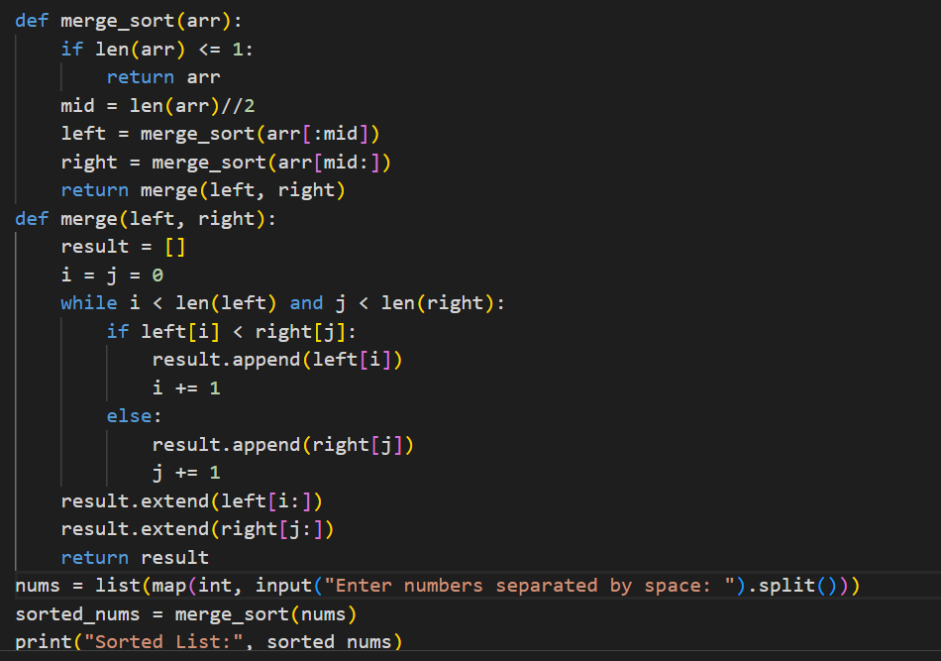
Output:
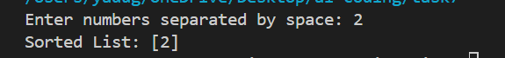
Observation: The list was successfully sorted using the divide-and-conquer approach.
The algorithm maintained O(n log n) time complexity for all cases.

Task2: Searching – Binary Search with AI loptimization
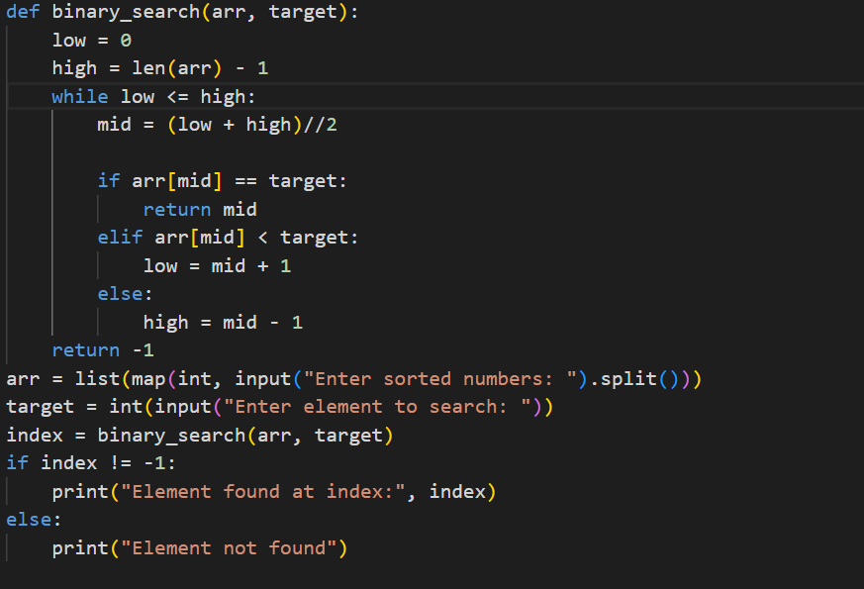output: 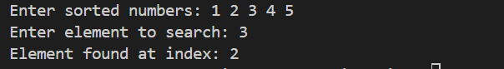
Observation: The target element was found efficiently in a sorted list.
The algorithm reduced search time to O(log n).

Task3: Smart Healthcare Appointment Scheduling
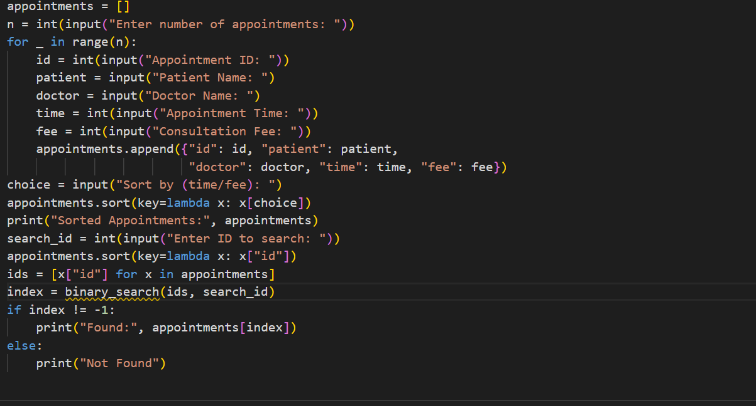
Output:
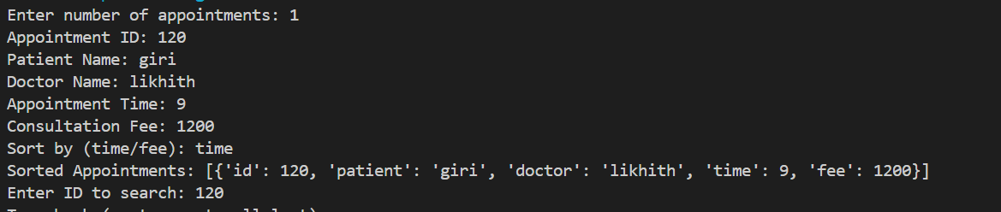
Observation: Appointment records were sorted correctly based on selected fields.
Searching by ID was fast and accurate using Binary Search.

Task4: Railway Ticket Reservation System
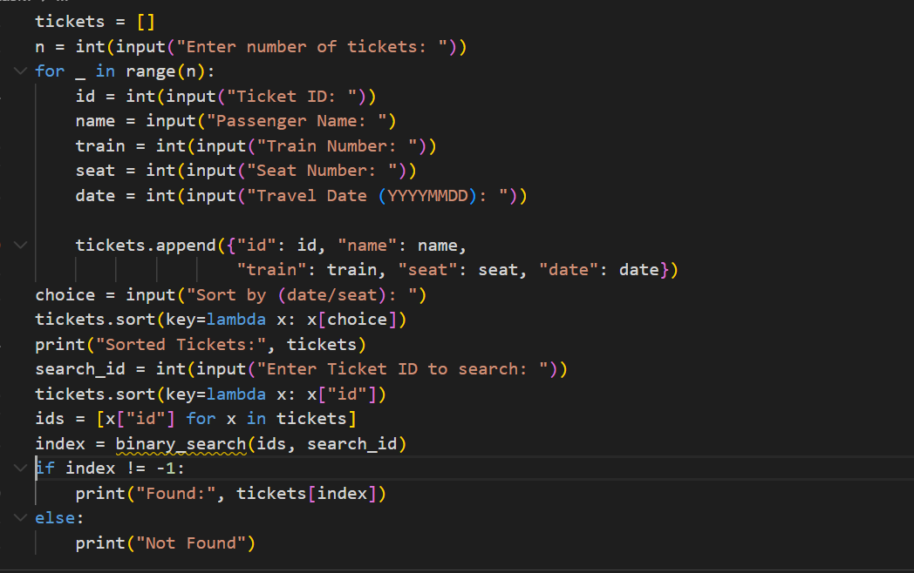
Output:
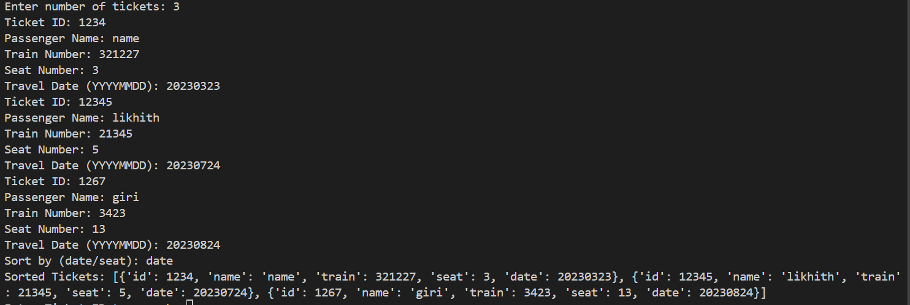
Observation: Ticket data was sorted properly by date or seat number.
Binary Search improved ticket lookup efficiency.

Task5: Smart Hostel Room Allocation System
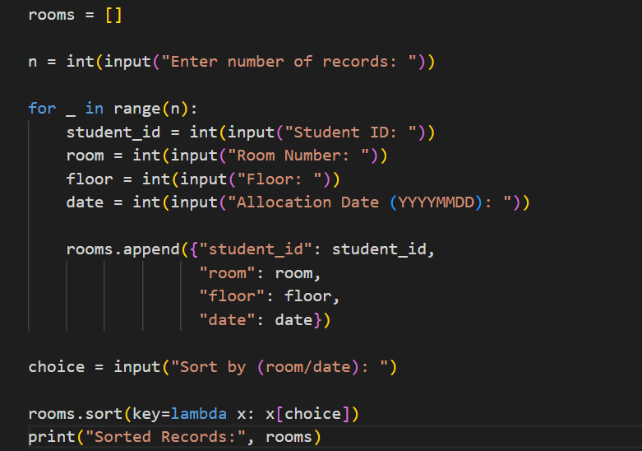
Output:
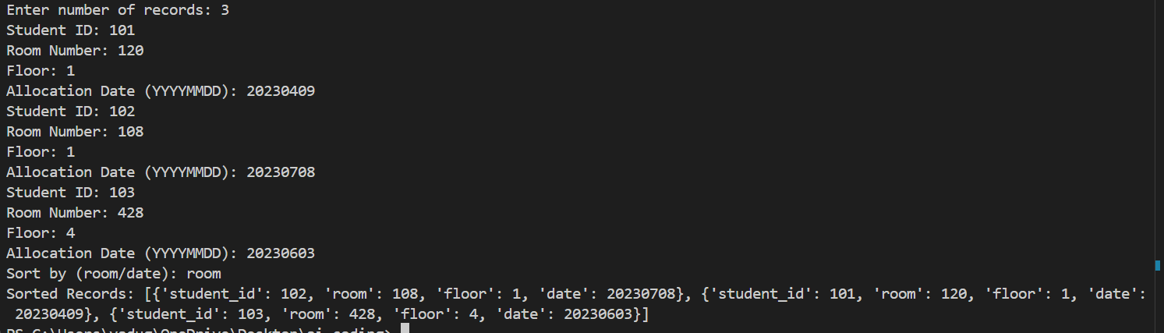
Observation: Room records were organized correctly after sorting.
Student ID search was efficient and accurate.

Task6: Online Movie Streaming Platform

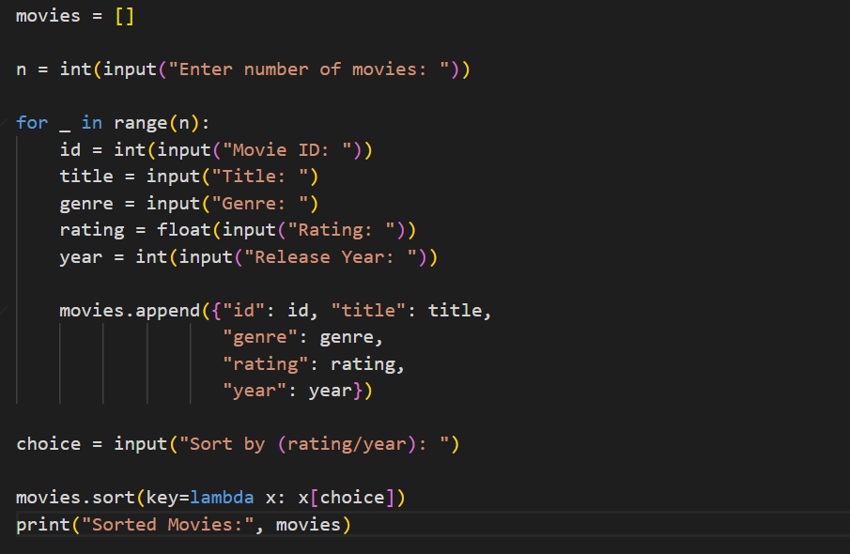
Output:
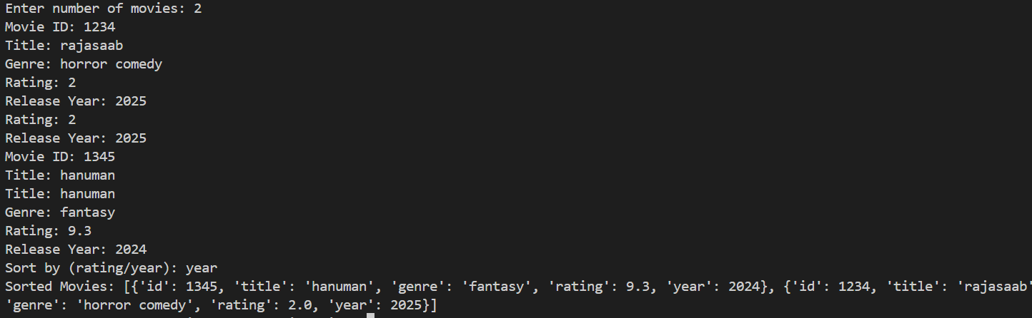
Observation : Movies were sorted successfully by rating or release year.
Searching by movie ID worked quickly on sorted data.

Task7: Smart Agriculture Crop Monitoring System
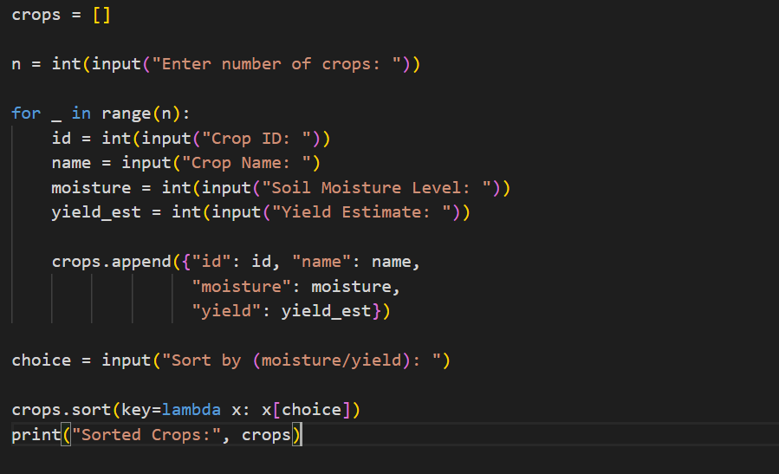
Output:
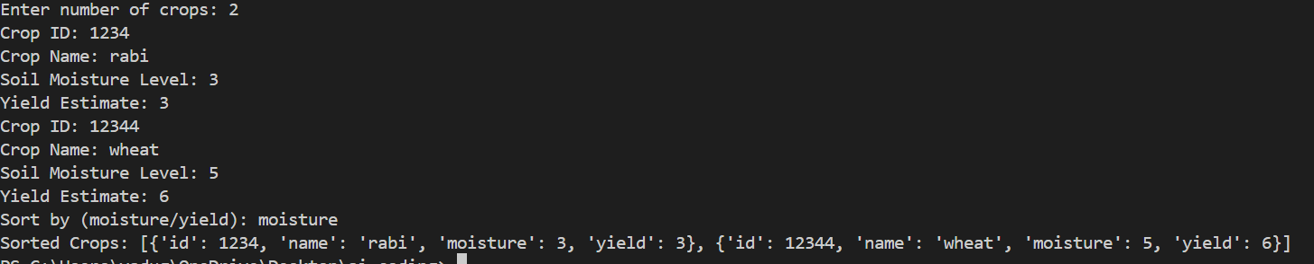
Observation: Crop data was sorted correctly based on moisture or yield.
Crop search by ID was efficient using Binary Search.
Task8: Airport Flight Management System

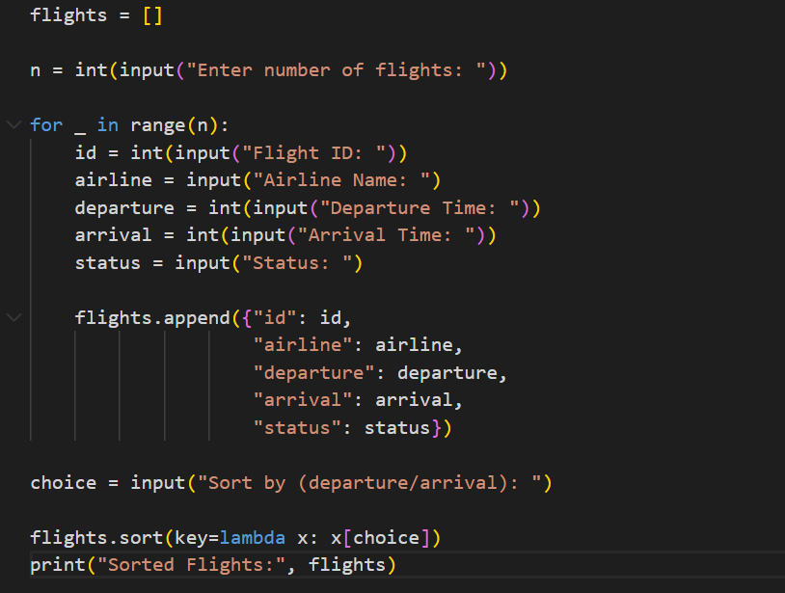
Output:
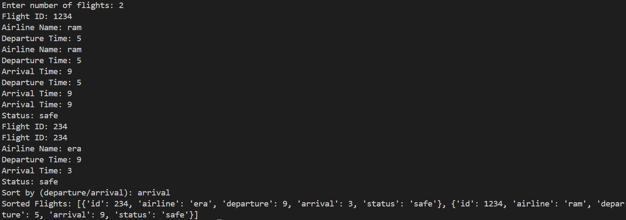
Observation: Flight records were arranged correctly by departure or arrival time.
Flight ID search was fast and reliable.

