AI ASSISTANT CODING ASSIGNMENT-9.3

Name: G.GIRIDHAR REDDY

HT. No: 2303A51285
Batch: 19

Task 1: Basic Docstring Generation

Code: Manual code with manual Google-style Docstring

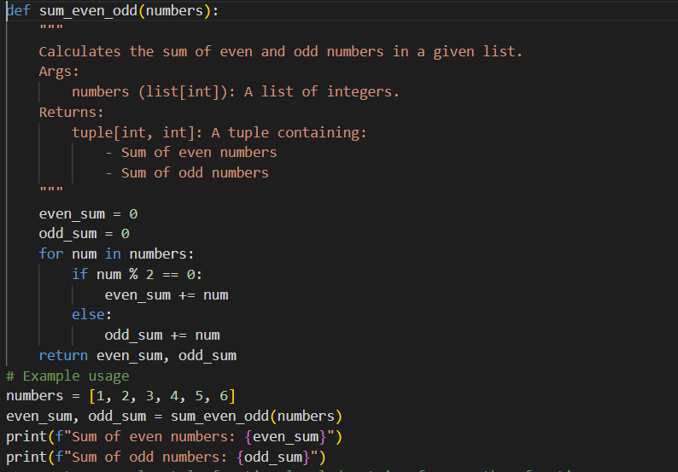

Prompt: Generate a Google-style function-level docstring for a Python function

that takes a list of integers and returns a tuple containing the sum of even numbers and the sum of odd numbers.

Include:

Short description

Args section

Returns section

Proper data types

AI-Generated Docstring

"""

Compute the total sum of even and odd integers from a list.

Args:

numbers (List[int]): A list of integer values.

Returns:

Tuple[int, int]: A tuple where the first element is the

sum of even integers and the second element is the sum

of odd integers.

"""

Analysis: The manual docstring was concise and directly matched the function requirements. The AI-generated docstring was slightly more detailed and formal in structure. Both were correct and complete, but AI added extra explanation. Manual writing gives better control, while AI improves speed.

Result:
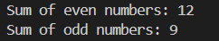

Observation:
The AI-generated docstring followed the Google style format correctly and provided clear parameter and return descriptions. However, it was slightly more verbose than necessary and added formal type hints that were not strictly required. The manual docstring was more concise and directly aligned with the function’s purpose. While AI improves speed and consistency, human refinement ensures clarity and precision.

Task 2: Automatic Inline Comments

Code: Python Class with Manual Inline Comments

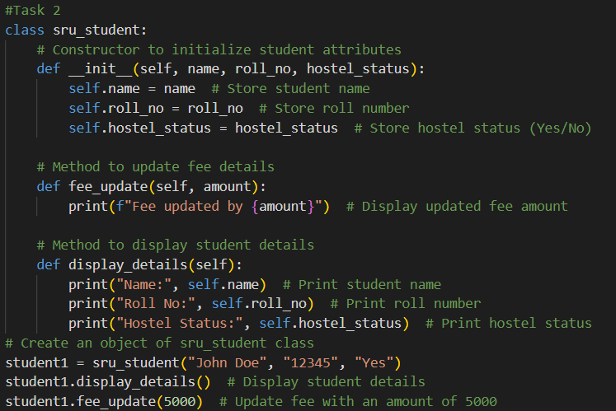

Prompt: Add meaningful inline comments to the following Python class.Explain logical blocks clearly. Do not modify the code structure.
Code: AI-Generated Inline Comments
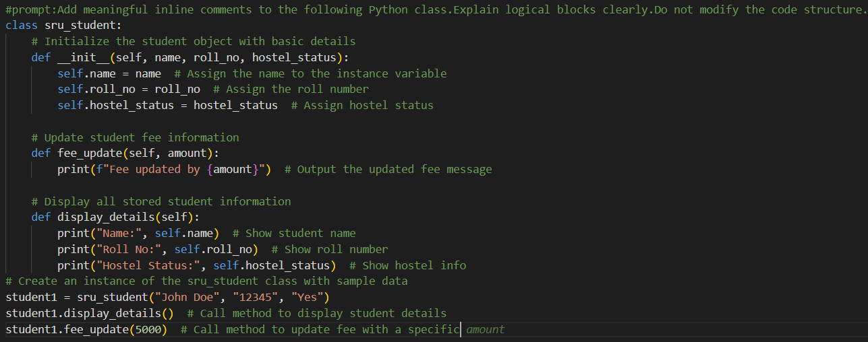
Result:
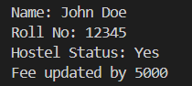

Analysis: Manual inline comments were simple and focused on important logic. AI-generated comments were more detailed but sometimes redundant. AI helps improve readability, but manual refinement is needed to avoid unnecessary explanations.

Observation:
The AI-generated inline comments explained nearly every line of code, improving readability for beginners but sometimes creating redundancy. The manual comments were shorter and focused only on important logical sections. Although AI enhances understanding and documentation speed, it may over-explain simple statements. Human review is necessary to maintain clean and professional commenting standards.

Task3: Module-Level and Function-Level Documentation
Code: Calculator Script with Manual NumPy Docstrings
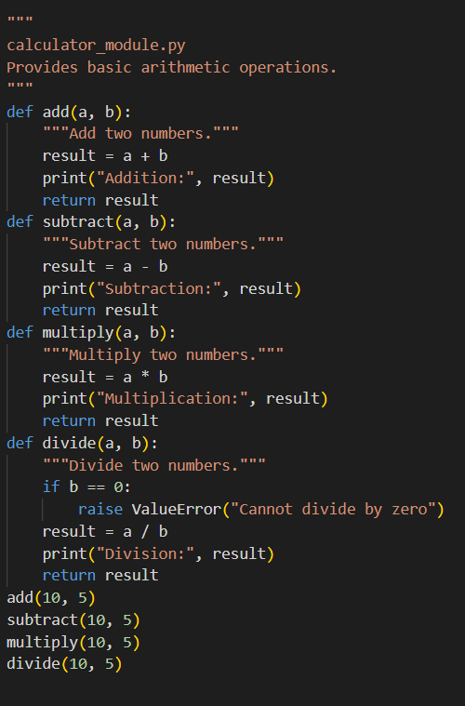

Prompt:
#Generate a NumPy-style module-level docstring for a calculator module
#that includes add, subtract, multiply, and divide functions.
#Include overview and usage.
#Generate NumPy-style docstrings for add, subtract, multiply, divide functions.
#Include Parameters, Returns, and Raises (for divide).

Code: AI Generated
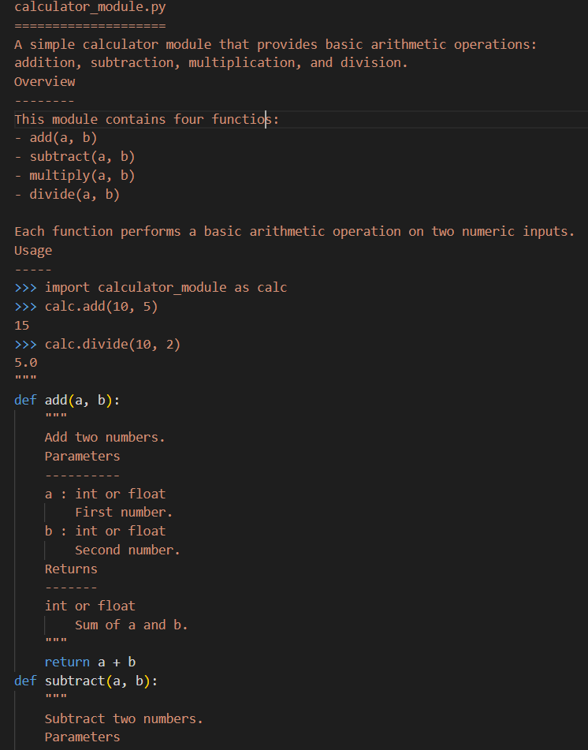
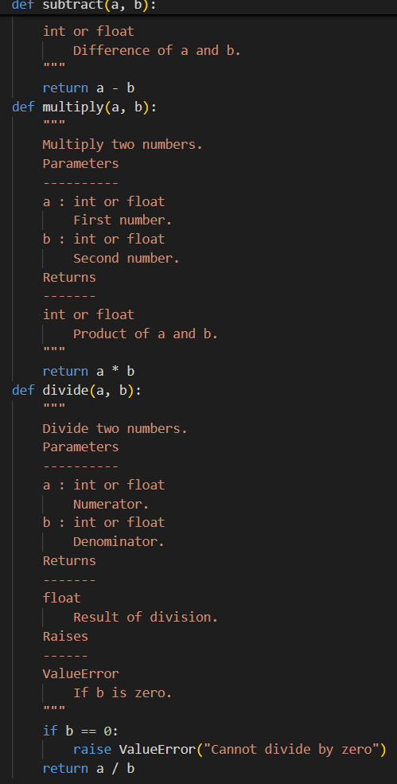
Result:
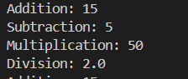

Analysis: The manual NumPy docstrings were accurate and structured properly. The AI-generated documentation was more descriptive and detailed. Both were correct, but AI tends to be more verbose. Human review ensures clarity and precision.

Observation:

The AI-generated module and function-level documentation correctly followed the NumPy format and included detailed parameter, return, and raise sections. However, the descriptions were slightly more elaborate than required. The manual documentation was accurate and structured but more concise. This task shows that AI is highly effective for generating structured documentation, but manual customization ensures better alignment with project-specific needs.
odules, which may be necessary in certain execution environments.

