Assignment 13.5
Name:G.Giridhar Reddy
HTNO:2303A51285
BATCH:19
Task:1
Prompt:
Refactor the following Python code to remove the global variable and pass it as a function parameter.
rate = 0.1
def calculate_interest(amount):
return amount * rate
print(calculate_interest(1000))
Code:
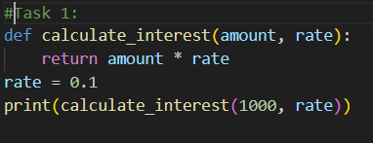
Output:
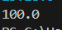
Observation:
The global variable rate is removed from the function. It is passed as a parameter, making the code more modular and easier to test.
Task:2
Prompt:
Refactor the following Python code to remove deeply nested if–else statements and make the logic cleaner and more readable.
score = 78
if score >= 90:
print("Excellent")
else:
if score >= 75:
print("Very Good")
else:
if score >= 60:
print("Good")
else:
print("Needs Improvement")

Code:
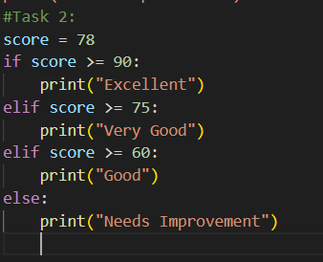
Output:
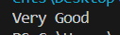
Observation:
The deeply nested if–else statements are refactored into a flat if–elif–else structure. This improves readability, makes the logic simpler, and the code is easier to maintain.
Task:3
Prompt:
Refactor the following Python code to remove repeated file handling and follow the DRY principle by using a reusable function and with open().
f = open("data1.txt")
print(f.read())
f.close()
f = open("data2.txt")
print(f.read())
f.close()
Code:
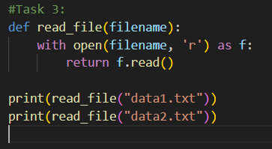
Observation:
The repeated file handling code is refactored into a reusable function read_file(). The with open() context manager is used, which automatically closes the file and follows the DRY principle, making the code cleaner and reusable.
Task 4:
Refactor the following Python code to optimize the search logic using a better data structure (set or dictionary) instead of a linear search.
users = ["admin", "guest", "editor", "viewer"]
name = input("Enter username: ")
found = False
for u in users:
if u == name:
found = True
print("Access Granted" if found else "Access Denied")
Code:
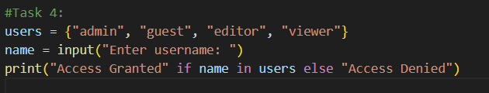
Output:
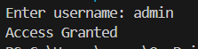
Observation:
The list is replaced with a set and the loop is removed. Membership is checked using name in users, which makes the code simpler and faster (O(1) average time) compared to the previous linear search O(n).
Task5:
Prompt:
Refactor the following Python procedural code into an Object-Oriented (class-based) design with proper attributes and methods.
salary = 50000
tax = salary * 0.2
net = salary - tax
print(net)
Code:
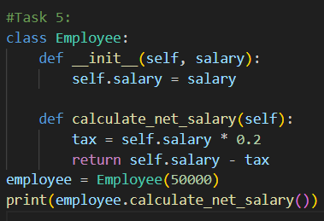
Output:
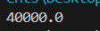
Observation:
The procedural code is refactored into a class Employee. The salary is stored as an attribute, and the net salary calculation is done using a method calculate_net_salary(). This improves encapsulation, reusability, and OOP structure.
Task:6
Prompt:
Refactor the following Python code to improve performance by replacing the loop with an optimized approach such as a mathematical formula or built-in function.
total = 0
for i in range(1, 1000000):
if i % 2 == 0:
total += i
print(total)
Code:
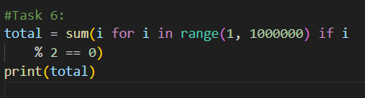
Output:
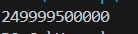
Observation:
The loop is refactored using the built-in sum() function with a generator expression. This reduces code length, improves readability, and provides better performance compared to the manual loop.
Task:7
Prompt:
Refactor the following Python code to remove hidden side effects by avoiding modification of global variables and returning values instead.
data = []
def add_item(x):
data.append(x)
add_item(10)
add_item(20)
print(data)
Code:
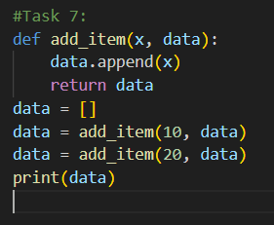
Output:
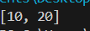
Observation:
The function add_item() adds a value to the list data.
First 10 is added, then 20 is added.
Finally, the list becomes [10, 20] and it is printed as the output.
Task 8:
Prompt:
Refactor the password validation code by creating separate functions for each rule (length, digit, uppercase) to make the code more readable, modular, and easy to test.
password = input("Enter password: ")
if len(password) >= 8:
if any(c.isdigit() for c in password):
if any(c.isupper() for c in password):
print("Valid Password")
else:
print("Must contain uppercase")
else:
print("Must contain digit")
else:
print("Password too short")

Code:
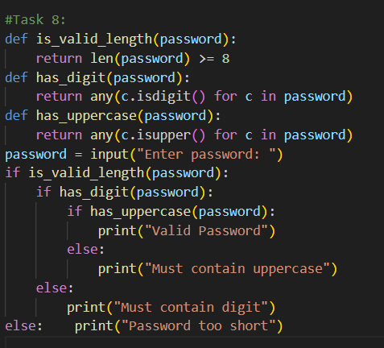
Output:
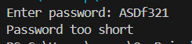
Observation:
The code checks the password using separate functions for length, digit, and uppercase letters.
It first checks if the password has at least 8 characters, then checks for a digit, and then an uppercase letter.
If all conditions are satisfied, it prints “Valid Password”; otherwise, it prints the corresponding error message.

