ASSIGNMENT-11.3
NAME : G.Giridhar Reddy
BATCH : 19
HTNO:2303A51285
Task 1: Smart Contact Manager (Arrays & Linked Lists)
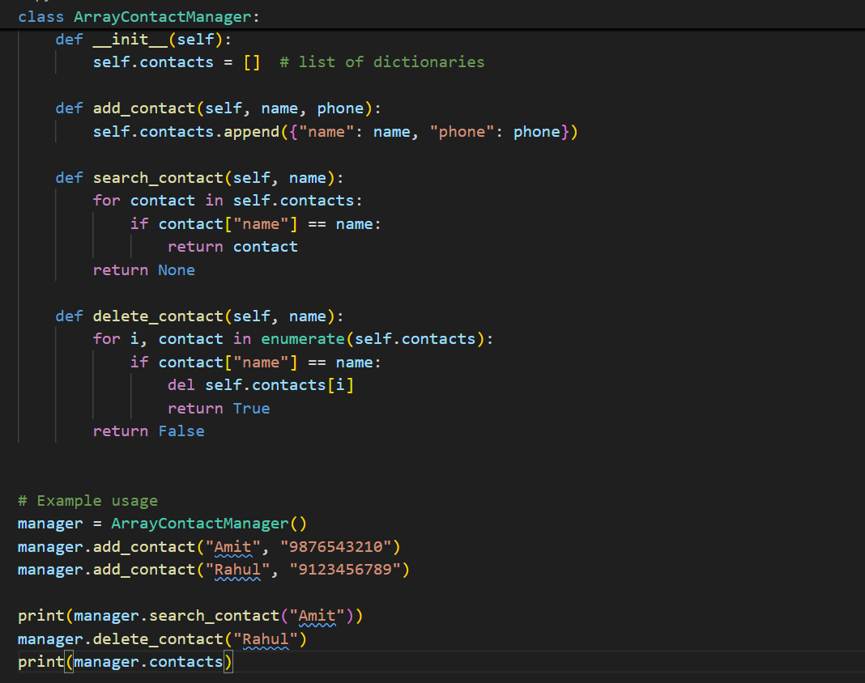
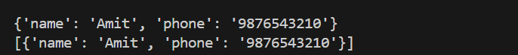
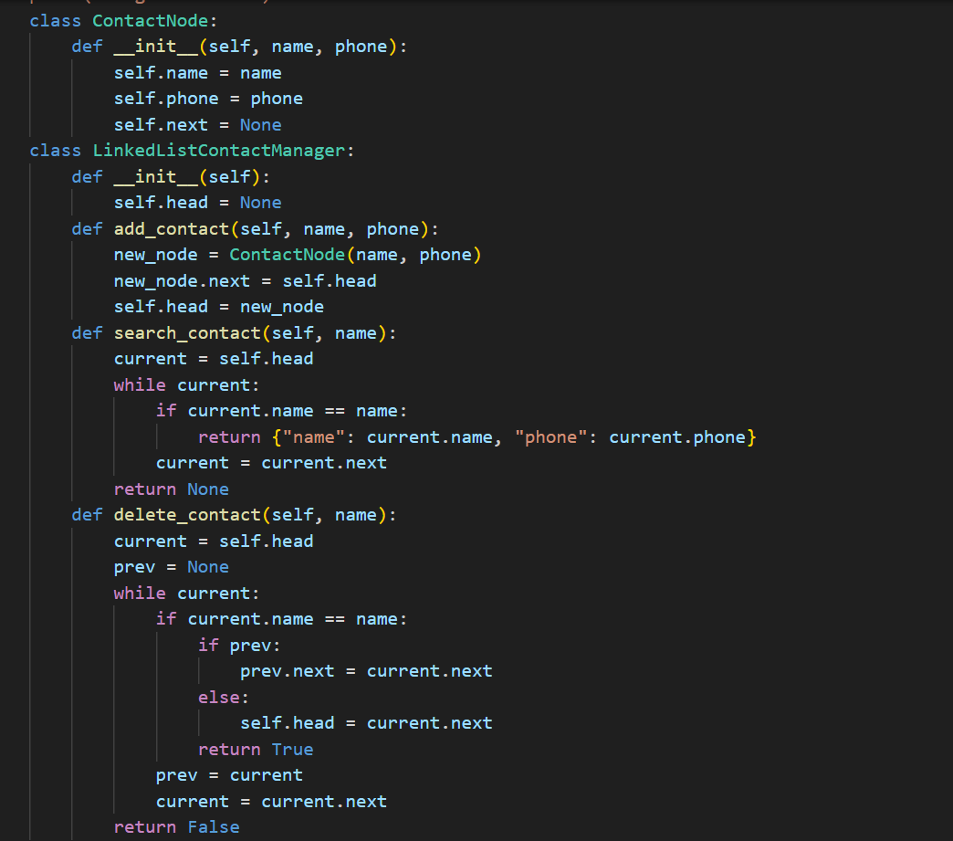

JUSTIFICATION:
The array-based implementation is simple and easy to use, making it suitable for small contact lists. However, deletion is inefficient because elements must be shifted after removal, leading to higher time complexity.
The linked list implementation provides better flexibility for dynamic memory allocation. Insertion is efficient as it does not require resizing, and deletion only involves pointer adjustments. However, linked lists consume more memory due to additional node pointers and have slower access times.
Task 2: Library Book Search System (Queues & Priority Queues)
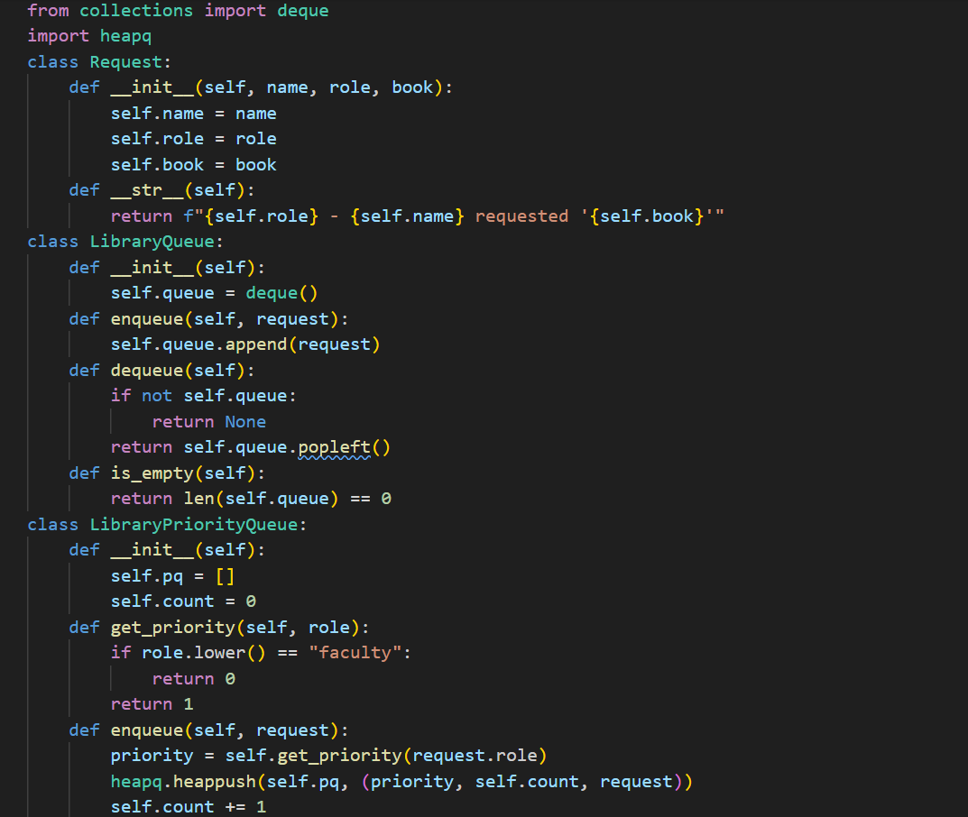
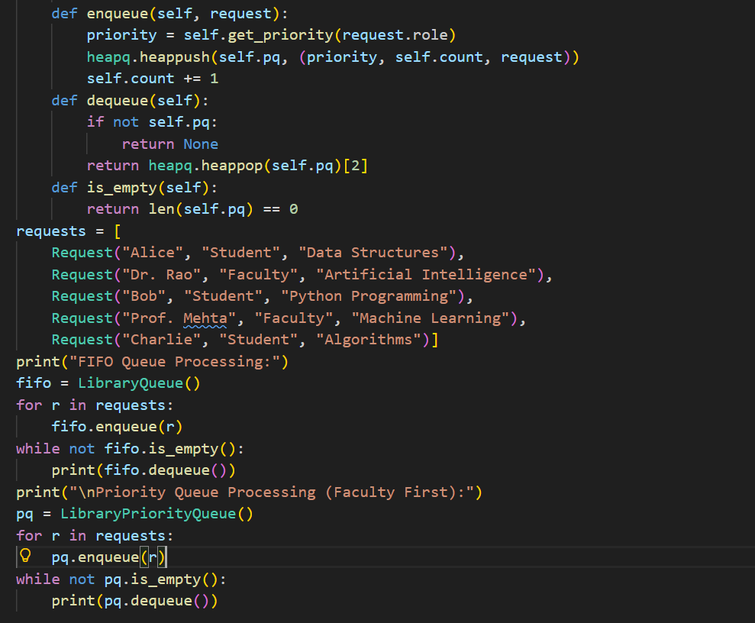
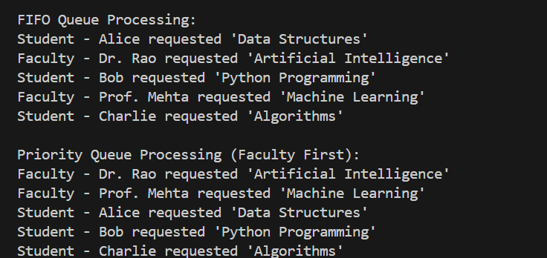
JUSTIFICATION:
The system uses a FIFO Queue to process book requests in the order they are received, ensuring fairness.A Priority Queue is added to prioritize faculty requests over student requests as required in the scenario.
Faculty are assigned higher priority (0) and students lower priority (1), so faculty requests are dequeued first.
The enqueue() and dequeue() methods correctly manage insertion and removal of requests in both structures.
Testing with mixed requests proves that FIFO works normally while the Priority Queue correctly gives preference to faculty.
Task 3: Emergency Help Desk (Stack Implementation)
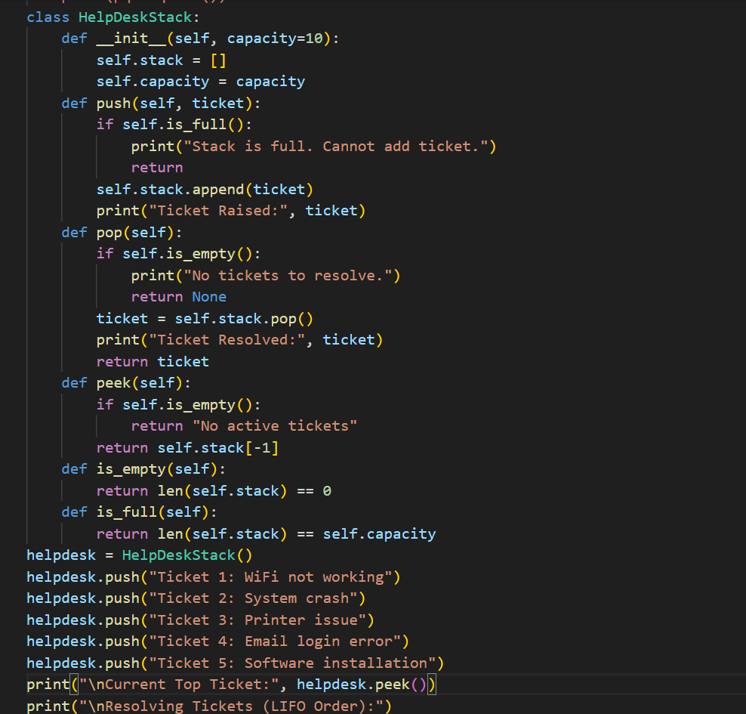
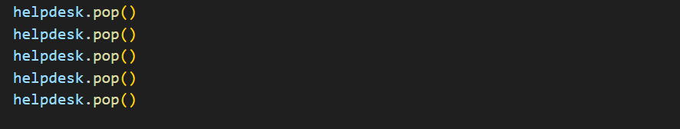
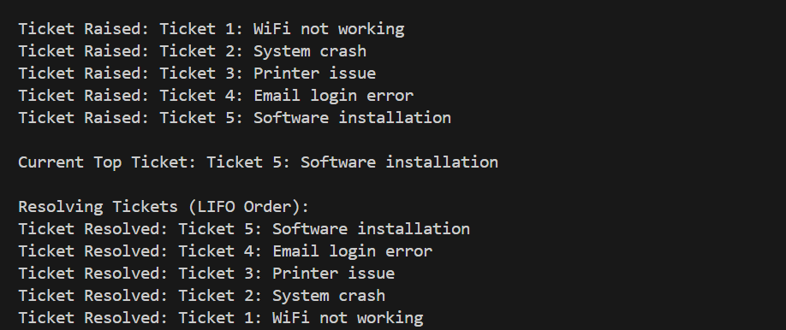
JUSTIFICATION:
The Emergency Help Desk system uses a stack data structure because ticket escalation follows the LIFO (Last-In, First-Out) principle, meaning the most recently raised ticket is resolved first. The push() operation is used to add new support tickets to the stack as they arrive, while the pop() operation resolves tickets in reverse order of arrival, accurately simulating real escalation handling. The peek() function helps identify the current top priority ticket without removing it from the stack. Additional operations like is_empty() and is_full() ensure proper validation and prevent errors during ticket management. The simulation of five tickets clearly demonstrates correct LIFO behavior, fulfilling the requirement of a functional stack-based ticket management system.
Task 4: Hash Table
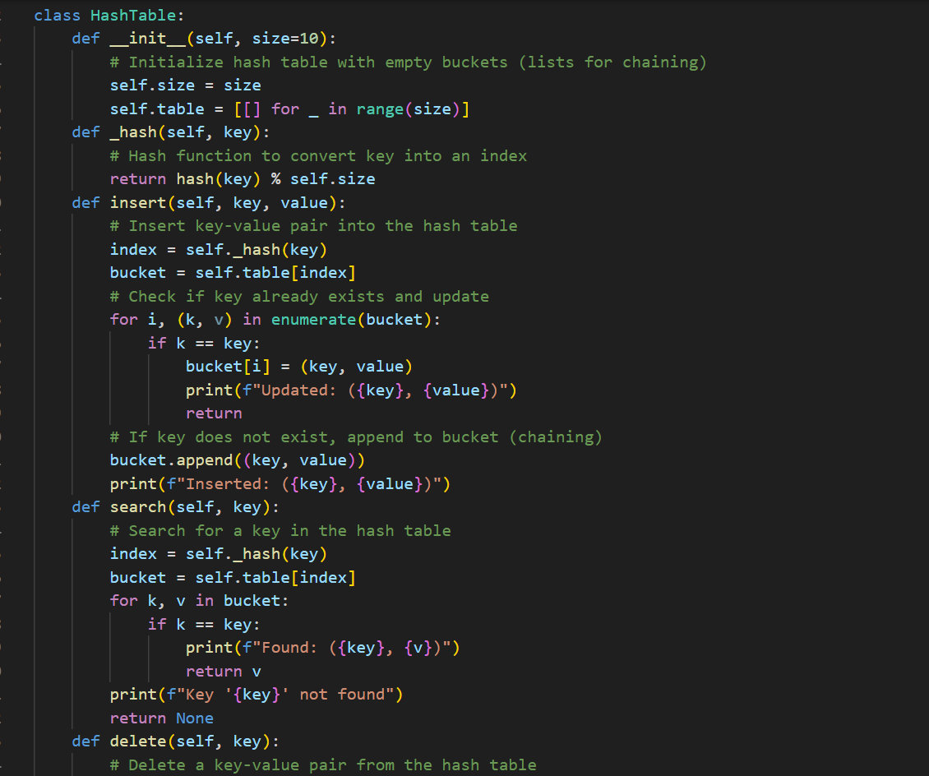
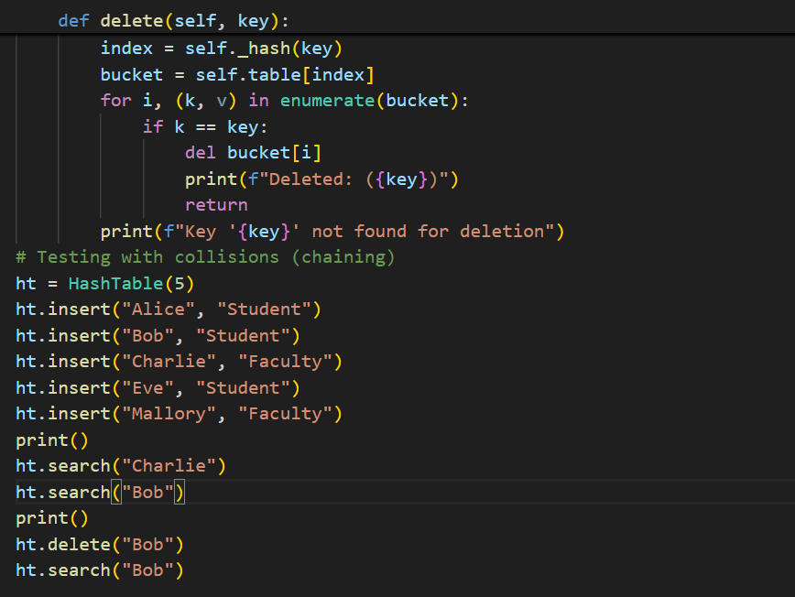
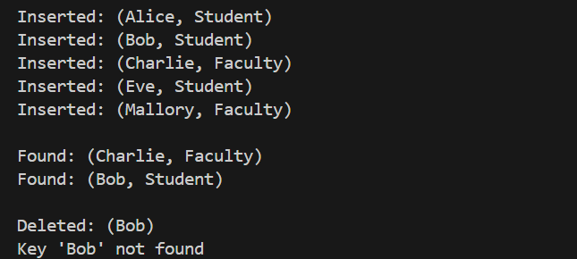
JUSTIFICATION:
The hash table is implemented using key-value pairs to allow efficient insertion, searching, and deletion of data. Collision handling is managed through chaining, where each index stores a list of elements that hash to the same bucket, preventing data loss during collisions. The insert() method adds new elements or updates existing ones, while the search() method retrieves values quickly using the hash function. The delete() method removes the specified key from its bucket without affecting other entries. Overall, the implementation satisfies the objective by demonstrating efficient storage, collision handling, and well-structured hash table operations.
Task 5: Real-Time Application Challenge
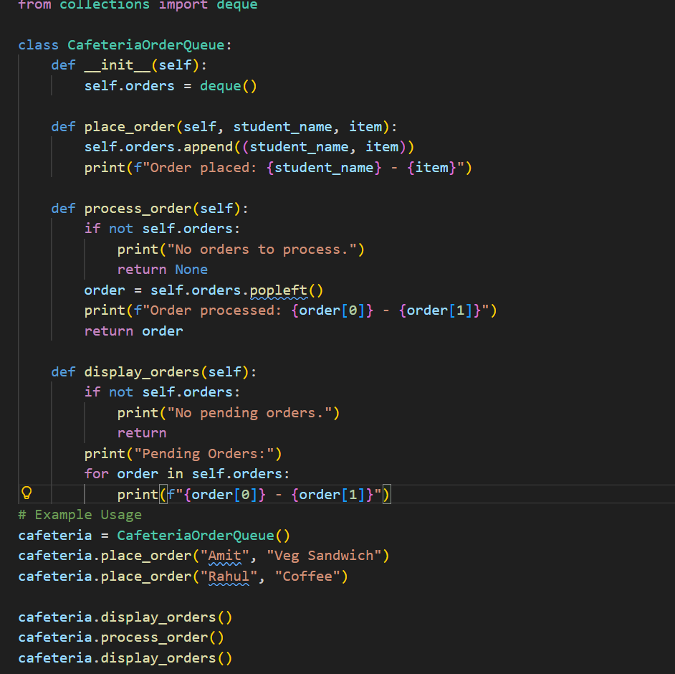
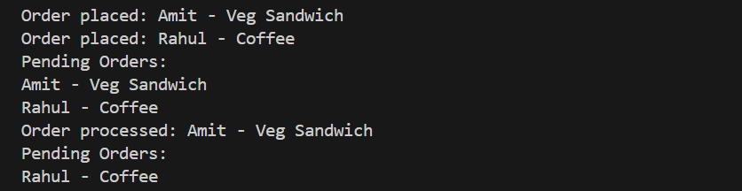
JUSTIFICATION:
The queue data structure is ideal for the cafeteria order system because food orders must be handled in the exact sequence in which they are placed. Using a FIFO (First-In-First-Out) approach ensures fairness and prevents order starvation. The deque structure in Python allows efficient insertion and removal operations with O(1) time complexity, making it suitable for real-time environments

