Third Disney Visit Report (4/8)
Summary
The third site visit was used to move the system from bench testing onto the maintenance vehicle itself. The vehicle's electrical system was verified as compatible, the LiDAR was mounted and calibrated on the vehicle, the full intrusion detection system was tested end-to-end including GPS and Microsoft Teams alerting, and additional camera data was collected. The system successfully detected both vegetation and a human intrusion within the depot and delivered alerts as designed. We have also collected some camera data within the depot grounds, yet more data is needed to train the visual recognition algorithm.
Objectives of the Visit
Objective | Outcome
Verify vehicle electrical system | Complete — connected to the 12 V battery, compatible
Mount and calibrate the LiDAR | Complete — Calibration completed
End-to-end software test | Complete — GPS fix, local logging on SD, Teams alerts
Detect an intrusion | Complete — human and vegetation intrusion detected, alert sent
Collect camera data | Partial — main track data is needed

1 · Power and Electrical Integration
- Connected to the 12 V battery located under the chair, and confirmed that our system is compatible with the vehicle's electrical system.
- Draw power from the 48 V on-train battery via new step-down transformer, or fitting a separate dedicated battery. Our team's preference is the on-train supply.
Next step: build an external casing for the Raspberry Pi and supporting modules, and finalise the power connection to the 48V
2 · LiDAR Mounting
- LiDAR mounted at the centre of the vehicle, approximately 38 cm above the rail.
- 3M VHB tape used as a temporary fixing for this visit.
- Mounted position calibrated against the clearance envelope.
Next step: decide and fabricate the final mounting stl before the next visit
3 · Software and Detection Testing
- Full detection pipeline tested on the vehicle (see attached video).
- GPS fix acquired successfully, with position attached to logged events.
- Alerts delivered both to local storage on the SD card and to Microsoft Teams.
- The live scope correctly identified close clusters of leaves within the depot.
- Human intrusion detected and an alert sent successfully.
- LiDAR position calibrated against measured references.
Next step: add a global shutter camera to capture the instant an intrusion alert is raised, and pair those images with visual model training so the system can classify the type of object intruding.

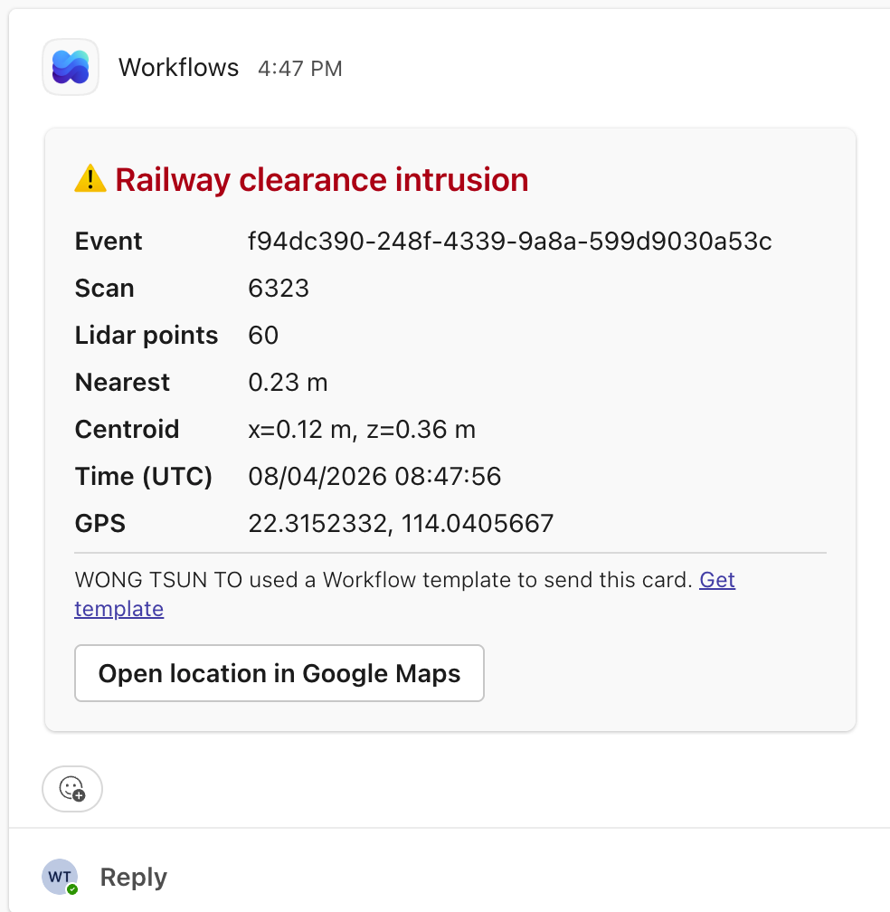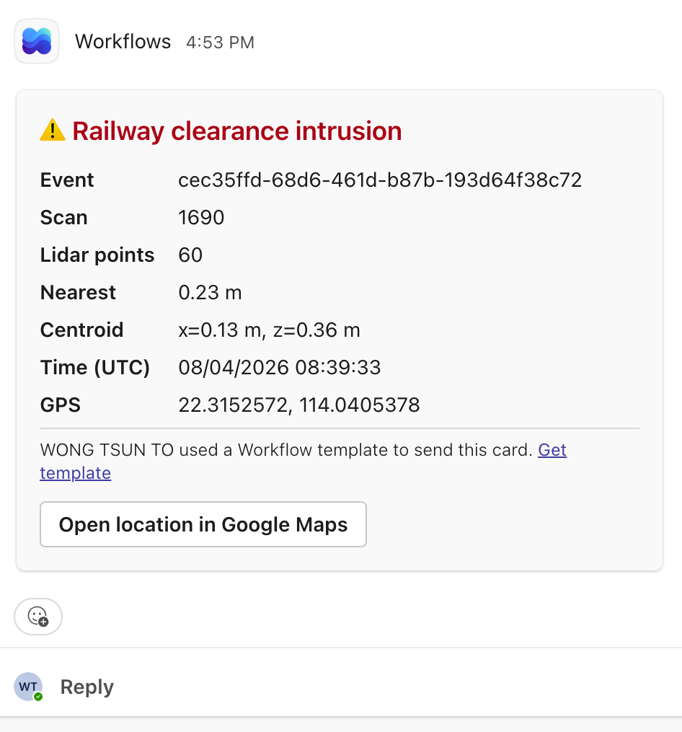
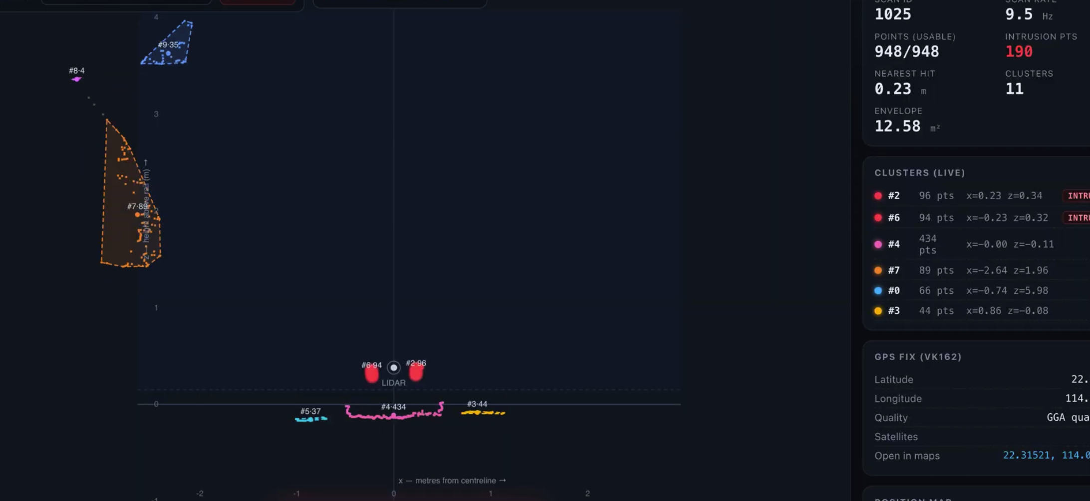

4 · Camera Detection System
- Additional camera data collected, though limited to the depot environment.
- Discussed mounting the camera on the bogie, and a possible LiDAR position beneath the bogie.
Next step: collect image data along the main track, and verify bolt and fixing placements along the track for the final mounting design.
5 · Next Step Summary
Subsystem | Action
Power | Build external casing; confirm and connect to the 48 V on-train supply.
Mounting | Design and fabricate the permanent LiDAR mount with vibration isolation.
Detection | Integrate a global shutter camera triggered on intrusion events.
Recognition | Collect main-track image data and train the object-classification model.
Survey | Verify bolt and fixing placements along the track.

