PROYECTO DAW

TAREA 2

Rafael gutiérrez ruiz

Contenido

DOCUMENTO DE ANÁLISIS DE REQUISITOS. 2

Requisitos funcionales. 2

Requisitos no funcionales. 2

DISEÑO DIAGRAMA DE CASOS DE USO 3

Obtención de cada uno de los casos de usos 3

Diagrama de Casos de Uso 4

DISEÑO DIAGRAMA DE INTERFACES 5

Acceso como usuario. 5

Acceso como administrador 6

DISEÑO DIAGRAMA DE BASE DE DATOS 6

1 . Modelo entidad – relación 7

Representación del diagrama E/R. 10

2 .Paso al Modelo Relacional 11

Representación del modelo relacional. 12

Creación e inserción de base de datos en SqLite 13

Necesidades hardware y software necesarias para la aplicación 63

# DOCUMENTO DE ANÁLISIS DE REQUISITOS.

El proyecto se trata de una aplicación web, donde se utilizará lenguaje php, javascript, MySQL y un el Framework Laravel.

El objetivo de esta aplicación está basada en la creación, visualización, modificación y eliminación, por parte del usuario, de recetas de cocina, y la gestión de esos usuarios y recetas por parte del administrador de la aplicación.

Tendrá implantado un sistema cliente-servidor, donde cada usuario a través de su cuenta podrá disfrutar de todas las funcionalidades de la aplicación. Será de carácter global y ayudará al usuario a tener de forma ordenada y clara las recetas que guarde.

## Requisitos funcionales.

El usuario que acceda a la página web puede ver todas las recetas registradas por los demás usuarios, y puede buscar recetas por el nombre o incluso por el tipo de receta, pero si no re registra o accede mediente su correo y contraseña no prodrá comentar la receta ni asignarla como favorita.

Una vez iniciada sesión tendrá acceso también a todas las recetas, incluidas la de los demás usuarios, donde podrá acceder a cada una de ellas, al igual como los usuarios no registrados, mostrándose foto de la receta, nombre, fecha y autor, también habrá información sobre los ingredientes, los pasos para la preparación, y una gráfica con los valores nutricionales de la receta, pero a diferencia de los usuarios no registrados, podrán realizar comentarios o asignarlas como favorita.

La página principal contará con una barra horizontal en la parte de arriba a modo de navegador, donde se visualizará el icono y título de la web, links para volver a la página inicial, una lista para visualizar lista de recetas según el tipo, y en caso de no estar logeado un link login y otro para registrarse en la web. Si el usuario ha accedido a la aplicación aparecerá su email y en él una lista con varias opciones.

Para la gestión por parte del administrador habrá que iniciar sesión con el usuario “admin@example.com” y contraseña “secret”, el cual administrará los usuarios y recetas de la base de datos

## Requisitos no funcionales.

Los datos tanto de usuarios como de las recetas, ingredientes (de las recetas), alimento (cada ingrediente con sus datos nutricionales), los pasos y comentarios o anotaciones se guardarán en una base de datos MySQL. Los datos de alimentos no podrán gestionarlos para evitar errores derivados.

Para entrar en la aplicación será indispensable cualquier dispositivo con navegador y acceso a Internet.

DISEÑO DIAGRAMA DE CASOS DE USO

## Obtención de cada uno de los casos de usos

La aplicación diferencia 3 casos de usos: los invitados, los usuarios y el administrador.

Los **invitados** al acceder a la página web pueden ver todas las recetas de cocina registradas en la web, pero no pueden ni crear recetas, ni comentar recetas, ni elegir recetas como favoritas, es decir, sólo podrán visualizar las recetas y entrar en cada receta para ver sus características, como la descripción, los ingredientes, los pasos, la gráfica de los nutrientes de la receta y los comentarios.

En el navegador superior tendrá enlaces, para la página de inicio, para ver recetas dependiendo del tipo (categorías), y enlaces para acceder con usuario y contraseña, o para registrarse. Si no estamos registrados nos registramos (el administrador ya está registrado y podrá acceder con su usuario y contraseña), aportando email, contraseña, y nombre del usuario.

Para el **usuario**, una vez que entra en su cuenta, le aparecerá página home con todas las recetas de todos los usuarios. Arriba en la barra de navegación estará su email que es una lista desplegable donde podrá crear una nueva receta, modificarla, acceder a sus recetas, modificar su perfil, acceder a sus recetas favoritas o salir.

Si no nos acordamos de la contraseña gestionamos la recuperación (tanto para usuarios como para administrador), con un envío de un código secreto al email del usuario, establecemos nueva contraseña y volvemos a la pantalla inicio ya validado.

Al acceder a nueva receta podrá asignarle una foto, nombre de la receta, descripción, tipo, agregará alimentos con cantidades, pasos y en caso correcto los campos guardarán la receta devolviendo un mensaje confirmándolo.

El usuario en la página de su perfil puede modificar la foto de usuario y nombre.

Por último podrá salir de su cuenta.

Para el **administrador**, entrará a la aplicación con su email y contraseña, entrará en su cuenta donde hay dos bloques que contienen enlace, uno de ellos es para eliminar y editar los usuarios registrados y otro para eliminar recetas. También puede ver todas las recetas y su contenido.

## Diagrama de Casos de Uso

### Diagrama Invitado



### Diagrama usuario

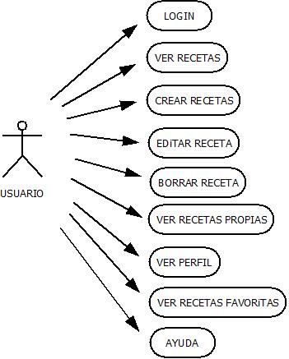

### Diagrama administrador

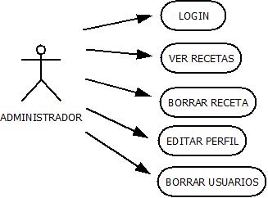

# DISEÑO DIAGRAMA DE INTERFACES

## Acceso como usuario.

  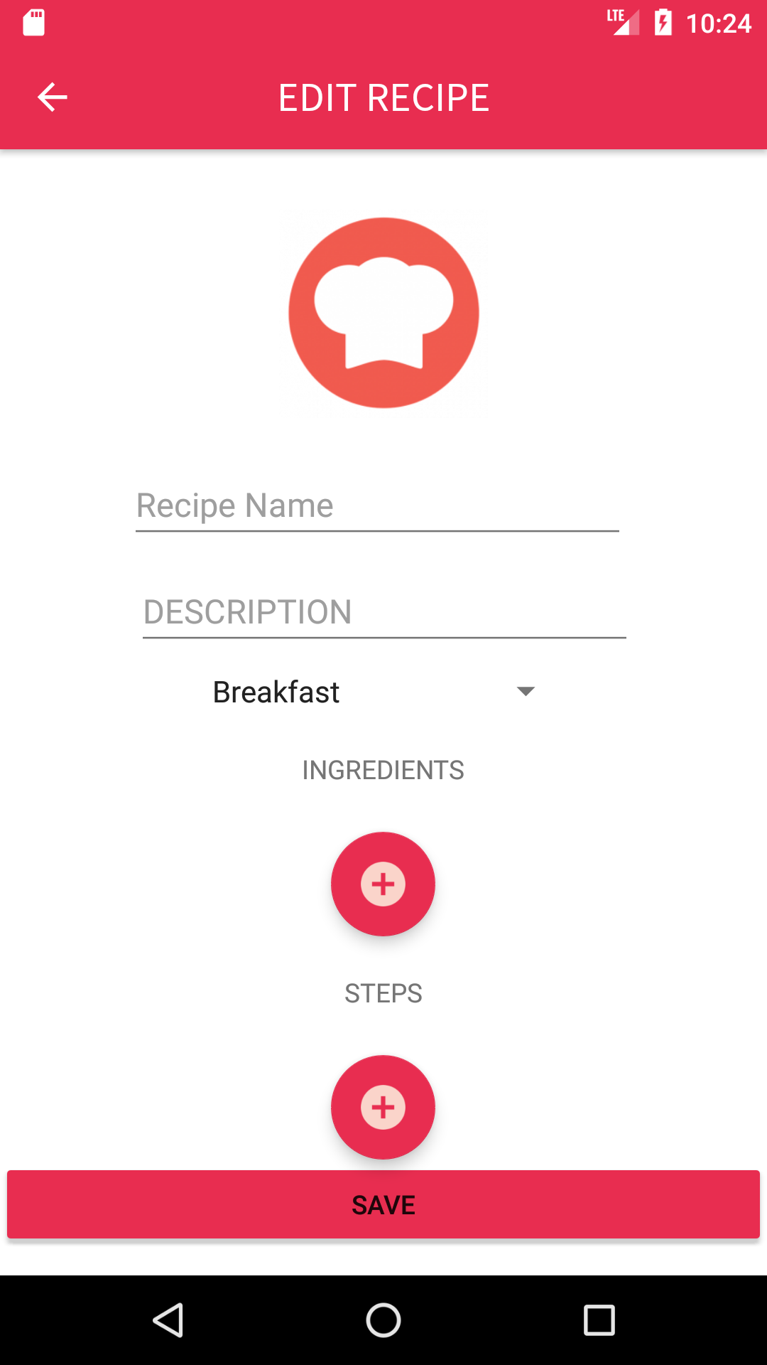

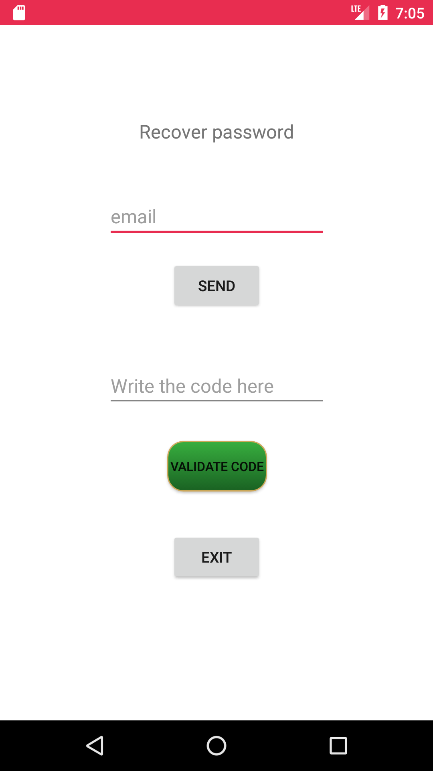 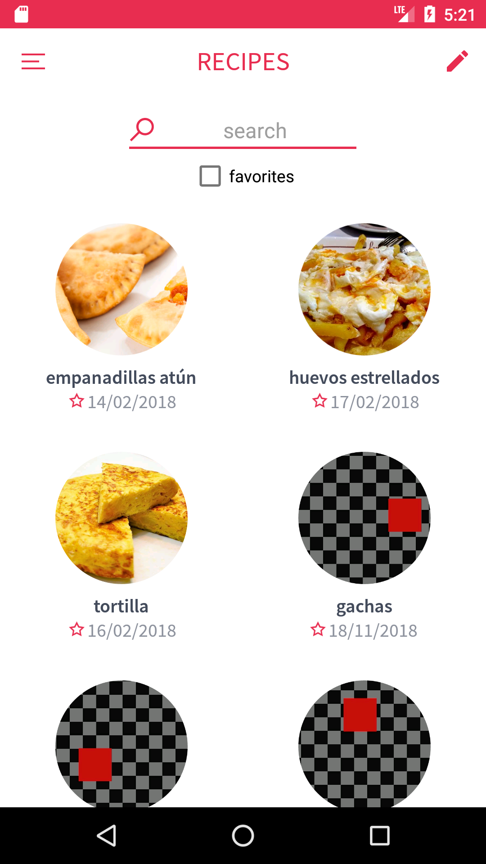 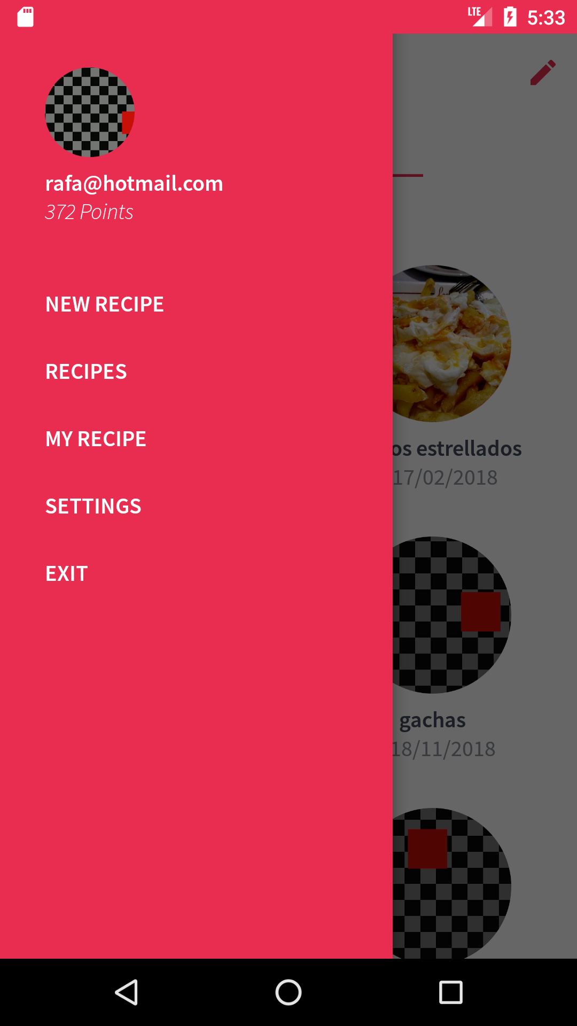

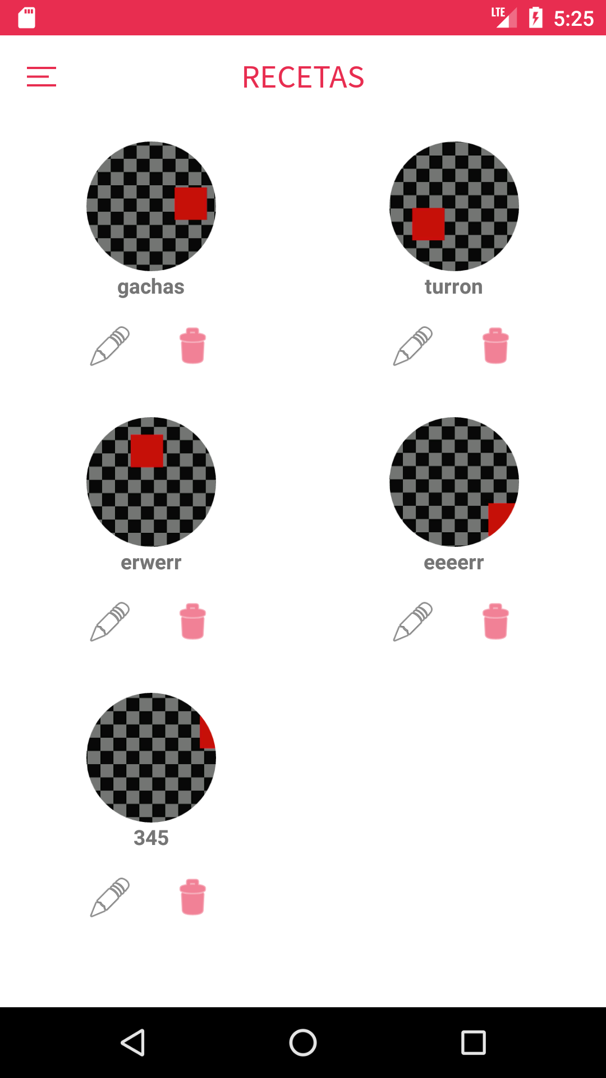 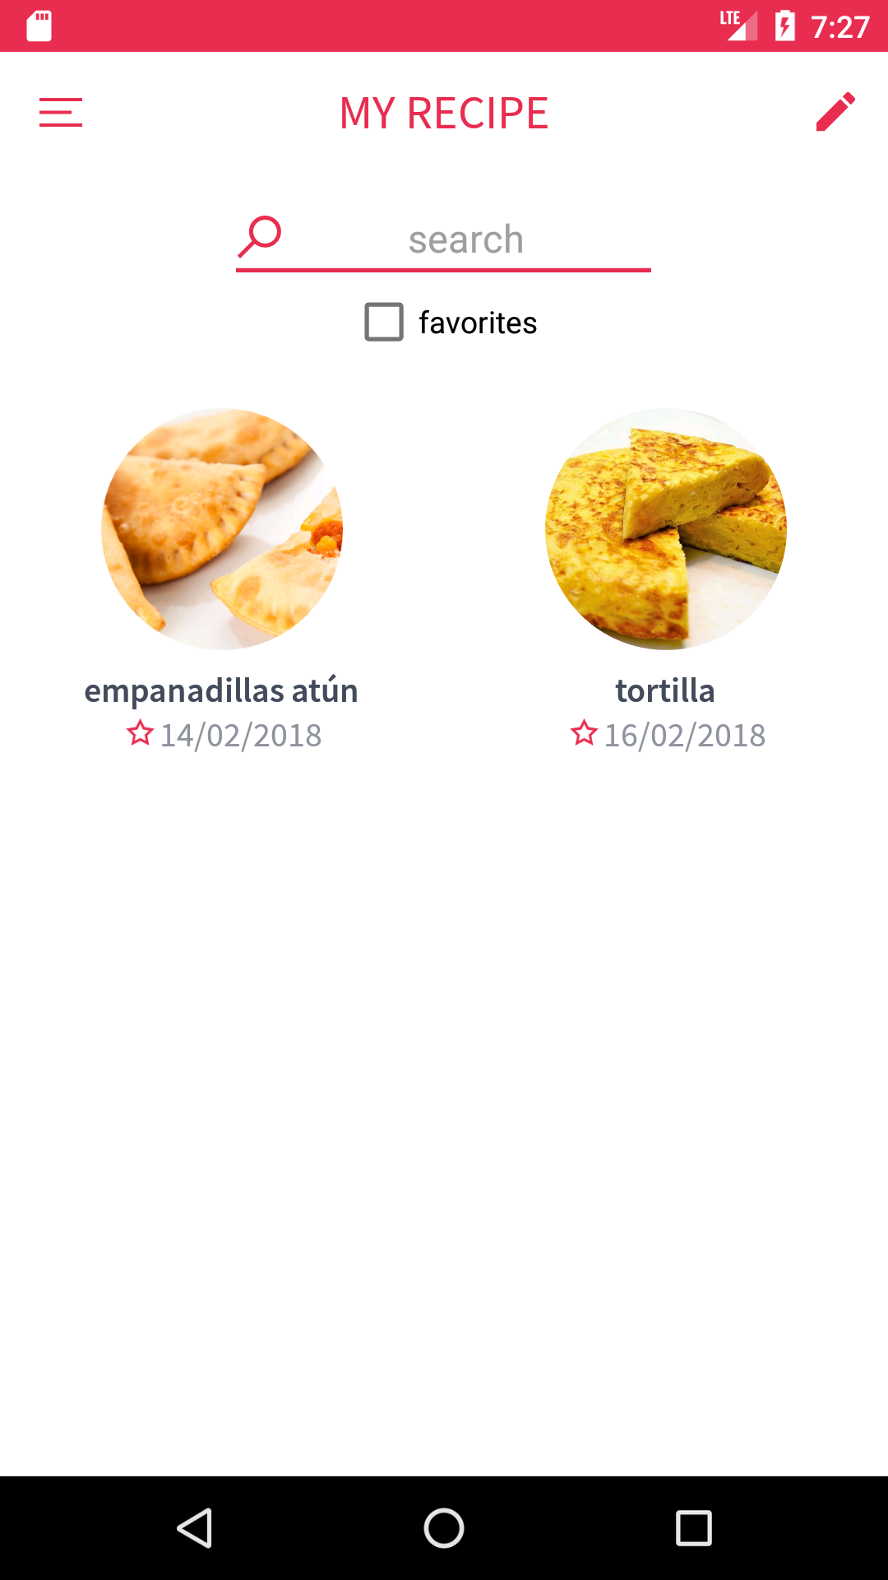 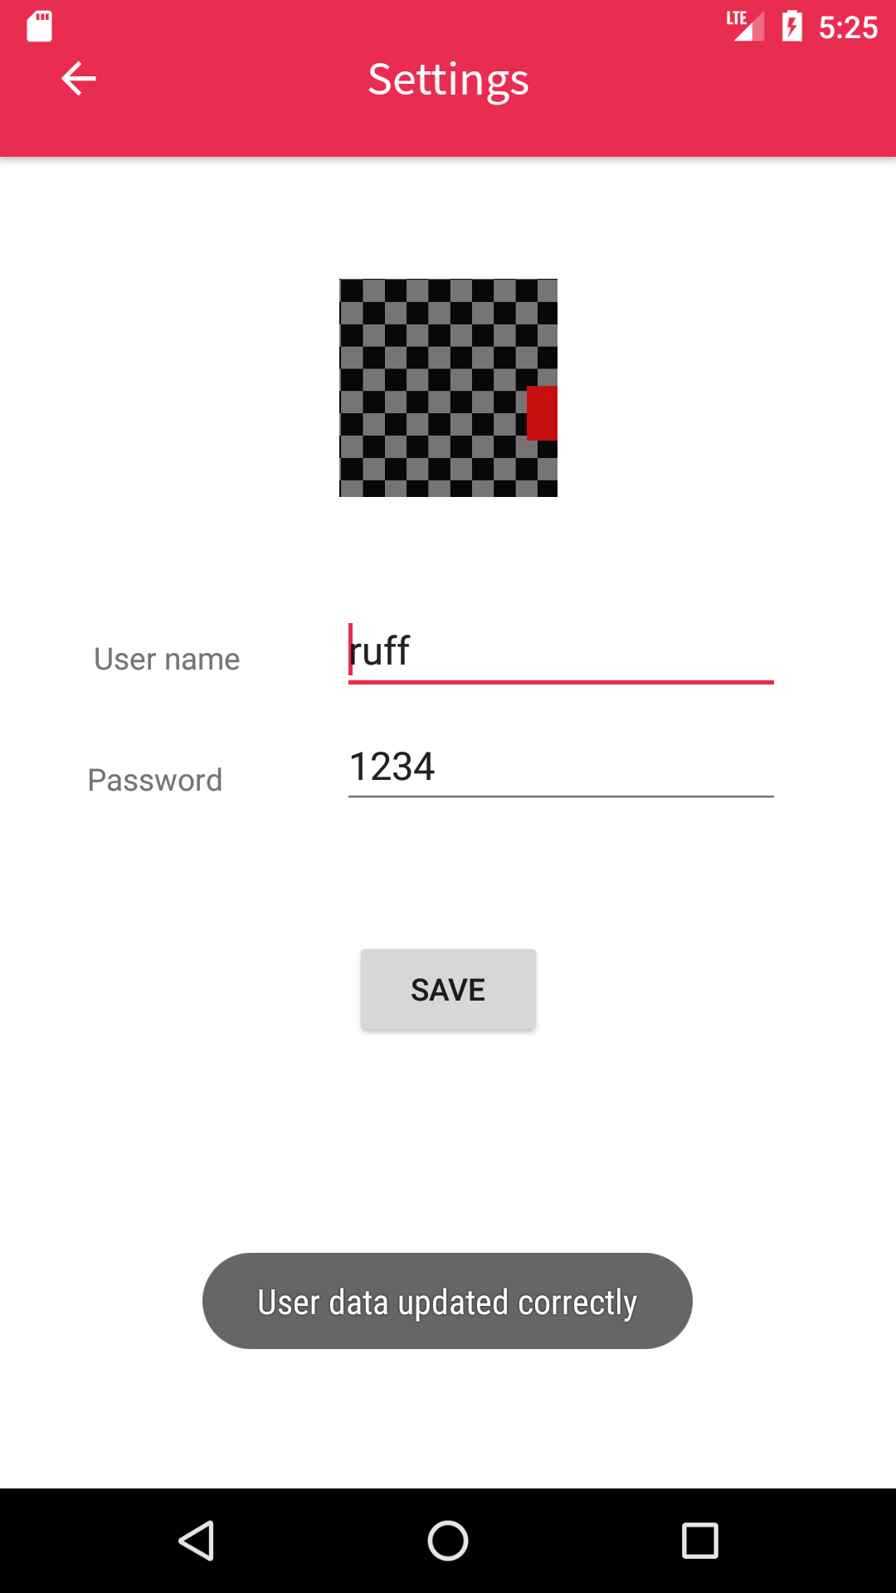

## Acceso como administrador

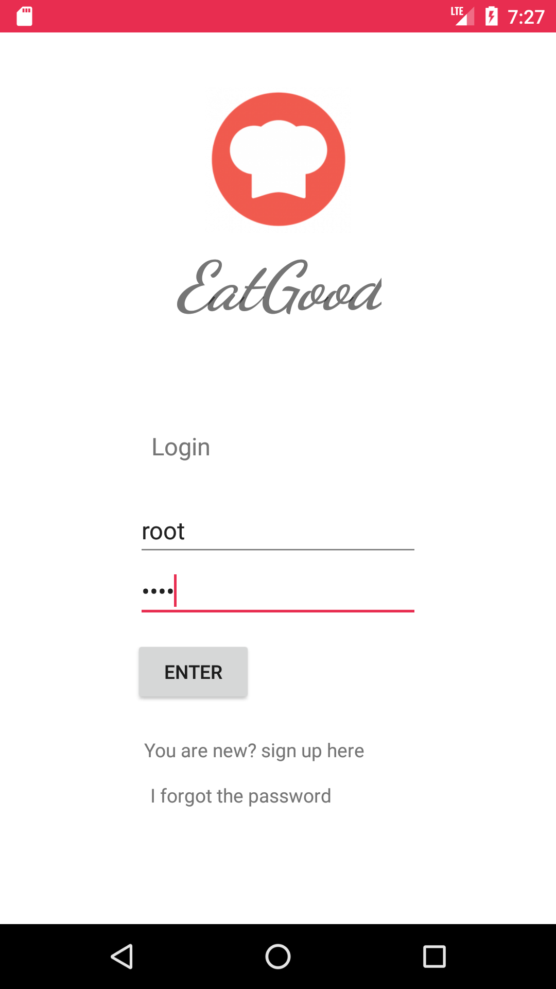 

# DISEÑO DIAGRAMA DE BASE DE DATOS

Atendiendo al objetivo y a la temática de la aplicación hay que tener en cuenta y analizar los datos que creamos, modificamos, eliminamos y mostramos.

La temática consiste en que el usuario accede mediante un registro a la aplicación. Podrá visualizar recetas de los demás usuarios, que tendrá la opción de marcarlas como favorita y también escribir comentarios, y visualizar y gestionar sus propias recetas.

El usuario puede crear una receta a partir de una lista de alimentos y estableciendo una cantidad. También explicará los pasos para realizar la receta y podrá introducir comentarios posteriormente. Al guardarla y visualizarla se mostrará al final de la receta los valores nutricionales que se sacarán de los datos de cada alimento dependiendo de la cantidad.

Cada usuario puede modificar su perfil, cambiar el nombre, email, contraseña y su foto.

Un usuario puede ser de tipo administrador o normal. El administrador gestionará los usuarios.

Tras analizar procedamos a diseñar la base de datos.

## 1 . Modelo entidad – relación

Vamos a establecer las entidades, atributos y relaciones.

Las **entidades** son: USER, RECETA, PASOS, COMENTARIOS y ALIMENTOS.

Las entidades PASOS y COMENTARIOS podríamos definirlas como entidades débiles. La entidad COMENTARIOS porque dependen del usuario que la escribe y de la receta a la cual es asignada, y la de PASOS porque sólo existe si la receta tiene asignada ese paso.

Los **atributos** de las entidades serán:

- USER: login, nombre, password, id_foto, tipo.

- RECETA: id, id_foto, nombre, fecha_rec, tipo_rec, descripción_rec.

- PASOS: id_pas, descripcion.

- COMENTARIOS: id_com, texto.

- ALIMENTO: ID, nombre, estado, caloria, proteina, grasa, hidrato_c, agua, ceniza, A, B1, B2, C, Niac, Na, K, Ca, Mg, Fe, Cu, P, S, Cl, Fen, Ileu, Leu, Lis, Met, Tre, Tri, Val, ACID, ALCAL.

Las **relaciones** entre entidades son:

- USER “gestiona” RECETA.

El usuario puede crear, modificar y eliminar una receta propia, las que son suyas, lo que se entiende que “gestiona” pero no en su totalidad, no puede eliminar ni modificar las de los demás usuarios.

- USER “elige favorita” RECETA.

El usuario puede elegir como favorita las recetas que desee.

- USER “realiza” COMENTARIOS.

El usuario puede realizar comentarios de la receta.

- RECETA “contiene” COMENTARIOS.

Las recetas pueden tener, o no, comentarios donde los usuarios puedan dar su opinión o consejos.

- RECETA “compone” ALIMENTOS.

Una receta la componen los alimentos que lo forman.

- RECETA “explica” PASOS.

La receta explicada por uno o varios pasos.

En la relación RECETA “compone” ALIMENTOS vemos que tiene un atributo para determinar la cantidad del alimento que compone la receta. Al igual que la fecha cuando el USER realiza COMENTARIOS, o cuando la GESTIONA (crea) una RECETA. También cuando el USUARIO elige favorita la RECETA tendrá un atributo booleano.

Cardinalidades entre entidades y relaciones.

Entre entidades son:

- RECETA “explica” PASOS.

Una receta está explicada por 1 o muchos pasos (1,n), y un paso está explicada en 1 receta y solo en 1 (1,1). La cardinalidad en la relación es 1:N.

- RECETA “contiene” COMENTARIOS.

Las recetas contiene 0 o muchos comentarios (0,n) y un comentario es de 1 receta y sólo 1 (1,1). En la relación es 1:N.

- RECETA “compuesta” ALIMENTOS.

Una receta la componen 1 o muchos alimentos (1,n), y un alimento puede estar en 0 recetas o en muchas (0,n). La relación es N:M.

- USER “elige favorita” RECETA.

El usuario puede elegir como favorita 0 o muchas (0,n), y una receta puede ser elegida por 0 o muchos usuarios (0,n). La relación es N:M.

- USER “gestiona” RECETA

El usuario gestiona 0 o muchas recetas (0,n), y una receta es gestionada por 1 y solo 1 usuario (1,1). La relación es 1:N.

- USER “realiza” COMENTARIOS

El usuario realiza 0 o muchos comentarios de la receta(0,n), y un comentario es realizado por 1 y solo 1 usuario (1,1). La relación es 1:N.

Para el paso a tablas tendremos en cuenta las cardinalidades de las relaciones “compone”, que la llamaremos ingredientes, y “elige favorita”, que la llamaremos favoritos, que al ser N:M se convertirán en tablas.

Claves de las entidades.

USER la clave primaria es login.

ALIMENTOS la clave es id, porque puede haber alimentos con el mismo nombre y distintos estados.

RECETA la clave es id, tendrá clave foránea de USER que es quien la crea id_usu_rec (lo veremos en el paso a tablas)

COMENTARIOS heredará como clave foránea de USER id_usu_com y id_rec_com de RECETA. Le he incluido una clave principal por comodidad a la hora de gestionarla id_com.

PASOS tiene clave foránea id_rec_pas y se ha incluido una clave id_pas para determinar el número del paso

Casos especiales y claves:

La relación que se convertirá en tabla, RECETA “compuesta” ALIMENTOS, la podríamos renombrar en la tabla como INGREDIENTES con los atributos id_alimento, id_receta, cantidad; donde la clave foránea sería id_receta y id_alimento.

- INGREDIENTES: id_alimento, id_receta, cantidad.

Otro caso sería la conversión a tabla de la relación USUARIO “elige favorita” RECETA, que podría desde el principio ser una tabla FAVORITO, aunque en el siguiente apartado la estableceremos, la clave foránea la heredaría de USUARIO id_usu_fav y de RECETA id_rec_fav, y quedaría así:

FAVORITOS: id_usu_fav, id_rec_fav.

### Representación del diagrama E/R.

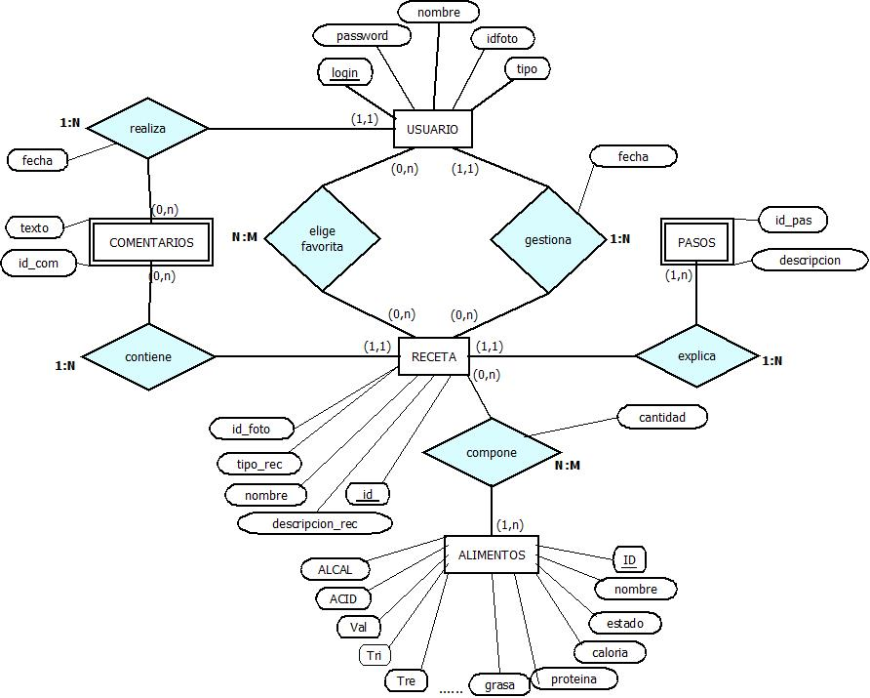

## 2 .Paso al Modelo Relacional

Identificaremos las entidades fuertes y débiles y las pasamos a tablas.

USUARIO( **login**, nombre, password, id_foto, tipo)

ALIMENTO( **ID**, nombre, estado, caloria, proteina, grasa, hidrato_c, agua, ceniza, A, B1, B2, C, Niac, Na, K, Ca, Mg, Fe, Cu, P, S, Cl, Fen, Ileu, Leu, Lis, Met, Tre, Tri, Val, ACID, ALCAL)

La tabla RECETA hereda de USUARIO su clave primaria, como clave foránea, e incluirá la fecha de la creación de una receta por la acción del USUARIO.

RECETA (**id**, id_usu_rec, nombre, descripción_rec, fecha_rec, tipo_rec)

Las tablas PASOS y COMENTARIOS heredan algunas claves foráneas

PASOS ( **id_pas**, id_rec_pas, descripcion)

COMENTARIOS ( **id_com**, id_usu_com, id_rec_com, fecha, texto)

Ya comentamos anteriormente que había dos relaciones que se convertirían en tablas. Una de ellas era la relación USUARIO “elige favorita” RECETA que podríamos llamar a la tabla FAVORITOS.

FAVORITOS (id_usu_fav, id_rec_fav)

Y la relación RECETA “compuesta” ALIMENTOS se puede llamar INGREDIENTES.

INGREDIENTES (id_receta, id_alimento, cantidad)

### Representación del modelo relacional.

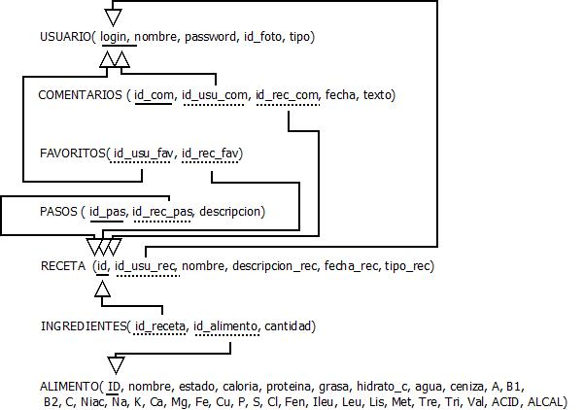

## Creación e inserción de base de datos en MySQL

BEGIN TRANSACTION;

CREATE TABLE IF NOT EXISTS `usuario` (

`login` TEXT NOT NULL UNIQUE,

`password` TEXT NOT NULL,

`nombre` TEXT NOT NULL,

`idfoto` TEXT,

`tipo` TEXT,

PRIMARY KEY(`login`)

);

INSERT INTO `usuario` (login,password,nombre,idfoto,tipo) VALUES ('root','toor','admin',NULL,'administrador'),

('rafa','1234','rafael','rafa.jpeg','normal'),

('javi','5678','javier','javi.jpeg','normal');

CREATE TABLE IF NOT EXISTS `receta` (

`id` INTEGER PRIMARY KEY AUTOINCREMENT UNIQUE,

`id_usu_rec` TEXT,

`nombre` TEXT,

`fecha` TEXT,

`tipo_rec` TEXT,

`foto` TEXT,

`descripcion` TEXT,

FOREIGN KEY(`id_usu_rec`) REFERENCES `usuario`(`login`) ON UPDATE CASCADE ON DELETE CASCADE

);

INSERT INTO `receta` (id,id_usu_rec,nombre,fecha,tipo_rec,foto,descripcion) VALUES (1,'rafa','empanadillas atún','14/02/2018','segundo','empanadilla_atun.jpg','Empanadillas rellenas de atún, huevo cocido y tomate'),

(2,'javi','huevos estrellados','17/02/2018','segundo','huevosestre.jpg','Patatas y huevos fritos revueltos'),

(3,'rafa','tortilla','16/02/2018','segundo','tortilla.jpg','Tortilla de patatas con cebolla');

CREATE TABLE IF NOT EXISTS `pasos` (

`id_pas` INTEGER,

`id_rec_pas` INTEGER,

`descripcion` TEXT,

FOREIGN KEY(`id_rec_pas`) REFERENCES `receta`(`id`) ON DELETE CASCADE ON UPDATE CASCADE

);

INSERT INTO `pasos` (id_pas,id_rec_pas,descripcion) VALUES (1,1,'Se mezcla la harina, el agua y la sal hasta formar una masa.'),

(2,1,'Se rellenan las obleas y se moja el filo para cerrarlas'),

(3,1,'Freimos las empanadillas en aceite caliente o se hornean 10 minutos.'),

(1,2,'Freimos en abundante aceite caliente las patatas.'),

(2,2,'Sacamos las patatas y freimos los huevos y se echamos sal.'),

(3,2,'Echamos sal a las patatas y rompemos las yemas de los huevos encima de las patatas y mezclamos.'),

(1,3,'Freimos en abundante aceite caliente las patatas.'),

(2,3,'Sacamos las patatas y la mezclamos con 6 huevos batidos.'),

(3,3,'Echamos la mezcla en la sartén y una vez cuajado el huevo se saca.');

CREATE TABLE IF NOT EXISTS `ingredientes` (

`id_alimento` INTEGER,

`cantidad` REAL,

`id_receta` INTEGER,

FOREIGN KEY(`id_receta`) REFERENCES `receta`(`id`) ON DELETE CASCADE ON UPDATE CASCADE,

FOREIGN KEY(`id_alimento`) REFERENCES `alimentos`(`ID`) ON DELETE CASCADE ON UPDATE CASCADE

);

INSERT INTO `ingredientes` (id_alimento,cantidad,id_receta) VALUES (20,190.0,1),

(251,1.0,1),(544,3.0,1),(242,100.0,1),(123,200.0,2),(250,2.0,2),(271,300.0,2),(544,5.0,2),(123,300.0,3),

(254,6.0,3);

CREATE TABLE IF NOT EXISTS `favoritos` (

`id_usu_fav` TEXT,

`id_rec_fav` INTEGER,

FOREIGN KEY(`id_usu_fav`) REFERENCES `usuario`(`login`) ON DELETE CASCADE ON UPDATE CASCADE,

FOREIGN KEY(`id_rec_fav`) REFERENCES `receta`(`id`) ON DELETE CASCADE ON UPDATE CASCADE

);

INSERT INTO `favoritos` (id_usu_fav,id_rec_fav) VALUES ('javi',1),

('rafa',2);

CREATE TABLE IF NOT EXISTS `comentarios` (

`id_com` INTEGER PRIMARY KEY AUTOINCREMENT,

`id_usu_com` TEXT,

`id_rec_com` INTEGER,

`fecha` TEXT,

`texto` TEXT,

FOREIGN KEY(`id_usu_com`) REFERENCES `usuario`(`login`) ON DELETE CASCADE ON UPDATE CASCADE,

FOREIGN KEY(`id_rec_com`) REFERENCES `receta`(`id`) ON DELETE CASCADE ON UPDATE CASCADE

);

INSERT INTO `comentarios` (id_com,id_usu_com,id_rec_com,fecha,texto) VALUES (1,'javi',1,'20/03/2018','Muy buena y deliciosa'),

(2,'rafa',1,'22/03/2018','Y que lo digas javi ;)');

CREATE TABLE IF NOT EXISTS `alimentos` (

`ID` INTEGER PRIMARY KEY AUTOINCREMENT,

`nombre` TEXT,

`estado` TEXT,

`caloria` TEXT,

`proteina` TEXT,

`grasa` TEXT,

`hidratos_c` TEXT,

`agua` TEXT,

`ceniza` TEXT,

`A` TEXT,

`B1` TEXT,

`B2` TEXT,

`C` TEXT,

`Niac` TEXT,

`Na` TEXT,

`K` TEXT,

`Ca` TEXT,

`Mg` TEXT,

`Fe` TEXT,

`Cu` TEXT,

`P` TEXT,

`S` TEXT,

`Cl` TEXT,

`Fen` TEXT,

`Ileu` TEXT,

`Leu` TEXT,

`Lis` TEXT,

`Met` TEXT,

`Tre` TEXT,

`Tri` TEXT,

`Val` TEXT,

`ACID` TEXT,

`ALCAL` TEXT

);

INSERT INTO `alimentos` (ID,nombre,estado,caloria,proteina,grasa,hidratos_c,agua,ceniza,A,B1,B2,C,Niac,Na,K,Ca,Mg,Fe,Cu,P,S,Cl,Fen,Ileu,Leu,Lis,Met,Tre,Tri,Val,ACID,ALCAL) VALUES (1,'arroz','descasac.','355','8,2','0,6','77','12,8','1,4','','50','30','','1500','14,3','113','16,6','30,5','1,2','0,12','110','78,5','16','367','358','658','298','130','290','82','558','96',''),

(2,'arroz','hervido','126','2,3','0,2','31,1','65','1,4','','10','6','','750','2,2','36','4','4,4','0,18','0,02','34','268','9','','','','','','','','','',''),

(3,'arroz','paella','320','6,9','0,4','74,5','16','1,5','','','','','1200','4,1','58','2,8','10','0,33','0,04','65','61','18','','','','','','','','','',''),

(4,'avena','grano','384','14,3','7,7','65,2','9,8','2,6','','530','140','','2800','20','360','55','124','4,12','0,5','368','170','62','','','','','','','','','132',''),

(5,'cebada','grano','355','8,6','1,4','78,2','9,4','2,3','71','450','115','','800','2,6','123','12','28,2','0,8','0,72','206','107','105','570','464','803','387','166','387','150','581','175',''),

(6,'cebada','hervida','125','2,6','0,6','27,6','67','2','','','','','','0,8','470','3,4','6,8','0,23','0,04','70','36,5','35,8','','','','','','','','','69',''),

(7,'centeno','grano','341','8,2','1,6','75','15,2','0,84','','285','380','','','','305','28,2','63','3,2','0,65','252','146','','','','','','','','','','',''),

(8,'maiz','grano','364','9,6','3,5','73,9','11,6','1,3','300','250','120','','','38','208','21','82','3,6','0,4','258','130','96','370','380','988','230','160','341','48','410','54',''),

(9,'trigo','grano','356','10,8','2,3','75','10,5','1,82','22','530','135','20000','','35','353','42','140','5,1','0,62','322','117','71','970','1090','1800','1970','487','1330','875','1800','57',''),

(10,'amidon de arroz','grano','353','0,8','','85,2','12,7','1,4','85','173','','','','6,1','110','3,5','12,8','0,38','0,05','90','75','24','','','','','','','','','',''),

(11,'almidon de maiz','grano','364','0,4','0,2','86,6','12','1,5','','','','','','56,5','87','26','12,1','3,5','0,16','273','','79','','','','','','','','','',''),

(12,'almidon de trigo','grano','352','1,1','0,2','84,1','12,9','1,5','15','145','83','','','4,1','146','18,8','61,8','2','0,3','181','','','','','','','','','','','',''),

(13,'harina de arroz','grano','361','7,4','0,6','79','12,1','1,2','92','58','30','','1500','6,2','112','13,6','18','0,93','0,05','117','76','26','350','342','593','277','118','302','87','497','47',''),

(14,'harina de avena','grano','402','13,2','7,7','70,2','9,1','','','','','','','42','385','57','133','4,8','0,45','375','178','73','','','','','','','','','132',''),

(15,'harina de avena','copos','368','6,7','0,9','84,3','9','','','250','','','','10,5','112','7,4','13,2','2,7','0,1','54','87','1500','','','','','','','','','20',''),

(16,'harina de cebada','cruda','359','9,1','14,5','76,2','11,6','2,4','43','278','86','','','2,3','130','9','18,5','0,59','0,9','200','101','98','593','476','782','428','153','423','138','390','',''),

(17,'harina de centeno','cruda','354','10','1,1','74,2','13','2','','189','223','','1300','35','183','26','97','1,7','0,65','217','138','43','528','481','803','231','113','332','119','502','',''),

(18,'harina de maiz','cruda','362','9,2','3,1','72,6','13','2,1','330','225','185','350','1800','45','128','15,3','61','1,8','0,13','58','5,9','58','338','342','912','222','148','301','48','387','65',''),

(19,'harina de trigo','integral','347','10,6','0,6','73,4','13','1,2','238','372','108','','1600','13,4','282','25,5','109','3,1','0,46','225','103','65','567','488','787','243','151','293','117','441','',''),

(20,'harina de trigo','primera','359','9,7','1,5','79,5','10','0,4','6','98','53','','2000','5,1','146','187','21','1,4','0,17','102','88','42','688','612','891','340','192','3873','121','531','110',''),

(21,'harina de trigo','segunda','355','10,1','1,2','78','10','0,7','9','107','75','','','4,2','183','22,3','57','2','0,27','142','43,1','39','','','','','','','','','69',''),

(22,'harina trigo manitoba','1','339','13,6','2,5','69,1','14','0,8','7','114','52','','','3,2','312','27,6','141','3,81','0,6','350','','38,5','','','','','','','','','',''),

(23,'harina trigo manitoba','0,85','350','13,4','1,5','72','13','0,7','7','120','57','','','4,1','146','18,5','61,8','2,7','0,34','188','','44,5','','','','','','','','','',''),

(24,'harina trigo manitoba','0,8','350','13,2','1,4','73,5','12','0,67','6','131','61','','','2,9','112','15,4','44,6','2,47','0,27','139','','48,5','730','593','928','443','192','403','','578','',''),

(25,'harina trigo manitoba','0,75','353','13,1','1,3','74,3','12','0,65','6','143','69','','','2,5','87','13,1','30,4','2,27','0,22','109','','48','','','','','','','','','',''),

(26,'harina trigo manitoba','0,7','352','12,8','1,2','74,9','12','0,6','5','151','72','','','2,2','82','12,8','26,9','2,23','0,18','97','','47,8','','','','','','','','','',''),

(27,'macarroneso fideos','crudos','358','12,8','1,3','78,6','12','0,9','7','400','126','','3500','16','162','20,3','41,7','1,3','0,3','152','122','61','638','617','862','397','203','492','137','701','70',''),

(28,'macarroneso fideos','cocidos','110','3,4','0,74','22','73,8','0,2','','50','35','','650','7,9','67','6,7','17,6','0,45','0,02','47','29,4','9,7','','','','','','','','','12',''),

(29,'pan de avena','natural','212','7,6','1,5','40,9','47,4','2,6','','93','114','','','23,4','165','43','68','3,15','0,16','147','89,2','58','','','','','','','','','',''),

(30,'pan de debada','natural','198','6,4','1,1','39,9','49,8','2,1','','147','58','','','1,5','61,2','3,7','9,7','0,3','0,45','93,2','51,6','1','','','','','','','','','68',''),

(31,'pan de centeno','natural','232','6,5','0,9','47,9','42,9','1,3','','160','190','','1100','560','100','21','26','0,89','','110','','49','','','','','','','','','',''),

(32,'pan dediabeticos','natural','235','8,7','0,7','47,8','41,9','0,5','','243','96','','','8,1','143','12,3','61','1,78','0,17','89,1','43,6','','','','','','','','','','75',''),

(33,'pan de maiz','natural','227','6,4','1,9','43,8','43,8','3,1','120','130','180','','1150','40,3','42','8,1','4','0,68','0,06','31,7','0,53','31,5','','','','','','','','','58',''),

(34,'pan de trigo','natural','241','8,9','1,6','36,7','36,7','2,9','','260','145','','1900','423','250','65','80','2,8','0,37','211','89','41','','','','','','','','','',''),

(35,'pan de trigo','moreno','246','8,4','1,9','37','37','2,6','140','130','170','','1300','393','147','17,2','52,3','2,1','0,32','158','607','531','','','','','','','','','71',''),

(36,'pan de trigo','blanco','262','8,2','1,3','35,6','35,6','1,6','','60,3','50','','800','428','83','38','25','1,43','0,2','76','54','592','','','','','','','','','',''),

(37,'pan de trigo','blanco tostado','314','9,4','0,9','20','20','1,8','','','','','','467','83','13,5','19,5','1,7','0,18','82','','720','','','','','','','','','',''),

(38,'pan de trigo','blanco frito','542','7,2','37,2','4','4','1,1','','','','','','348','62','10,1','14,5','1,27','0,13','61','','537','','','','','','','','','',''),

(39,'pan de viena','','265','8,2','2,2','33','33','1,7','','135','88','','1400','','','19','','1,2','','52','','','425','357','594','184','98','271','410','87','',''),

(40,'buñuelos','fritos','408','6,3','20,1','20,8','20,8','1,2','120','150','120','','1200','','','69','','0,6','','276','','','','','','','','','','','',''),

(41,'galletas','natural','435','7,4','13','5,2','5,2','1,3','','140','','','','244','170','45,4','14,3','1,24','0,08','41','83,4','260','','','','','','','','','38',''),

(42,'polvo para flanes','','353','0,5','0,7','8','8','','','','','','','51,6','61','18','7,2','1,43','0,13','39','1,1','71','','','','','','','','','6',''),

(43,'sagú','natural','348','1,8','0,2','14,8','14,8','0,9','','5','100','','','3,8','14','10,2','2,5','1,1','0,03','18','2,5','14,3','','','','','','','','','18',''),

(44,'semola','natural','349','9,8','1,4','12,5','12,5','1,3','','70','30','','900','11,8','170','14','41','1','0,15','91','91,8','71','','','','','','','','','67',''),

(45,'soja','harina','440','43','22','7,8','7,8','3,2','9','420','12100','10000','2100','4','1800','223','235','6,9','','597','24','','1843','2010','3012','2401','497','1492','512','2003','',''),

(46,'tapioca','natural','350','0,6','0,2','12,6','12,6','0,5','','','100','','','4,6','20','9,2','2','0,51','0,07','20','3,8','14,2','','','','','','','','','12',''),

(47,'tarta manzana','natural','250','2,1','9,1','38','38','','150','28','22','770','213','','','6,9','','0,3','','22','','','','','','','','','','','',''),

(48,'almortas','crudos','328','27,8','1,1','10','10','2,6','397','182','267','','','36,14','786','173,1','131,6','1,2','0,16','315','116','33,4','','','','','','','','','',''),

(49,'garbanzos','crudos','355','21,8','5,1','12,6','12,6','2,5','','530','190','1700','1500','72,5','937','94,2','86','6','0,36','301','96,4','56,1','993','1100','1498','1447','268','726','167','998','','305'),

(50,'garbanzos','cocidos','150','10,2','5','65','65','1,7','','320','180','23000','1900','23,7','246','35,5','36,2','2','0,19','96,3','31,5','17,3','','','','','','','','','','72'),

(51,'guisantes frescos','crudos','98','7,2','0,4','73,9','73,9','0,21','890','110','80','15000','1100','0,8','342','20','30,2','1,88','0,23','118','53','35','252','291','397','320','51','253','49','277','','13'),

(52,'guisantes frescos','cocidos','68','4','0,3','85','85','0,2','540','750','260','1800','3000','270','160','18','21,4','1,6','0,15','83,3','43,5','7,8','','','','','','','','','','14'),

(53,'guisantes secos','crudos','323','23,5','1,8','9,7','9,7','2,7','350','23','','31','','38','895','60,8','125','7,73','0,6','303','159','55','1187','1270','1981','1735','291','1012','271','1307','','103'),

(54,'guisantes secos','hervidos','77','6,9','','73,3','73,3','1,3','','47','','','','12,6','267','24,4','30,3','1,44','0,17','113','39','9,3','','','','','','','','','','12'),

(55,'guisantes secos','conserva','91','5,9','','73,7','73,7','1,1','','210','185','','','260','201','25,7','24,4','1,87','0,21','169','44','318','','','','','','','','','29',''),

(56,'habas','crudos','315','29,4','1,5','14,5','14,5','0,7','89','31','','','','80','1500','143','164','1,3','1,2','338','87','46','','','','','','','','','','355'),

(57,'habas','cocidos','108','7,1','0,9','70,5','70,5','0,5','','','','','','16,2','398','103','33,3','1,07','0,16','86,5','47,2','2,4','','','','','','','','','','60'),

(58,'judias blancas','crudas','320','20,8','1,7','62,5','13,1','1,5','','580','230','2000','2100','53','1160','145,8','183','7,6','0,87','362','192','23','1203','1218','1852','1602','205','903','203','1311','','188'),

(59,'judias blancas','cocidas','99','7,6','0,8','18,3','72,9','1,2','290','120','110','15000','980','125','200','87','45,3','1,6','0,13','110','63,5','69','321','302','492','338','62','281','49','297','','43'),

(60,'judias rojas','crudas','332','20,1','1,5','63,5','13,1','2,3','','470','230','2000','2200','71,3','983','84','193','7,1','0,73','348','223','2','1268','1291','2003','1692','241','1011','198','1407','','238'),

(61,'judias rojas','cocidas','92','6,6','0,4','16,3','75','1,2','','48','50','','800','11,6','235','43','65','1,7','0,27','97','72,8','1,1','295','298','461','397','54','238','48','347','','53'),

(62,'lentejas secas','crudas','339','23,7','1,2','62,5','10,7','1,4','350','450','220','5000','2200','36','788','67','62','7,62','0,58','348','172','63,5','1095','1297','1775','1517','192','903','198','1372','','20'),

(63,'lentejas secas','cocidas','102','7,1','0,3','19,5','71,9','0,25','180','115','70','','520','9,4','217','18,5','16,6','2,2','0,27','95','37,3','12,7','','','','','','','','','','4'),

(64,'soja fresca','crudas','135','13,9','4,8','10,3','70,8','','1080','600','310','20000','','','','99','','2,8','','272','','','','','','','','','','','',''),

(65,'soja seca','crudas','342','34,9','18,1','34,3','7,5','4,7','110','1070','310','','2300','4','1900','286','242','8','0,9','580','','','','','','','','','','','',''),

(66,'acederas','crudas','18','2,5','0,4','2,2','92,2','3,4','14000','68','','60000','','','','','','1,4','','','','','','','','','','','','','',''),

(67,'acederas','cocidas','5','0,9','0,1','1,1','96,3','2,1','','','','','','','','','','','','','','','','','','','','','','','',''),

(68,'acelgas','crudas','18','1,9','0,3','2,4','92,7','2,6','2000','78','277','38000','','','','','','','','','','','','','','','','','','','',''),

(69,'acelgas','cocidas','5','0,36','','0,9','97,2','1,5','','41','','','','','','','','','','','','','','','','','','','','','',''),

(70,'achicoria','cruda','16','1,2','0,2','2,9','95,1','1,8','7000','75','180','12000','510','18','297','52','12,6','0,8','0,14','32','21','46','','','','97','38','','25','','','46'),

(71,'achicoria','tostada','280','28,1','2','42','15','12','','','','','','64','746','114,3','96,2','58,1','15','181,6','133,1','176,3','','','','','','','','','',''),

(72,'ajo','bulbo','115','6,6','0,1','26,1','66,2','','','','','12800','','','','10','','2','','140','','','','','','','','','','','',''),

(73,'alcachofa','cruda','67','3','0,8','18,8','77,2','0,12','212','116','80','7500','','87','572','66,3','47,2','1,8','0,6','81','28','105','','','','','','','','','',''),

(74,'alcachofa','cocidas','16','1,1','0,2','3,5','93,7','0,7','','','','','','14,8','327','43,5','27,2','0,49','0,09','39,7','15,5','83,5','','','','','','','','','','76'),

(75,'apio','crudos','19','1,2','0,2','4,5','73,2','0,9','23','35','42','7500','390','120','285','52,2','18','0,51','0,11','39','19','154','','','22','20','16','','12','','','81'),

(76,'apio','cocidos','9,5','1','0,15','2,1','96,1','','','20','20','8000','200','66,5','132','43','8,6','0,35','1','22','8,3','100','','','','','','','','','','50'),

(77,'batata','cruda','127','2,1','0,6','29,5','66,5','1,2','6000','98','88','17000','600','41','385','38','22,1','0,75','0,3','55','22','95','97','89','95','83','35','82','80','129','','79'),

(78,'batata','cocidas','98','1,7','0,5','26','77','0,9','5800','80','55','14000','550','17,8','296','27','12,3','0,65','0,15','47,1','14,9','60','','','','','','','','','','50'),

(79,'berenjena','cruda','19','1,2','0,2','4,9','92,8','0,8','50','62','50','5100','600','8','218','13,2','12','0,42','0,08','25,1','12','61','47','55','69','31','6','39','12','62','','45'),

(80,'berenjena','cocidas','10','1,1','','2,6','95,6','0,8','','','','','','1,6','173,2','8,3','6,4','0,18','0,05','6,3','4,72','36','','','','','','','','','','28'),

(81,'berros','crudos','25','2,1','0,3','47,7','91,8','1,1','3600','112','195','63000','860','60','314','192','24','2,9','0,13','49','145','118','','','','','','','','','','75'),

(82,'brocoli','crudos','29','3,2','0,2','4,9','86,7','1','4200','97','190','116000','1100','17','290','138','67','1,4','0,1','68','97','51,2','107','123','158','142','53','119','36','169','','43'),

(83,'brocoli','cocidos','17','1,3','0,13','4,2','93','','2870','65','130','60000','700','','','90','','1,1','','34','','','','','','','','','','','',''),

(84,'calabaza','cruda','28','0,7','0,1','6,3','91,8','0,4','500','50','60','9000','380','2,8','309','39','9,5','0,62','0,08','28','9,9','38,7','15','21','29','32','7','19','51','25','','67'),

(85,'calabaza','cocidas','21','1,08','0,22','4,8','93,1','0,12','80','56','75','30500','320','1,1','283','16,2','4,3','0,31','0,05','18,7','4,7','23,7','27','38','54','46','9','21','12','35','','51'),

(86,'calabacin','crudo','23','4,2','0,1','7,3','88,1','1,2','16','45','80','9000','','1,7','291','19','9,6','0,42','0,07','20,1','8,9','43,2','','','','','','','','','','90'),

(87,'calabacin','cocidos','6','0,9','','1,6','97,1','0,5','','9','','','','0,9','86','21,4','3,9','0,17','0,03','18,6','3,9','35,7','','','','','','','','','','72'),

(88,'cardo','crudo','24','2,3','0,3','5,3','90','2,1','6100','60','125','24000','400','81','549','89','58','2,6','0,15','75','125','153','','','','','','','','','',''),

(89,'cardo','cocidos','17','1,4','0,2','3,6','92,4','1,7','4600','32','89','14000','800','25,7','286','73','42,3','1,8','0,06','57','63,3','96,4','','','','','','','','','',''),

(90,'cardillo','crudo','15','1,05','','5,2','91,9','1,8','820','45','95','8000','','29,7','315','40,1','53,2','1,5','0,04','112,9','56,3','82,5','','','','','','','','','',''),

(91,'cardillo','cocidos','10','0,7','','2,4','95,2','1,5','','','','','','15,6','182','23,6','23,1','0,63','0,03','79,8','41,8','61,6','','','','','','','','','',''),

(92,'cebolla','crudo','38','1,3','0,2','8,8','89,1','0,5','50','35','32','7500','200','8,2','137','31,2','9,3','0,4','0,11','42','60','21','39','21','35','68','13','22','19','33','','10'),

(93,'cebolla','cocidas','20,2','0,4','0,2','4,3','93,9','0,5','34','15','21','4500','158','6,6','78','24,4','4,9','0,25','0,07','19','23,7','4,9','','','','','','','','','','2'),

(94,'cebolla','frita','335','1,8','33,3','13,2','51','0,5','','','','','','20','267','61','14,8','0,59','0,16','59','87,8','38','','','','','','','','','','16'),

(95,'col','cruda','28','1,7','0,2','6,1','90,6','0,9','100','90','80','51000','280','29,2','260','61','14,8','0,9','0,08','36','69','39,6','29','41','55','270','12','37','11','42','','37'),

(96,'col','cocidas','15','1,3','0,1','2,6','94,9','0,9','','73','','31000','','13,5','144','58,2','7,3','0,47','0,04','16,2','23,4','13,7','','','','','','','','','','49'),

(97,'col','acida','23','1,4','0,3','4,1','91,6','2,3','38','26','60','17000','100','630','140','36','','0,5','','','','','','','','','','','','','',''),

(98,'col debruselas','cruda','42','3,8','0,5','8,2','85,6','1,5','330','88','120','70000','600','11,8','380','37','25,3','1,2','0,11','67','135','36,5','151','193','202','203','43','148','45','201','','40'),

(99,'col debruselas','cocidas','20','3,1','0,4','5,1','91,5','1,3','280','33','108','41000','500','7,7','247','26','10,6','0,8','0,08','49','77,8','11,4','','','','','','','','','','8'),

(100,'col rizada','cruda','33','3,2','0,4','5,2','90','1,9','160','220','45','45000','200','','','50','','','','','','','','','','','','','','','',''),

(101,'coliflor','cruda','28','2,3','0,2','5,04','91,1','1,3','70','135','115','60000','600','21','318','23','10,1','0,68','0,06','62','55','11,6','73','98','152','129','48','97','33','151','','41'),

(102,'coliflor','cocida crudo','20','1,9','0,7','3','93,8','1,1','61','45','67','22000','390','10,3','140','16,1','5,7','0,53','0,05','36','26','10,8','','','','','','','','','','14'),

(103,'colinabo','crudo','33','2,2','0,1','6,8','89,9','0,8','300','70','60','45000','200','50','371','52','37','0,8','','52','50','','','','','','','','','','',''),

(104,'champiñon','crudo','27','3,7','0,2','3,7','92','','','60','30','1900','4','','','25','','','','','','','','','','','','','','','',''),

(105,'chirivia','crudo','5,8','1,5','0,5','13,5','83,5','1','','110','108','18000','200','9','425','56','25','0,6','0,1','80','18','40,5','','','','','','','','','','75'),

(106,'chirivia','cocidos','34','1,1','0,4','8,5','90','0,8','','45','80','12000','100','4,1','293','42','13','0,5','0,1','62','14,6','32,7','','','','','','','','','','67'),

(107,'escarola','crudo','20','1,6','0,2','4','94,1','0,6','7000','68','180','13000','400','30','390','58','12','2,2','0,09','56','28','70,5','','','','','','','','','','68'),

(108,'esparragos','crudos','25','2,3','0,2','4,1','92,2','0,5','700','150','160','29000','900','3,5','252','27','19','1,1','0,25','71','62','45','71','79','92','98','31','71','28','99','','8'),

(109,'esparragos','cocidos','20','2,1','0,2','3,8','93,6','0,3','600','110','130','18000','800','200','190','21','10,4','1','0,18','56','46,6','31,4','52','63','78','79','26','49','19','82','','10'),

(110,'espinacas','crudas','26','2,5','0,3','4,1','91,2','1,4','13000','140','290','39000','800','66','527','85','55','4,5','0,2','47','27','65','101','103','181','139','41','99','36','131','','270'),

(111,'espinacas','cocidas','20','2,2','0,2','5,2','91','1,1','7000','40','130','16000','450','211','365','98','59,2','3','0,26','39','86,5','55,5','','','','','','','','','','386'),

(112,'judias verdes','crudas','35','2,3','0,2','6,2','90,2','0,85','850','240','160','18000','500','9,7','270','65','32','1,7','0,8','40','21','28','58','112','141','124','37','89','35','109','','63'),

(113,'judias verdes','cocidas','15','1','0,1','3,2','95','0,75','400','48','50','6000','325','3,4','110','38,6','10,1','1,2','0,1','17','8,3','10,7','25','47','61','49','13','39','12','50','','37'),

(114,'lechuga','crudas','17','1,2','0,2','2,9','94,8','0,8','1200','65','82','10000','200','10','180','29','10,5','0,9','0,11','27','15','45','','','','','','','','','','38'),

(115,'lombarda','crudas','35','2,6','0,15','5,2','90,5','0,9','20','130','','46000','','28','210','42','19','5','0,09','23','68','80','','','','','','','','','','59'),

(116,'lombarda','cocida','10','1,1','','2,8','95,3','0,7','','','','','','18,3','146','29,3','10,7','0,21','0,04','21','36','38','','','','','','','','','','34'),

(117,'mostaza','cruda','20','2,1','0,3','3,8','92,3','1,3','6800','75','190','70000','750','37','420','180','27','3,1','0,12','45','170','89','','','','','','','','','23',''),

(118,'nabos','crudos','30','1,8','0,3','5,8','90,7','0,7','9000','80','380','60000','500','58','330','60','8,5','0,9','0,08','36','29','52','151','102','198','132','51','123','47','152','','62'),

(119,'nabos','cocidos','21','1,3','0,2','4,7','93,8','0,5','7500','40','130','28000','400','32','160','55','6,6','0,8','0,04','27','21,2','31,4','','','','','','','','','','52'),

(120,'patata','cruda','85','2,1','0,2','19','77,8','1','30','100','45','16000','1200','6,5','430','10,1','26','0,75','0,16','52','30','56','91','91','99','112','23','81','19','110','','86'),

(121,'patata','cocida','65','1,7','0,3','15,4','82','0,6','10','45','25','9000','700','225','280','6,1','15','0,48','0,11','32','22,2','40,7','75','77','89','89','18','68','21','89','','53'),

(122,'patata','asada','110','2,6','0,7','29,4','65,2','1,3','20','110','50','16000','1200','8,6','745','12','32','0,9','0,2','29','56,3','103','','','','','','','','','','128'),

(123,'patata','frita','230','3,3','10,6','30,1','55','1,5','30','105','67','16000','1800','11,7','1020','16','43,3','1,2','0,27','82','44,7','140','','','','','','','','','','196'),

(124,'patata','pure','121','1,8','5,5','16,3','75,6','0,7','150','80','50','7000','800','24','302','21','14,4','0,5','0,1','42','23,5','71','','','','','','','','','','51'),

(125,'patata','almidon','350','1,8','0,9','81,8','14,1','1,3','220','273','','','','6,1','426','6,5','20,3','0,74','0,13','31,2','28,3','71,2','','','','','','','','','',''),

(126,'pepino','crudo','10','0,7','0,15','2,7','96,3','0,4','125','40','40','8500','200','8','140','18','9','0,3','0,09','22','11,5','27','','','','','','','','','','51'),

(127,'perejil','crudo','50','3,9','0,9','8,8','93,9','2,4','8500','115','280','191000','1200','30','920','240','52,2','5,3','0,26','92','','156','','','','','','','','','',''),

(128,'pimienta','crudo','28','1,2','0,2','5,9','92,4','0,5','700','47','65','118000','300','36','175','7','12','0,4','0,1','27','19','','','','','','','','','','',''),

(129,'pimiento','crudo','27','1,3','0,6','7,2','90,1','0,7','820','48','40','121000','400','0,5','186','11','12','0,4','0,1','26','19','19','','','','','','','','','','17'),

(130,'pimiento','cocidos','18','0,9','0,25','4,5','94,1','0,6','2000','18','75','111000','500','','','8','','0,8','','16','','','','','','','','','','','',''),

(131,'puerros','crudo','37','2,8','0,35','7,7','88,6','1,3','900','120','40','22000','500','8,9','315','62','46,1','2,8','0,12','45,2','72,2','69,5','','','','','','','','','','72'),

(132,'puerros','cocidos','25','2,3','','4,9','91,5','1,1','','85','','','','6,4','278','60,5','12,5','2','0,09','27,5','48,9','42,6','','','','','','','','','','55'),

(133,'rabanos','crudo','18','1,2','0,1','3,6','93,7','1,5','30','55','32','26000','280','38','240','43','13','0,13','0,13','27','36','25','','','','','','','','','','51'),

(134,'remolacha','cruda','43','1,8','0,1','10,6','85,7','1,1','55','65','70','10000','380','73','392','37','27','1,1','0,18','41,3','27,4','75','31','49','57','82','7','33','17','48','','110'),

(135,'remolacha','cocida','35','1,9','0,1','8,9','87,9','0,9','18','22','36','6500','250','64','350','27','16,9','0,7','0,14','29','22,1','75,5','','','','','','','','','','89'),

(136,'repollo','crudo','25','1,6','0,2','5,2','92,1','0,8','1780','75','90','51000','','18','228','49','27','3,2','','43','64','14,2','','','','','','','','','','82'),

(137,'salsifi','cocidos','18','1,9','','2,18','94,3','','','','','','','8,4','183','60','14,2','1,23','0,12','53','25','46','','','','','','','','','','29'),

(138,'seta','cruda','17','1,9','0,3','3,8','92,8','','','35','250','6000','3000','5','520','7,2','','0,9','','95','','','','528','291','','172','','6','372','',''),

(139,'seta','frita','217','2,2','24,3','5,8','67,2','','','60','','','','11','568','3,5','16','1,25','0,66','166','73,8','103','','','','','','','','','16',''),

(140,'tomate','cruda','21','1,3','0,25','4','93,6','0,6','1300','70','40','27000','450','3','258','11,5','13','0,5','0,9','24','12,2','48','30','31','39','40','7','35','10','27','','55'),

(141,'tomate','cocida','19','1','0,1','3,8','94,5','0,4','1000','60','30','16000','700','20','220','11','12','0,6','0,09','22','14','63','','','','','','','','','',''),

(142,'tomate','frito','73','2,3','6,2','4,2','86,5','0,31','','','','','','3,3','277','36','12,4','0,56','0,1','23','7,9','','','','','','','','','','',''),

(143,'tomate','jugo','18','0,8','1,2','3,5','93,6','1','1050','50','30','16000','800','126','270','7','10','0,4','','15','5','39','','','','','','','','','',''),

(144,'trufa','fresca','63','7,6','0,5','6,6','82,1','','','','','','','77','400','24','18','','','62','','','','','','','','','','','',''),

(145,'trufa','seca','260','36,9','2','28,9','6,4','','','','','','','','','','','','','','','','','','','','','','','','',''),

(146,'verduras (medio)','crudas','23','1,3','0,2','38','','','2500','100','100','35000','600','','','49','','','','','','','','','','','','','','','',''),

(147,'zanahoria','cruda','40','1,1','0,3','8,8','88,8','0,7','11000','75','70','6000','500','76','281','44','15','0,8','0,9','34','17','54','39','43','67','49','9','38','9','58','','98'),

(148,'zanahoria','cocida','27','0,8','0,4','6,1','91,6','0,25','9000','32','28','2000','470','80','107','32','7,6','0,6','0,08','24','8','29,2','','','','','','','','','','53'),

(149,'aceitunas sevillanas','','181','2,9','24,8','4,7','67','0,34','350','8','','','','1500','300','82','14','1,5','0,18','15','29,5','','','','','','','','','','30',''),

(150,'albaricoque','crudo','45','0,8','0,6','9,9','88','0,4','2800','30','80','6800','700','5','294','15,8','11,3','0,5','0,11','21','6','1,2','','','','','','','','','','76'),

(151,'albaricoque','conserva','72','0,5','0,3','18','80,6','0,5','1200','18','20','4000','300','1,5','135','10','7,2','0,5','0,05','14','1','1,5','','','','','','','','','','69'),

(152,'albaricoque','jugo','50','0,45','0,7','11,8','86,4','0,5','1100','8','13','900','240','3,5','98','8,2','','0,3','','11,8','','','','','','','','','','','',''),

(153,'arandano','crudo','53','0,8','0,6','13,1','85,1','0,5','270','70','37','12000','220','1,4','79','14','9,3','0,8','0,14','11,8','11','8','','','','','','','','','','27'),

(154,'cerezas','crudas','65','1,3','0,6','15,9','81,6','0,45','670','50','55','8000','320','2,5','267','17,5','10,2','0,4','0,07','21','6,8','0,9','','','','','','','','','','67'),

(155,'cerezas','cocidas','23','0,8','0,4','9,1','89,2','','300','30','20','6000','200','1,5','108','7,1','4,1','0,11','0,04','7,4','2,8','0,1','','','','','','','','','','29'),

(156,'ciruelas','crudas','58','0,75','0,3','15,5','82,5','0,55','300','110','40','5000','500','0,8','195','17','8,5','0,4','0,08','21','3','1,5','','','','','','','','','','77'),

(157,'ciruelas','crudas','71','0,4','','19,5','80','','','35','85','1000','400','7','240','25','','1,3','','40','','','','','','','','','','','',''),

(158,'frambuesas','crudas','45','1,1','0,5','11,1','86','1,2','160','38','65','27000','300','2,5','180','40','22','1,6','0,7','31','17,8','22','','','','','','','','','','64'),

(159,'frambuesas','crudas','38','0,2','','10,6','89','','100','25','41','15000','250','','','23','','0,8','','11','','','','','','','','','','','',''),

(160,'fresa','jugo','40','0,8','0,6','8,9','88,8','0,7','63','30','70','58000','280','1,8','161','27','11,8','0,8','0,12','26','12','15','','','','','','','','','','43'),

(161,'freson','crudas','25','1,8','0,1','5,3','92','0,5','60','20','45','20000','','0,8','212','31,6','10,6','0,43','0,11','29,7','12,6','23,2','','','','','','','','','','50'),

(162,'granada','crudas','60','2,5','0,8','16,2','80,3','0,3','','','10','5000','100','0,9','204','5,6','3,1','0,8','0,07','9,8','4,2','52,5','','','','','','','','','','35'),

(163,'grosella','crudas','42','1,3','0,2','9,5','88,2','0,6','230','60','140','30000','','2','230','28,3','10,2','0,7','0,13','35','21','10,1','','','','','','','','','','27'),

(164,'guindas','crudas','55','0,66','','13,3','85,6','0,36','40','35','','4000','','3,2','318','14,1','7,4','0,26','0,05','21,3','12,3','0,2','','','','','','','','','','38'),

(165,'higo comun','crudas','69','1,3','0,4','16,1','81,9','0,1','78','80','65','2000','540','3','218','44','20','0,7','0,06','33','12','17','','','','','','','','','','69'),

(166,'limon','crudas','36','1','1,5','9,3','87,8','0,4','140','50','35','50000','150','6','142','58','10,2','0,4','0,26','19,5','10,2','5,1','','','','','','','','','','85'),

(167,'limon','cruda','25','0,5','0,3','8,1','91','0,2','30','45','30','45000','100','1,5','142','12,5','6,6','0,2','0,13','10,7','2','2,6','','','','','','','','','','38'),

(168,'majuela','zumo','131','4,1','','24,6','','0,3','10000','','7','400000','','24,9','244','49','140','4','','48','36','7,9','','','','','','','','','','152'),

(169,'mandarina','jugo','33','1,2','0,9','10,8','86,5','0,4','580','60','','29000','','','','','','','','','','','','','','','','','','','',''),

(170,'mango','crudos','66','0,7','0,2','17,2','','','6350','60','60','41000','900','','','9','','0,2','','13','','','','','','','','','','','',''),

(171,'manzana','crudos','52','0,3','0,4','13,8','84,8','0,25','70','38','40','7500','300','5,7','95','5,5','6','0,3','0,09','8,9','4,7','2','9','14','13','11','4','7','','8','','32'),

(172,'manzana','crudo','102','0,8','0,5','27','70,3','1,3','','24','24','2400','240','2,2','128','4,2','3','0,3','0,09','11,9','','','','','','','','','','','',''),

(173,'manzana','asada','52','0,5','','13,8','84,9','0,3','40','16','32','900','','4','100','6','','2,5','','10','','','','','','','','','','','',''),

(174,'melocoton','jugo','48','0,7','0,2','12,1','96,7','0,3','950','40','55','8000','800','2','180','7','9','0,5','0,05','19','6,5','3','','','','','','','','','','55'),

(175,'melocoton','crudo','68','0,4','0,1','18,2','81','0,3','480320','10','21','4200','700','2','110','6','6,3','0,9','0,06','17','1','4,2','','','','','','','','','','41'),

(176,'melocoton','conserva','49,6','0,32','0,1','13,4','86','','2600','8','8','800','300','2,9','','4,5','','0,2','','7,3','','','','','','','','','','','',''),

(177,'melon','jugo','29','0,4','0,2','6,4','92,8','0,2','','47','56','13000','400','12','242','17','15','0,6','0,04','21','13','46','','','','','','','','','','54'),

(178,'membrillo','crudo','42','0,6','0,93','11,4','86,5','0,46','130','','','','','3,2','203','13,9','6','0,32','0,13','19','5,2','1,9','','','','','','','','','','49'),

(179,'mora','crudo','56','1,1','0,9','10,2','87','0,6','','30','40','198000','350','3,5','180','40','26','0,9','0,12','31','14','18','','','','','','','','','','68'),

(180,'mora','crudo','15','0,7','','3,2','91','','80','','','','','1,9','104','32','14,8','0,43','0,06','11,9','4,6','11,8','','','','','','','','','','42'),

(181,'mora','cocidas','32','3','','7,5','','','250','25','30','','','0,7','156','','','','','','','','','','','','','','','','',''),

(182,'naranja','jugo','45','0,8','0,2','10,5','87,1','1,2','225','88','42','50000','200','2,9','175','36','12,9','0,4','0,07','23','8,5','3,6','','','','20','4','','3','','','58'),

(183,'naranja','crudas','44','0,7','0,2','10,1','87,2','1,6','2700','90','40','42000','240','0,9','184','22','11,5','0,3','0,06','17','6','2,3','','','','','','','','','','55'),

(184,'nispero','zumo','80','0,8','0,8','22,3','75,8','0,2','18','40','45','10000','','6','258','22','9,5','0,35','0,17','24','11','3,1','','','','','','','','','','60'),

(185,'peras','crudo','58','0,7','0,4','16,8','81,2','0,8','','40','55','4000','150','4','125','12','9','0,3','0,13','15','6,2','2,3','','','','','','','','','','36'),

(186,'peras','crudos','90','1,3','','22,6','75','1,1','5','10','','','','1,7','70','5','2,9','0,11','0,08','10,2','2,4','1,1','','','','','','','','','','15'),

(187,'peras','asadas','75','0,8','0,1','25,2','73','0,8','','10','20','2100','130','3','71','8,1','5,9','1,2','0,04','8,2','3,2','2,8','','','','','','','','','','19'),

(188,'peras','conserva','51','0,3','0,08','13,7','84,8','0,8','110','8','8','800','80','1','','5,6','','0,4','','7,2','','','','','','','','','','','',''),

(189,'piña','nectar','51','0,45','0,2','13,6','84,5','1,5','80','76','31','22000','210','1,1','228','14','15','0,3','0,08','9,7','5,1','35','','','','11','6','','6','','','69'),

(190,'piña','crudas','76','0,4','0,1','19,8','78','1,1','75','65','20','8900','190','0,7','97','28','8,1','0,7','0,05','7','2,7','4,2','','','','','','','','','','22'),

(191,'piña','conserva','51','0,3','0,1','13,1','85','0,4','300','66','18','8500','150','0,9','140','15','','0,5','','8','','','','','','','','','','','',''),

(192,'platano','jugo crudo','91','1,2','0,3','21,8','75,8','0,8','32','63','60','9000','600','1,5','321','7,3','38','0,5','0,16','22','10,8','78','38','71','101','61','9','51','12','84','','61'),

(193,'ruibardo','crudo','16','0,5','0,1','3,8','95,5','0,1','590','30','','8500','100','2,2','425','72','13,6','0,45','0,13','24','10,2','14,2','','','','','','','','','','78'),

(194,'sandia','crudo','31','0,5','0,2','6,9','92,1','','16','50','50','6000','200','0,3','121','7','10','0,2','','12','9','8','','','','','','','','','','27'),

(195,'toronja','crudo','32','0,6','0,2','8','90,2','1,2','60','50','35','40000','200','1,8','212','17','10','0,3','0,06','17','6,4','2,2','','','','','','','','','','51'),

(196,'uva blanca','crudo','74','0,8','1','17','81,3','0,55','21','52','33','5000','300','1,6','248','18','6,7','0,4','0,1','18','8,8','1,5','','','','','','','','','','42'),

(197,'uva negra','crudo','110','1,47','','26','72,3','0,21','','50','50','40000','','1,4','265','3,5','3,4','0,29','0,07','13,5','6,2','0,2','','','','','','','','','','58'),

(198,'uva (jugo)','fresco','38','2,5','0,1','8','89,2','','','40','20','40000','160','0,64','160','8','','0,3','','11','','','','','','','','','','','',''),

(199,'uva (jugo)','conserva','67','1,8','','18','80','','','40','50','','180','2,1','180','16','','0,4','','18','','','','','','','','','','','',''),

(200,'albaricoque','seco','268','5,3','0,4','67,6','24,6','2,1','7400','14','128','11000','3200','37','1700','88','65,2','4,6','0,27','118','164','34,5','','','','','','','','','','510'),

(201,'almendras','seco','612','19,7','54,5','17,6','5,4','2,8','395','195','670','6500','4600','4,5','750','250','252','4,3','0,14','453','145','10,5','1140','865','1430','572','248','607','168','1130','','148'),

(202,'avellana','seco','620','15,5','62,2','15,5','6,3','0,31','320','430','300','6000','300','12','420','240','99','3,8','0,21','317','138','38','','','','','','','','','39',''),

(203,'cacahuete','seco','550','26,1','44,2','20','8','2,2','208','510','150','1000','12000','8','535','61','160','2,1','0,22','367','268','5,4','','','','','','','','','98',''),

(204,'cacahuete','tostado','610','26,5','48,1','18,3','4,3','2,8','3','400','145','','21000','200','680','62','171','2,3','0,23','382','258','28','1590','1343','2008','1190','310','882','358','1595','76',''),

(205,'cacao','polvo','340','26','18,8','38','8,1','','','90','450','','1500','60','900','135','420','2,7','4,3','709','203','51','','','','','','','','','',''),

(206,'castaña seca','cruda','350','8,2','3,5','75,3','12,3','0,32','400','380','390','30000','800','18','1000','98','138','3,9','0,23','230','135','42','','','','','','','','','','113'),

(207,'castaña tierna','cruda','188','3,2','2,5','40','54,1','0,1','','80','240','25000','1000','12,1','600','38','42','2,5','','70','48','','','','','','','','','','','100'),

(208,'ciruela pasa','cruda','262','2,4','0,6','72','23','1,8','1400','150','170','3000','1300','6','610','52','31','3,2','0,15','78','20,8','3,3','','','','','','','','','','155'),

(209,'coco','fresco','350','3,8','34,8','14,8','45,6','0,8','','68','180','39000','1100','37','397','16','45','4,1','0,32','110','38','114','171','181','259','148','70','122','33','195','','49'),

(210,'coco','leche','25','0,4','0,2','5,8','93,1','0,14','','','','','','96','312','27','30','0,1','1,04','32','29','183','','','','','','','','','','75'),

(211,'coco','seco','580','4,7','48','41,3','4,8','0,9','','','','','','31','720','39','83','3,7','0,55','188','76','196','159','170','259','148','71','120','38','198','','85'),

(212,'datiles','secos','271','2,2','0,6','72','24','0,9','160','75','80','','2000','4,1','719','66','58','1,6','0,19','59','51','278','59','69','74','65','29','61','58','91','','111'),

(213,'higos','secos','280','3,9','1,3','67,2','26','1,6','70','145','100','','1500','47','890','212','86','3,4','0,24','91,5','75','140','','','','','','','','','','271'),

(214,'melocoton','secos','253','3','0,5','63','0','3,14','3100','11','200','19000','5400','11','1150','42','54,1','6,75','0,63','124','240','10,5','','','','','','','','','','121'),

(215,'nuez','secos','643','17,8','57,6','17,6','5,3','0,52','400','370','135','11000','900','4,7','520','81','185','2,9','0,31','410','146','39','772','772','1217','451','308','591','182','1010','','89'),

(216,'piñones','secos','310','26,4','40','29,2','6,7','0,5','30','480','130','3000','1200','','','','','','','','','','','','','','','','','','',''),

(217,'uva','pasa','288','3,1','0,9','69,2','25,4','0,9','70','150','90','','500','22','568','61','36','3','0,23','105','23','8,5','','','','','','','','','','209'),

(218,'helado','','206','3,9','12','21','','','500','40','180','1200','600','80','135','138','58','0,1','','115','','','','','','','','','','','',''),

(219,'leche de burra','fresca','42','1,7','1,5','5,8','90,5','0,5','','','','','','','','','','','','','','','','','','','','','','','',''),

(220,'leche de cabra','fresca','68','3,6','4,4','4,5','86,8','0,6','120','47','107','1800','290','48','202','128','13,8','0,2','','98','37','14','119','91','282','309','67','221','41','142','','87'),

(221,'leche de mujer','fresca','68','1,5','3,8','6,9','88','0,3','250','27','80','4800','230','26','91,2','47','8,5','0,16','0,15','42','33','73','59','76','125','89','30','59','24','85','','26'),

(222,'leche deoveja','fresca','86','5,6','5,5','5,7','82,4','0,64','50','20','100','3500','','67','201','240','18,5','0,13','0,03','152','56,7','99','','','','','','','','','','40'),

(223,'leche de vaca','fresca','68','3,5','3,8','5','87,5','0,5','140','40','183','1500','100','50','140','120','14,5','0,1','0,02','95','28','98','169','219','349','268','89','163','49','238','','35'),

(224,'leche de vaca','desnatada','36','3,6','0,1','4,9','90,5','0,6','19','40','173','1500','100','44','140','120','14,5','0,1','0,02','93','18','91','159','209','319','248','79','153','47','290','','31'),

(225,'leche de vaca','concentrado','157','7,6','8,6','11,1','71','1,5','400','50','380','1000','200','142','395','280','34,8','0,2','0,11','223','75','277','338','450','688','550','169','319','100','479','','84'),

(226,'leche vaca condens.','con azucar','348','8,1','8,9','54,8','27','0,9','410','64','390','1000','200','143','380','285','36','0,2','0,08','238','83','284','361','469','731','580','179','339','98','511','','68'),

(227,'leche de vaca','total seca','510','26,8','27,9','38,8','4,8','1,3','1450','300','1500','6000','800','400','1200','965','112','0,6','0,16','745','234','784','1331','1739','2708','2131','681','1358','381','1881','','130'),

(228,'leche vaca cond. Desn.','seca','356','36,8','1,3','53,9','6,8','1,2','40','330','1800','6800','100','570','1280','1290','111','0,55','1,39','1030','300','1130','','','','','','','','','','95'),

(229,'leche de vaca','con cacao','100','3,3','4,3','12','80','','170','50','160','','100','','','100','','0,3','','110','','','','','','','','','','','','45'),

(230,'mantequilla','fresca','718','0,68','81,3','0,7','15,2','1,3','3350','3300','50','800','100','223','41','24','4,6','0,2','0,03','20','7','320','30','40','55','48','15','28','10','39','','12'),

(231,'nata','fresca','362','2,3','38','3,1','56','0,1','1700','50','130','800','100','34','68','76','9,3','3,31','0,15','32','33','62','','','','','','','','','','27'),

(232,'queso brugos','natural','190','12,1','14,6','3,16','67,8','2,9','','','','','','','','','','','','','','','','','','','','','','','',''),

(233,'queso cabrales','natural','400','26,7','34,7','2,1','32,2','4,1','3500','65','420','','','','','','','','','','','','','','','','','','','','','51'),

(234,'queso emmertal','natural','397','26,8','30,5','2,3','35,58','5,8','2600','40','420','1000','9240','750','96','900','52,6','0,9','0,05','758','187','2050','','','','','','','','','',''),

(235,'queso gervaia','natural','415','19,7','36','2','387','3,3','3000','40','550','','','173','70','492','21,3','0,75','0,03','401','191','875','','','','','','','','','89',''),

(236,'queso gorgonzola','natural','365','24,5','28','1,8','38','4,1','3100','50','360','','100','1220','172','585','37,38','0,8','0,15','392','177','1800','','','','','','','','','3',''),

(237,'queso graso','natural','270','8','25','3','','','4000','118','125','20','','','','150','','0,1','','100','','','','','','','','','','','',''),

(238,'queso gruyere','natural','420','33','32,2','4','23,2','5,3','3100','87','450','','350','542','128','1000','45','0,8','0,27','710','206','825','1571','1969','2845','2098','757','1081','388','2009','','58'),

(239,'queso magro','natural','200','39','1,8','4,2','55','','100','35','400','','150','','','1050','','0,7','','425','','','','','','','','','','','',''),

(240,'queso manchego','natural','400','32,5','32','1,4','30','41','3200','62','480','','','','','','','','','','','','','','','','','','','','',''),

(241,'queso roquefort','natural','393','23,4','33,6','2,5','38,8','','3900','88','550','','1350','','','750','','1','','450','','','','','','','','','','','',''),

(242,'queso semigraso','natural','253','36,2','9,9','3','46','','600','30','310','','100','88','131','961','42','1','','610','218','','','','','','','','','','','67'),

(243,'queso villalon','natural','450','17,5','46','1,9','28,5','6,3','','40','275','','','','','','','','','','','','','','','','','','','','',''),

(244,'requeson miraflores','','150','8,7','12,1','4,8','73,1','1,1','','30','200','','100','','','300','','','','','','','','','','','','','','','',''),

(245,'yogur','natural','62','3,8','3,5','4,3','86','2,6','70','58','210','','100','64','6','145','','','','123','','','209','281','29','339','109','198','59','298','',''),

(246,'huevo entero','Crudo','155','13,6','10,9','0,55','74','0,8','1300','138','340','','300','97','124','56','14','2,1','0,2','190','184','135','708','817','1098','802','41','608','198','918','142',''),

(247,'huevo clara','Crudo','53','10,4','0,3','0,7','87,8','0,5','','25','250','','85','127','98','8,8','11,5','0,15','0,03','19','228','188','669','680','898','658','419','456','163','2649','56',''),

(248,'huevo yema','Crudo','352','16,4','30,1','0,6','52','1,2','3350','350','420','','','52','118','142','16,3','5,9','0,02','495','178','124','669','1012','1378','1075','415','837','237','1135','332',''),

(249,'huevo','Escalfado','154','12,2','11,3','0,6','74,7','1,1','1080','80','250','','','111','118','52','11,2','2,4','0,03','212','181','155','707','820','1076','790','378','598','193','895','197',''),

(250,'huevo','Frito','220','13,6','17,5','2','64,3','1,9','1200','60','270','','50','220','176','81','13,9','2,3','0,05','230','206','199','707','820','1076','790','378','598','193','895','165',''),

(251,'huevo','Hervido','155','12,1','11,6','0,6','73,5','1,8','1100','70','260','','54','118','121','54','12,3','2,5','0,03','209','173','159','707','820','1076','790','378','598','193','895','162',''),

(252,'huevo','Revuelto','250','11,7','18,3','1,2','63,8','1,5','26','67','240','','45','1260','132','66','12','2','0,05','180','144','1910','707','820','1076','790','378','598','193','895','125',''),

(253,'huevo','seco','567','44,1','43','2,8','6,5','4,1','3300','430','1270','','280','519','483','190','41,4','8','0,18','776','630','592','2650','2989','4080','3010','1380','2300','790','3400','598',''),

(254,'huevo','Tortilla','258','9,1','26,3','4,6','58,3','1,7','','15','','','','1010','90','39','8,4','1,63','0,04','143','111','1520','707','820','1076','790','378','598','193','895','102',''),

(255,'huevo de pata','Crudo','141','9,1','10,2','2,4','78,1','0,6','1200','105','425','','110','','','58','','1,7','','191','','','','','','','','','','','',''),

(256,'huevo de pava','Crudo','162','13,2','1','11,3','','','','','','','','','','','','','','','','','','','','','','','','','',''),

(257,'azucar','refinado','401','','','99,8','0,1','','','','','','','','','','','','','','','','','','','','','','','','',''),

(258,'azucar','sin refinar','378','1,4','','93,6','8','','','','','','','','','','','','','','','','','','','','','','','','',''),

(259,'azucar de uva','','391','','','99','1','','','','','','','','','','','','','','','','','','','','','','','','',''),

(260,'caldo en Cubitos','','190','11','1,4','47','35','','','20','1000','','25000','27000','1500','40','','4,2','','510','','','','','','','','','','','',''),

(261,'caramelos','','397','2,4','11,6','79,5','5,3','1','160','25','130','','','','','131','2','2,1','','82','','','','','','','','','','','',''),

(262,'confituras','','292','0,6','2,1','69,2','26','','10','22','20','5700','200','13','13','16','','0,4','','11,1','','','','','','','','','','','',''),

(263,'chocolate','amargo','561','5,7','53,3','38','2','','64','49','247','','1000','24','570','','','5,1','','411','95','71','','','','','','','','','68',''),

(264,'chocolate','lacteado','558','7,4','31,3','53','1','','162','56','380','','470','180','380','170','58,9','1,3','0,49','310','','170','','','','','','','','','',''),

(265,'jaleas','','270','3,1','0,3','67','24','','10','20','20','4300','200','25,2','25','31,5','4,4','1,74','0,16','38','42','26','','','','','','','','','','1'),

(266,'levadura','prensada','96','13,1','0,28','12,2','72','2,4','480','480','1900','28000','','4,7','401','20','16','2,9','','350','51','21','','','','','','','','','40',''),

(267,'levadura','seca','276','38,9','1,8','39,9','8,2','8,9','','9690','5450','','','150','1700','106','','18,2','','1893','','','','','','','','','','','',''),

(268,'malta (extracto)','seco','300','5,2','','84,8','8','2','','','185','','','','','','','','','','','','','','','','','','','','',''),

(269,'melaza','','242','2,4','','69,6','24,4','3,6','','65','105','','800','43','1238','218','81','6,7','','45','50','501','','','','','','','','','','178'),

(270,'miel de abeja','','328','0,4','','81','18,4','0,2','','','50','5000','150','5','10','5','6','0,9','0,07','16','15','5','','','','','','','','','19',''),

(271,'aceite oliva','','884','0','100','0','','','0','0','0','0','','','','','','','','','','','','','','','','','','','',''),

(272,'aceite higado bacalao','','916','','99,8','','','','85000','','','','','0,1','','','','','','','','100','','','','','','','','','',''),

(273,'mahonesa','','720','1,5','78','8','16','1,5','210','40','40','6000','200','590','25','19','','1','','60','','','','','','','','','','','',''),

(274,'manteca cerdo grasa','','893','0,5','99,2','','0,3','','','','','','','9','','','','','','','','','','','','','','','','','',''),

(275,'margarina','','732','0,5','88,5','0,7','12,3','2,5','3200','','','','','1160','800','18','','','','18','','945','','','','','','','','','73',''),

(276,'abadejo','fresco','58','13,6','0,3','','85,5','0,6','','120','25','','','67','288','21','35','3,2','','74','104','241','','','','','','','','','195',''),

(277,'abadejo (seco)','salado','361','81,5','2,7','','14,7','1,1','','100','150','','','175','421','136','51,3','3,1','','253','246','283','','','','','','','','','',''),

(278,'abadejo','cocido','107','23,7','1,1','0,7','74,7','0,5','','50','60','','2500','120','390','14,2','34,3','0,5','','216','248','108','','','','','','','','','135',''),

(279,'abadejo','frito','170','17,6','9,5','6,8','65,5','0,6','','','','','','153','238','92','40','1,6','','232','201','219','','','','','','','','','117',''),

(280,'almeja','fresco','81','13,5','1,6','8,4','78,9','2,6','110','100','210','','1400','289','261','96','68','6,7','','141','276','463','','','','702','','','148','','244',''),

(281,'almeja','cocido','68','12,1','2,4','','82,4','3,1','88','45','','','970','210','97','197','25','13,5','','331','328','315','','','','101','','','418','','287',''),

(282,'anchoas','fresco','138','21,4','5,8','0,9','70,4','1,5','','','','','','225','302','22,9','50,3','5,1','','426','236','185','','','','','','','','','214',''),

(283,'anchoas','conserva','185','18,8','11,2','1','42,6','','','','','','','','','18','','','','840','','','809','1090','1472','1481','387','793','109','891','',''),

(284,'anguila de rio','fresco','142','18,8','13,6','3,9','62,8','1,7','8500','260','290','1700','1400','67,2','230','414,4','34,8','4','','320','219','60','685','1008','1388','1642','538','789','178','988','90',''),

(285,'anguila de rio','cocida','232','13,1','17,3','3,5','64,7','1,4','','100','','','','72','200','14,4','14,8','1','','200','199','68','','','','','','','','','',''),

(286,'arenque','fresco','120','16,8','8,7','','72,3','2,2','915','80','190','1000','3100','110','307','73','31,7','1,3','','225','191','122','679','927','1381','1593','538','787','198','968','115',''),

(287,'arenque','frito','212','21,9','13,7','1,5','59,8','3,1','130','14','153','','3050','101','415','49,5','34,7','1,6','','290','261','125','','','','','','','','','219',''),

(288,'atun','fresco','148','18,9','9,1','0,3','71,3','0,6','6200','400','140','','','','','','','','','','','','','','','','','','','','',''),

(289,'atun','conserva','261','33,2','14,6','','49,4','2,5','210','45','125','','380','670','360','51','','1,6','','825','','','1170','1553','1595','2791','791','1358','352','1755','',''),

(290,'bacalao','fresco','64','14,3','0,5','6,5','84','1,2','3000','85','75','','2200','86','327','18','22','0,8','','192','150','','597','841','1253','1452','476','721','159','881','',''),

(291,'bacalao seco','salado','230','38,7','7,2','','40,6','7','18000','42','185','','4000','4300','128','63','81,6','2,3','0,21','298','463','806','895','1258','1797','2149','728','1073','236','1278','239',''),

(292,'balalao','cocido','94','19,2','3,1','5','75,1','2,6','','','','','','115','196','19,3','27,6','1,2','0,1','205','303','160,4','','','','','','','','','',''),

(293,'bacalao','frito','181','21,7','9','','63,2','2,1','139','69','','','2600','161','342','49,6','26,8','1,2','0,1','223','243','145','','','','','','','','','156',''),

(294,'barbo','fresco','95','15,2','4,6','','79','1,1','','','','','','100','226','12,1','25,8','0,8','','311','203','74','','','','','','','','','132',''),

(295,'barbo','cocido','120','19,3','5','','73,6','1,5','','','','','','108','317','13,9','26,6','0,6','','212','215','108','','','','','','','','','145',''),

(296,'barbo','frito','153','18,8','10,5','','69,1','1,2','','','','','','120','323','19,1','25,7','2,3','','228','199','150','','','','','','','','','148',''),

(297,'bonito','fresco','147','26,7','4,5','','67,3','1,2','3500','800','100','','','75','282','26','21,8','0,6','','214','221','85','','','','','','','','','150',''),

(298,'boqueron','fresco','110','21,2','3,2','','73,4','19','','65','55','','','186','273','203','36,4','1,3','0,2','199','22','96','','','','','','','','','105',''),

(299,'boqueron','conserva','177','22','10,2','','65,5','2,3','','','','','','212','305','231','41,6','3,1','0,21','296','245','104','','','','','','','','','124',''),

(300,'breca','fresca','75','17','0,9','','81,7','0,9','1200','120','145','','','163','301','20,4','29,2','2,1','','315','186','82','','','','','','','','','115',''),

(301,'breca','frita','146','19,6','8,3','','70','13','','','','','','191','332','31,6','33,2','2,8','','419','236','99','','','','','','','','','126',''),

(302,'calamar','fresco','62','8,7','3,6','','85,4','2,2','','315','180','','','236','321','263','15,3','1,6','','185','320','103','','','','','','','','','136',''),

(303,'calamar','cocido','73','9,4','4,3','','83,2','2,6','','','','','','245','315','298','24,3','2,6','','268','401','165','','','','','','','','','152',''),

(304,'calamar','frito','118','10,1','9,2','','76,8','2,9','','','','','','301','265','343','39,1','2,8','','321','409','116','','','','','','','','','161',''),

(305,'camaron','fresco','121','26,5','1,6','4,2','63,7','4','58','14','31','','2100','150','293','117','58','2,5','0,95','240','385','143','','','','','','','','','168',''),

(306,'camaron','cocido','128','25,2','1,8','0,45','70,3','2,2','40','13','28','','1800','200','280','105','45,8','1,9','0,83','230','368','141','968','1327','1991','2100','755','998','258','1500','156',''),

(307,'cangrejo','fresco','89','14,2','2,7','1,6','78','2,2','45','55','55','12600','2100','1000','110','42','','0,9','','176','','','','','','','','','','','',''),

(308,'cangrejo','cocido','103','14','4,1','','79','2,9','','49','63','','1300','800','170','43','47,9','0,8','','223','465','270','','','','','','','','','395',''),

(309,'carpa','fresco','97','19,4','1,9','','77,9','0,9','380','180','36','1000','','102','226','25','24,2','1,3','','161','247','210','','','','','','','','','144',''),

(310,'carpa','cocido','92','19,2','1,5','','75','1,1','','','','','','194','346','15,3','29,6','2,2','','326','184','102','','','','','','','','','136',''),

(311,'carpa','frita','115','20,1','4,6','','75,2','1','','','','','','180','349','16,1','29,2','2,4','','296','179','115','','','','','','','','','139',''),

(312,'caviar','conserva','276','32','16','','57','','','900','650','','','458','200','86','25','2,8','','190','16','1600','1497','1893','2784','2403','875','2032','307','2061','116',''),

(313,'centollo','fresco','64','13,6','2,5','','79,1','4','','','','','','165','267','34','36,2','1,1','','312','369','482','','','','','','','','','372',''),

(314,'centollo','cocido','75','14,8','2,7','','76,9','4,7','','','','','','166','281','29,4','47,9','1,3','','350','465','570','','','','','','','','','395',''),

(315,'congrio','fresco','98','15,7','4,5','','78,5','1','560','135','65','','','784','260','22,4','21,3','0,4','','165','202','62','','','','','','','','','122',''),

(316,'congrio','cocido','109','20,8','3,5','','74','1,3','','','','','','99','347','29,8','28,4','0,5','','220','269','82','','','','','','','','','163',''),

(317,'congrio','frito','246','17,3','19','6,5','55,7','1,5','','','','','','108','353','24,2','29,4','1','','247','222','156','','','','','','','','','168',''),

(318,'chirla','fresco','79','12,8','1,4','3,4','80,3','2,1','110','100','180','','1000','320','195','98','89','7','','118','219','','','','','','','','','','',''),

(319,'dorada','fresco','83','18,6','1','','77,1','1,2','310','205','133','','','86','178','14,3','18','0,4','','156','145','89','','','','','','','','','111',''),

(320,'dorada','cocido','91','19,9','1,4','','76,5','1,4','','','','','','139','287','23','29','0,6','','251','234','143','','','','','','','','','179',''),

(321,'faneca','fresca','76','18,8','0,14','','78,5','1,55','480','65','23','','','146','295','25,8','31,2','0,7','','224','315','173','','','','','','','','','182',''),

(322,'faneca','cocida','83','20,1','0,4','','77,1','1,7','','','','','','175','312','293,3','33,6','0,73','','236','341','193','','','','','','','','','195',''),

(323,'faneca','frita','124','19','6,1','','73','1,7','','','','','','181','304','26,7','35,2','0,71','','231','345','191','','','','','','','','','191',''),

(324,'gallo','fresco','79','19','1,2','','77,7','0,96','','90','180','','','147','315','40,1','33,3','0,8','','226','211','151','','','','','','','','','128',''),

(325,'gallo','cocido','97','20,6','1,6','','76,8','1','','','','','','146','304','36','30,3','0,7','','242','236','162','','','','','','','','','147',''),

(326,'gallo','frito','122','20,6','5,3','','72,6','1','','','','','','151','330','41,6','32,3','0,79','','234','226','175','','','','','','','','','140',''),

(327,'gambas','fresco','96','20,1','2','','75,5','2,1','','210','190','','','164','386','305','96','1,4','0,7','259','321','1263','','','','','','','','','14',''),

(328,'gambas','cocidas','107','22,3','2,4','','72,4','2,3','','','','','','179','404','320','105','1,8','0,8','270','340','189','','','','','','','','','16',''),

(329,'hipoglomo (halibut(','fresco','126','18,9','4,9','','75,2','1','440','70','130','','9200','92','430','12','223,2','0,6','0,12','238','227','143','','','','','','','','','186',''),

(330,'langosta','fresca','90','17,5','1,8','','77,8','2,2','','73','85','','1900','370','212','58','30','0,7','16,7','242','493','501','','','','','','','','','234',''),

(331,'langosta','cocida','106','8,2','3,4','','76','2','300','66','74','','1200','218','165','58','34,3','0,7','','224','515','825','178','287','749','1167','150','346','13','185','384',''),

(332,'langostino','fresco','240','45,7','10,2','','40,3','3,6','','220','315','','','','','','','','','','','','','','','','','','','','',''),

(333,'langostino','cocido','124','39,2','8,3','','49','3,5','','','','','','','','','','','','','','','','','','','','','','','',''),

(334,'lenguado','fresco','74','17,3','0,8','','79,3','1','','83','75','','1800','78','308','73','26,1','0,8','','217','221','128','549','760','1118','1295','429','651','152','788','158',''),

(335,'lenguado','cocido','93','19,4','1,4','','78,4','0,8','','49','54','','1600','112','283','82','26','0,8','','280','235','139','630','860','1268','1476','488','725','170','893','176',''),

(336,'lenguado','frito','221','20,1','15,3','','63,7','0,85','','49','54','','1600','166','252','93','25','1,1','','232','231','198','','','','','','','','','143',''),

(337,'lija','cocida','98','21,8','0,9','','75,4','','','','','','','135','356','10,4','29,6','0,5','','215','256','136','','','','','','','','','157',''),

(338,'lija','frita','169','17','8,2','','66,3','','','','','','','164','400','11,3','31,7','1,2','','206','206','197','','','','','','','','','111',''),

(339,'lubina','fresca','97','15,4','4,5','','79','0,75','','135','','','','79','284','39,1','24,3','0,6','','211','200','81','','','','','','','','','163',''),

(340,'lubina','cocida','123','19,5','5,1','','79,9','1,2','','','','','','75','326','46,9','26,9','0,7','','220','233','85','','','','','','','','','150',''),

(341,'mecarel','fresca','160','18,9','9,3','','70,1','0,9','210','60','410','','6000','110','340','12','33','1,1','0,23','251','197','170','687','951','1398','1639','621','702','195','1005','',''),

(342,'mecarel','frito','185','19,8','11,2','','65,6','2,4','430','60','210','','5800','153','418','107','34,8','1,7','0,2','278','210','114','','','','','','','','','127',''),

(343,'mejillon','fresco','62','9,8','1,6','2,2','84,3','1,1','180','','','','','289','315','88','22,7','5,8','','236','367','463','','','','','','','','','244',''),

(344,'mejillon','cocido','87','16,8','2','','79','','','','','','','210','92','197','25','13,5','','331','348','315','','','','','','','','','287',''),

(345,'merluza','fresco','87','16,7','2,3','','79,5','1,5','850','55','180','','','114','294','24,1','21,3','0,4','0,09','207','176','91','','','','','','','','','119',''),

(346,'merluza','cocido','104','18,3','3,3','','76,2','1,8','','','','','','118','310','15,9','26,7','0,6','0,12','218','193','95','','','','','','','','','127',''),

(347,'merluza','frita','170','18,3','9,3','6,2','63,7','1,9','','40','90','','2600','153','297','19,6','28','0,8','0,17','218','197','134','','','','','','','','','148',''),

(348,'mero','fresco','86','19,2','1,04','','75,9','1,28','450','155','100','','','86','305','20,3','24','0,5','0,1','185','203','96','','','','','','','','','153',''),

(349,'mero','cocido','107','20,4','3,4','','74,5','1,5','','','','','','94','364','15,3','31','0,7','0,13','230','214','125','','','','','','','','','175',''),

(350,'mujol','fresco','68','17,8','1,2','','79,4','1,2','','','','','','96','249','12,6','26,3','1,7','','239','241','81','','','','','','','','','196',''),

(351,'mujol','cocido','123','21,6','4','','72,7','1,5','','','','','','94','275','14,2','30','2','','256','252','277','','','','','','','','','201',''),

(352,'navajas','fresco','118','26,7','1,6','','63,7','6,2','','','','','','','','124','','','','','','','','','','','','','','','',''),

(353,'ostras','fresco','53','9,6','1,5','3,8','84,7','1,3','210','170','205','3000','1100','470','204','91','40,5','6,2','3,6','172','205','763','','','','','508','','158','','148',''),

(354,'ostras','cocido','87','5,3','5,4','5,3','82,6','1,4','280','60','180','','400','','','117','','1,5','','110','','','','','','','','','','','',''),

(355,'percas','fresco','83','16,7','1,4','','81','0,9','405','190','68','1200','4000','71','288','14','22','0,9','','186','214','83','','','','','','','','','140',''),

(356,'percas','cocido','92','18,4','2,2','0,8','78,6','1,2','','','','','','104','369','32','28','0,9','','232','228','96','','','','','','','','','151',''),

(357,'percebes','cocido','75','19,2','1,9','0,8','76,5','1,6','','','','','','','','101','','','','','','','','','','','','','','','',''),

(358,'pescadilla','fresco','70','16,4','0,5','','81,9','1,2','520','110','165','','','116','293','19,1','24,1','0,6','','163','285','90','','','','','','','','','159',''),

(359,'pescadilla','cocido','95','20,9','0,8','1,2','75,6','1,5','','','','','','127','299','42','28,3','1','','189','307','93','','','','','','','','','164',''),

(360,'pescadilla','frito','183','19,6','10,7','2,8','65,3','1,6','','','','','','199','317','47,7','32,5','0,7','','258','267','194','','','','','','','','','169',''),

(361,'platija','fresco','80','15,8','1,7','','80,8','','','120','195','','','96','353','16,6','22','0,8','','218','214','98','','','','','','','','','140',''),

(362,'platija','cocido','90','16,9','1,5','','77,2','','','','','','','115','279','20,6','20','0,6','0,12','247','241','117','','','','','','','','','194',''),

(363,'platija','frita','219','15,4','13','9,3','47,7','','','','','','','136','250','95','22','1,1','0,16','241','189','124','','','','','','','','','119',''),

(364,'rana (ancas)','fresco','72','16,3','0,3','','82','1,1','','140','250','','1200','1,6','148','19','28','2,2','','123','160','40','','','','','','','','','158',''),

(365,'rana (ancas)','frita','283','22','7,9','8,8','61,8','','','110','336','','1100','','','','','','','','','','','','','','','','','','',''),

(366,'rape','fresco','73','15,8','1,4','','82,2','1','620','105','1358','','','65','298','19,9','20,6','0,2','','173','236','79','','','','','','','','','128',''),

(367,'rape','cocido','82','16,5','2,1','','80','1,3','','','','','','79','316','21,3','20,9','0,3','','189','272','65','','','','','','','','','136',''),

(368,'raya','frito','242','15','16,4','7,5','55,4','','','','','','','182','236','19,4','23,2','1,2','','238','213','266','','','','','','','','','193',''),

(369,'rodaballo','fresco','81','18,1','1,2','','79,5','1','','80','70','','1800','84','288','40','28','0,8','','192','214','116','548','749','1118','1297','441','653','150','786','171',''),

(370,'rodaballo','cocido','117','26,2','1,6','','70,8','1,3','','','','','','92','260','14,3','28,7','0,6','0,13','210','238','129','','','','','','','','','178',''),

(371,'salmon','fresco','145','21,5','7,8','','70,6','1','270','130','180','900','7000','87,6','280','37','41','2,1','','274','187','176','','','','','','','','','110',''),

(372,'salmon','cocido','195','20,8','10,6','3,4','63,4','1,8','110','54','185','','7200','311','302','78','32','1,2','','302','22','64','757','1015','1580','1775','575','887','193','1073','162',''),

(373,'salmon','conserva','155','20,3','8,2','0,2','70','1,3','72','','','','','136','320','66,4','29,8','1,3','0,05','285','235','94','757','1017','1587','1777','578','887','190','1071','201',''),

(374,'salmonete','fresco','69','13,5','1,8','','83','1,07','200','260','190','','2000','106','343','24','28,1','0,8','','280','246','97','','','','','','','','','179',''),

(375,'salmonete','cocido','118','21,4','4,3','','72,5','1,3','','','','','','118','364','29,2','32,8','0,9','','282','268','101','','','','','','','','','185',''),

(376,'salmonete','frito','164','17,6','10,5','0,7','70','1,2','100','30','200','','3000','115','351','24','31,2','0,8','','276','250','98','','','','','','','','','182',''),

(377,'sardina','fresco','141','21,8','6,3','1,7','66,5','1,7','1800','48','86','','','137','320','23,4','31,3','4,8','','475','198','191','','','','','','','','','138',''),

(378,'sardina','cocido','225','24,9','14','1,2','56,7','3,2','260','40','150','','5000','470','430','49','35,6','3,1','','487','245','195','','','','','','','','','150',''),

(379,'sardina','frita','347','19,6','33,4','','45,2','1,8','','','','','','132','409','51','45,8','4,5','','635','284','182','','','','','','','','','85',''),

(380,'sardina','conserva','209','19,8','14,5','0,9','60,7','4,1','95','45','210','','5000','347','410','95','41,3','4','0,04','382','283','215','','','','','','','','','265',''),

(381,'sollo','fresco','80','17,1','1,8','','80','1,1','2500','90','73','','2800','75','220','42','25','1,1','','195','198','94','','','','','','','','','178',''),

(382,'sollo','cocido','122','23,2','4','','71,3','1,5','','','','','','108','128','15,2','18,5','2','','263','291','138','','','','','','','','','261',''),

(383,'tenca','fresco','55','8,2','2,7','','88','1,1','750','85','125','','','105','136','28','22','0,6','','150','204','128','','','','','','','','','174',''),

(384,'tenca','cocido','88','16','3,1','','79,5','1,4','','','','','','','','','','','','','','','','','','','','','','','',''),

(385,'trucha','fresco','96','19,2','2,1','','77,5','0,9','310','135','150','','2800','70','290','22','23','0,9','','195','184','73','','','','','','','','','95',''),

(386,'trucha','cocido','133','22,3','3,8','1,3','71,4','1,2','','','','','','88','374','35,8','30,9','1','','270','218','70','','','','','','','','','193',''),

(387,'trucha','frita','188','26','10,2','','62,7','1,1','80','55','120','','12800','435','278','19','26,3','1,2','','274','176','55','858','1047','1518','2528','529','918','','1182','',''),

(388,'vieira','fresco','73','14,8','1,9','','80,7','2,3','','','','','','175','286','78','','','','315','','','','','','','','','','','142',''),

(389,'volador','fresco','87','15,8','3','','79','1,2','','','','','','226','315','104','14,2','1,1','','215','280','79','','','','','','','','','167',''),

(390,'volador','cocido','130','21,6','5,9','','71','1,4','','','','','','275','361','123','16,3','1,4','','221','275','87','','','','','','','','','182',''),

(391,'ballena (carne)','cruda','120','20','4','1','','','','','','','','','','','','','','','','','','','','','','','','','',''),

(392,'caballo (carne)','cruda','112','19','4','0,9','75,2','0,9','','70','120','','4300','22','156','11','28','3,4','','123','','9','','','','','','','','','69',''),

(393,'cabra (carne)','cruda','127','19,6','4,3','0,5','74,1','1,8','','170','320','','5000','','','11','','2,2','','','','','','','','','','','','','',''),

(394,'cabrito (carne)','cruda','40','7,2','1,6','0,1','90','0,8','','','','','','','','','','','','','','','','','','','','','','','',''),

(395,'carnero (carne)','cruda','210','17,5','16','0,2','75,1','1,2','150','180','230','','5350','84','301','10','24','2,7','','194','211','85','','','','','','','','','93',''),

(396,'corazon','crudo','117','16,8','4,9','0,4','76','','30','430','1240','6000','6000','','','85','','2,7','','132','','','657','870','1238','1378','418','778','221','880','',''),

(397,'costillas magras','crudo','215','14,5','17','0,3','67,1','1,1','','710','225','1500','4000','69','295','10','18,5','2,1','0,09','165','218','82','350','448','651','724','218','403','108','461','126',''),

(398,'costillas magras','estofado','306','22,1','24,2','2,1','51','1,8','','238','100','','4300','58','320','7,6','18','3','0,09','201','188','75','978','1281','1829','2043','619','1148','318','1148','187',''),

(399,'costillas magras','frito','308','21,5','26,6','','50,2','1,2','','','','','','73','296','9,3','18,2','2,6','0,09','196','256','109','865','1128','1756','1890','548','927','222','1178','233',''),

(400,'costillas semimagr.','estofado','505','18,6','50,3','','29,8','1,1','','','','','','471','208','32','26','2,1','0,09','137','148','52','','','','','','','','','138',''),

(401,'costillas semimagr.','frito','560','15,2','62','','22','0,8','','','','','','52','216','7,8','12,3','1,8','0,07','163','181','69,3','','','','','','','','','186',''),

(402,'higado','crudo','134','19,4','4,9','1,8','72,4','1,5','8100','415','8050','23000','15900','77','350','10','','18','','342','','','987','1025','1820','1468','457','925','287','1240','',''),

(403,'higado','frito','236','22,7','10,8','9,5','55,6','1,4','12000','355','3100','11000','14800','','','13,5','','20,1','','391','','','1176','1317','2157','1762','549','1108','348','1482','',''),

(404,'jamon','crudo','262','15,8','18,7','0,3','63,7','1,5','','840','235','','4800','900','321','11,2','15,7','2,3','0,17','164','185','1880','858','1118','1727','1887','550','918','220','1167','119',''),

(405,'jamon','cocido','354','20,3','32,1','0,3','45,6','1,7','','475','226','','4300','718','328','12','22','2,6','','227','280','','1065','1468','2266','2557','728','1249','287','1521','223',''),

(406,'jamon York','crudo','454','17,2','43','0,8','37,9','1,1','','750','280','','4250','1120','340','14,2','14,6','1,6','','136','162','1770','','','','','','','','','76',''),

(407,'jamon York','cocido','435','16,2','39,6','','48,6','','','','','','','1490','322','12,7','17,4','2,5','','192','198','2350','','','','','','','','','162',''),

(408,'lomo graso','asado','412','23,7','35,8','','39,6','0,8','','1168','181','','5300','60','420','9,8','20','3,3','0,09','211','199','77','1147','1505','2157','2408','733','1357','391','1532','146',''),

(409,'lomo graso','estofado','404','18,6','41,3','','39,1','0,8','','','','','','71','273','7,4','19,1','2,6','0,08','193','186','76','','','','','','','','','143',''),

(410,'lomo graso','frito','489','16,1','53,2','','30','0,7','','','','','','63','252','7,1','20,3','1,9','0,07','180','175','71','','','','','','','','','138',''),

(411,'lomo magro','asado','271','26,1','18,1','','56','0,8','','638','167','','2500','47','327','5,3','24,3','3,5','0,09','225','243','101','1080','1398','2007','2252','678','1268','347','1412','170',''),

(412,'lomo magro','estofado','285','20,3','23,2','1,8','53,8','0,9','','330','195','','3200','52','277','7,2','21,3','2,6','0,09','188','239','96','908','1187','1708','1907','579','1078','297','1205','171',''),

(413,'lomo magro','frito','316','19,6','28,1','','51,5','0,8','','780','230','','4000','458','355','7,3','112','2,8','0,08','195','231','85','','','','','','','','','165',''),

(414,'manteca','crudo','877','0,8','98','','1','0,1','','','','','','3,6','0,9','0,7','0,8','1,1','0,02','2,1','52','4','','','','','','','','','28',''),

(415,'pierna','asado','317','24,6','23,2','','','','','','','','','66','308','5,2','22,6','1,7','','363','253','93','','','','','','','','','286',''),

(416,'promedio','','736','3,9','80','','','','','1200','240','','','69','304','10','24','2,2','','215','206','','','','','','','','','','',''),

(417,'riñon','crudo','105','15,2','4,3','0,8','','','120','540','1570','12000','8700','','','9','','6,8','','209','','','758','787','1420','1177','327','712','238','948','',''),

(418,'tocino','salado','763','6,6','80,2','0,7','9','3,5','','180','40','','900','2300','127','7','','0,6','0,05','42','','','148','197','292','309','101','178','49','198','30',''),

(419,'corazon','asado','239','25','14,7','','57,3','','','','','','','','','','','','','','','','','','','','','','','','',''),

(420,'costillas grasas','crudo','312','14,9','29,3','','54,9','0,9','','120','150','','4000','75','246','10,5','18,7','1,6','0,16','162','149','70','','','','','','','','','107',''),

(421,'costillas grasas','estofado','424','20,1','40,1','','39,7','1,1','','210','330','','7800','92','391','13,5','19,8','2,8','0,18','195','213','90','818','1047','1567','1638','491','932','258','993','141',''),

(422,'costillas grasas','asado','396','21,7','37,8','','39,3','1,1','','88','126','','4600','118','293','13,2','19,1','2,3','0,17','185','201','89','','','','','','','','','153',''),

(423,'costillas grasas','frito','480','15,4','52,6','','34,69','1','','','','','','86','241','14','17,9','2,6','0,12','184','166','92','','','','','','','','','126',''),

(424,'costillas magras','crudo','158','19,3','8,3','','71,4','1','','180','160','','','91','350','12,6','27,2','1,7','0,16','195','208','84','','','','','','','','','121',''),

(425,'costillas magras','estofado','235','26,9','14,9','','57,1','1,1','','','','','','127','400','20,9','30','2,5','0,18','239','286','110','','','','','','','','','170',''),

(426,'costillas magras','asado','195','23,3','11,7','0,8','63','1,2','','60','35','','','136','393','22,1','31,6','2,8','0,2','247','287','119','','','','','','','','','187',''),

(427,'costillas magras','frito','305','24,8','23,6','','50,5','1,1','','228','305','','8000','96','412','11,3','23','3,1','0,3','224','250','134','','','','','','','','','166',''),

(428,'cuello','estofado','326','24,2','24,4','','','','','','','','','66','186','50','26,6','6,8','','220','259','82','','','','','','','','','203',''),

(429,'higado','crudo','131','20','3,8','2,8','','','48000','385','3100','32000','15800','','','8','','11,6','','350','','','1047','1088','1928','1568','487','1003','321','1316','',''),

(430,'higado','cocido','232','24,8','8,5','10,5','','','57000','330','3200','19000','15900','','','10,5','','13','','410','','','971','995','2278','1836','478','908','365','1553','',''),

(431,'lengua','estofado','297','18','24','','56,9','','','','','','','79','109','11,1','13,2','3,4','','196','187','80','','','','','','','','','187',''),

(432,'paletilla','cocido','335','23,5','24,6','','50','','','167','268','','6200','60','395','6','23','3','','231','','','995','1268','1897','1987','587','1119','323','1207','',''),

(433,'pierna','crudo','235','18','17,5','0,3','63','0,8','','130','190','','4800','70','370','9','','2,5','','213','','','','','','','','','','','',''),

(434,'pierna','estofado','262','20,3','17,8','','60,5','1,1','','163','221','','5100','63','312','4,5','24','4,1','0,24','223','280','67','','','','','','','','','225',''),

(435,'pierna','asado','260','22','19','','57,8','1,2','','148','250','','4900','91','312','8,3','18','3,1','','223','271','62','841','1071','1545','1667','497','948','271','1008','199',''),

(436,'riñon','crudo','99','16,6','3','0,9','78,6','0,9','1070','427','1800','12000','6900','250','254','12,5','16','9,8','0,31','226','166','295','778','798','1437','1193','338','742','251','971','157',''),

(437,'riñon','frito','192','28','9,1','','61,8','1,1','','','','','','261','304','16,6','6,7','14,5','0,3','433','275','288','','','','','','','','','310',''),

(438,'sesos','cocido','103','11,7','6,7','','80,8','0,8','','260','215','1000','','170','268','10,8','17,8','2,2','','339','129','144','','','','','','','','','177',''),

(439,'carne','cruda','134','19,2','6,6','0,4','72,7','1,1','','','','','','64','138','12,1','18,3','2,3','','156','188','94','','','','','','','','','193',''),

(440,'carne','cocida','165','23,3','9,2','','66,1','1,2','','','','','','93','121','12,3','14,1','3,8','','217','199','96','','','','','','','','','198',''),

(441,'corazon','crudo','130','15,4','7,1','1','76','','','600','','','9700','103','370','11','35','6,2','','246','295','125','758','846','1496','1378','398','782','221','969','85',''),

(442,'costillas','crudo','135','19,5','7,5','0,4','71,6','1','50','175','310','','6100','91','385','11','19,7','2,5','','271','301','106','','','','','','','','','',''),

(443,'costillas','asado','232','30,5','12,6','0,3','56,6','1,2','','118','211','','6200','86','432','12,6','26,5','3,2','','332','330','113','1350','1748','2431','2772','760','1428','427','1708','285',''),

(444,'costillas','frito','296','27,5','20,1','4,4','46,8','1,2','','172','262','','5500','72','435','11,5','25,1','2,8','','283','329','112','','','','','','','','','246',''),

(445,'filete','crudo','108','20,1','2,7','','','','','','','','','107','357','7,6','25','2,3','','258','220','68','','','','','','','','','161',''),

(446,'filete','asado','232','30,5','11,5','','55,1','','','','','','','97','427','14,3','27,6','2,5','','355','330','113','','','','','','','','','285',''),

(447,'higado','crudo','134','18,7','5,2','3,6','71,1','1,4','22000','190','2800','32000','14000','93','342','11,2','21,7','11','6,8','313','243','100','947','987','1762','1418','439','897','291','1202','156',''),

(448,'higado','cocido','167','20,7','7','4,7','66,1','1,5','21000','130','2300','15000','11000','91','336','19','20,1','12','5,9','350','264','135','889','928','1651','1329','418','851','266','1132','272',''),

(449,'higado','frito','237','26,5','13,3','3,7','55','1,5','24000','155','3000','18030','15000','120','407','9,3','23,8','19','','480','431','120','','','','','','','','','495',''),

(450,'lechecillas','crudo','103','17,6','3,8','','77,5','1,1','','148','230','','4000','57','215','11,7','12,1','1,4','','543','176','68','','','','','','','','','87',''),

(451,'lechecillas','estofado','162','22,7','8,1','','68','1,2','17','80','230','44000','3000','78','307','12,2','15,4','1,4','','480','185','74','','','','','','','','','117',''),

(452,'lengua','estofado','190','15,9','14,8','0,1','68,3','0,9','','','','','','56','67','16','12','2,5','','172','98','50','','','','','','','','','142',''),

(453,'promedio','','184','19,1','12','','','','','','','','','89','359','12','23','2,4','','221','203','','','','','','','','','','',''),

(454,'riñon','cocido','102','15,4','4,8','','78','1,2','750','350','2200','10000','7000','223','215','10,4','16,4','8,3','','192','1245','234','','','','','','','','','264',''),

(455,'riñon','frito','182','14,8','15,3','','68,5','1,1','','','','','','216','208','10,4','14,2','12,2','','203','128','215','','','','','','','','','297',''),

(456,'sesos','cocido','115','10,3','8,3','0,8','79,4','1,2','','430','175','18000','4300','135','305','13','13,3','2','','340','132','167','','','','','','','','','207',''),

(457,'solomillo','crudo','93','19,3','1,6','2,3','75,7','1,1','','110','220','','1600','70','251','16','19','1,8','','222','191','71','','','','','','','','','197',''),

(458,'solomillo','asado','192','28,7','8,5','3,2','58,3','1,3','','142','210','','6700','140','720','12,1','30','3,3','','252','282','96','1118','1461','2025','2308','642','1203','371','1416','193',''),

(459,'solomillo','frito','268','23,8','20,1','','54','1,2','','148','213','','7100','133','368','7,9','31','2,6','','265','271','75','968','1271','1762','1997','538','1038','307','1237','176',''),

(460,'tripas','cocido','99','18','3,4','','77,2','1,2','','','','','','72','9','12,4','7,9','1,6','','132','145','30','','','','','','','','','81',''),

(461,'bistec','crudo','177','19,2','10,5','','68,8','','','','','','','69','334','5,4','24,5','4,3','','276','202','70','','','','','','','','','185',''),

(462,'bistec','frito','273','20,4','20,4','','56,9','','','','','','','80','371','5,2','24,8','6','','257','216','90','','','','','','','','','173',''),

(463,'carne','crudo','140','18,2','7,5','0,3','72,9','1,1','88','95','240','1500','5000','69','334','7,8','24,5','4,3','','276','202','70','','','','','','','','','185',''),

(464,'carne','congelado','142','20,3','7,3','','71,1','1,3','','','','','','74','350','8','25','3,7','0,16','200','215','74','','','','','','','','','137',''),

(465,'carne semigrasa','crudo','246','17,1','16,2','0,3','60','','88','175','270','','6000','48','235','9','24','2,3','','167','245','63','','','','','','','','','237',''),

(466,'carne semigrasa','asado','355','18,1','25,2','','63,9','','','100','120','','4000','','','9','','2,3','','167','','','','','','','','','','','',''),

(467,'carne semigrasa','cocido','210','32,5','8,2','0,4','58,3','','','','','','','','','','','','','','','','','','','','','','','','',''),

(468,'corazon','crudo','112','17,2','4,6','0,7','75,8','','100','498','830','7500','7100','110','270','9,5','27','4,8','','218','296','122','758','836','1501','1398','412','771','219','969','91',''),

(469,'costilla','cocido','280','26,3','5,8','','','','','50','200','','3600','','','','','','','','','','1013','1405','2135','2238','677','1114','298','1450','',''),

(470,'falda','cocido','413','18,1','38','','','','','40','200','','3000','56','290','12','13','','','129','','','731','928','1467','1558','441','758','209','978','',''),

(471,'higado','crudo','130','20','3,5','3,8','71,2','1,5','22000','310','1980','32000','14000','85','329','7,7','26','11','2,08','370','330','89','988','1027','1804','1468','453','942','303','1241','147',''),

(472,'higado','cocido','148','23','7,8','4','77,7','1,5','','145','210','','','88','355','8,3','25,2','16,8','','516','410','78','','','','','','','','','351',''),

(473,'higado','frito','229','26','9,1','9,5','53,8','1,6','53000','280','3200','30000','15000','92','384','8,8','23','9,8','','512','410','82','1177','1232','2171','1761','548','257','347','1468','409',''),

(474,'lengua','crudo','210','15,8','16,3','0,4','66,4','1,1','','220','340','','5000','56','147','17','12','5,1','','163','184','57','597','732','1177','1248','331','658','178','767','108',''),

(475,'lengua','cocido','239','19,3','15,3','0,5','63,7','1,2','','116','210','','4500','97','207','21','26,2','3','','206','200','91','668','797','1289','1348','347','711','189','850','236',''),

(476,'promedio','cocido','268','17,5','22','','','','','','','','','','','','','','','','','','','','','','','','','','',''),

(477,'riñon','crudo','122','16,2','6','0,8','76,1','0,9','810','316','2100','12000','6600','242','233','9','19','8,2','','230','180','250','698','725','1297','1090','299','671','218','882','103',''),

(478,'riñon','cocido','165','27','5,4','','66,8','0,8','','','','','','164','164','20,8','22,4','7,1','','392','242','144','','','','','','','','','305',''),

(479,'sangre','crudo','77','18,1','0,2','','80,8','','','','1800','','25000','10000','2200','','','','','','','','','','','','','','','','',''),

(480,'sesos','crudo','120','10','8,5','0,8','81','','','232','245','18000','4500','110','305','11','','2','','351','','','509','508','847','768','2242','510','142','551','',''),

(481,'sesos','cocidos','126','10,4','9,2','','78,6','','','','','','','147','270','16','13,3','1,5','','355','132','167','','','','','','','','','207',''),

(482,'solomillo','crudo','120','21','3,9','0,6','73,3','1,2','150','270','260','1250','3600','42','162','8,2','20','3,6','','170','257','68','','','','','','','','','201',''),

(483,'solomillo','asado','214','25,3','12,1','1','60,3','1,3','','58','170','','4100','68','370','9','23','2,8','0,2','210','281','66','1039','1319','2077','2218','629','1118','302','1408','230',''),

(484,'solomillo','cocido','172','22','9,1','','67,7','1,2','','61','182','','4000','46','220','10,1','25,9','4,1','','185','345','49','769','978','1557','1672','478','127','218','1028','289',''),

(485,'solomillo','frito','279','19,1','23,2','','56,3','1,4','','100','130','','4500','80','371','8','24,8','4,7','0,05','222','216','90','','','','','','','','','173',''),

(486,'tripas','crudo','96','17','2','0,15','79','','','10','93','','2500','53','18','73','7,9','1,4','','132','145','30','','','','','','','','','81',''),

(487,'butifarra','Natural','150','9,8','13,4','','71,2','3,2','150','90','70','','5000','','','10','','','','','','','','','','','','','','','',''),

(488,'chorizo','natural','614','13,6','70,2','','8,1','1,8','','','','','','','','','','','','','','','','','','','','','','','',''),

(489,'chorizo','frito','360','19,6','60,8','','7,3','2','','','','','','','','','','','','','','','','','','','','','','','',''),

(490,'morcilla','natural','258','5,3','22,5','14,7','55,8','1,5','100','','','','','','130,2','31,5','15,5','19,5','0,26','27','173','','','','','','','','','','44',''),

(491,'morcilla','cocido','335','13,7','29,1','15,3','40,3','1,6','','','','','','','141','22','18,1','12','0,31','92','196','','','','','','','','','','59',''),

(492,'morcilla','frita','453','13,9','42,9','15,9','25,7','1,6','300','90','48','','4800','','143','28','17,6','24,9','0,3','28,1','185','','','','','','','','','','63',''),

(493,'salchicha de cerdo','natural','390','9,8','36,3','9,8','58,5','1,6','','150','160','','2300','69','197','9,2','11,5','1,9','0,12','178','73','','','','','','','','','','25',''),

(494,'salchicha de cerdo','cocida','360','16,5','28,6','7','46,2','1,7','','360','240','','3200','','189','14','12,1','2,6','0,14','123','82','','','','','','','','','','29',''),

(495,'salchicha de cerdo','frita','326','13,4','29,3','12,7','42,8','1,8','','100','130','','4200','','205','15','14,9','2,8','0,15','161','95','','','','','','','','','','36',''),

(496,'salchicha de vaca','natural','140','9,1','8,3','10,5','70,2','1,6','','','','','','','226','18,4','15,36','3,8','0,16','153','141','','','','','','','','','','97',''),

(497,'salchicha de vaca','cocida','210','15,6','12,1','13,6','56,7','1,8','','','','','','','242','20,9','15,8','4','0,17','160','158','','','','','','','','','','115',''),

(498,'salchicha de vaca','frita','264','13,8','18,4','15,7','50,1','1,9','','','','','','','255','21,2','16,6','4,1','0,17','168','163','','','','','','','','','','129',''),

(499,'salchicha de Frankfurt','natural','248','14','20','2','62','2','','160','180','','2500','1100','219','6','','1,2','','50','','','508','681','997','1118','302','567','121','698','',''),

(500,'salchichon','Natural','430','20,3','36,7','0,1','40,8','2,1','120','165','240','','3900','','','10','','3,6','','260','','','','','','','','','','','',''),

(501,'capon','crudo','158','18,7','9,3','','70,8','1,2','','85','170','','10800','91','372','16','22,6','2,7','','240','315','85','808','1092','1487','1805','528','881','248','1007','193',''),

(502,'capon','asado','238','22,7','18,6','','57,2','1,3','','','','','','115','428','18,1','24,4','3,3','','295','300','96','','','','','','','','','215',''),

(503,'codoriz','crudo','175','16,7','11,8','','69,9','1,6','','220','360','8000','','40','170','18','','3,2','','263','','','','','','','','','','','',''),

(504,'codoriz','estofado','230','18,5','19,1','','60,6','1,7','','','','','','','','','','','','','','','','','','','','','','','',''),

(505,'codoriz','asado','240','19,3','20,3','','58,5','1,7','','100','90','','','','','','','','','','','','','','','','','','','','',''),

(506,'faisan','crudo','138','22','5,3','0,5','71,1','1,1','','185','215','','','91','375','28','31,2','5,7','','268','271','89','','','','','','','','','172',''),

(507,'faisan','estofado','250','28,6','17,2','','52,8','1,2','','','','','','96','389','46,2','33,1','7,8','','294','286','93','','','','','','','','','185',''),

(508,'faisan','asado','256','30,8','14,3','','53,9','1,3','','75','35','','','104','411','49,3','35','8,4','','308','306','108','','','','','','','','','216',''),

(509,'gallina joven','crudo','112','21','2,2','','73,2','1,1','','800','210','','5800','142','185','12','42','3,2','','180','291','240','','','','','','','','','243',''),

(510,'gallina vieja','crudo','302','17','24','','','','','80','160','','7500','68','290','12','','1,3','','197','','','698','960','1298','1578','467','764','208','876','',''),

(511,'gallina vieja','asado','194','30,1','7,1','','59,1','','','45','145','','550','','','14','','1,3','','240','','','','','','','','','','','',''),

(512,'ganso','crudo','320','15,6','26,2','','7,3','0,9','','140','220','13000','4500','92','392','8,6','27,3','2,86','','186','286','133','','','','','','','','','152',''),

(513,'ganso','asado','322','24','26,1','','48,7','1,2','','65','','','','145','406','10,4','30,8','4,6','','267','319','169','','','','','','','','','215',''),

(514,'paloma','crudo','135','20,4','12','0,5','46,7','0,4','','175','255','9000','5000','61','296','16','28,3','4,4','','348','224','71','','','','','','','','','216',''),

(515,'paloma','estofado','212','24,5','13,2','','61,6','0,7','','','','','','74','299','17,6','31,2','9,8','','352','243','75','','','','','','','','','257',''),

(516,'paloma','asado','212','26,9','10,4','','55,6','5,9','','','','','','105','410','16,3','36,8','19,4','','404','302','99','','','','','','','','','291',''),

(517,'pato','crudo','232','17,4','17,2','','64,3','1,1','','125','400','7800','7500','127','286','14','18,9','3','','185','336','142','628','827','1236','1378','402','698','165','765','196',''),

(518,'pato','asado','196','22,8','23,6','','52,3','1,3','','50','75','','','195','319','19','23,9','5,8','','231','395','158','','','','','','','','','244',''),

(519,'pavo','crudo','184','18,5','19','0,5','60,8','1,2','','105','165','','7800','112','332','26','24','3,6','','305','226','118','799','1048','1537','1817','561','847','','986','114',''),

(520,'pavo','asado','200','27,1','12,1','','59,4','1,4','0,2','62','94','','9800','130','367','39,3','28,2','4,6','','360','234','123','1228','1607','2340','2768','848','1293','','1514','195',''),

(521,'perdiz','crudo','120','22,2','3,8','0,5','72,1','1,4','','170','55','','','93','386','39,6','31,3','6,8','','287','371','81','','','','','','','','','215',''),

(522,'perdiz','asado','217','35,2','8,8','','54,5','1,5','','95','10','','','100','407','45,8','36','7,7','','303','399','99','','','','','','','','','279',''),

(523,'perdiz','estofado','218','36,1','9,6','','52,5','1,6','','','','','','121','416','51,3','37,1','8,1','','316','401','106','','','','','','','','','248',''),

(524,'pintada','crudo','210','32,5','8,2','','56,9','','','','','','','136','430','19,2','28,7','9,3','','292','363','179','','','','','','','','','263',''),

(525,'pollo','crudo','117','18','3,1','3','75,1','0,8','100','520','230','2000','5500','78','349','11,2','23,5','2,2','','235','268','693','817','1088','1507','1842','537','902','247','1015','142',''),

(526,'pollo','cocido','186','25,8','9,1','0,2','64','0,9','','30','125','','5300','98','381','12','26,4','1,9','','187','293','62','819','1103','1498','1827','539','891','249','1018','207',''),

(527,'pollo','asado','189','27,3','9,2','','38,6','0,9','','100','195','','8400','80','355','14,7','23','2,3','','260','324','100','807','1095','1507','1808','542','882','248','1018','254',''),

(528,'pollo (corazon)','crudo','156','19,7','6,9','1,7','72','','30','125','890','5800','5000','','','21','','1,8','','139','','','919','1038','1827','1690','491','938','257','1178','',''),

(529,'pollo (higado)','crudo','136','20,8','4','2,9','70,7','1,7','28000','220','2380','24000','12000','72','160','17','','7,3','','220','','','1108','1147','2035','1649','517','1046','328','1381','',''),

(530,'pollo (higado)','cocido','241','28,3','12,1','3,4','55','','40000','170','3000','12000','14000','','','20','','8','','297','','','1398','1405','2532','1979','631','1359','409','1688','',''),

(531,'ciervo','Crudo','116','18,2','4','0,6','84,1','1,1','','320','320','','7400','203','331','20','31','5,9','','193','268','58','','','','','','','','','209',''),

(532,'ciervo','Asado','180','30,2','4,4','','63,1','1,3','','240','1875','','7100','86','364','26','33,4','4,9','','276','321','89','','','','','','','','','238',''),

(533,'cobaya','Crudo','86','19,2','1,7','','','','','60','140','','6000','','','30','','1,8','','248','','','','','','','','','','','',''),

(534,'conejo','Crudo','128','16,5','6,6','0,4','75,3','1,2','50','85','60','2600','8000','32','215','12','26','2,4','0,2','145','212','45','1325','502','1927','1158','392','1522','','1525','180',''),

(535,'conejo','Asado','218','29,1','12,8','','56,8','1,2','','','','','','36','204','10,9','21,2','1,9','0,19','190','241','41','','','','','','','','','197',''),

(536,'conejo','Estofado','181','27,6','7,8','','63,3','1,3','','100','140','','6500','36','210','11,3','21,7','2','0,2','200','245','43','','','','','','','','','291',''),

(537,'corzo','Crudo','116','18,3','4','0,4','76,3','1','','320','180','','','83','320','14,8','25,3','4,9','','240','293','67','','','','','','','','','155',''),

(538,'corzo','Asado','168','29','5,7','2','78,2','1,1','','160','50','','','91','341','19,1','26,4','7,3','','274','316','75','','','','','','','','','218',''),

(539,'jabali','Crudo','158','16','11,2','0,4','71,2','1,2','','','','','','','','','','','','','','','','','','','','','','','',''),

(540,'jabali','Asado','460','29,5','43,2','','25,8','1,3','','','','','','85','','','','','','','','','','','','','','','','','',''),

(541,'liebre','Crudo','128','19,8','5,4','0,5','73,1','1,2','','88','115','','8500','41','196','16','18,6','4,7','','208','298','65','','','','','','','','','208',''),

(542,'liebre','Asado','219','36,2','7,3','0,2','54,8','1,5','','65','20','','','53','403','28,2','30','9,8','0,24','337','347','108','','','','','','','','','300',''),

(543,'liebre','Estofado','209','29,4','10,2','','59,1','1,3','','','','','','40','211','20,7','22,2','10,8','','248','320','74','','','','','','','','','281',''),

(544,'sal','fina','0','0','0','0','','','0','','','','','38,76','8','24','1','0,3','','','','','','','','','','','','','',''),

(545,'pimienta negra','molida','251','10','3,3','64','','','547','','','0','','20','1329','443','171','9,7','','','','','','','','','','','','','',''),

(546,'oregano','seco','265','9','4,28','68,92','9,93','7,87','690,30','177','528','2300','4640','25','1260','1597','270','36,8','0,633','148','','','449','441','780','500','127','322','203','585','',''),

(547,'curry','polvo','325','14,29','14,01','55,83','8,8','7,07','19','176','200','700','3260','52','1170','525','255','19,1','1,2','367','','','580','630','890','700','190','350','110','750','','');

COMMIT;

# Necesidades hardware y software necesarias para la aplicación

El **hardware** utilizado para la realización de la aplicación consta de un pc y un portátil.

Pc sobremesa con procesador Intel® Core™ i5-2500 CPU @ 3.30GHz, 8 GB de RAM, 1TB HDD y SO Windows 10 64 bits.

Portatil con procesador Intel® Core™ i3-4005U CPU @ 1.70GHz, 4 GB de RAM, 500 GB HDD y SO Windows 10 64 bits.

También se utilizará un dispositivo móvil físico para correr la aplicación y realizar pruebas, un Huawei ULite.

El **software** para el diseño de diagramas he utilizado DIA.

Para el diseño de las interfaces he utilizado capturas desde el emulador de Android Studio 3.

Para el desarrollo de la aplicación voy a utilizar Android Studio 3.

El nivel de API de la aplicación será API 22: Android 5.1 (Lollipop) ya que correrá en un 14.4% de dispositivos, y con factor de forma de teléfono y tableta.

Se podría utilizar el API 23: Adroid 6.0 (Marshmallow) pero he optado por la posterior porque la API 21 correrá en un 3.5% de dispositivos, y al tratarse de un porcentaje tan bajo de usuarios no merece la pena utilizar ese nivel.

Para correr y hacer las pruebas utilizaré el emulador de dispositivos virtuales Genymotion Android Emulator indistintamente con el “run ‘app’” de Android Studio, pero voy a usar principalmente Genymotion porque es un 10% más rápido en cargar la aplicación.

El dispositivo virtual configurado tendrá una resolución de 1080 x 1920; 420dpi, API 25, Target Android 7.1.1, CPU/ABI x86, Tamaño en disco 4 GB.