Database System Engineering and Distributed Backend Development Course Code: 25CS1302E
Week-1
2520030098
Gutha Sushma Sree
Section - 3

Query 1: Create the database
Output:
Query 2: Select the database
Output:
Query 3: Create the books table
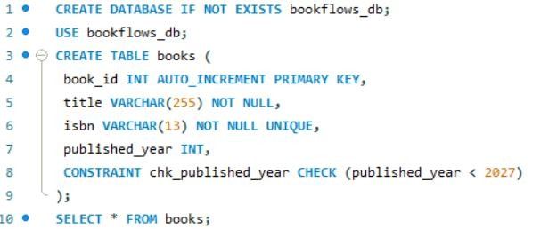
Output:
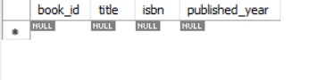
Query 4: Create the members table:
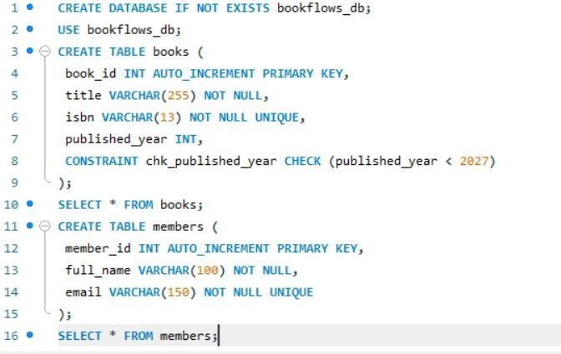
Output:
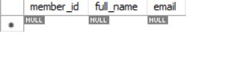
Query 5 (verification): Inspect the table structures
Output:
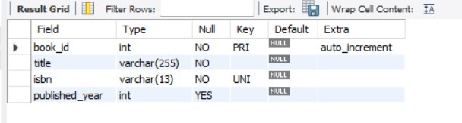
Output:
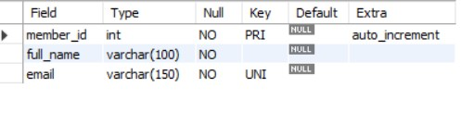
Query 6: Insert 3 books
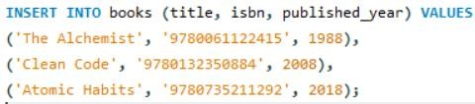
Output:
Query 7: Insert 3 members
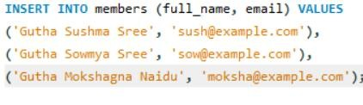
Output:
Output:
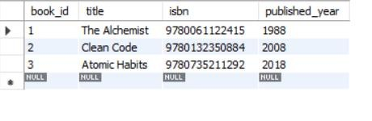

Output:
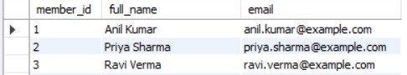
Constraint Tests (These MUST Fail):
Test 1: Duplicate ISBN (UNIQUE violation)
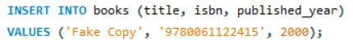
Output:
Test 2: NULL title (NOT NULL violation)
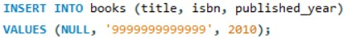
Output:
Test 3: Future publication year (CHECK violation)
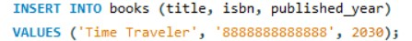
Output:
Test 4: Duplicate email (UNIQUE violation):
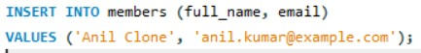
Output:
-------------X---------------

