OSSP (Operating Systems And Systems Programming)
Course code: 25CS2104E
Practical-02: system calls open(), read(), write(), and close()
Output:
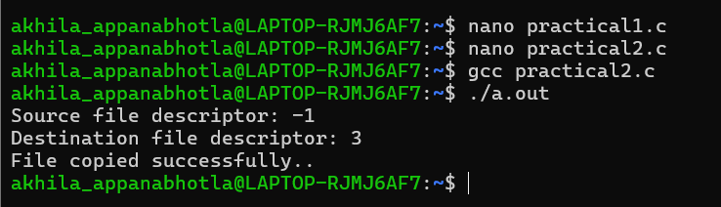
Contents of source file:
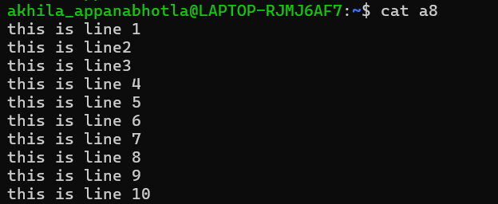
Contents of destination file:
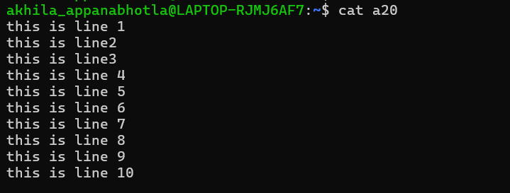
Strace-
