Wsl installation-
Step 1: Open PowerShell as Administrator
- Press Windows.
- Search for PowerShell.
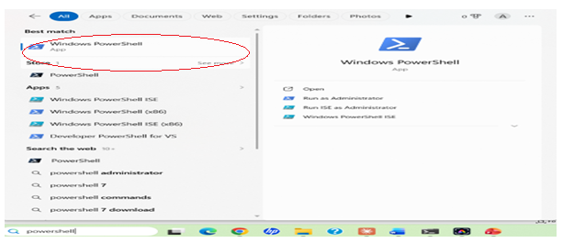
- Right-click Windows PowerShell.
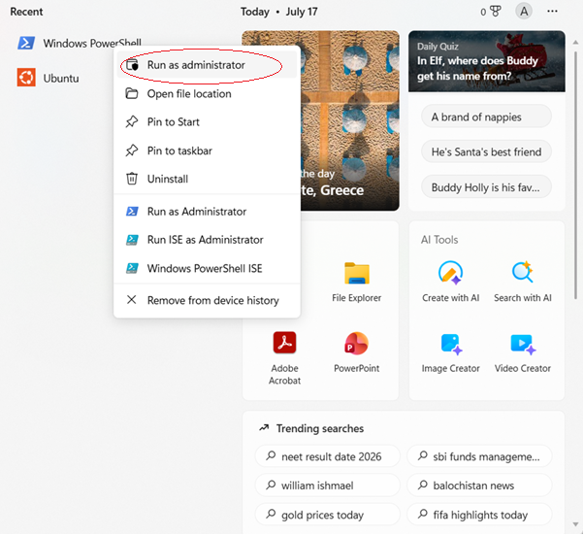
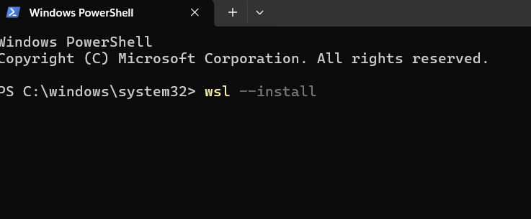
Step 3: Restart Your Computer
After installation, restart your PC when prompted.
Step 4: Complete Ubuntu Setup
After restarting:
- Ubuntu opens automatically (or search for Ubuntu in the Start menu).
- Wait for the installation to finish.
- Create a Linux username.
Example:
Enter new UNIX username: anusha
Step 5: Create a Password
You'll then be prompted to create a password.
New password: ****
Retype new password:****
Step 6: Update Ubuntu
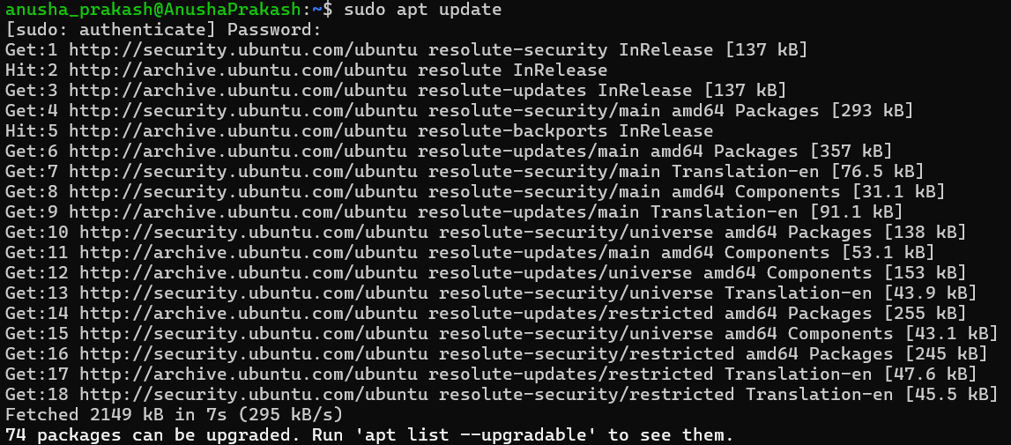

Step 7: Install GCC (C Compiler) 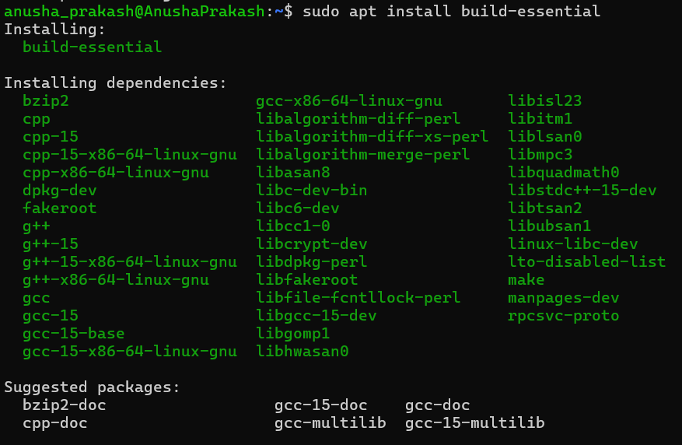

Step 8: Verify the Installation
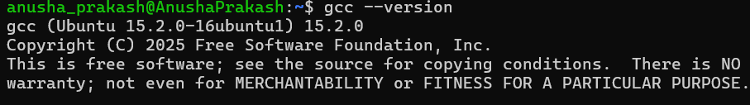
Step 9: Create Your C Program

Example: nano process.c
Step 10: Compile the Program
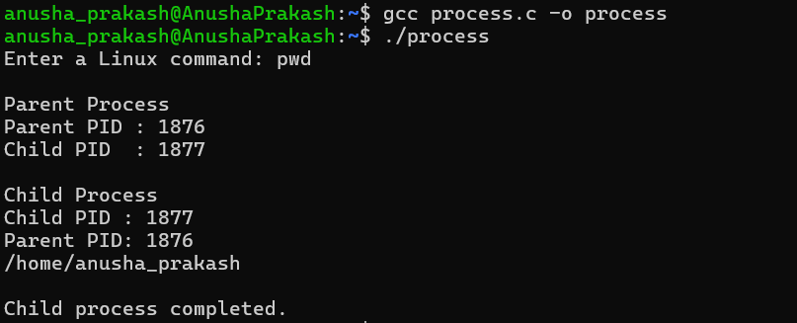
Install and configure GCC for compiling C programs.
- Open the Ubuntu Terminal.
- Update the package list:
sudo apt update
- Install GCC:
sudo apt install gcc
- Check the GCC version:
gcc --version
- Create a C file:
nano hello.c
- Write the C program:
#include <stdio.h>

int main() {
printf("Hello, Ubuntu!\n");
return 0;
}

7.Save the file using Ctrl + O → Enter, then exit using Ctrl + X.
8.Compile the program:
gcc hello.c -o hello
- Run the program:
./hello
- If you get Hello, Ubuntu!, GCC is successfully installed and working.
Create a project folder and initialize it as a Git repository using git init.
- Open the Ubuntu Terminal.
- Create a project folder:
mkdir os-project
- Enter the project folder:
cd os-project
- Initialize the folder as a Git repository:
git init
- Check the Git repository status:
git status
- If successful, you will see something like:
On branch master/main
No commits yet
This means the project folder has been successfully converted into a Git repository.
  - Create folders such as src, bin, docs, and tests.
  - Create basic project files like README.md, Makefile, and main.c.
- Go to your project folder:
cd os-project
- Create the required folders:
mkdir src bin docs tests
- Create the README.md file:
touch README.md
- Create the Makefile:
touch Makefile
- Create the main.c file inside the src folder:
touch src/main.c
- Check the project structure:
ls
- To see everything inside the folders:
find .
  - Check the current shell using echo $SHELL and view the shell process using ps.
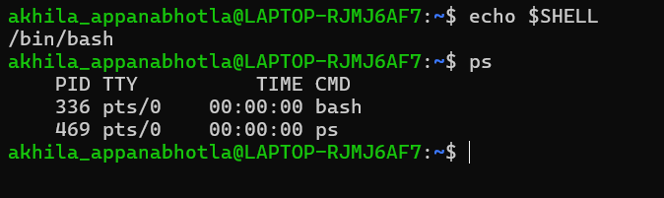
- Create a simple C program inside the src folder.
- Create a Makefile with GCC compilation commands.

