OSSP (Operating Systems And Systems Programming)
Course code: 25CS2104E
Practical-01: Linux Command Execution
Output:
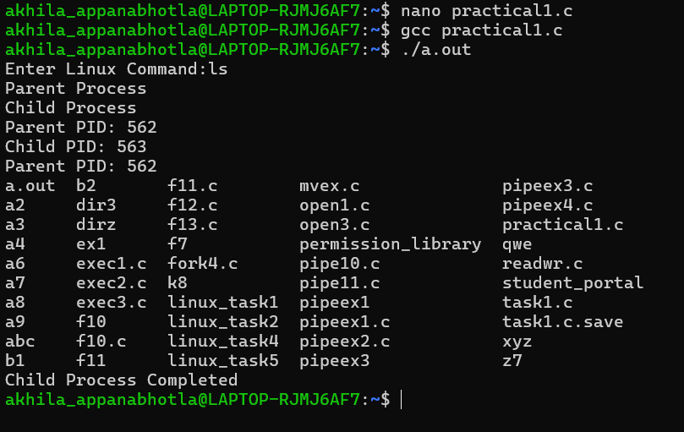
B) Linux terminal commands: (uname, lscpu, lsblk, ps, top)
uname:
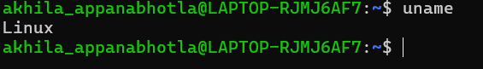
Lscpu:
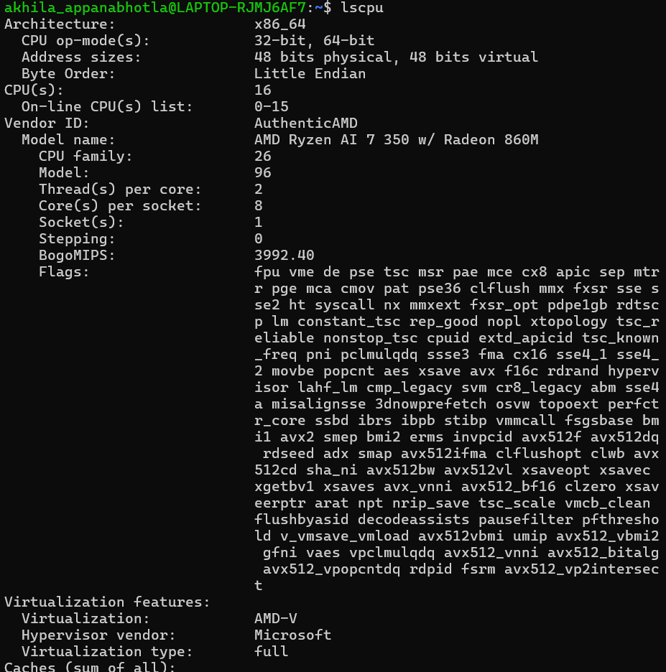
Lsblk:
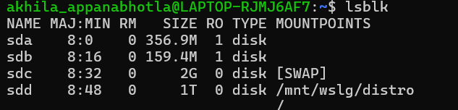
Ps:
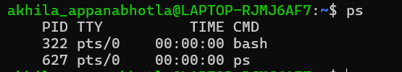
Top:
