TITLE: Cognitive resilience in American Indians: the Strong Heart Study

AUTHORS: Astrid M Suchy-Dicey, WT Longstreth Jr, Dedra S Buchwald, Kristoffer Rhoads, Thomas J Grabowski

AFFILIATIONS

CORRESPONDING AUTHOR
Astrid M Suchy-Dicey
Elson S Floyd College of Medicine (ESFCOM) Washington State University (WSU)
astrid.suchy-dicey@wsu.edu
1100 Olive Way Suite 1200 Seattle WA 98101

INTRODUCTION
Cognitive resilience, sometimes also called cognitive reserve, is usually conceptualized as the ability to overcome the influence of accumulating pathology, in order to maintain a healthy trajectory in daily functioning. However, this abstract concept may be quantified or operationalized in different ways. One method may declare intact cognition despite presence of (imaged) pathology; however, identifying intact and impaired cognition requires neuropsychological score dichotomization, which is not clinically validated for all populations, and may be unnecessarily reductionistic. A more ideal approach would provide an individualized, continuous estimate. Furthermore, a method which accounts for confounding could reduce estimation bias and misspecification. An example of such a technique involves regressing and then predicting cognitive function, for example standardized test scores, against pathological status, such as imaged brain volume, with adjustment for confounding features; then estimating the discrepancy, or residual, between observed and the expected values along for each individual, thus providing an intra-individual estimate of positive resilience over empirical, population-averaged pathological status for the chosen cognitive domain.¹ This method has been evaluated with cross-sectional and longitudinal imaging, cognition, sociodemographic, and clinical features in non-Hispanic Whites from multiple studies. However, no method has yet described or evaluated cognitive resilience defined as such in minority populations, such as American Indians. This study proposes to evaluate intraindividual cognitive resilience, defined as retained processing speed in the context of whole brain atrophy, using descriptive and inferential analysis in a large, population-based cohort of older American Indians, with the ultimate goal of identifying features that have the potential to identify or even confer healthier aging trajectories for all persons.

METHODS
Setting: The Strong Heart Study (SHS) is a longitudinal study of American Indians from the Northern Plains, Southern Plains, and Southwest, recruited for multiple examinations between 1989-1999.² SHS was followed with two ancillary neurology examinations among all surviving study participants in 2010-2013 (n=818) and again in 2017-2019 (n=403), collectively forming the Cerebrovascular Disease and its Consequences in American Indians study (CDCAI). The neurology data collections included detailed medical history, clinical information, neuropsychological examination, and brain imaging. All procedures were reviewed by institutional, Indian Health Service, and tribal ethical review boards. All participants provided written, informed consent.
MRI: Participants underwent 1.5T MRI at both visits, which were processed for structural volumetric estimation in whole brain, both grey and white tissue, standardized to intracranial size, using FreeSurfer software³; and for voxel-wise intraindividual percent change in overall brain tissue using intraindividual principal component analysis (IPCA).⁴
Cognitive Testing: At CDCAI Visit 1 (2010-2013, N=818), four cognitive tests were administered. Weschler Adult Intelligence Scale 4th edition digit symbol coding subtest (WAIS-DSC, processing speed/ visuomotor speed)⁵ involved asking participants to pair a set of typographic symbols with Arabic numerals (1-9), presented in random order, within a span of 120 seconds. Modified Mini Mental Status Examination (3MSE, general cognition/ multi-domain) comprises a global screening tool for general cognitive functioning.⁶ Controlled Oral Word Association FAS version (COWA-FAS, phonemic fluency, executive functioning) asked participants to produce as many words beginning with each of 3 letters in 3 sequential trials of 60 seconds.⁷ The California Verbal Learning Test II –Short Form (CVLT II-SF, multiple indices - learning, memory) involved multile trials of word learning and repetition, both without and with cues.⁸
At CDCAI Visit 2 (2017-2019, N=403), WAIS, 3MSE, COWA, CVLT, were repeated, and several new tests added. The National Alzheimer’s Coordinating Center Uniform Data Set (NACC UDS) version 3.0 form C2⁹ evaluated multiple cognitive domains related to Alzheimer’s disease and related dementias, including the Montreal Cognitive Assessment (MoCA), a screening tool covering executive function, attention, phonemic and semantic fluency, abstraction, delayed verbal memory, and orientation.¹⁰ UDS also included Number Span Test forward and backward, an index of auditory attention and working memory; Benson Complex Figure copy and recall for visuospatial and visual recall abilities;¹¹ animal and vegetable naming tests; Trail Making Test A and B for visuospatial simple and divided attention;¹² Craft Story immediate and delayed recall for contextual verbal memory;¹³ and Multilingual Naming Test (MINT) assessing semantic memory and naming ability.¹⁴ Of note, lower cognitive scores correspond with poorer cognition for all except the Trail Making timed tests, where higher times needed to complete the activity correspond to poorer performance.
Other Data: At each exam, participants also self-reported age (years); sex (male, female); years of formal education; annual household income; and current habitual use of alcohol (drinks per day). Participants underwent clinical and anthropometric examination, including basic blood and urine lab testing, medical history, and medications for high body mass index (BMI), diabetes mellitus (DM), hgypertension (HTN), chronic kidney disease (CKD). BMI was defined as height divided by weight²; HTN as seated averaged systolic blood pressure ≥130 mmHg diastolic ≥90 or use of antihypertensive medications; DM as fasting blood glucose ≥126 mg/dL or use of antihyperglycemic medications or insulin; chronic kidney disease (CKD) as estimated glomerular filtration rate <60 mL/min. Finally, participants self-responded to emotional and mental health questionnaire, including the Short Form 36 heath related quality of life scale and the 20-item Centers for Epidemiologic Studies Depression symptoms scale (CES-D).
Analyses: Cognitive resilience, or cognitive reserve, was operationalized based on regression of WAIS score (processing speed, cognition) over continuous estimate of brain volume (pathology), both unadjusted and adjusted for age and sex; predicted values for each individual participant according to the regression line were subtracted from their observed values, producing a “residual”, or estimated degree of positive resilience. In this paradigm, positive values indicate higher cognition than expected, and negative indicate lower than expected. Residuals were then separated into tertiles, categorizing the population set into low, middle, and high resilience groups. Descriptive analyses of residuals, residual/resilience categories, and resilience across other features used tabulation with mean and standard deviation, count and percent, and graphical representation such as histogram, scatterplot, boxplot with whiskers, and linear fit with 95% confidence interval. Statistical tests for association included one way ANOVA (F-test) for between-group differences in a continuous feature; T-test for equivalence in distributions. For analyses with multiple comparisons, false discvovery rate (FDR) was calculated using the Benjamini Hochberg method. All analyses were done using Stata v17 and R v4.

RESULTS
This cohort of American Indians was older, majority female, with field center distribution as reported in earlier reports (Table 1).^{15, 16} Most attended at least some college, but with annual household income below $20,000. Nearly half had high BMI, diabetes, and chronic kidney disease, and a large majority were hypertensive. The mean self-reported alcoholic drinks per day was 3.3, among those who drink; the mean self-reported depression symptom score was 11.1 (standard deviation, SD 8.7). The mean score on WAIS digit symbol coding test at Visit 1 was 44.8 (SD 14.7) and the mean brain volume, expressed as % of intracranial volume, was 77.5 (SD 4.7).
Tertiles of unadjusted and age/sex-adjusted regression residuals of WAIS score over brain volume, standardized to IC volume, separate the population into 3 equivalent categories of high, middle, and low cognitive resilience, or cognitive performance beyond expectation based on imaged findings (Figure 1). Data and model checks demonstrated even distribution in the raw cognitive data, with decrease as expected over time; normality in residual distributions from the regression model; and independence (no association) of residuals with age, after age- adjustment.
Sociodemographic (Figure 2), clinical (Figure 3), mental health and behavioral (Figure 4) features evaluated for association with the age- and sex-adjusted continuous residual variable representing cognitive resilience (WAIS-brain volume) identified statistically significant findings for education (P<0.0001), income (P<0.0001), geographic region or field center (P=0.0003), diabetes (P=0.001), health related quality of life (P<0.0001), and depression symptoms (P<0.0001). No association was statistically detected for CKD, hypertension, BMI, or alcohol use. Those reporting higher education, higher income, better quality of life had higher resilience; those living in the Southwest, living with diabetes, or reporting depression symptoms had lower resilience.
Longitudinal analyses of cognitive resilience defined at Visit 1 (2010-2013), based on age- and sex-adjusted residuals of WAIS-brain volume, examined associations with categorical features defined at Visit 2 (2017-2019; Table 2). For all Visit 2 cognitive tests, scores were dose-dependently better across categories of increasing cognitive resilience, as measured by age- and sex-adjusted residuals from (Visit 1) WAIS-brain volume regression. Cognitive test scores (and domains) with statistically significant findings after adjustment for multiple comparisons included 3MSE (P<0.001; general cognition, multidomain, dementia screening), MoCA (P<0.001; general cognition, multidomain, dementia screening), WAIS (P<0.001; processing speed), COWA (P<0.001 verbal fluency, executive function), CVLT cued recall (P=0.018; episodic verbal learning and memory, with encoding but not free retreival), animal (P=0.002) and vegetable (P=0.002) naming tests (semantic fluency), Craft story immediate (P<0.001) and delayed (P<0.001) recall (attention, concentration, memory), number span forward (P=0.003) and reverse (P<0.001; attention, working memory), Trail making test A (P<0.001; visual search speed, processing speed, set switching flexibility, executive functioning), and MINT (P<0.001; pictographic, confrontational naming ability).

DISCUSSION
Overall, these findings suggest that cognitive resilience is readily defined and consistently, dose-dependently associated with contextual, sociodemographic, environmental, clinical, behavioral, mental health, and long-term outcomes important to cognitive aging in American Indian elders. Although temporality is not directly observable in these data, education, income are likely to represent precursors to better cognitive resilience, whereas better cognitive resilience may be either a contributor or effect of diabetes, depression, and health related quality of life. In longitudinal associations, better cognitive resilience was associated with later performance in general cognition, memory, semantic and phonemic fluency, attention, and executive function but not visuospatial domains.
In the context of prior findings in non-Hispanic Whites identified associations of a similarly-defined, multivariate adjusted cognitive resilience score (cross-sectionally) with cognitive test scores, non-AD pathology, APOE e4 genotype; associations with sociodemographics, education, anxiety, depression, and other neurological conditions (but not diabetes) were significant in unadjusted models. In longitudinal analyses, global cognition was associated with resilience, independent of age. In contrast, our findings detected statistical associations with multiple environmental, behavioral, and clinical conditions, even cross-sectionally, independent of age and sex. Furthermore, we expand on this prior work by examining domain-specific associations. We did not examine non-AD pathology, APOE e4 genotype, or other neurological conditions, which represent opportunities for future research.
Other areas for future research, whether cognitive resilience is promoted by any of these features or itself engenders improvements in these features is yet to be defined, and future research should conduct longitudinal analyses to examine temporal sequence. Additionally, whether other types of resilience, such as psychological or community, are connected to individual cognitive resilience is as yet unaddressed. Finally, as these analyses examine only one type of cognitive resilience, as defined by residuals in WAIS (processing speed) – whole brain volume (imaged atrophy), other forms or models for cognitive resilience may offer alternative patterns of association, and would be worth considering both conceptually and analytically.
Some other limitations are that, as a cohort of American Indians from the Southwest, Southern Plains, and Northern Plains, these findings may not generalize to other groups. Also, as a survival cohort, our findings may be subject to Type II error, if exposure and outcome are associated with likelihood of participation. However, Visit 1 has as yet shown no evidence of selective survival,¹⁷ and furthermore, any such error would contribute bias to the null, which would only serve to strengthen-- rather than negate-- our positive findings.
In summary, this work represents a first description and analysis of cognitive reslience in American Indian elders, finding associations with multiple determinants and outcomes, including specifics of cogntive domains that may be influenced by better resilience. Future work should expand on these findings with different operationalization methods, different models of cognitive resilience, and longitudinal patterns to directly observe temporal sequence in precursors and outcomes. This work has the potential to identify subsets of the populations that may be at uniquely high risk, and to identify particular factors that could be especially affected by rapid-decliners in the context of Alzheimer’s disease and related dementias.

TABLE 1

Table 1: Selected characteristics of American Indian participants age 65-95 in the Strong Heart Study / CDCAI study, at Visit 1 (n=818, 2010-2013)

WAIS score | 44.8 (14.7)
Brain volume, as % intracranial vol | 77.5 (4.7)
Arizona field center | 12.0%
Dakota field center | 45.7%
Oklahoma field center | 42.3%
Age (years) | 73.0 (5.9)
Female sex | 67.5%
Education: up to / any high school | 19.8%
Education: high school graduate | 25.6%
Education: any college | 39.3%
Education: bachelor’s degree | 15.1%
Income <$10K per year | 30.5%
Income $10-20K per year | 28.7%
Income $20-35K per year | 21.4%
Inmcome >$35K per year | 19.3%
Diabetes mellitus | 49.5%
Hypertension | 80.8%
Chronic kidney disease | 48.4%
BMI: normal | 15.3%
BMI: overweight | 30.0%
BMI: obese | 54.7%
Short form 36 quality of life score | 2.9 (0.3)
CES-D depression symptoms score | 11.1 (8.7)
Alcohol drinks per day | 3.3 (3.7)

DESCRIPTIVE FINDINGS

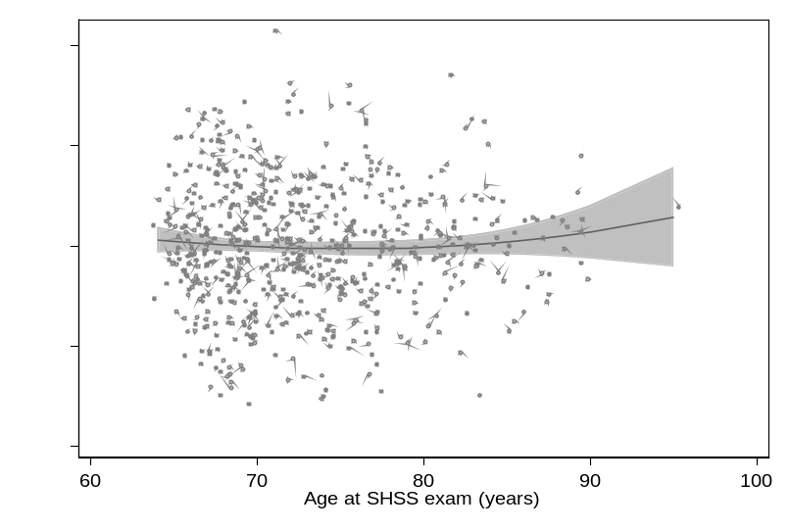
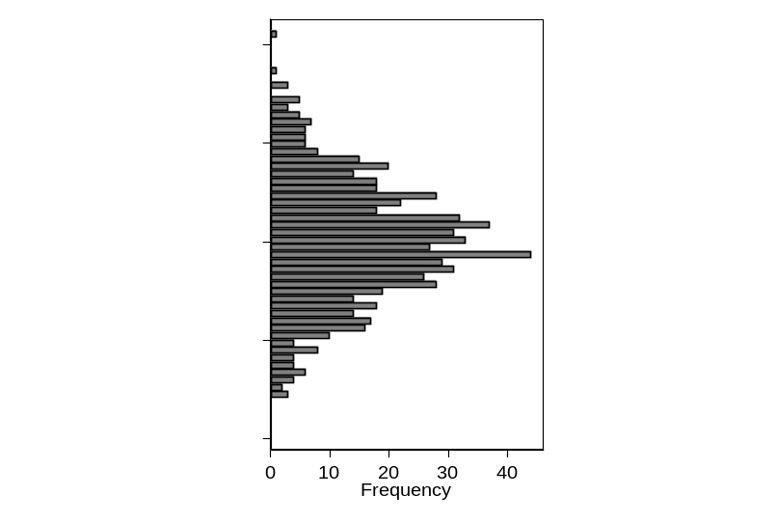
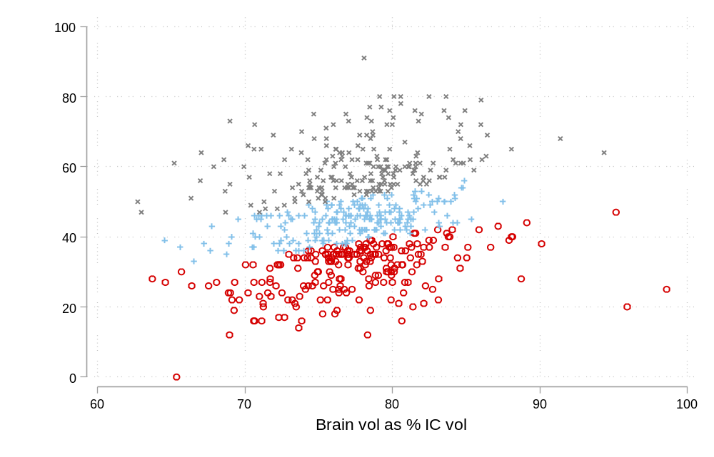
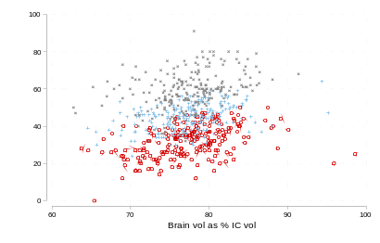
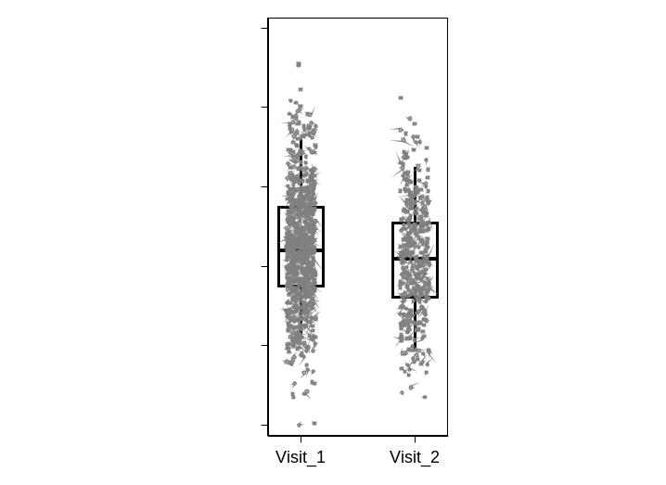
Figure 1: WAIS digit symbol coding test (processing speed) scores over Visit 1 (2010-2013) and Visit 2 (2017-2019) in American Indians, with bar and whisker with scatter overlay showing score distributions (bottom, left). Tertiles of cognitive resilience, operationalized as WAIS scores regressed over whole brain volume standardized to intracranial (IC) volume, without adjustment (top, primary figure) and with adjustment for age and sex (top, inset). Tertiles of observed performance-over-expectation WAIS scores with brain volumes, separating participants into equal groups of high (gray exes), middle (blue crosses), and low (red circles) cognitive resilience. Age- and sex-adjusted intraindividual residuals from regression for cognitive resilience (WAIS scores over brain volumes), with positive values denoting better resilience, i.e. better than expected performance for observed level of atrophy and negative values corresponding to lower performance and lower resilience. Per adjustment, residuals should be independent of age (and sex); scatterplot of residuals over age, including fractional polynomial fit line and 95% confidence interval (bottom, middle) shows flat line of no association. Evaluation of model assumptions includes normally distributed residuals; histogram of residuals (bottom, right) shows approximately normal distribution.
SOCIODEMOGRAPHIC FINDINGS

Figure 2: Cognitive resilience--operationalized as residuals of observed performance in WAIS digit symbol test against expectation based on degree of brain atrophy standardized to intracranial volume (adjusted for age and sex)--summarized over categories of formal education, annual household income, and field center. Cognitive resilience statistically significant with education (one way ANOVA F-test: P<0.0001), income (P<0.0001); and Field center (P=0.0003).
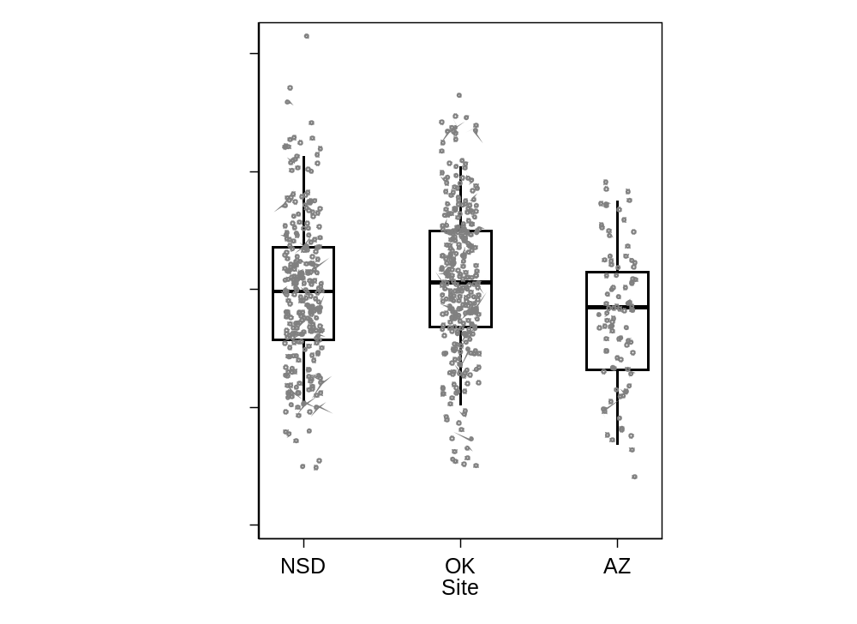
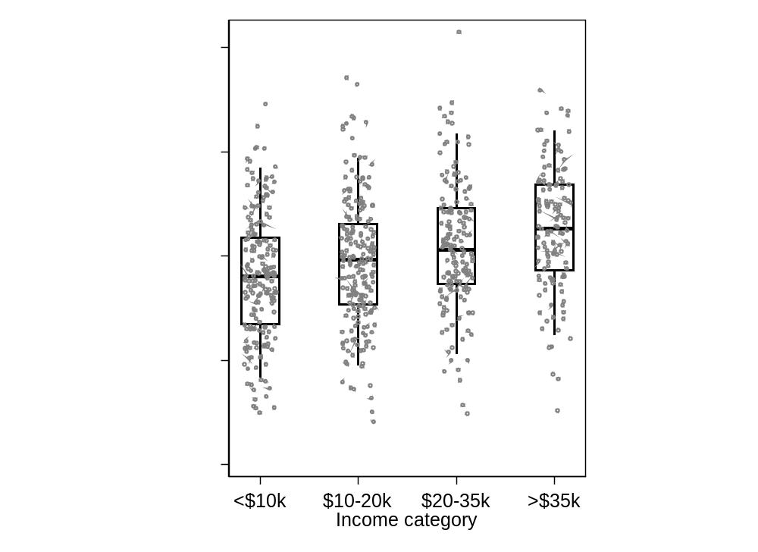
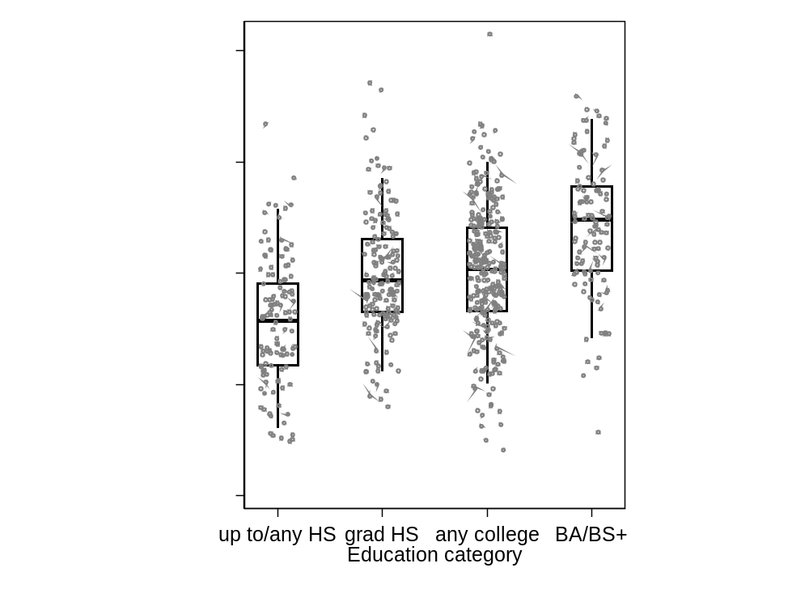

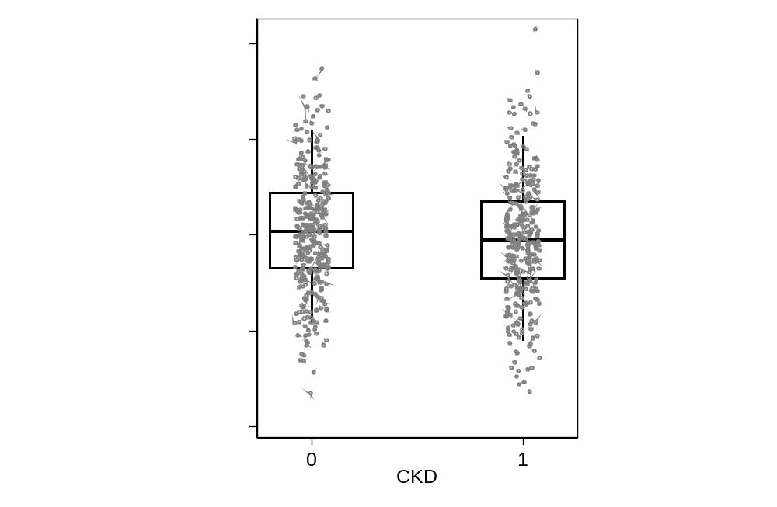
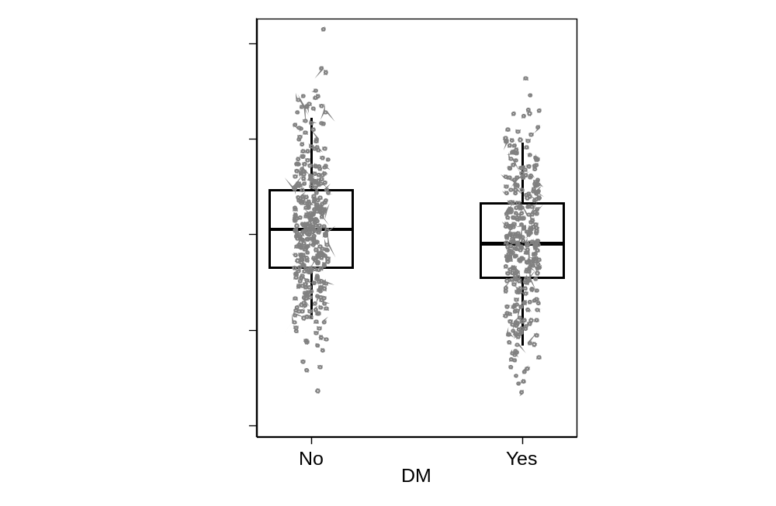
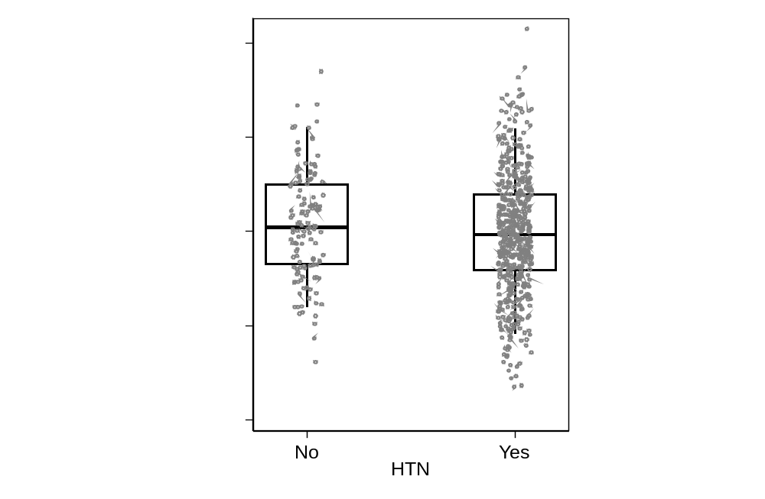
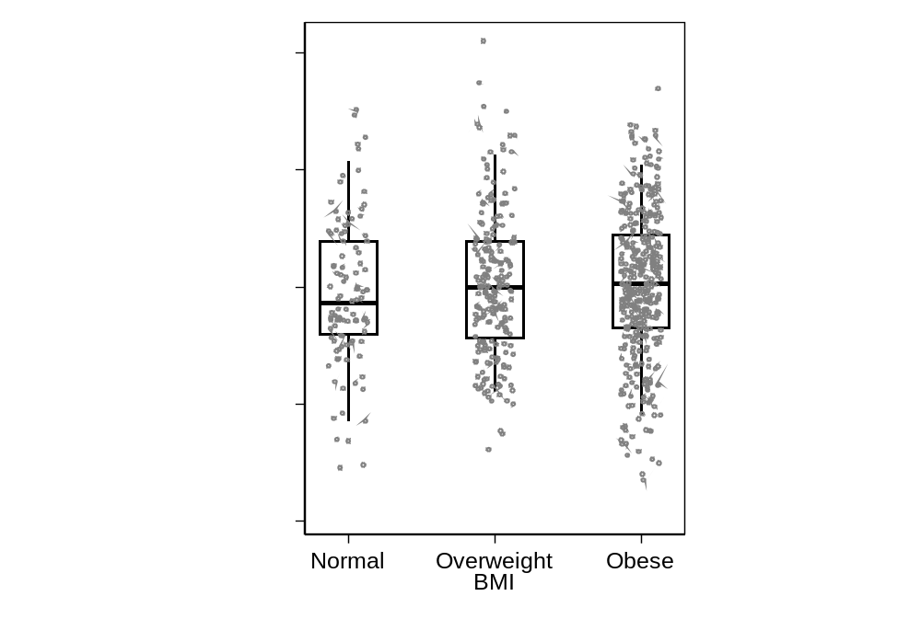
CLINICAL FINDINGS
Figure 3: Cognitive resilience--operationalized as residuals of observed performance in WAIS digit symbol test against expectation based on degree of brain atrophy standardized to intracranial volume (adjusted for age and sex)--summarized over presence vs absence of diabetes (DM), hypertension (HTN), chronic kidney disease (CKD), and categories of BMI. Cognitive resilience statistically significantly lower with DM (T-test P=0.001), but not different for CKD (P=0.07), HTN (P=0.11), BMI (F-test P=0.63).

MENTAL AND BEHAVIORAL FINDINGS

Figure 4: Cognitive resilience--operationalized as residuals of observed performance in WAIS digit symbol test against expectation based on degree of brain atrophy standardized to intracranial volume (adjusted for age and sex)--regressed over short form 36 (SF36) health-related quality of life scale scores; Centers for Epidemiologic Studies Depression (CESD) symptoms scale scores; and self-reported usual use of alcoholic drinks per day. Cognitive resilience statistically significantly associated with SF36 (T-test P<0.0001) and with CESD (P<0.0001), but not alcohol use (P=0.194).

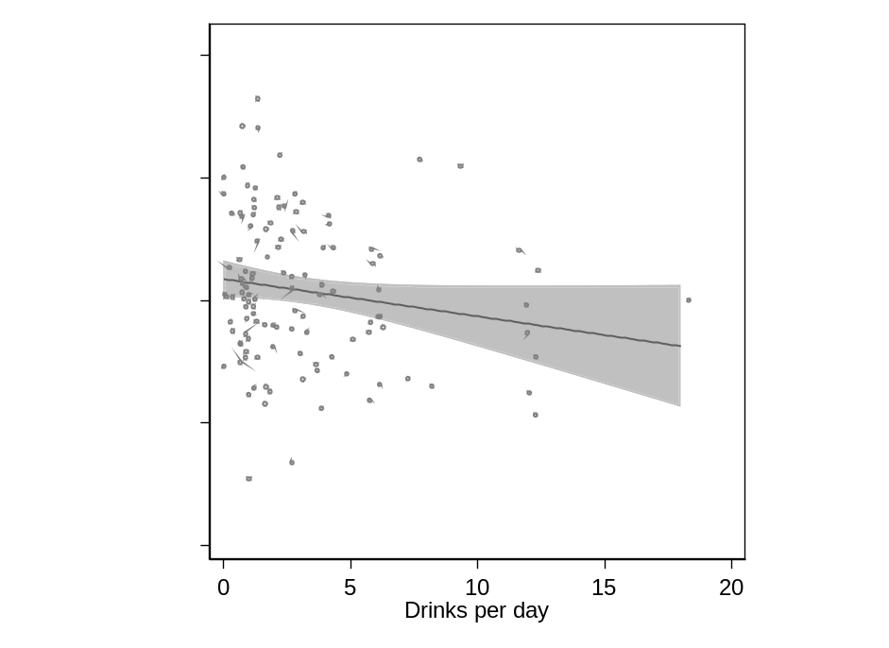
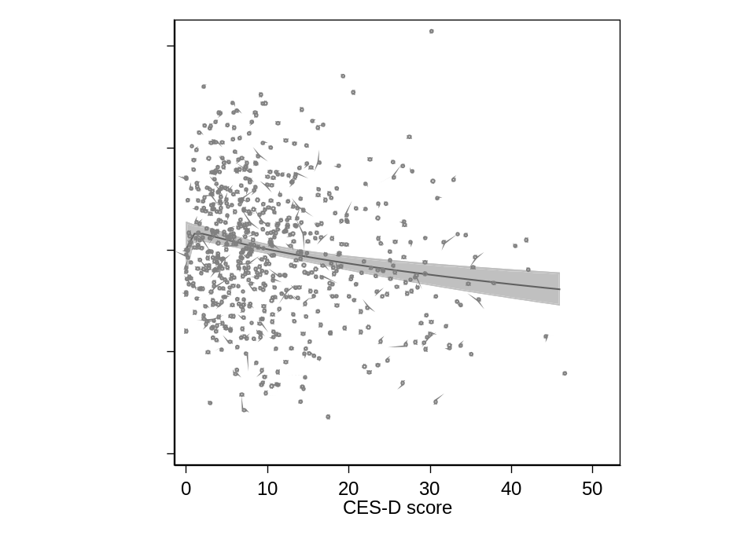
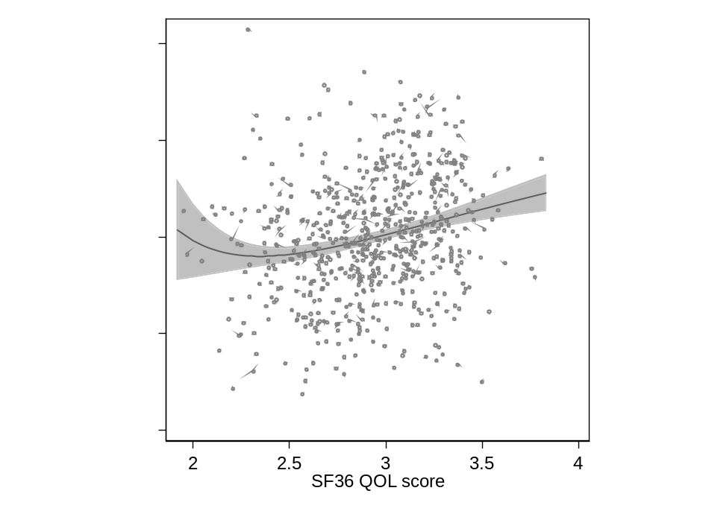

LONGITUDINAL FINDINGS
Table 2: Cognitive test scores in American Indians age 70-95 at CDCAI Visit 2 (2017-2019), over tertile defined categories of high, middle, and low cognitive resilience--operationalized as residuals of observed performance in WAIS digit symbol test against expectation based on degree of brain atrophy standardized to intracranial volume (adjusted for age and sex) at CDCAI Visit 1 (2010-2013).
Raw cognitive test score at Visit 2: | Tertile1:  Low reserve at Visit 1 | Tertile2:  Mid reserve at Visit 1 | Tertile3:  High reserve at Visit 1 | Oneway ANOVA P | FDR Q
3MSE | 82.5 (11.2) | 87.2 (8.3) | 90.0 (8.2) | <0.0001 | <0.001
WAIS digit | 31.6 (10.7) | 39.6 (10.9) | 51.5 (12.3) | <0.0001 | <0.001
COWA fas | 20.0 (9.4) | 24.5 (10.6) | 27.5 (12.0) | <0.0001 | <0.001
CVLT short free | 5.1. (2.4) | 5.5 (1.8) | 5.7 (2.1) | 0.140 | 0.158
CVLT long free | 4.3 (2.5) | 4.6 (2.3) | 4.8 (2.5) | 0.299 | 0.299
CVLT long cued | 4.7 (2.5) | 5.2 (2.1) | 5.7 (2.3) | 0.013 | 0.018
MoCA | 16.9 (4.6) | 18.9 (4.2) | 20.2 (3.5) | <0.0001 | <0.001
Animal name | 12.5 (4.6) | 13.8 (4.5) | 14.8 (4.4) | 0.001 | 0.002
Vegetable name | 8.7 (3.3) | 9.5 (3.3) | 10.4 (3.3) | 0.001 | 0.002
Craft immediate | 8.2 (4.3) | 10.5 (4.4) | 10.9 (3.9) | <0.0001 | <0.001
Craft delayed | 7.0 (4.5) | 8.9 (4.4) | 9.8 (4.2) | 0.0001 | <0.001
Benson copy | 15.2 (1.7) | 15.8 (1.4) | 15.6 (1.9) | 0.089 | 0.107
Benson recall | 8.3 (3.8) | 8.5 (3.6) | 9.1 (3.8) | 0.224 | 0.237
Number span forward | 6.0 (2.2) | 6.2 (2.2) | 7.1 (2.4) | 0.002 | 0.003
Number span backward | 3.8 (1.6) | 4.4 (1.7) | 5.1 (2.0) | <0.0001 | <0.001
Trails A seconds | 78.5 (32.5) | 66.9 (32.2) | 54.3 (25.9) | <0.0001 | <0.001
Trails B seconds | 181.7 (85.7) | 174.9 (78.5) | 156.3 (73.7) | 0.054 | 0.069
MINT total | 25.8 (4.1) | 27.5 (2.7) | 28.1 (2.2) | <0.0001 | <0.001

REFERENCES

1. Yao T, Sweeney E, Nagorski J, Shulman JM, Allen GI. Quantifying cognitive resilience in Alzheimer's Disease: The Alzheimer's Disease Cognitive Resilience Score. PLoS One 2020;15:e0241707.
2. Lee ET, Welty TK, Fabsitz R, et al. The Strong Heart Study. A study of cardiovascular disease in American Indians: design and methods. Am J Epidemiol 1990;132:1141-1155.
3. Suchy-Dicey A, Su Y, Buchwald DS, Manson SM, Reiman EM. Volume atrophy in medial temporal cortex and verbal memory scores in American Indians: Data from the Strong Heart Study. Alzheimers Dement 2022.
4. Chen K, Reiman EM, Alexander GE, et al. An automated algorithm for the computation of brain volume change from sequential MRIs using an iterative principal component analysis and its evaluation for the assessment of whole-brain atrophy rates in patients with probable Alzheimer's disease. Neuroimage 2004;22:134-143.
5. Wechsler D. Wechsler Adult Intelligence Scale (4th ed.). 4th ed. San Antonio, TX: Pearson, 2008.
6. Teng EL, Chang Chui H. The Modified Mini-Mental (3MS) Examination. Journal Clinical Psychiatry 1987;48:314-318.
7. Benton AL, Hansher K. Multilingual aphasia examination, 2nd ed. Iowa City, IO: AJA Associates, 1976.
8. Delis DC, Kramer JH, Kaplan E, Ober BA. California Verbal Learning Test (CVLT-II), 2 ed. US: The Psychological Corporation, 2000.
9. Morris JC, Weintraub S, Chui HC, et al. The Uniform Data Set (UDS): clinical and cognitive variables and descriptive data from Alzheimer Disease Centers. Alzheimer Dis Assoc Disord 2006;20:210-216.
10. Nasreddine ZS, Phillips NA, Bedirian V, et al. The Montreal Cognitive Assessment, MoCA: a brief screening tool for mild cognitive impairment. J Am Geriatr Soc 2005;53:695-699.
11. Possin KL, Laluz VR, Alcantar OZ, Miller BL, Kramer JH. Distinct neuroanatomical substrates and cognitive mechanisms of figure copy performance in Alzheimer's disease and behavioral variant frontotemporal dementia. Neuropsychologia 2011;49:43-48.
12. Llinas-Regla J, Vilalta-Franch J, Lopez-Pousa S, Calvo-Perxas L, Torrents Rodas D, Garre-Olmo J. The Trail Making Test. Assessment 2017;24:183-196.
13. Liew TM. Developing a Brief Neuropsychological Battery for Early Diagnosis of Cognitive Impairment. J Am Med Dir Assoc 2019;20:1054 e1011-1054 e1020.
14. Ivanova I, Salmon DP, Gollan TH. The multilingual naming test in Alzheimer's disease: clues to the origin of naming impairments. J Int Neuropsychol Soc 2013;19:272-283.
15. Suchy-Dicey AM, Oziel K, Sawyer C, et al. Educational and Clinical Associations With Longitudinal Cognitive Function and Brain Imaging in American Indians: The Strong Heart Study. Neurology 2022;99:e2637-2647.
16. Suchy-Dicey AM, Shibata D, Best LG, et al. Cranial Magnetic Resonance Imaging in Elderly American Indians: Design, Methods, and Implementation of the Cerebrovascular Disease and Its Consequences in American Indians Study. Neuroepidemiology 2016;47:67-75.
17. Suchy-Dicey AM, Muller CJ, Madhyastha TM, et al. Telomere Length and Magnetic Resonance Imaging Findings of Vascular Brain Injury and Central Brain Atrophy: The Strong Heart Study. Am J Epidemiol 2018;187:1231-1239.

