Journal Submissions:
- Social Science and Medicine (under 9,000 words - APC with Michigan; transfer options to SSM-PH or SSM-MH)
- Journal of Cross-Cultural Psychology (15 to 35 double-spaced)
- Journal of Racial and Ethnic Health Disparities (under 7000 words)
- Psychology of Religion and Spirituality (< 30 pages)

Carley Vornlocher
Department of Psychology
Arizona State University
950 McAllister Ave.
Tempe, AZ 85287 USA
June 2024
To the editorial board,
We wish to submit an original research article entitled “Religious Antecedents of Health and Well-being in the MASALA, Strong Heart, Hispanic Community Health, and Nurses’ Health Studies” for consideration by Social Science and Medicine. We confirm that this work is original and has not been published elsewhere, nor is it currently under consideration for publication elsewhere.
In this paper, we explore the mediating role of religious coping strategies in the relationship between religiosity/spirituality and health outcomes. Importantly, we differentiate between positive and negative religious coping strategies, finding that negative religious coping strategies consistently hurt mental health but the use of positive religious coping strategies do not necessarily benefit mental health. We close with recommendations for practitioners who work with religiously diverse patients.
We believe that this manuscript is appropriate for publication by SS&M because it provides mechanistic insight into the relationship between religion and health, which is typically understood to be a positive one. Additionally, our diverse samples lend themselves towards generalizability.
We recommend the following potential reviewers, all of whom have experience in religion and health, or the samples used in this study.
Laura Upenieks (laura_upenieks@baylor.edu)
Marah Al-Kire (ralkire@uw.edu)
Hannah Pearson (hannahip@hawaii.edu)
Wade Rowatt (wade_rowatt@baylor.edu)
We have no conflicts of interest to disclose. Additionally, all code and materials are publicly available at an OSF site; an anonymized URL is provided for peer review within the manuscript. Please address all correspondence concerning this manuscript to me at cvornloc@asu.edu. Thank you for your consideration of this manuscript.
Sincerely,

Carley Vornlocher
Arizona State University

Title: Religious Antecedents of Health and Well-being in the MASALA, Strong Heart, Hispanic Community Health, and Nurses’ Health Studies

Authors: Carley Vornlocher¹*, Daniel McNeish¹ , Shelly Cole², Martha L. Daviglus³, A. Heather Elliassen⁴, Alka Kanaya⁵, & Alexandra S. Wormley⁶

Affiliations:
¹ Department of Psychology, Arizona State University, Tempe, AZ, 85287
² Texas Biomedical Research Institute, San Antonio, TX 78227
³ College of Medicine, University of Illinois at Chicago, Chicago, IL 60612
⁴ School of Public Health, Harvard University, Boston, MA 02115
⁵ School of Medicine, University of California at San Francisco, San Francisco CA 94115
⁶ Department of Psychology, University of Michigan, Ann Arbor, MI 48109
*Corresponding author. Email: cvornloc@asu.edu

Abstract:
In 2022, over 25% of U.S. adults reported being too stressed to function most days. One way that individuals may cope with stress is by engaging with their religious faith. However, religion may not always benefit one’s ability to cope successfully. Here, we explore if and how positive and negative religious coping strategies differentially mediate the relationship between religious/spiritual experiences and health outcomes. Using data from four diverse US samples, we find spiritual and religious individuals tend to rely more on positive religious coping strategies, but not negative religious coping strategies. Further, individuals who used negative religious coping strategies reported worse mental health, but the use of positive religious coping strategies had no consistent effect on self-reported health outcomes.

Keywords: religion, religious coping, well-being, health, emotion regulation
Word Count: XXXX
Statement of Relevance:
Integrating perspectives from affective science, health sciences, and the psychology of religion, this study refines our understanding of the relationship between religion and well-being. While past work has broadly found that religious individuals show better health (Koenig, 2012), this work has not properly differentiated between religiosity and spirituality, nor acknowledged how religion may be deleterious through health. In doing so, healthcare providers and religious practitioners can better provide guided support for enhancing the lives of over 200 million religious Americans. It is especially important to do so using data and feedback from historically-underserved communities.

Funding: This is a paper of the International Consortium on Psychosocial Stress, Spirituality, and Health. This work was supported by The John Templeton Foundation (Grant #s 59607 & 62016, AES) and the National Science Foundation’s Graduate Research Fellowship (ASW). The Nurses’ Health Study II was supported by NIH grants U01CA176726 and R01CA163451. The content is solely the responsibility of the authors and does not necessarily represent the official views of the National Institutes of Health. The MASALA Study was supported by NIH grants 1R01HL093009, 2R01HL093009, R01HL120725, UL1RR024131, UL1TR001872, and P30DK098722. The Strong Heart Study has been funded in whole or in part with federal funds from the National Heart, Lung, and Blood Institute, National Institute of Health, Department of Health and Human Services, under contract numbers 75N92019D00027, 75N92019D00028, 75N92019D00029, & 75N92019D00030. The study was previously supported by research grants: R01HL109315, R01HL109301, R01HL109284, R01HL109282, and R01HL109319 and by cooperative agreements: U01HL41642, U01HL41652, U01HL41654, U01HL65520, and U01HL65521. The content is solely the responsibility of the authors and does not necessarily represent the official views of the National Institutes of Health or the Indian Health Service (IHS).The Hispanic Community Health Study/Study of Latinos was carried out as a collaborative study supported by contracts from the National Heart, Lung, and Blood Institute (NHLBI) to the University of North Carolina (N01-HC65233), University of Miami (N01-HC65234), Albert Einstein College of Medicine (N01-HC65235), Northwestern University (N01-HC65236), San Diego State University (N01-HC65237), and the University of Washington (HHSN268201300005C). The following Institutes/Centers/Offices contribute to the HCHS/SOL through a transfer of funds to the NHLBI: National Center on Minority Health and Health Disparities, the National Institute of Deafness and Other Communications Disorders, the National Institute of Dental and Craniofacial Research, the National Institute of Diabetes and Digestive and Kidney Diseases, the National Institute of Neurological Disorders and Stroke, and the Office of Dietary Supplements.

Religious Antecedents of Health and Well-being in the MASALA, Strong Heart, Hispanic Community Health, and Nurses’ Health Studies

Though extensive research highlights stress as a risk factor for poor psychological and physical health (Thoits, 2010), in 2022, over 25% of U.S. adults reported being too stressed to function most days (American Psychological Association, 2022). Thus, understanding how people can most effectively combat stress remains a major public health concern. An expansive body of evidence underscores that religion can bolster physical and psychological health (Chamberlain & Zika, 1992; Holt et al., 2018; Koenig et al., 1997; M. E. Mccullough et al., 2009; VanderWeele, 2017; Wallace et al., 2019; Wormley et al., 2023, in press). These benefits are attributable, at least in part, to the resources afforded by religion to help people deal with stress and distress (Chamberlain & Zika, 1992; Dolcos et al., 2021; Fredrickson, 2002; Holt et al., 2018; M. Mccullough & Willoughby, 2009). However, religious experiences are diverse, and less is known about the distinct pathways through which different aspects of religious experiences contribute to physical and psychological health. Thus, the current study seeks to examine how religiosity and spirituality uniquely contribute to health and well-being outcomes, and if these pathways are explained by the ways in which people leverage religious coping strategies to manage stress.
Under challenging circumstances, people frequently engage in processes that are aimed at reducing distress known as coping, which involves cognitive and/or behavioral efforts to overcome, tolerate, or reduce conflict between internal/external demands (Carver, 1997; Lazarus & Folkman, 1987). Coping strategies most often refer to the toolkit of techniques people use to deal with specific stressors and/or the resulting emotional impact of said stressors. A fruitful tradition of research has explored the diverse ways in which people cope, as well as when, how, and for whom these strategies may be helpful or harmful (Gross, 2015). Broadly, past work has consistently linked certain coping strategies—such as reappraising, accepting, or directly acting upon the stressor— to both increased psychological well-being (Aldao et al., 2010; T. L. Webb et al., 2012) and physical health (Penley et al., 2002). In contrast, certain strategies—such as avoiding the stressor or suppressing one’s feelings—have been linked to diminished well-being (Webb et al., 2012) and physical health (Penley et al., 2002), highlighting which strategies people implement to deal with stressors in the moment can pose costs and benefits in the long-term.
Religious individuals may benefit from an expanded toolkit of coping techniques, with additional strategies that leverage aspects of their religious experience, such as their spiritual connection with God and the social resources afforded by their religious community. For example, positive reappraisal—finding the silver lining in a challenging experience (Shiota, 2006)— may be easier for religious individuals, who can attribute the experience to God’s desire to make them stronger (DeAngelis & Ellison, 2017; Dolcos et al., 2021; Vishkin et al., 2016). Past work has demonstrated that use of such religious coping indeed serves a protective function, predicting increased well-being and decreased mental illness (Ano & Vasconcelles, 2005; Koenig et al., 2012; Pankowski & Wytrychiewicz-Pankowska, 2023). The relationship between religious coping and physical health, however, is more ambiguous, though some studies of elderly populations have shown that positive religious coping strategies can bolster physical health (Pargament et al., 2004; Whitehead & Bergeman, 2020).
Though religious coping is generally viewed as salubrious, use of negative religious coping strategies (e.g., appraising God as punishing) has been shown to negatively influence mental health outcomes. Those who implement negative religious coping strategies tend to experience greater depression over time, especially when these strategies are used to cope with chronic stressors or traumatic events (Gerber et al., 2011; Pargament et al., 2004; Wijngaards-de Meij et al., 2005; Zwingmann et al., 2006). Further, reliance on negative religious coping predicts worsening symptoms in pre-existing conditions such as HIV/AIDS and cancer (Cummings & Pargament, 2010).
Importantly, religious experiences are themselves diverse. While spirituality involves pursuit of meaning and self-transcendence, religiosity reflects participation in organized religion and engagement in corresponding rituals and theology (Zinnbauer et al., 1997; Zinnbauer & Pargament, 2005). Though these constructs are certainly related, they reflect two distinct dimensions of an individual’s religious experience and may independently influence religious coping. Recent work suggests that coping strategies may be implemented in ways that reflect other goals above and beyond that of stress reduction per se, such as social connection or positive emotion generation (Langley et al., 2023; Tamir, 2016), and pursuit of these goals may uniquely predict health and well-being.
Individual differences in religiosity/spirituality (R/S) likely reflect differences in goals and, in turn, could influence which strategies people opt for. Indeed, some existing work has linked spirituality and religiosity to distinct patterns of coping strategy use. In times of distress, spiritual individuals may turn to the Divine for emotional relief or guidance (Pargament et al., 2000). For example, belief in Divine control provides a beneficial buffer when dealing with health issues in certain populations (Pargament et al., 1998; Umezawa et al., 2012; Upenieks, 2022). These forms of coping are important resources that may be afforded by one’s sense of spirituality and have been linked to better psychological adjustment (Ano & Vasconcelles, 2005). In contrast, religious individuals tend to rely upon and benefit from communities that convey social support in times of need. Extensive evidence has identified how the social support provided by one’s religious group can provide health benefits (Chatters, 2000; Fredrickson, 2002; Krok, 2015; M. E. Mccullough et al., 2009; Wallace et al., 2019).

The Current Study
In this project, we use data from four diverse samples to investigate the mediating role of positive and negative religious coping strategies in the relationship between R/S and well-being. Using structural equation modeling across the four samples, we investigated three questions:
Q1: How do religious and spiritual experiences differentially predict positive and
negative religious coping strategies?
Q2: Do positive and negative religious coping strategies differentially mediate the
relationship between religious/spiritual experiences and health?
Q3: Does religious affiliation moderate the effects of religious coping strategies on health
and well-being?

Method

Transparency and Openness

Study materials and R code and output are available on OSF (https://osf.io/kg7xv/?view_only=ea948c958cc44d568875a6c9b23914d1). Due to data use agreements, data is not available for this study without prior approval. The current study’s objectives, hypotheses, and analytic plan were preregistered on OSF prior to the start of data analysis.

Participants
This study utilized questionnaire responses from four separate samples: 1) the Nurses’ Health Study II (NHSII), a longitudinal, cohort sample of female nurses born between 1947 and 1964 in the United States, surveyed in 2016-2017; 2) the Strong Heart Study (SHS), a longitudinal sample from a family-based cohort of American Indians from the northern plains, surveyed in 2018-2019; 3) the Hispanic Community Health Study / Study of Latinos (HCHS/SOL), a longitudinal sample containing 994 Hispanic/Latino individuals, surveyed in 2018-19 on the relevant questionnaires; 4) Mediators of Atherosclerosis in South Asians Living in America (MASALA), a longitudinal sample of South Asian Americans, surveyed in 2016-2017 (Table 1). Data were collected as part of the Study on Stress, Spirituality, and Health (SSSH; see Warner et al., 2021 for procedural details). All samples were analyzed separately. Prior to data usage, the authors received approval from the relevant cohorts and the [HOME UNIVERSITY] Institutional Review Board.

Table 1. Descriptive statistics by sample.
Variable |  | NHSII | SHS | SOL/HCHS | MASALA
N |  | 4268 | 708 | 999 | 990
Age in 2016 |  | 32.73  (4.37) | 49.66  (13.27) | 54.30  (12.34) | 59.95  (9.01)
Gender (N = Female) |  | 4268 | 429 | - | 464
Sex (N = Female) |  | - | - | 622 | -
Marital Status
Never married |  | 190 | 199 | 174 | 15
Married |  | 3417 | 323 | 603 | 647
Widowed or Separated |  | 646 | 151 | 215 | 62
Income
 | < $15,000 | 19 | 265 | 289 | 40
 | $15,000 - $50,000 | 480 | 230 | 564 | 118
 | > $50,000 | 3295 | 141 | 46 | 730
Religion/Spirituality
 | Religious and Spiritual | 2651 | 415 | 534 | 515
 | Spiritual but not Religious | 1204 | 179 | 266 | 74
 | Religious but not Spiritual | 85 | 59 | 139 | 263
 | Neither Religious nor Spiritual | 195 | 49 | 51 | 90
 | No Response Available | - | 6 | 9 | -
Positive Religious Coping |  | 2.76  (.94) | 2.85  (.85) | 3.60  (.61) | 2.75  (.89)
Negative Religious Coping |  | 1.21  (.35) | 1.76  (.72) | 1.82  (.75) | 1.46  (.61)
SF-12 Mental |  | 56.02  (5.64) | 46.08  (7.79) | 49.91  (9.83) | 53.93  (7.66)
SF-12 Physical |  | 49.31  (9.21) | 41.40  (6.04) | 46.28  (8.24) | 49.93  (7.91)

Measures

Religious and Spiritual Identity
To assess religious and spiritual identity, participants were asked to endorse one of four statements: 1) I am both spiritual and religious; 2) I am spiritual but not religious; 3) I am religious, but not spiritual; or 4) I am neither spiritual nor religious. These were recoded into two binary variables – spiritual and religious – where 0 represented not identifying and 1 represented identifying with each respective label.
Religious Coping
Religious coping strategy was assessed by asking participants to report how often they relied on fourteen different, religiously-based coping strategies during “recent stressful events.” On a scale of 1 (not at all) to 4 (a great deal), participants rated their reliance upon strategies such as wondering “what I did for God to punish me” and working “together with God to relieve my worries.” Factor analyses conducted by the SSSH study team indicated a 2-factor structure of these items, with factors representing positive and negative religious coping strategies. Items showed strong primary factor loadings and no secondary loadings (see Warner et al., 2021 for more details). Based on these factor loadings, items were averaged to create two composite scores of positive and negative religious coping strategy use. See Appendix A for all items.
Mental Health
Mental health was assessed using the Mental Component Summary of the SF-12 which captures general psychological distress and well-being, with higher scores indicating better health. Items include questions such as “Have you felt calm and peaceful?” and “Have you felt down-hearted and blue?”.
Physical Health
Physical health was assessed using the Physical Component Summary of the SF-12 which captures general perceptions of one’s health as good or bad, as well as the extent to which
daily activities are interrupted by physical health symptoms. Items include questions such as “Does your health now limit you in moderate activities?” and “Have you accomplished less than you would like as a result of your physical health?”.
Demographics
All relevant covariate data was collected within three years of key variables. When available, covariates included year of birth, gender (except for the NHSII sample which was entirely women), marital status, and income. Descriptive statistics are available in Table 1.

Analytical Strategy

The lavaan package in R was used to examine the proposed path models. All variables were treated as manifest variables. Missing data were handled using Full Information Maximum Likelihood (FIML). To establish the mediating role of positive and negative religious coping strategies, we began by building a model where religious and spiritual identity directly predicted mental and physical health as shown in Equation 1 and Figure 1. If the direct effect of the R/S variables on physical and mental health variables are null, this justifies the removal of the direct effect in subsequent models and the introduction of religious coping as mediating variables.
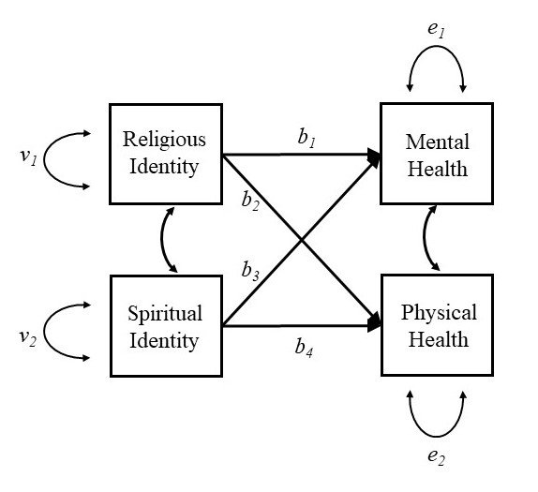
Figure 1. Path model for depicting direct effects of R/S on mental and physical health.

Equation 1. Model used to estimate the direct effect of religious and spiritual identity upon health (Model 1).
MentalHealth_{i} = b₁ · Religious_{i} + b₃ · Spiritual_{i} + e_{1i}
PhysicalHealth_{i} = b₂ · Religious_{i} + b₄ · Spiritual_{i} + e_{2i}

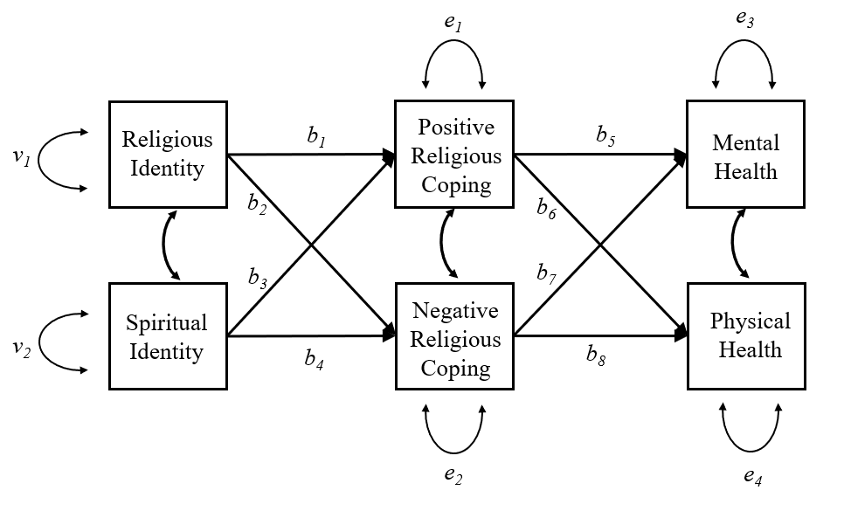
Figure 2. Path model for Model 2.

Then, we built a model which removed the direct effects of R/S identity on the health variables to account for the potential mediating effects of positive and negative religious coping. The following equations specify the hypothesized significant effects based on the theoretical model illustrated in Figure 2:

Equation 2. Model used to estimate the mediating effect of religious coping in the relationship between religious/spiritual identity and health (Model 2).
PosReligCop_{i} = b₁ · Religious_{i} + b₃ · Spiritual_{i} + e_{1i}
NegReligCop_{i} = b₂ · Religious_{i} + b₄ · Spiritual_{i} + e_{2i}
MentalHealth_{i} = b₅ · PosReligCop_{i} + b₇ · NegReligCop_{i} + e_{3i}
PhysicalHealth_{i} = b₆ · PosReligCop_{i} + b₈ · NegReligCop_{i} + e_{4i}

Correlations between religious and spiritual identity, positive and negative coping, and mental and physical health were also included in the model. Two versions of each model were run; the first included no covariates, while the second included year of birth, gender (when applicable), marital status, and income as covariates.

Further, we preregistered a third model, which included religious affiliation as a moderating variable on paths b₁ - b₄. No consistent effects were found. Results are included in the supplemental materials.

Acceptable model fit was assessed using a SRMR less than .08 (Hu & Bentler, 1999), though we also report χ² CFI, TLI, and RMSEA for interested readers in Table 2.

Results
Sample 1: NHSII
The direct effect model was designed to test the significance of the direct effect of religious and spiritual affiliation on physical and mental health. Spirituality did not significantly predict mental health (β = -.001 [-.033, .031], p = .958) or physical health (β = -.006 [-.039, .026], p = .697). Religiosity did not predict physical health (β = .000 [-.032, .032], p = .985), but it positively predicted mental health (β = .074 [.042, .106], p < .001).
The χ² test of model fit indicated that this model produced a covariance matrix that was not significantly different than the sample covariance matrix, χ²(4) = 8.072, p = .089, and this was supported by the other model fit indices (SRMR = .006; Table 2). Those who identified as religious were significantly more likely to report using positive religious coping strategies (β = .556 [.535, .578], p < .001), as well as negative religious coping strategies (β = .166 [.135, .198], p < .001). Those who identified as spiritual were significantly more likely to report using positive religious coping strategies (β = .151 [.122, .180], p < .001), but spiritual identity was not related to use of negative religious coping strategies (β = -.013 [-.049, .024], p = .498).
Table 2. Model fit statistics across the four samples for Model 2.
 | χ² | d.f. | RMSEA | CFI | TLI | SRMR
NHSII | 8.072 | 4 | .016 | .998 | .994 | .006
SHS | 2.547 | 4 | .000 | 1.00 | 1.015 | .010
HCHS/SOLS | 3.390 | 4 | .000 | 1.00 | 1.021 | .012
MASALA | 1.775* | 4 | .042 | .983 | .937 | .018
Note: * p < .05
Use of positive religious coping strategies predicted better mental health (β = .150 [.118, .182], p < .001), but was not related to physical health (β = -.010 [-.043, .024], p = .571). Use of negative religious coping strategies predicted diminished mental health (β = -.179 [-.212, -.146], p < .001) and physical health (β = -.091 [-.124, -.057], p < .001). In the version of the model including covariates, substantive effects were the same (Table S2)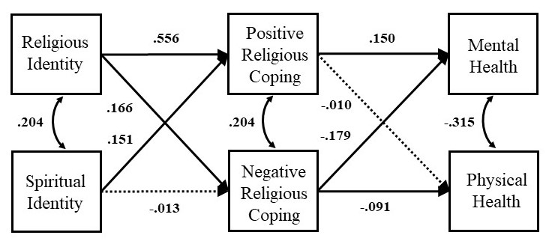

Figure 3. Path diagram for Model 2 with NHSII data.
Sample 2: SHS
Like the NHSII model, the direct effect model did not find significant effects of spirituality on physical health (β = -.040 [-.116, .036], p = .306) or mental health (β = .007 [-.069, .083], p = .854). Additionally, there was no direct effect of religiosity on physical health (β = -.011 [-.089, .067], p = .776) or mental health (β = .019 [-.059, .097], p = .635).
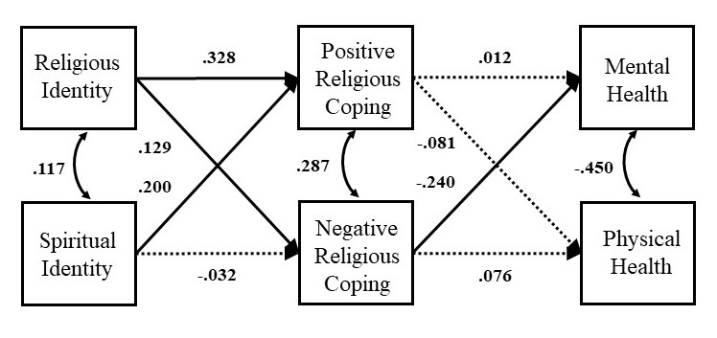
The χ² test of model fit indicated that this model produced a covariance matrix that was not significantly different than the sample covariance matrix, χ²(4) = 2.547, p = .636, and this was supported by the other model fit indices (SRMR = .010; Table 2). Those who identified as religious were significantly more likely to report using positive religious coping strategies (β = .328 [.261, .395], p < .001), as well as negative religious coping strategies (β = .129 [.053, .205], p < .001). Those who identified as spiritual were significantly more likely to report using positive religious coping strategies (β = .200 [.131, .269], p < .001), but spiritual identity was not related to use of negative religious coping strategies (β = -.032 [-.108, .043], p = .402). Use of positive religious coping strategies did not predict mental health (β = .012 [-.070, .093], p = .778) or physical health (β = -.081 [-.164, .002], p = .055). Use of negative religious coping strategies predicted diminished mental health (β = -.240 [-.321, -.159], p < .001) but not physical health (β = .076 [-.008, .160], p = .076). In the version of the model including covariates, substantive effects were the same (Table S3).
Figure 4. Path diagram for Model 2 with SHS data.
Sample 3: HCHS/SOL
In the direct effect model, none of the main effects of religiosity or spirituality on the health outcomes were significant.
The χ² test of model fit indicated that the second model produced a covariance matrix that was not significantly different than the sample covariance matrix, χ²(4) = 3.39, p = .495, and this was supported by the other model fit indices (SRMR = .012; Table 2). Those who identified as religious were significantly more likely to report using positive religious coping strategies (β = .165 [.103, .228], p < .001) but not negative religious coping strategies (β = .061 [-.004, .126], p = .07). Those who identified as spiritual were significantly more likely to report using positive religious coping strategies (β =.197 [.134, .259], p < .001), but spiritual identity was not related to use of negative religious coping strategies (β = -.041 [-.105, .024], p = .22). Use of positive religious coping strategies predicted better mental health (β = .105 [.038, .172], p = .002), but was not related to physical health (β = -.034 [.103, .035], p = .33). Use of negative religious coping strategies predicted diminished mental health (β = -.189 [-.257, -.121], p < .001) but not physical health (β = -.052 [-.123, .019], p = .15). In the version of the model including covariates, substantive effects were the same (Table S4).
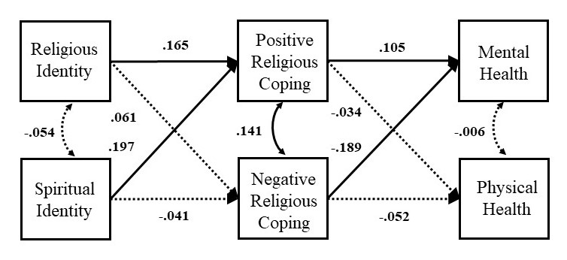
Figure 5. Path diagram for Model 2 with HCHS/SOL data.
Sample 4: MASALA
As previously found, spirituality was not related to mental health (β = .023 [-.044, .087], p = .503). However, in this sample, spirituality was negatively related to physical health (β = -.132 [-.197, -.067], p < .001); however, this is in the opposite direction than previous research would suggest. Religiosity was not related to mental health (β = -.013 [-.079, .053], p = .702) nor physical health (β = .051 [-.015, .117], p = .128).
The χ² test of model fit indicated that the second model produced a covariance matrix that was significantly different from the sample covariance matrix, χ²(4) = 1.775, p = .03. However, other model fit indices indicated adequate model fit (SRMR = .018; Table 2). Those who identified as religious were significantly more likely to report using positive religious coping strategies (β = .129 [.067, .191], p < .001) but were not more likely to use negative religious coping strategies than the non-religious (β = -.039 [-.108, .030], p = .265). Those who identified as spiritual were significantly more likely to report using positive religious coping strategies (β = .439 [.384, .494], p < .001), and spiritual identity was related to greater use of negative religious coping strategies (β = .238 [.172, .304], p < .001). Only the use of negative coping strategies was significantly related to a health outcome; greater use of negative coping strategies led to lower mental health (β = -.138 [-.213, -.063], p = .001). In the model which included control variables, the effect of positive religious coping strategies on mental health was significant (β = .078 [.003, .153], p < .001; Table S5).
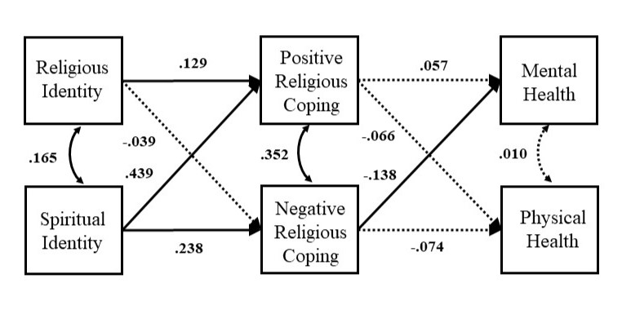
Figure 6. Path diagram for Model 2 with MASALA data.

Discussion
The relationship between religiosity/spirituality and health has received considerable attention from researchers. Though typically understood to be a salubrious relationship, less is understood about what features of religious and spiritual life might promote health. Across four religiously and ethnically diverse samples, we find that:
- Spiritual and/or religious individuals rely on positive religious coping strategies more than those who do not identify as spiritual and/or religious.
- The use of negative religious coping strategies is not consistently related to religious or spiritual identity.
- Individuals who utilize negative religious coping strategies show worsened mental health.
- The use of positive religious coping strategies is not consistently related to physical or mental health outcomes.

Table 3. Summary of the direction of findings across samples for Model 2.
Path | NHSII | SHS | HCHS/SOL | MASALA
Spirituality → PRC | + | + | + | +
Religiosity → PRC | + | + | + | +
Spirituality → NRC | NULL | NULL | NULL | +
Religiosity → NRC | + | + | NULL | NULL
PRC → Physical Health | NULL | NULL | NULL | NULL
PRC → Mental Health | + | NULL | + | NULL
NRC → Physical Health | - | NULL | NULL | NULL
NRC → Mental Health | - | - | - | -
Note: PRC = Positive Religious Coping; NRC = Negative Religious Coping
Practically, these findings lead to several recommendations for health practitioners. Given the consistent, negative relationship between negative religious coping strategies and mental health, identifying and addressing the beliefs may be critical to improving well-being. Additionally, among some groups, boosting positive religious coping strategies may improve mental health, but there is no consistent link between positive religious coping strategies and physical health. This may suggest that religious or cultural identity moderate this relationship. More research is needed to understand under which individual and situational conditions positive religious coping strategies promote better mental health.
The samples and measures used in this study pose several limitations. First, contrary to the existing literature, we failed to find consistent, significant direct effects of religious or spiritual identity on our health variables; this may be attributable to the dichotomization of religious and spiritual identity failing to capture variance. Similarly, the scales used to measure positive and negative religious coping strategies may not be generalizable to all religious and spiritual identities. For example, focusing on religious strategies related to God may limit responses for polytheists and atheists. Further, the scale lacked religious social coping strategies such as “seeking guidance from clergy”, which is important to differentiating between intrinsic and extrinsic religious experiences. Lastly, this data does not lend itself to causal claims. It is possible that, for those with better mental health, it is easier to engage in positive religious coping strategies, while for those with poorer mental health, negative religious coping strategies such as viewing God as punishing, are reflective of broader, negative beliefs about the world.
To address these limitations and further explore this space, researchers should develop longitudinal methods to test how using different coping strategies impacts health over time. Additionally, the religious coping strategies measured here fail to account for two key components of religious and spiritual life: rituals and community. Future work should expand the coping scale to account for these components (ex. religious ceremonies to process grief, social support within religious settings). Further, religion is just one form of culture (Cohen, 2009); other forms of culture also prescribe ways to cope (ex. cultures that promote alcohol as a form of negative coping). How do these culturally-prescribed coping strategies interact with religiously-prescribed coping strategies (ex. temperance)? Lastly, when considering the broader coping strategy landscape, it is important to ask whether strategies based in religion are enough to deal with life’s challenges. Is a coping toolkit that combines these religious strategies with secular strategies most beneficial to health well-being? Does the strength of one’s religious identity matter? Relatedly, is there something unique about positive and negative religious coping strategies (Moon et al., 2022), or do these strategies impact health and well-being in the same way their positive and negative secular coping strategies would?
Conclusion
Our data suggests that, across religious, spiritual, and cultural identities, individuals do utilize a variety of religious coping strategies. However, it is unclear how using positive versus negative religious coping strategies impacts physical and mental health. While there is significant variance in religious coping strategy usage, by-and-large, we find that religious and spiritual individuals are more likely to use positive religious coping strategies and that the usage of negative religious coping strategies is especially detrimental to one’s mental health.
References
Aldao, A., Nolen-Hoeksema, S., & Schweizer, S. (2010). Emotion-regulation strategies across psychopathology: A meta-analytic review. Clinical Psychology Review, 30(2), 217–237. https://doi.org/10.1016/j.cpr.2009.11.004
American Psychological Association. (2022). Stress in America 2022: Concerned for the future, beset by inflation. American Psychological Association. https://www.apa.org/news/press/releases/stress/2022/concerned-future-inflation
Ano, G. G., & Vasconcelles, E. B. (2005). Religious coping and psychological adjustment to stress: A meta‐analysis. Journal of Clinical Psychology, 61(4), 461–480. https://doi.org/10.1002/jclp.20049
Carver, C. S. (1997). You want to measure coping but your protocol’s too long: Consider the brief COPE. International Journal of Behavioral Medicine, 4(1), 92–100. https://doi.org/10.1207/s15327558ijbm0401_6
Chamberlain, K., & Zika, S. (1992). Religiosity, meaning in life, and psychological well-being. In J. F. Schumaker (Ed.), Religion and Mental Health. Oxford University Press.
Chatters, L. M. (2000). Religion and health: Public health research and practice. Annual Review of Public Health, 21, 335. https://doi.org/10.1146/annurev.publhealth.21.1.335
Cohen, A. B. (2009). Many forms of culture. American Psychologist, 64(3), 194–204. https://doi.org/10.1037/a0015308
Cummings, J. P., & Pargament, K. I. (2010). Medicine for the spirit: Religious coping in individuals with medical conditions. Religions, 1(1), 28–53. https://doi.org/10.3390/rel1010028
DeAngelis, R. T., & Ellison, C. G. (2017). Kept in his care: The role of perceived divine control in positive reappraisal coping. Religions, 8(8), 133. https://doi.org/10.3390/rel8080133
Dolcos, F., Hohl, K., Hu, Y., & Dolcos, S. (2021). Religiosity and resilience: Cognitive reappraisal and coping self-efficacy mediate the link between religious coping and well-being. Journal of Religion and Health, 60, 2892–2905. https://doi.org/10.1007/s10943-020-01160-y
Fredrickson, B. L. (2002). How Does Religion Benefit Health and Well-Being? Are Positive Emotions Active Ingredients? Psychological Inquiry, 13(3), 209–213.
Gerber, M. M., Boals, A., & Schuettler, D. (2011). The unique contributions of positive and negative religious coping to posttraumatic growth and PTSD. Psychology of Religion and Spirituality, 3(4), 298. https://doi.org/10.1037/a0023016
Gross, J. J. (2015). Emotion regulation: Current status and future prospects. Psychological Inquiry, 26(1), 1–26. https://doi.org/10.1080/1047840x.2014.940781
Holt, C. L., Roth, D. L., Huang, J., & Clark, E. M. (2018). Role of religious social support in longitudinal relationships between religiosity and health-related outcomes in African Americans. Journal of Behavioral Medicine, 41(1), 62–73. https://doi.org/10.1007/s10865-017-9877-4
Koenig, H. G., Hays, J. C., George, L. K., Blazer, D. G., Larson, D. B., & Landerman, L. R. (1997). Modeling the Cross-Sectional Relationships Between Religion, Physical Health, Social Support, and Depressive Symptoms. The American Journal of Geriatric Psychiatry, 5(2), 131–144. https://doi.org/10.1097/00019442-199700520-00006
Koenig, H. G., King, D., & Carson, V. B. (2012). Handbook of religion and health. Oup Usa.
Krok, D. (2015). The Role of Meaning in Life Within the Relations of Religious Coping and Psychological Well-Being. Journal of Religion and Health, 54(6), 2292–2308. https://doi.org/10.1007/s10943-014-9983-3
Langley, E. B., Vornlocher, C., Manapat, P. D., & Shiota, M. N. (2023). Coping with COVID: Use, factor structure, and health behavior implications of specific emotion regulation strategies during the coronavirus pandemic. Social and Personality Psychology Compass, 17(10), e12812. https://doi.org/10.1111/spc3.12812
Lazarus, R. S., & Folkman, S. (1987). Transactional theory and research on emotions and coping. European Journal of Personality, 1(3), 141–169. https://doi.org/10.1002/per.2410010304
Mccullough, M. E., Friedman, H. S., Enders, C. K., Martin, L. R., Hoyt, W. T., & Larson, D. B. (2009). Does Devoutness Delay Death? Psychological Investment in Religion and Its Association With Longevity in the Terman Sample. Journal of Personality and Social Psychology, 97(5). https://doi.org/10.1037/a0016366
Mccullough, M., & Willoughby, B. (2009). Religion, Self-Regulation, and Self-Control: Associations, Explanations, and Implications. Psychological Bulletin, 135, 69–93. https://doi.org/10.1037/a0014213
Moon, J. W., Cohen, A. B., Laurin, K., & MacKinnon, D. P. (2022). Is religion special? Perspectives on Psychological Science, 8(2), 340–357. https://doi.org/10.1177/17456916221100485
Pankowski, D., & Wytrychiewicz-Pankowska, K. (2023). Turning to religion during COVID-19 (Part I): A systematic review, meta-analysis and meta-regression of studies on the relationship between religious coping and mental health throughout COVID-19. Journal of Religion and Health, 62(1), 510–543. https://doi.org/10.1007/s10943-022-01703-5
Pargament, K. I., Koenig, H. G., & Perez, L. M. (2000). The many methods of religious coping: Development and initial validation of the RCOPE. Journal of Clinical Psychology, 56(4), 519–543. https://doi.org/10.1002/(sici)1097-4679(200004)56:4<519::aid-jclp6>3.0.co;2-1
Pargament, K. I., Koenig, H. G., Tarakeshwar, N., & Hahn, J. (2004). Religious coping methods as predictors of psychological, physical and spiritual outcomes among medically ill elderly patients: A two-year longitudinal study. Journal of Health Psychology, 9(6), 713–730. https://doi.org/10.1177/1359105304045366
Pargament, K. I., Smith, B. W., Koenig, H. G., & Perez, L. (1998). Patterns of positive and negative religious coping with major life stressors. Journal for the Scientific Study of Religion, 710–724.
Penley, J. A., Tomaka, J., & Wiebe, J. S. (2002). The association of coping to physical and psychological health outcomes: A meta-analytic review. Journal of Behavioral Medicine, 25, 551–603. https://doi.org/10.1023/a:1020641400589
Shiota, M. N. (2006). Silver linings and candles in the dark: Differences among positive coping strategies in predicting subjective well-being. Emotion, 6(2), 335. https://doi.org/10.1037/1528-3542.6.2.335
Tamir, M. (2016). Why Do People Regulate Their Emotions? A Taxonomy of Motives in Emotion Regulation. Personality and Social Psychology Review, 20(3), 199–222. https://doi.org/10.1177/1088868315586325
Thoits, P. A. (2010). Stress and health: Major findings and policy implications. Journal of Health and Social Behavior, 51(S), S41–S53. https://doi.org/10.1177/0022146510383499
Umezawa, Y., Lu, Q., You, J., Kagawa-Singer, M., Leake, B., & Maly, R. C. (2012). Belief in Divine Control, Coping, and Race/Ethnicity among Older Women with Breast Cancer. Annals of Behavioral Medicine, 44(1), 21–32. https://doi.org/10.1007/s12160-012-9358-5
Upenieks, L. (2022). Religious/spiritual struggles and suicidal ideation in the COVID-19 era: Does the belief in divine control and religious attendance matter? Psychology of Religion and Spirituality, 14(3), 338–350. https://doi.org/10.1037/rel0000467
VanderWeele, T. J. (2017). Religious Communities and Human Flourishing. Current Directions in Psychological Science, 26(5), 476–481. https://doi.org/10.1177/0963721417721526
Vishkin, A., Bigman, Y. E., Porat, R., Solak, N., Halperin, E., & Tamir, M. (2016). God rest our hearts: Religiosity and cognitive reappraisal. Emotion, 16(2), 252–262. https://doi.org/10.1037/emo0000108
Wallace, L. E., Anthony, R., End, C. M., & Way, B. M. (2019). Does Religion Stave Off the Grave? Religious Affiliation in One’s Obituary and Longevity. Social Psychological and Personality Science, 10(5), 662–670. https://doi.org/10.1177/1948550618779820
Warner, E. T., Kent, B. V., Zhang, Y., Argentieri, M. A., Rowatt, W. C., Pargament, K., Koenig, H. G., Underwood, L., Cole, S. A., Daviglus, M. L., Kanaya, A. M., Palmer, J. R., Huang, T., Blais, M. A., & Shields, A. E. (2021). “The Study on Stress, Spirituality, and Health (SSSH): Psychometric Evaluation and Initial Validation of the SSSH Baseline Spirituality Survey.” Religions, 12(3), 150. https://doi.org/10.3390/rel12030150
Webb, T. L., Miles, E., & Sheeran, P. (2012). Dealing with feeling: A meta-analysis of the effectiveness of strategies derived from the process model of emotion regulation. Psychological Bulletin, 138(4), 775. https://doi.org/10.1037/a0027600
Whitehead, B. R., & Bergeman, C. S. (2020). Daily religious coping buffers the stress–affect relationship and benefits overall metabolic health in older adults. Psychology of Religion and Spirituality, 12(4), 393. https://doi.org/10.1037/rel0000251
Wijngaards-de Meij, L., Stroebe, M., Schut, H., Stroebe, W., van den Bout, J., van der Heijden, P., & Dijkstra, I. (2005). Couples at risk following the death of their child: Predictors of grief versus depression. Journal of Consulting and Clinical Psychology, 73(4), 617. https://doi.org/10.1037/0022-006x.73.4.617
Wormley, A. S., Vornlocher, C., Aglozo, E. Y., & Cohen, A. B. (in press). Spirituality as a Manifestation of Culture and Diversity. In J. R. Webb (Ed.), Handbook of Spirituality, Health, and Well-Being: A Psychological Perspective.
Wormley, A. S., Vornlocher, C., Aglozo, E. Y., Jayawickreme, E., Johnson, K. A., Moon, J. W., Van Cappellen, P., Verma, A., & Cohen, A. B. (2023). Religion and human flourishing. The Journal of Positive Psychology, 1–16. https://doi.org/10.1080/17439760.2023.2297208
Zinnbauer, B. J., & Pargament, K. I. (2005). Religiousness and spirituality. Handbook of the Psychology of Religion and Spirituality, 54, 1–6.
Zinnbauer, B. J., Pargament, K. I., Cole, B., Rye, M. S., Butter, E. M., Belavich, T. G., Hipp, K. M., Scott, A. B., & Kadar, J. L. (1997). Religion and Spirituality: Unfuzzying the Fuzzy. Journal for the Scientific Study of Religion, 36(4), 549–564. https://doi.org/10.2307/1387689
Zwingmann, C., Wirtz, M., Müller, C., Körber, J., & Murken, S. (2006). Positive and negative religious coping in German breast cancer patients. Journal of Behavioral Medicine, 29, 533–547. https://doi.org/10.1007/s10865-006-9074-3

Appendix A: Religious Coping Strategies Scale
In facing recent stressful life events. . .
Positive Religious Coping
- I saw my situation as part of [God]’s plan
- I tried to see how [God] might be trying to strengthen me in these situations.
- I tried to make sense of the situation with [God].
- I worked together with [God] to relieve my worries.
- I did what I could and put the rest in [God]’s hands.
- I took control over what I could, and gave the rest up to [God].
- I sought [God]’s love or care.
- I trusted that [God] would be by my side.

Negative Religious Coping
- I wondered what I did for God to punish me.
- I wondered if [God] allowed this event to happen to me because of my wrongdoings.
- I believed [the devil] or evil spirits were responsible for my situation
- I felt as though [the devil] or an evil spirit was trying to turn me away from [God].
- I wondered whether [God] had abandoned me.
- I questioned [God]’s love or care for me.

Table S1. Religious affiliation by sample.
Religious Affiliation | NHSII | SHS | SOL/HCHS | MASALA
- Evangelical | 934 | 27 | 207 | 0
- Mainline Protestant | 1128 | 115 | 42 | 13
- Black Protestant | 0 | 0 | 0 | 0
- Catholic | 1186 | 179 | 649 | 14
- Jewish | 77 | 0 | 1 | 0
- Buddhist | 63 | 1 | 0 | 8
- Hindu | 1 | 0 | 0 | 605
- Muslim | 2 | 0 | 0 | 77
- Sikh | 0 | 0 | 0 | 56
- Jain | 0 | 0 | 0 | 50
- TNAP | 0 | 119 | 0 | 0
- TNAP/Christian | 0 | 177 | 0 | 0
- Other | 89 | 41 | 39 | 73
- None | 294 | 25 | 51 | 30
- Agnostic | 236 | 5 | 5 | 32
- Atheist | 103 | 5 | 5 | 25
- Missing Data | 155 | 14 | 1 | 7
Note: TNAP: Traditional Native American Practice

Table S2. Standardized path coefficients for models using NHSII data.
 |  | Model 1 | Model 2 | Model 3
Direct Effects
 | Spirituality → Physical Health | -.006 [-.039, .026]
 | Spirituality → Mental Health | -.001 [-.033, .031]
 | Religiosity → Physical Health | .000 [-.032, .032]
 | Religiosity → Mental Health | .074 [.042, .106]*
Hypothesized Relationships
 | Spirituality → PRC |  | .151 [.122, .18]* | .151 [.122, .18]*
 | Religiosity → PRC |  | .556 [.535, .578]* | .556 [.535, .578]*
 | Spirituality → NRC |  | -.013 [-.049, .024] | -.012 [-.049, .024]
 | Religiosity → NRC |  | .166 [.135, .198]* | .167 [.135, .198]*
 | PRC → Physical Health |  | -.010 [-.043, .024] | -.017 [-.05, .016]
 | PRC → Mental Health |  | .150 [.118, .182]* | .158 [.125, .19]*
 | NRC → Physical Health |  | -.091 [-.124, -.057]* | -.092 [-.125, -.059]*
 | NRC → Mental Health |  | -.179 [-.212, -.146]* | -.171 [-.204, -.139]*
Covariance
 | Religiosity ↔ Spirituality | .204 [.175, .233]* | .204 [.175, .233]* | .204 [.175, .233]*
 | PRC ↔ NRC |  | .204 [.173, .235]* | .204 [.173, .235]*
 | Physical Health ↔ Mental Health | -.296 [-.325, -.268* | -.315 [-.343, -.286]* | -.308 [-.336, -.279]*
Control Relationships
 | Income → Mental Health |  |  | .016 [-.017, .048]
 | Year of Birth → Mental Health |  |  | -.113 [-.143, -.082]*
 | Marital Status → Mental Health |  |  | -.028 [-.059, .003]
 | Income → Physical Health |  |  | .079 [.046, .112]*
 | Year of Birth → Physical Health |  |  | .135 [.104, .166]*
 | Marital Status → Physical Health |  |  | -.019 [-.051, .012]
Note: PRC = Positive Religious Coping; NRC = Negative Religious Coping; * p < .05

Table S3. Standardized path coefficients for models using SHS data.
 |  | Model 1 | Model 2 | Model 3
Direct Effects
 | Spirituality → Physical Health | -.040 [-.116, .036]
 | Spirituality → Mental Health | .007 [-.069, .083]
 | Religiosity → Physical Health | -.011 [-.089, .067]
 | Religiosity → Mental Health | .019 [-.059, .097]
Hypothesized Relationships
 | Spirituality → PRC |  | .200 [.131, .269]* | .200 [.131, .270]*
 | Religiosity → PRC |  | .328 [.261, .395]* | .328 [.261, .395]*
 | Spirituality → NRC |  | -.032 [-.108, .043] | -.033 [-.109, .043]
 | Religiosity → NRC |  | .129 [.053, .205]* | .129 [.053, .205]*
 | PRC → Physical Health |  | -.081 [-.164, .002] | -.032 [-.117, .053]
 | PRC → Mental Health |  | .012 [-.070, .093] | -.012 [-.098, .073]
 | NRC → Physical Health |  | .076 [-.008, .160] | .078 [-.008, .163]
 | NRC → Mental Health |  | -.240 [-.321, -.159]* | -.203 [-.289, -.117]*
Covariance
 | Religiosity ↔ Spirituality | .117 [.044, .190]* | .117 [.044, .190]* | .117 [.044, .190]*
 | PRC ↔ NRC |  | .287 [.217, .357]* | .288 [.217, .358]*
 | Physical Health ↔ Mental Health | -.448 [-.510, -.387]* | -.450 [-.512, -.388]* | -.453 [-.515, -.391]*
Control Relationships
 | Income → Mental Health |  |  | .117 [.037, .197]*
 | Year of Birth → Mental Health |  |  | -.096 [-.185, -.008]
 | Marital Status → Mental Health |  |  | -.007 [-.094, .080]
 | Gender → Mental Health |  |  | -.031 [-.109, .047]
 | Income → Physical Health |  |  | .063 [-.017, .143]
 | Year of Birth → Physical Health |  |  | .220 [.135, .306]*
 | Marital Status → Physical Health |  |  | .012 [-.075, .098]
 | Gender → Physical Health |  |  | -.012 [-.090, .066]
Note: PRC = Positive Religious Coping; NRC = Negative Religious Coping; * p < .05

Table S4. Standardized path coefficients for models using HCHS/SOL data.
 |  | Model 1 | Model 2 | Model 3
Direct Effects
 | Spirituality → Physical Health | -.057 [-.124, .010]
 | Spirituality → Mental Health | .041 [-.026, .109]
 | Religiosity → Physical Health | -.012 [-.081, .057]
 | Religiosity → Mental Health | -.028 [-.097, .040]
Hypothesized Relationships
 | Spirituality → PRC |  | .197 [.134, .259]* | .197 [.135, .260]*
 | Religiosity → PRC |  | .165 [.103, .228]* | .166 [.103, .228]*
 | Spirituality → NRC |  | -.041 [-.105, .024] | -.041 [-.106, .024]
 | Religiosity → NRC |  | .061 [-.004, .126] | .061 [-.004, .126]
 | PRC → Physical Health |  | -.034 [-.103, .035] | .008 [-.060, .077]
 | PRC → Mental Health |  | .105 [.038, .172]* | .120 [.053, .188]*
 | NRC → Physical Health |  | -.052 [-.123, .019] | -.049 [-.118, .020]
 | NRC → Mental Health |  | -.189 [-.257, -.121]* | -.187 [-.255, -.119]*
Covariance
 | Religiosity ↔ Spirituality | -.054 [-.116, .008] | -.054 [-.116, .008] | -.054 [-.116, .008]
 | PRC ↔ NRC |  | .141 [.077, .205]* | .140 [.076, .204]*
 | Physical Health ↔ Mental Health | .002 [-.066, .071] | -.006 [-.075, .062] | -.033 [-.101, .036]
Control Relationships
 | Income → Mental Health |  |  | .136 [.067, .204]*
 | Year of Birth → Mental Health |  |  | .008 [-.063, .079]
 | Marital Status → Mental Health |  |  | .008 [-.062, .078]
 | Gender → Mental Health |  |  | -.038 [-.106, .031]
 | Income → Physical Health |  |  | .113 [.043, .182]*
 | Year of Birth → Physical Health |  |  | .217 [.147, .286]*
 | Marital Status → Physical Health |  |  | .039 [-.031, .109]
 | Gender → Physical Health |  |  | -.041 [-.109, .028]
Note: PRC = Positive Religious Coping; NRC = Negative Religious Coping; * p < .05

Table S5. Standardized path coefficients for models using MASALA data.
 |  | Model 1 | Model 2 | Model 3
Direct Effects
 | Spirituality → Physical Health | -.132 [-.197, -.067]*
 | Spirituality → Mental Health | .023 [-.044, .087]
 | Religiosity → Physical Health | .051 [-.015, .117]
 | Religiosity → Mental Health | -.013 [-.079, .053]
Hypothesized Relationships
 | Spirituality → PRC |  | .439 [.384, .494]* | .438 [.383, .493]*
 | Religiosity → PRC |  | .129 [.067, .191]* | .129 [.067, .192]*
 | Spirituality → NRC |  | .238 [.172, .304]* | .236 [.170, .303]*
 | Religiosity → NRC |  | -.039 [-.108, .030] | -.039 [-.108, .030]
 | PRC → Physical Health |  | -.066 [-.139, .007] | .013 [-.059, .086]
 | PRC → Mental Health |  | .057 [-.016, .130] | .078 [.003, .153]*
 | NRC → Physical Health |  | -.074 [-.149, .002] | -.058 [-.131, .015]
 | NRC → Mental Health |  | -.138 [-.213, -.063]* | -.127 [-.203, -.052]*
Covariance
 | Religiosity ↔ Spirituality | .165 [.103, .227]* | .165 [.103, .227]* | .165 [.103, .227]*
 | PRC ↔ NRC |  | .352 [.293, .411]* | .352 [.293, .411]*
 | Physical Health ↔ Mental Health | .021 [-.044, .087] | .010 [-.055, .076] | .011 [-.054, .077]
Control Relationships
 | Income → Mental Health |  |  | .085 [.012, .158]*
 | Year of Birth → Mental Health |  |  | -.103 [-.170, -.036]*
 | Marital Status → Mental Health |  |  | -.032 [-.110, .045]
 | Gender → Mental Health |  |  | -.063 [-.129, .004]
 | Income → Physical Health |  |  | .106 [.035, .177]*
 | Year of Birth → Physical Health |  |  | .241 [.178, .304]*
 | Marital Status → Physical Health |  |  | -.071 [-.146, .005]
 | Gender → Physical Health |  |  | -.168 [-.231, -.105]*
Note: PRC = Positive Religious Coping; NRC = Negative Religious Coping; * p < .05

Model 4: the moderating role of religious affiliation

We preregistered a third model, which included religious affiliation as a moderating variable on paths b₁ - b₄ in Model 2. Religious affiliation was dummy coded as the effect of being in the dominant religion in the sample where 1 represented being a part of the majority religion in the sample and 0 represented not being a part of the majority religion in the sample: Catholicism in NHSII, Catholicism in SHS, Catholicism in HCHS/SOLS, and Hinduism in MASALA. Thus, Hindu participants were coded as 1 and non-Hindu participants were coded as 0. For example, in NHSII, Model 4 was:

PosReligCop_{i} = b₁ · Religious_{i} + b₃ · Spiritual_{i} + b₅ · Catholic_{i} + b₇ · Catholic*Religious_{i} + b₉ · Catholic*Spiritual_{i} + e_{1i}
NegReligCop_{i} = b₂ · Religious_{i} + b₄ · Spiritual_{i} + b₆ · Catholic_{i} + b₈ · Catholic*Religious_{i} + b₁₀ · Catholic*Spiritual_{i} + e_{2i}
MentalHealth_{i} = b₁₁ · PosReligCop_{i} + b₁₃ · NegReligCop_{i} + e_{3i}
PhysicalHealth_{i} = b₁₂ · PosReligCop_{i} + b₁₄ · NegReligCop_{i} + e_{4i}
The interactions were interpreted as the effect of identifying as the dominant religion and religious (ex. Catholic*Religious) and the effect of identifying as the dominant religion and spiritual (ex. Catholic*Spiritual).
Within the NHSII sample, there was a positive effect of being Catholic on the use of positive religious coping strategies. However, identifying as Catholic and religious was negatively related to the use of positive coping strategies. Model fit was poor (χ²(19) = 19637.038, p < .001; SRMR = .232).
Within the SHS sample, there was a positive main effect of identifying as Catholic on the use of negative religious coping strategies. However, identifying as religious and Catholic decreased the usage of negative coping strategies. Model fit was poor (χ²(19) = 242.389, p < .001; SRMR = .219).
Within the HCHS/SOLS sample, there was a positive effect of being Catholic on the use of positive religious coping strategies but no effect on negative religious coping. Identifying as Catholic and spiritual had a negative effect on the use of positive religious coping strategies. Model fit was poor (χ²(19) = 3704.26, p < .001; SRMR = .211).
Within the MASALA sample, there was no main effect of identifying as Hindu on the use of positive or negative religious coping strategies. However, individuals who identified as spiritual and Hindu were less likely to rely on positive religious coping strategies. Again, model fit was poor (χ²(19) = 3284.966, p < .001; SRMR = .208).
In sum, the lack of consistent effects and poor model fit do not lend themselves to interpretation.
Table S6. Standardized path coefficients for Model 4 in all samples.
 |  | NHSII | SHS | HCHS/SOLS | MASALA
Hypothesized Relationships
 | Spirituality → PRC | .149 [.118, .179]* | .193 [.111, .276]* | .305 [.216, .394]* | .503 [.434, .573]*
 | Religiosity → PRC | .565 [.537, .592]* | .327 [.251, .402]* | .179 [.090, .268]* | .092 [-.010, .194]
 | Spirituality → NRC | -.004 [-.046, .037] | -.001 [-.087, .085] | -.075 [-.197, .047] | .281 [.182, .381]*
 | Religiosity → NRC | .183 [.147, .219]* | .182 [.106, .257]* | .077 [-.026, .181] | -.056 [-.170, .058]
 | PRC → Physical Health | -.010 [-.045, .025] | -.082 [-.165, .001] | -.037 [-.111, .038] | -.070 [-.147, .007]
 | PRC → Mental Health | .157 [.123, .191]* | .013 [-.069, .095] | .113 [.040, .186]* | .060 [-.017, .136]
 | NRC → Physical Health | -.092 [-.126, -.058]* | .081 [-.008, .170] | -.053 [-.124, .019] | -.076 [-.153, .001]
 | NRC → Mental Health | -.181 [-.215, -.147]* | -.252 [-.339, -.165]* | -.189 [-.258, -.121]* | -.140 [-.216, -.064]*
Effects of Religious Affiliation
 | Dominant Religion → PRC | .173 [.062, .284]* | -.095 [-.273, .082] | .189 [.036, .342]* | .012 [-.150, .174]
 | Dominant Religion * Spirituality → PRC | -.061 [-.172, .050] | -.015 [-.181, .150] | -.217 [-.367, -.068]* | -.136 [-.252, -.020]*
 | Dominant Religion * Religiosity → PRC | -.139 [-.190, -.087]* | .054 [-.104, .212] | -.044 [-.173, .084] | .067 [-.099, .233]
 | Dominant Religion → NRC | .106 [-.048, .261] | .211 [.040, .382]* | .023 [-.160, .207] | .035 [-.147, .216]
 | Dominant Religion * Spirituality → NRC | -.072 [-.222, .078] | -.084 [-.252, .084] | .064 [-.119, .247] | -.077 [-.215, .060]
 | Dominant Religion * Religiosity → NRC | -.067 [-.135, .002] | -.231 [-.383, -.079]* | -.049 [-.195, .098] | .040 [-.146, .226]
Covariance
 | Religiosity ↔ Spirituality | .204 [.175, .233]* | .117 [.044, .190]* | -.054 [-.116, .008] | .165 [.103, .227]*
 | PRC ↔ NRC | .202 [.171, .233]* | .290 [.220, .360]* | .142 [.078, .206]* | .351 [.292, .411]*
 | Physical Health ↔ Mental Health | -.315 [-.343, -.287]* | -.45 [-.512, -.388]* | -.006 [-.075, .062] | .010 [-.055, .076]
Note: PRC = Positive Religious Coping; NRC = Negative Religious Coping; * p < .05

