

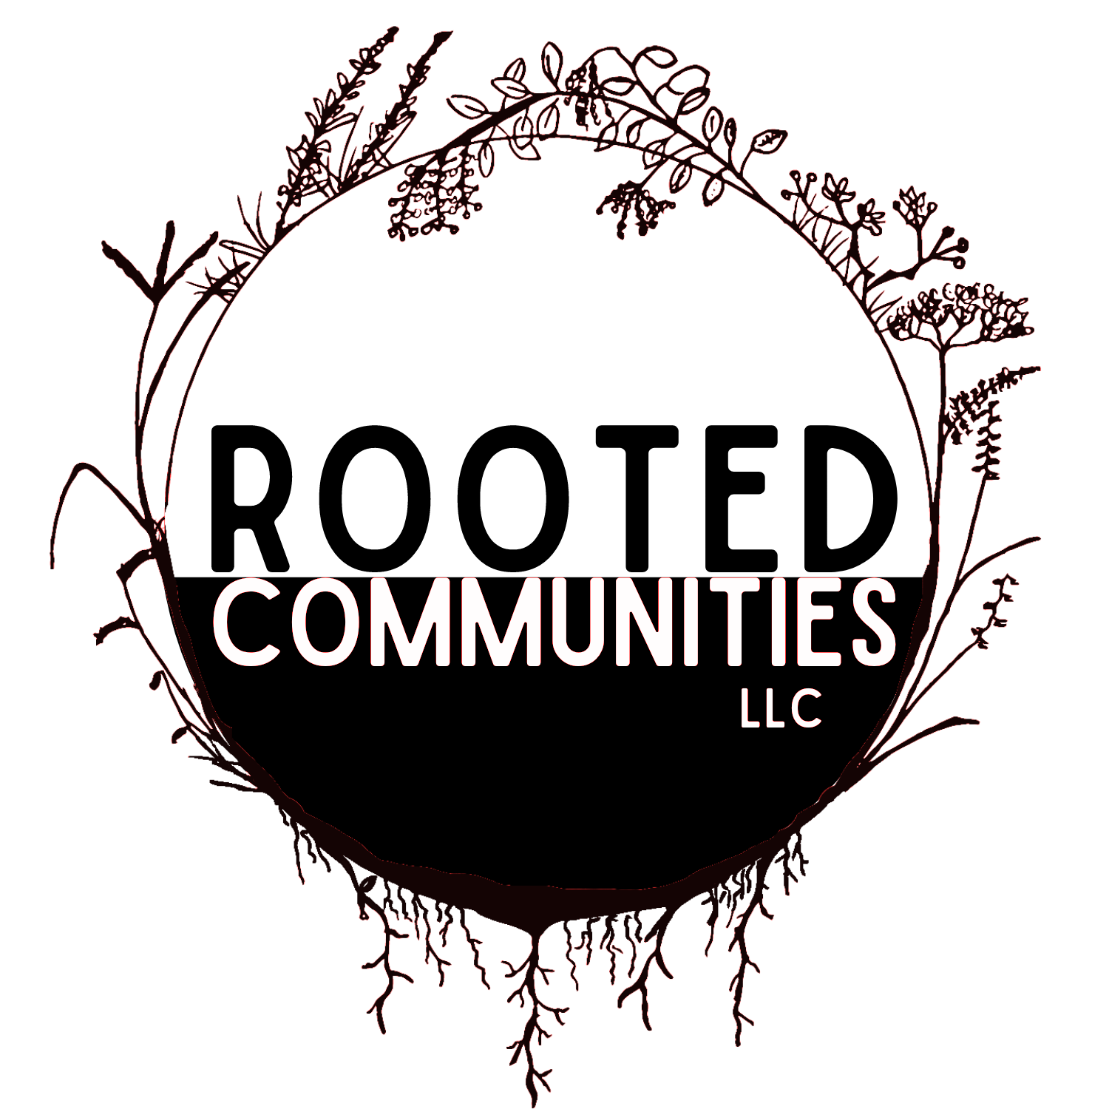

ROOTED COMMUNITIES, LLC
Pitch: Assisted Living
May 15, 2025
─
Kelsey Scott
Owner
16736 BIA HWY 8
Gettysburg, SD 57442

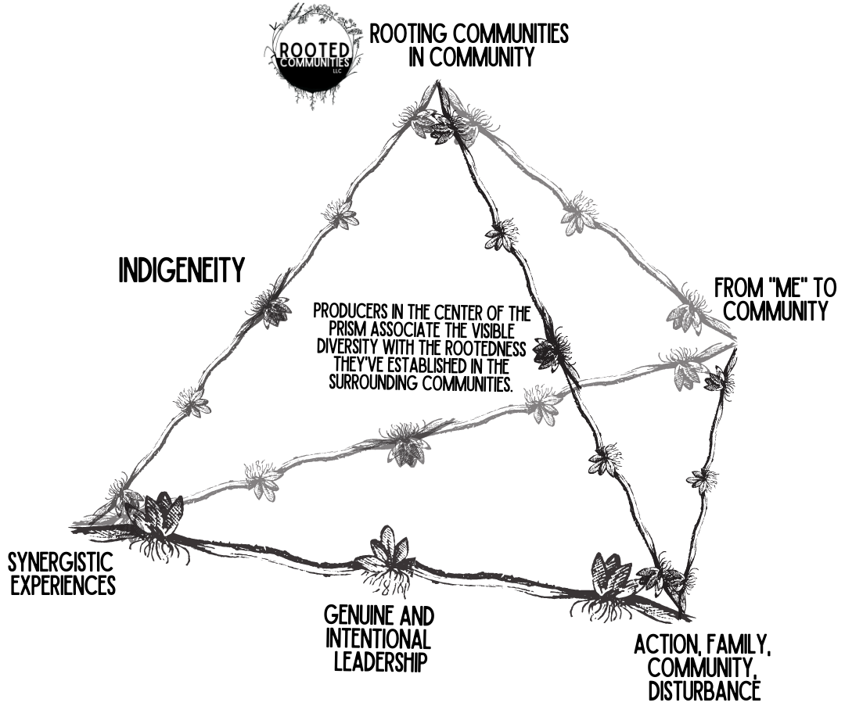
Rooted Communities, LLC
16736 BIA HWY 8
Gettysburg, SD 57442

Evolutionary Purpose
Kinship is Keystone.
Empowering a deeper connectedness in kinship as good relatives of nature. The creation of communities within communities. Rooted Communities empowers a deeper appreciation for the act of building relationships as a means of curating a more robust, resilient, and rooted future.
Root (noun) /rōōt/
“The part of a plant which attaches it to the ground or to a support, typically underground, conveying water and nourishment to the rest of the plant via numerous branches and fibers.”
Community (noun) /ke’myōōnedē/
“1. a particular area or place considered together with its inhabitants.
2. a feeling of fellowship with others, as a result of sharing common attitudes, interests, and goals.
3. a group of interdependent organisms of different species growing or living together in a specified habitat.”

Source Idea
A synergistic experience within and amongst communities that enlightens, inspires, and motivates a greater good.

Pattern Integrity

Action Oriented.
Individuals feel motivated & empowered in taking action, with informed options ground-truthed against their values.
- Embracing problems as opportunities.
- Detail-oriented planning to offer concise communication and cross-generational impact.
- Realistic understanding of desired outcomes, labor demand, implementation timelines.

Family Focused.
At the heart of decision-making should be one’s right to a family-focused lifestyle.
- Identifying roles and commitments to family.
- Prioritizing healthy boundaries for family & work lifestyles on the ranch.

Community Inspired.
Aware that multiple communities inspire our reality.
- Acknowledging the communities impacted.
- Seeking community with other like missions.

Welcoming Disturbance.
Inviting challenge, regrowth, regeneration.
- New normalcy, flexibility, personal growth.
- Preparing with redundancies when necessary.

Intellectual Property

From “Me” to “Community.”
Tools, conversation styles, and accountability methods that support a paradigm-shifting evolution in one’s consideration for their relationship with the world.

Source Idea to Pattern Integrity

Genuine & Intentional Leadership.
Decision influencers humbly embrace their power in informing consistent, and reliable input.
Sharing in vulnerability, we will release guilt, connect deeply, and inspire accountability.

Vector of Power (VP)

Indigeneity.
Embracing the indigenous identity of the lands we call home. We must call out discrimination, recognize inequity, and embrace the traumas that have informed worldviews. We must help Mother Earth to heal from the traumas she’s had to endure; in turn, she will help to heal us.

Collaboratively designed with the support of RootedCommunitiesGPT

Oahe Legacy Living

Honors the passing of wisdom and stewardship between generations.
Scoping document for a one-of-a-kind assisted living facility rooted in the syntropic principles of Rooted Communities LLC. This facility aims to serve aging farmers, ranchers, and tribal elders on the banks of the Missouri River near Forest City, South Dakota.

🌱 Project Overview: A Syntropic Assisted Living Community

Vision
To create an intergenerational, nature-integrated assisted living facility that honors the land, supports aging rural and tribal populations, and facilitates land succession to the next generation.

Location
Situated on the banks of the Missouri River near Forest City, SD, the site offers access to prairie lands, river breaks, and scenic beauty. The land is part of a Tribal Indian Reservation, presenting opportunities for tribal investment and collaboration.

📊 Contextual Landscape

Aging Rural Population
- South Dakota's elderly population (65+) is projected to increase from 122,862 in 2010 to 225,744 by 2035.
- By 2035, elders will constitute over 20% of the population in all but 10 South Dakota counties, with 27 counties seeing elders make up over 40% of the local population. (My LRC+)

Assisted Living Shortage
- From 2015 to 2023, 18 nursing homes in South Dakota closed, many due to caregiver shortages.
- Adult day services have decreased from 30 to three in the last seven years. (South Dakota Searchlight, South Dakota Searchlight)

Land Succession Challenges
- The average age of South Dakota farmers and ranchers is 57.2 years.
- 59% of young farmers report that finding access to affordable land is "very or extremely challenging." (Red River Farm Network, South Dakota News Watch)

🧭 Strategic Objectives
- Provide Quality Care: Offer assisted living services that cater to the unique needs of aging farmers, ranchers, and tribal elders.
- Facilitate Land Transition: Support the transfer of agricultural land to the next generation by providing aging landowners with a dignified living option.
- Integrate Community and Nature: Design the facility to promote interaction with nature and community engagement, enhancing the well-being of residents.
- Leverage Family Expertise: Utilize the diverse professional backgrounds of the owning family to operate and manage the facility effectively.

👥 Family Roles in the Business
- ER Trauma Doctor: Oversee emergency medical protocols and staff training.
- IT Director for Native BioData Consortium: Manage health data systems and telehealth infrastructure.
- Physical Therapist: Develop rehabilitation programs and mobility initiatives.
- Nurse (Former Director of Nursing): Lead nursing staff and ensure quality care standards.
- Nurse Practitioner (Telehealth Specialist): Implement telehealth services to extend care reach.
- Doctor (Rural Medical Residency Program Leader): Establish partnerships with medical institutions for staffing and training.
- Culinary Enthusiast: Manage meal planning and kitchen operations, focusing on nutrition and resident preferences.
- Ranch Staff: Organize outdoor activities like horse therapy, pasture walks, and fishing trips to engage residents with nature.(My LRC+)

🌿 Facility Features
- Nature-Integrated Design: Incorporate outdoor spaces, gardens, and walking trails to connect residents with the natural environment.
- Cultural Sensitivity: Design spaces and programs that respect and celebrate tribal traditions and cultures.
- Community Spaces: Create areas for social interaction, events, and family visits to foster a sense of community.
- Sustainable Practices: Implement eco-friendly building materials and energy-efficient systems.

💰 Funding and Investment Opportunities
- Tribal Investment: Engage with tribal leadership to explore funding and partnership opportunities.
- State Incentives: Apply for state programs aimed at supporting rural healthcare and aging populations.
- Federal Grants: Seek federal funding for rural development, healthcare infrastructure, and elder care services.
- Private Investment: Attract investors interested in socially responsible and community-focused projects.

📅 Next Steps
- Feasibility Study: Conduct a comprehensive analysis to assess the viability of the project.
- Stakeholder Engagement: Initiate discussions with tribal leaders, state officials, and potential partners.
- Business Plan Development: Draft a detailed business plan incorporating syntropic principles and family roles.
- Funding Applications: Identify and apply for relevant grants and investment opportunities.
- Design and Planning: Collaborate with architects and designers to create facility plans that align with project goals.

This scoping document serves as a foundational step towards realizing a unique assisted living facility that embodies the values and principles of Rooted Communities LLC. Let's proceed to develop a detailed business plan and engage with key stakeholders to bring this vision to life.

Here are two tailored pitches — one for tribal leaders and another for South Dakota lawmakers — aligning with the vision and values of your proposed facility:

🪶 Pitch to Tribal Leaders
Title: Reclaiming Kinship: A Tribal-Empowered Home for Our Elders
Opening Statement:
“Our tribal elders are the roots of our community. Their stories, traditions, and teachings have carried us through generations. Yet, today, many of them lack access to culturally rooted, compassionate end-of-life care.”
The Opportunity:
We propose a partnership to establish a tribally empowered assisted living facility — Tiospaye Place — nestled along the Missouri River near Forest City. A place of beauty, kinship, and healing, it is designed to reflect the values of our people while honoring the lives and wisdom of our elders.
Why This Matters:
- Our tribal lands face a critical lack of elder care infrastructure. Many elders are moved off-reservation, away from family and familiar ways.
- This facility would be built with tribal values at the core — integrating traditional healing, communal living, and language preservation in daily life.
- Designed and staffed in part by Native professionals — doctors, nurses, and caregivers — many of whom come from families already rooted in this land.
The Invitation:
We invite you to see this as more than a facility — but as a community within community, where our elders can thrive in dignity, cultural continuity, and connection to land. Tribal investment could make this a sovereign success story — reclaiming how we care for our people.

🌾 Pitch to South Dakota Lawmakers
Title: Legacy Exchange: A State-Inspired Solution for Rural Land Transfer & Elder Care
Opening Statement:
“South Dakota’s agricultural backbone is aging. With an average farmer age of 57.2 and limited assisted living options, we’re nearing a critical bottleneck — both for elder care and land succession.”
The Proposal:
Support the development of a flagship rural assisted living facility — Legacy Horizon — on the Missouri River near Forest City, SD. In exchange for a dignified place in this facility, aging producers could voluntarily enter land succession agreements that transition land to the next generation of farmers and ranchers.
Why It Works:
- Solves two urgent problems: aging rural populations without adequate care, and young producers without land access.
- Offers producers peace of mind that their land stays in agriculture, within families or community-aligned stewards.
- Creates economic opportunity in a tribal and rural frontier, leveraging healthcare, construction, and land-based services.
The Request:
We’re asking lawmakers to support policies or pilot programs that incentivize this land-for-care exchange — perhaps through tax incentives, matching grants, or state-supported trusts. This would be a South Dakota-led model — values-forward, future-focused.

Would you like help turning either pitch into a formal one-pager or presentation slide deck next?

