Semester Project Report: Software Fault Localization
XU Wenbo,
SHU Honglin, 19095389g
Gu Tianyi,
Hong Kong Polytechnic University

Abstract

Introduction
In the semester project, our group implement three automated debugging approaches which are separately Tarantula, Crosstab-based Statistical Method, and Back Propagation Neural Network. A sorting algorithm program (merge sort algorithm) and value operation program (mid-count) become the experiment object in the evaluation section.
Introduction to Coverage Information
In this project, we tested the effectiveness of the model with two different types of programs, one is for a sorting algorithm program, and the other is for a value operation program.
Sorting Algorithm Program
A sorting algorithm is a way of rearranging a set of data in a particular order. There are exist vary kind of sorting algorithm such as bubble sort, quick sort, heap sort, merge sort, and so forth. In our experiment, we use merge sort as the experiment object to test the effectiveness of three different fault localization method. The source code of the merge sort is showing as follow:
- def merge(arr, l, m, r):
- n1 = m - l + 1
- n2 = r- m
- L = [0] * (n1) # create a temporary array
- R = [0] * (n2) # create a temporary array
- for i in range(0 , n1): # copy the data to the temporary arrays
- L[i] = arr[l + i]
- for j in range(0 , n2):
- R[j] = arr[m + 1 + j]
- i = 0 # initialise the index of first sub-array
- j = 0 # initialise the index of second sub-array
- k = l # initialise the index of merge sub-array
- while i < n1 and j < n2 :
- if L[i] <= R[j]:
- arr[k] = L[i]
- i += 1
- else:
- arr[k] = R[j]
- j += 1
- k += 1
- while i < n1:
- arr[k] = L[i]
- i += 1
- k += 1
- while j < n2:
- arr[k] = R[j]
- j += 1
- k += 1

- def mergeSort(arr, l, r):
- if l < r:
- m = int((l+(r-1))/2)
- mergeSort(arr, l, m)
- mergeSort(arr, m+1, r)
- merge(arr, l, m, r)

Value Operation Program
We use a middle number count program as the value operation program, where the program request user to input three number and then the program would find the middle number from the three inputs. For instance, user randomly input three number like 77, 23, and 56. Since 56 is lesser than 77 and 56 is greater than 23, 56 is the middle number among the 77, 23, and 56. The source code is as following:
- def mid(x, y, z):
- m = z
- if y < z:
- if x < y:
- m = y
- elif x < z:
- m = x
- elif x > y:
- m = y
- elif x > z:
- m = x
- return m

Generation of Test Cases and Corresponding Results
We generated five different sets of test cases, which are separately 100 number of test case, 500 number of test case, 1000 number of test case, 2000 number of test case, and 5000 number of test cases. These different groups of test cases are used to test the effectiveness of the model in different numbers of test cases.
For the merge sort program, we designed a program to randomly generate test cases. Each test case is an array of lengths from 3 to 50, and all the elements in the array are integers ranging from 0 to 49. These arrays are stored line by line in a .txt file. When a test cases is be generated, the test case would become the input of the merge sort program (without bug). Then the merge sort program (without bug) will output the correct result and save the result to a .txt
file. Following is an example of test case for the merge sort program:
[4, 6, 5, 2,0, 3, 7, 1]
For the middle number count program, we designed a program to randomly generate test with three integers ranging from 0 to 99. These integers will be saved into a .txt file, line by line. The generation of corresponding result is similar with the merge sort program, and a series of result will be saved into a .txt file. Following is an example of test case for middle number count program:
[32, 65, 33]

Generation of Coverage Information
After the generation of test case, we need to use those test cases to execute the buggy program for collecting the coverage data. Three different fault localization approaches are both base on statement coverage information. In a nutshell, the statement coverage information is whether or not a statement is executed.
To find out if a statement in a program is being executed, we use coverage.py, a python library, to help us collect the execution of the statement and generate a .json file as a report.(coverage.py is a tool for getting coverage information in Python. We can use it to know which line in our program is executed or missed. It is helpful to generate the coverage matrix.) Following is an example of the coverage information report:
- {
- "meta": {
- "version": "5.0.1",
- "timestamp": "2020-01-07T17:28:38.032533",
- "branch_coverage": false,
- "show_contexts": false
- },
- "files": {
- "Merge_Sorting_0b.py": {
- "executed_lines": [2, 3, 4, 5, 6, 7, 8, 9, 10, 11, 12, 13, 14, 15, 16, 18, 19, 20, 21, 22, 23, 24, 25, 26, 27, 28, 30, 31, 32, 33, 34],
- "summary": {
- "covered_lines": 31,
- "num_statements": 33,
- "percent_covered": 93.93939393939394,
- "missing_lines": 2,
- "excluded_lines": 0
- },
- "missing_lines": [1, 29],
- "excluded_lines": []
- }
- },
- "totals": {
- "covered_lines": 31,
- "num_statements": 33,
- "percent_covered": 93.93939393939394,
- "missing_lines": 2,
- "excluded_lines": 0
- }
- }

Generation of Coverage Matrix
In three different fault localization approaches, the coverage matrix is necessary. Below figure is a sample of coverage matrix:
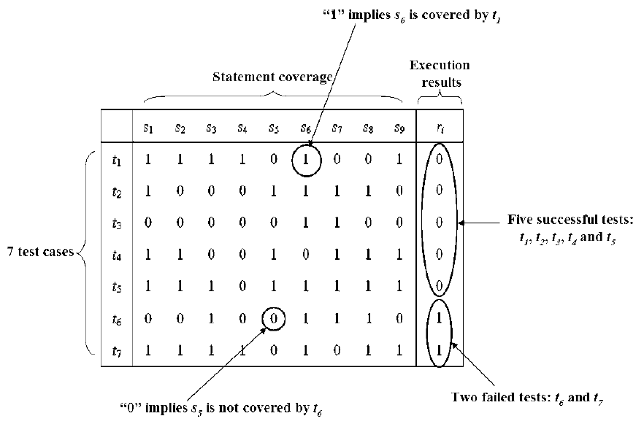
Figure. 1. A Sample of Coverage Matrix [1]
In the Figure 1, Each line represents the execution of all executable statements of a program under a certain test case. ‘1’ implies that the statement was executed in a certain test case, and ‘0’ implies that the statement was not executed in a certain test case. The last line(column?) in the Figure 1, can be consider as a vector which represent whether the execution of certain test case is success of fail (‘1’ represents that the test case is fail and ‘0’ represents that the test case is success).
For creating such a coverage matrix in our program, we firstly read the number of executable statements from to be tested program and number of test cases from .txt file. Then we create number of executable statements × number of test cases matrix, with all element are zero(下面一句有提到initialized). After the matrix was constructed and initialized, we read the test case from .txt file, line by line, as the input of different model. When each test case input to the model(faulty program可能更好？), the program will generate a coverage information report, then the program will extract the information about which statement is executed from the report, and revise the corresponding elements in the coverage matrix from the ‘0’ to ‘1’.
In addition, we need to create a 1 × number of test cases matrix of all elements of 0, the matrix is used to record each test case execution. Each test case is be input to a buggy program will have a corresponding actual output, the actual output will compare with the expected output which we had already collected before(可以优化一下句子). If the actual output and target output is different, it will result the matrix of the corresponding element assignment ‘1’.
Tarantula Fault Localization Technique
Tarantula make use of pass/fail information and coverage information of the program under test. In general, the statemen are executed by a failed test case will have a high suspicious of bug. Based on this idea, Tarantula will count the hue value by the following equation:
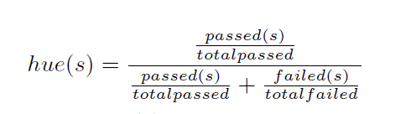(From:Empirical Evaluation of the Tarantula Automatic FaultLocalization Technique)
The totalpassed and totalfailed are the number of passed and failed test case. The passed and failed value is the number of passed and failed test case that can coverage this statement. Sometimes, the totalpassed and totalfailed may be zero which means it may not be covered by any test case. We set hue of this statement to zero.
The suspicious value is equal to 1-hue. We rank the suspicious value of all statements. The statement with maximal suspicious may be the fault. If the first statement is not the fault after examined. We continue to examine the next statement based on the rank list.

Crosstab-based Statistical Method
Crosstab-based method also use the coverage information.

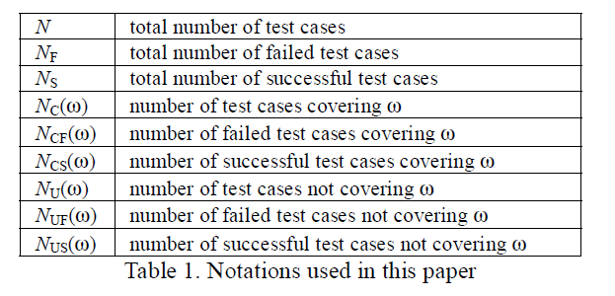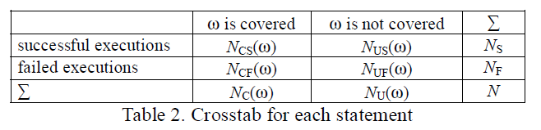
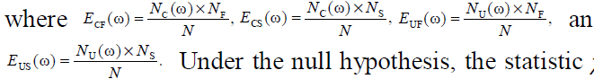(公式最好能打出来)

For each crosstab, we do hypothesis test to know the dependency relationship.
H0: Program execution result is independent of the
coverage of statement ω
The chi-square test can determine whether this hypothesis should be rejected. If we want to know more about the degree of association between the executed result and the coverage of each statement. We should computer the M (ω).
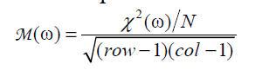
In our case, the row and col are two. Next, we want to know the relationship about the failed and passed result and the coverage information of statement. For each one, we count the PF(ω) and PS(ω). We define Phi ϕ(ω) as
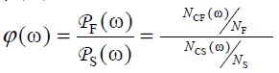
When phi > 1, statements is highly related to failed executed result. If phi < 1, it related to successful result. If phi = 1, the coverage of this statement is independent.
Thus, the suspicious of statement is defined as Zeta.
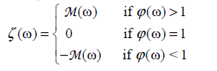
When phi > 1, larger Zeta has higher probability to be the fault. The smaller M value give higher suspicious to fault in phi < 1 region.

Back Propagation Neural Network-Based Fault Localization
The Back Propagation Neural Network is the second method for fault localization. The BP Neural Network localization method was raised and designed by Wong and Qi [1]. They mention that this model can conquer the duplication of suspiciousness problem that carried by Tarantula, and provide more precise guideline [1]. In our project, the BPNN method is implemented by Python and its library NumPy.
The Structure of Back Propagation Neural Network
In general case, this BPNN has three layer which are separately input layer with m neurons, hidden layer with three neurons, and output layer with one neuron. The input layer has m neurons where m is number of executable statements in a program. There has one hidden layer and three neurons in the hidden layer but there is not a standard case to define how many hidden layer and neurons should be used. If we use more than three neurons in the hidden layer, the results may be same with the result of the BPNN with three neurons in the hidden layer but the convergence speed may be slow down [1]. At the output layer, the only one neuron used to output an estimation for each test case. The structure of BPNN as following figure.
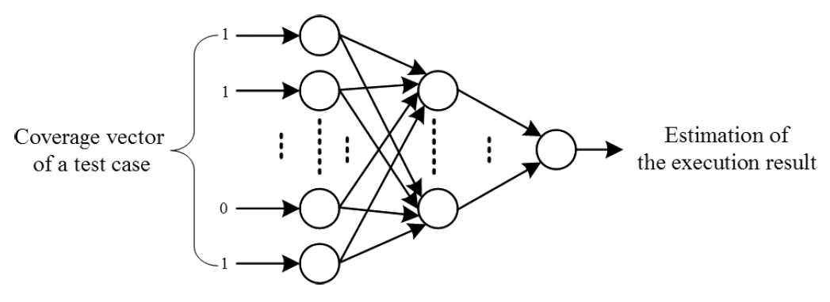
Figure. X. A Sample of the Structure of BPNN [1]

Evaluation
In this section, we are going to introduce our experiment design and a metric that we used to evaluate the effectiveness of fault localization tools. After that, we will evaluate and compare the performance of three different fault localization methods.
Experiment Design and Metric
The experiment in our project was be separated to two different section. In the first part of the experiment, we observed the effect of bug number in the program on the effectiveness of the different fault localization tools. More specific, we injected 1 to 4 number of bugs to the middle number count program and merge sort program, then we generate the coverage matrix for different bug version program and then using three different fault localization models detected the localization of the bug in different bug version program. In the second part, we observed the effect of test case number on the effectiveness of the different fault localization tools. In the introduction to coverage information section, we mentioned that we generated different numbers of test case sets. Based on the first part of the experiment, we used the coverage matrix generated by different numbers of test cases as the input of the model to test the effectiveness of different fault localization models.
The evaluation of the effectiveness of the fault localization models standard is EXAM score. The definition of the EXAM score is in terms of the percentage of the statements are be examined until the last statement containing bug is reached [3]. The calculation expression of EXAM score shows as below: (EXAM还可以解释为%statement should examined before find all bug（or the first bug）所以最后画图的时候可以参照bpnn论文的图，横坐标是%statement should be examined,纵坐标为%bug has been found，实验限制图这样画可能会好看点)
For instance, a program has 10 executable statements and 2 statement has bug among those 10 executable statements. We suppose the BP neural network model generate a suspiciousness list for the program, and the last bug is be found at second position of the suspiciousness list (Ranking 2). Hence, the EXAM score in this program (with 2 bugs) for BP neural network is 0.2. In short, the lower the EXAM score, the better the model effective on the program being tested.

Conclusion
The conclusion should summarize key points from the paper.
References
[1] Wong, W. E., & Qi, Y. (2009). Bp Neural Network-Based Effective Fault Localization. International Journal of Software Engineering and Knowledge Engineering, 19(04), 573–597. doi: 10.1142/s021819400900426x
[2] Jones, J. A., & Harrold, M. J. (2005). Empirical evaluation of the tarantula automatic fault-localization technique. Proceedings of the 20th IEEE/ACM International Conference on Automated Software Engineering - ASE 05. doi: 10.1145/1101908.1101949
[3] Wong, E., Wei, T., Qi, Y., & Zhao, L. (2008). A Crosstab-based Statistical Method for Effective Fault Localization. 2008 International Conference on Software Testing, Verification, and Validation. doi: 10.1109/icst.2008.65

