Министерство образования и молодежной политики

Свердловской области

государственное автономное профессиональное

образовательное учреждение Свердловской области

«Уральский радиотехнический колледж им. А.С. Попова»

Учебная практика по программированию

по МДК.02.01 «Разработка, внедрение и адаптация программного обеспечения»

РК 09.02.05.315 14 ПР

|  |  |  |
| --- | --- | --- |
|  |  | Руководитель  _____________ Н.Н. Шутова  «____»_______________ 2019 г. |
|  |  |  |
|  |  | Разработчик  _____________ А.А. Рожков  «____»_______________ 2019 г. |

2019

Задание

Among the many measurement systems available, two seem to be the most widespread: metric and imperial. To make things simpler, we assume that the first one uses the "meter"as its only unit (expressed as a real number), while the second uses the "foot" (always an integer) and the "inch" (a real number).

Your task is to write a simple "measurement converter". We want it to perform the following actions:

* ask the user which system she/he uses to input data; we assume that 0 means "metric"and 1 means "imperial";
* depending on the user's answer, ask either for meters or feet and inches;
* output the distance in proper (different) units:either in feet and inches or in meters;
* a result outputted as metric should look like 123.4m;
* a result outputted as imperial should look like 12'3.5".

Look at the code below – it's only a template.

Use it to implement the whole converter. Make your code smart – it shouldn't be fooled by stupid or unreasonable inputs.

Test your code using the data we've provided.

Код C++:

#include <bits/stdc++.h>

using namespace std;

int main ()

{

setlocale(LC_ALL, "Russian");

int x,y;

float z1, z;

cin>>x;

if(x==0)

{

cin>>z;

cout<<floor( (z*3.37008)*1 )/1<<"\'"<<z*3.37008<<"\"";

}

else if(x==1)

{

cin>>y;

if(y==0)

{

cin>>z;

cout<<z*0.0254<<"m";

}

else if(y==1)

{

cin>>z;

cout<<z*3.28<<"m";

}

else if(y==2)

{

cin>>z;

cout<<z/(3.28)<<"m";

}

}

}

Код Python:

x=int(input())

if(x==0):

z=int(input())

print(int(z*3.37008),"\'",z*3.37008,"\"")

elif(x==1):

y=int(input())

if(y==0):

z=int(input())

z=z*0.0254

print(z,"m")

elif(y==1):

z=int(input())

z=z*3.28

print(z,"m")

elif(y==2):

z=int(input())

print(z/(3.28),"m")

Блок-схема показана на рисунке 1.

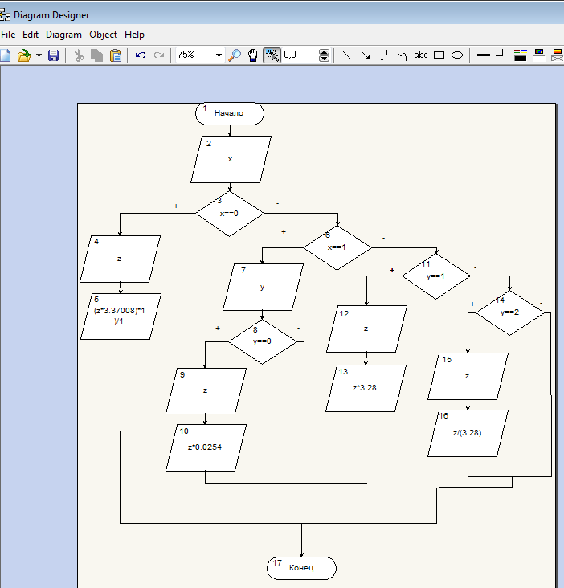

Рисунок 1 – Блок-схема