Министерство образования и молодежной политики

Свердловской области

государственное автономное профессиональное

образовательное учреждение Свердловской области

«Уральский радиотехнический колледж им. А.С. Попова»

Учебная практика по программированию

по МДК.02.01 «Разработка, внедрение и адаптация программного обеспечения»

РК 09.02.05.315 14 ПР

|  |  |  |
| --- | --- | --- |
|  |  | Руководитель  _____________ Н.Н. Шутова  «____»_______________ 2019 г. |
|  |  |  |
|  |  | Разработчик  _____________ А.А. Рожков  «____»_______________ 2019 г. |

2019

Задание

Have you ever wondered how to find a weekday for any (past or future) date? Okay, you can check it in a calendar (you probably have one on your smartphone), but this is no solution for a coder. We do it the harder and more exciting way – we're going to write a program for it (did you ever suspect we were going to offer you anything else?)

One of the most popular algorithms for this task is the so-called "Zeller's congruence". Sounds complicated? Nothing could be further from the truth, and we're going to show you exactly that. You'll need three values:

* year number (int – let's assume that we're interested only in dates from the 20th and 21st centuries);
* month number (int – 1 to 12);
* day number (int – 1 to it depends

Be patient – this will take a while:

1. Decrease month number by 2;

2. if month number becomes less than 0, increment it by 12 and decrement year by 1;

3. take month number and multiply it by 83 and divide it by 32;

4. add day number to month;

5. add year number to month;

6. add year/4 to month;

7. subtract year/100 from month;

8. add year/400 to month;\

9. find the remainder of dividing month by 7;

10. Congrats! A weekday number is ready for you! 0 – Sunday, 1 – Monday, ... and so on.

We want you to write a code which finds a weekday number for a date entered by a user. The program should ask the user for the year, month and day (in this order) and output a value indicating a weekday.

Make your code as smart as possible.

Test your code using the data we've provided.

Код С++:

#include <bits/stdc++.h>

using namespace std;

int main ()

{

setlocale(LC_ALL, "Russian");

int y,m,d;

cin>>y;

cin>>m;

cin>>d;

m=m-2;

if(m<0)

{

m+=12;

y--;

}

m=(m*83)/32;

m+=d;

m+=y;

m+=y/4;

m-=y/100;

m+=y/400;

m=m%7;

cout<<m;

}

Код Python:

y=int(input("year "))

m=int(input("mought "))

d=int(input("day "))

m=m-2

if(m<0):

m=m+12

y=y-1

m =int((m*83)/32)

m=int(m+d)

m=int(m+y)

m=int(m+y/4)

m=int(m-y/100)

m=int(m+y/400)

m=int(m%7)

print(m)

Блок-схема представлена на рисунке 1.

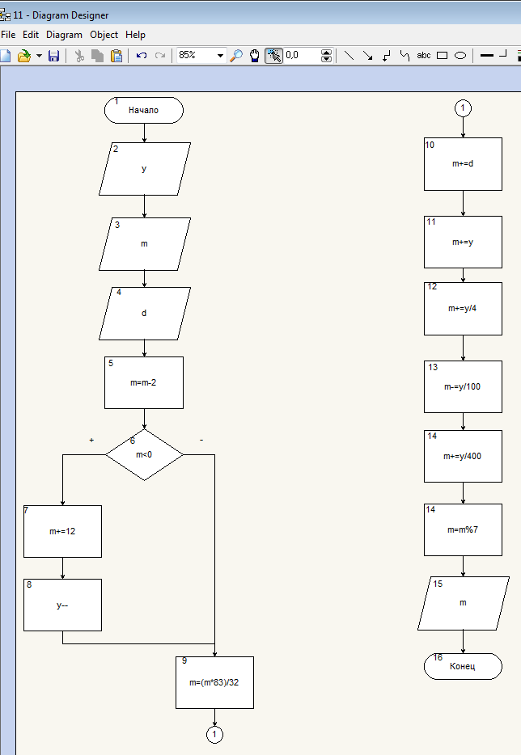

Рисунок 1 – Блок-схема