Министерство образования и молодежной политики

Свердловской области

государственное автономное профессиональное

образовательное учреждение Свердловской области

«Уральский радиотехнический колледж им. А.С. Попова»

Учебная практика по программированию

по МДК.02.01 «Разработка, внедрение и адаптация программного обеспечения»

РК 09.02.05.315 14 ПР

|  |  |  |
| --- | --- | --- |
|  |  | Руководитель  _____________ Н.Н. Шутова  «____»_______________ 2019 г. |
|  |  |  |
|  |  | Разработчик  _____________ А.А. Рожков  «____»_______________ 2019 г. |

2019

Задание

Easter is a so-called moveable feast, and its date depends on two astronomical phenomena: the beginning of spring in the Northern hemisphere and the first full moon occurring after it. You may think that finding the date of Easter would be extremely complex and connected to complicated astronomicalcalculations, but, fortunately, it's much, much easier.

The algorithm we're going to show you was created by a famous German mathematician, Carl Friedrich Gauss. It's known in many variations – we're going to use one of the simpler forms adapted for the 20th and 21st centuries. The only data it uses is the year number. Okay, let's go!

1. Divide year by 19 and find the remainder – assign it to a;
2. divide year by 4 and find the remainder – assign it to b;
3. divide year by 7 and find the remainder – assign it to c;
4. take a, multiply it by 19, add 24, divide by 30 and find the remainder – assign it to d
5. divide (2b + 4c + 6d + 5) by 7 and find the remainder - assign it to e;
6. check the value of d + e;
7. if it's less than 10, Easter falls on the (d + e + 22) day of March;
8. otherwise it falls on the (d + e – 9) day of April;
9. that's all!

Now you're familiar with all the theory you need to write a code to find the date of Easter. The program should ask the user for the year number and output a date in the form Month Day, e.g. April 5.

Test your code using the data we've provided.

Код на C++:

#include <bits/stdc++.h>

using namespace std;

int main ()

{

setlocale(LC_ALL, "Russian");

int a,b,c,d,e,y;

cin>>y;

a=int(y%19);

b=int(y%4);

c=int(y%7);

d=int(((a*19)+24)%30);

e=int((2*b+4*c+6*d+5)%7);

if(d+e<10)

cout<<"March "<<d+e+22;

else

cout<<"April "<<d+e-9;

}

Код на Python:

y=int(input("year "))

a=int(y%19)

b=int(y%4)

c=int(y%7)

d=int(((a*19)+24)%30)

e=int((2*b+4*c+6*d+5)%7)

if(d+e<10):

print("March ",d+e+22)

else:

print("April ",d+e-9)

Блок-схема представлена на рисунке 1.

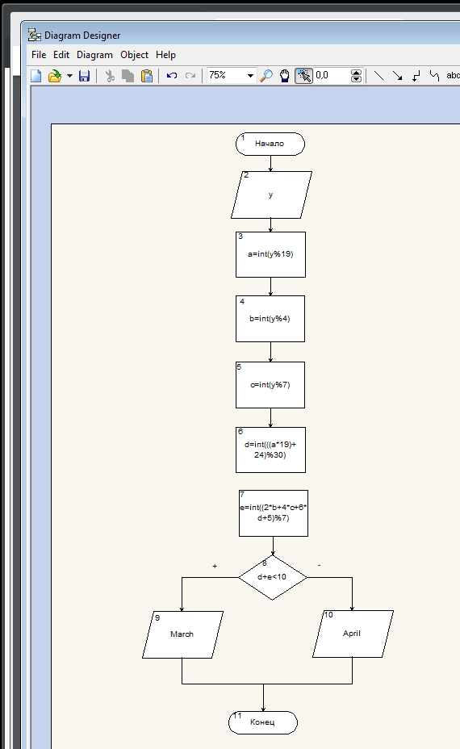

Рисунок 1 – Блок-схема