Министерство образования и молодежной политики

Свердловской области

государственное автономное профессиональное

образовательное учреждение Свердловской области

«Уральский радиотехнический колледж им. А.С. Попова»

Учебная практика по программированию

по МДК.02.01 «Разработка, внедрение и адаптация программного обеспечения отраслевой направленности»

РК 09.02.05.315 14 ПР

|  |  |  |
| --- | --- | --- |
|  |  | Руководитель  _____________ Н.Н. Шутова  «____»_______________ 2019 г. |
|  |  |  |
|  |  | Разработчик  _____________ А.А. Рожков  «____»_______________ 2019 г. |

2019

Задание

In 1937, a mathematician named Lothar Collatz formulated an intriguing hypothesis that remains unsolved to this day (perhaps this would be a good challenge for you?) which can be described in the following way:

1. take any non-negative and non-zero integer number and name it c0;

2. if it's even, evaluate a new c0 as c0 / 2

3. otherwise, if it's odd, evaluate a new c0 as 3 ⋅ c0 + 1

4. if c0 ≠ 1, skip to point 2

The hypothesis says that, regardless of the initial value of c0, it willalways (always!) go to 1.

Of course, it's an extremely complex task to use a computer in order to prove the hypothesis for any natural number (it may in fact need artificial intelligence), but you can use C++ to check some individual numbers. Maybe you can find the one that disproves the hypothesis and become a famous mathematician.

Okay, let's start. Write a program which reads one natural number and executes the above steps as long as c0 remains different from 1. Moreover, we'll give you another task – we want you to count the steps needed to achieve the goal. Your code should output all intermediate values of c0, too – it'll be very illustrative, won't it?

Hint: the most important part of the problem is how to transform Collatz's idea into a "while" loop – this is the key to success.

Test your code using the data we've provided.

Код на С++:

#include <bits/stdc++.h>

using namespace std;

int main ()

{

setlocale(LC_ALL, "Russian");

int c,i=0;

cin>>c;

while(c!=1)

{

if((c%2)!=0)

{

c=3*c+1;

cout<<c<<endl;

}

else

{

c=c/2;

cout<<c<<endl;

}

i++;

}

cout<<"Steps = "<<i;

}

Код на Python:

i=0

c=int(input())

while(c!=1):

if((int(c%2))!=0):

c=int(3*c+1)

print(c)

else:

c=int(c/2)

print(c)

i=i+1

print("Steps = ",i)

Блок – схема представлена на рисунке 1.

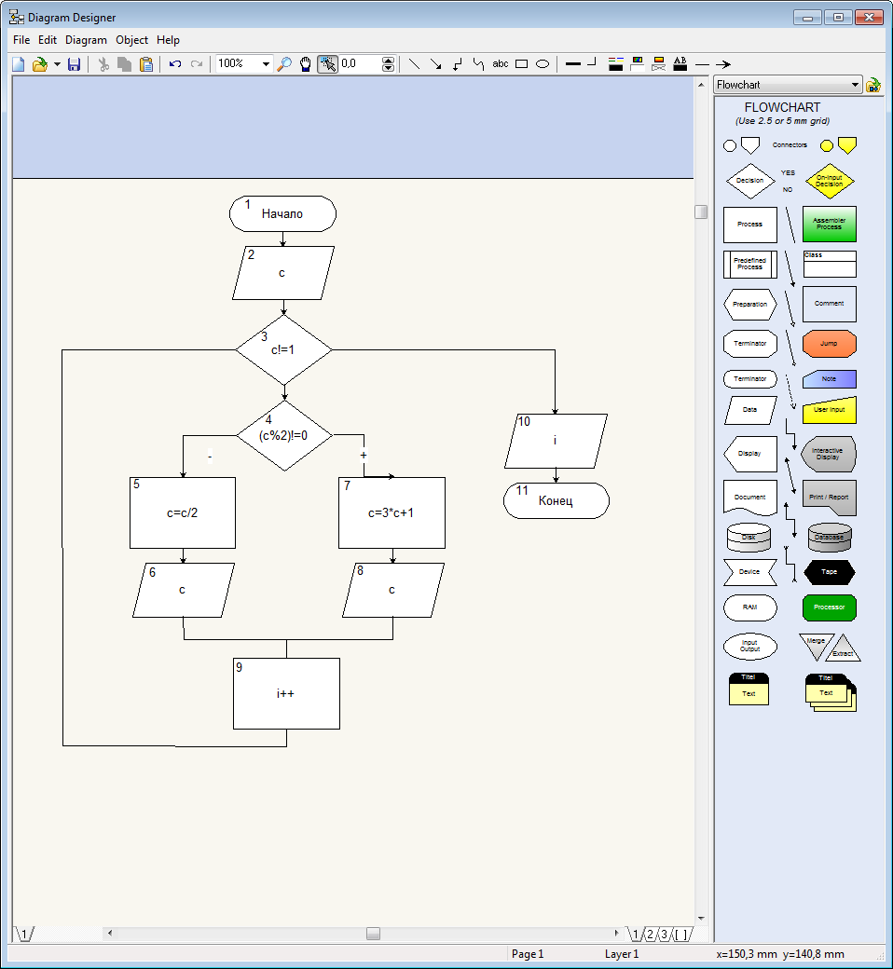

Рисунок 1 – Блок – схема кода