Министерство образования и молодежной политики

Свердловской области

государственное автономное профессиональное

образовательное учреждение Свердловской области

«Уральский радиотехнический колледж им. А.С. Попова»

Учебная практика по программированию

по МДК.02.01 «Разработка, внедрение и адаптация программного обеспечения»

РК 09.02.05.315 14 ПР

|  |  |  |
| --- | --- | --- |
|  |  | Руководитель  _____________ Н.Н. Шутова  «____»_______________ 2019 г. |
|  |  |  |
|  |  | Разработчик  _____________ А.А. Рожков  «____»_______________ 2019 г. |

2019

Задание

As you surely know, due to some astronomical reason, a year may be leap or common. The former is 366 days long while the latter is 365 days. Since the introduction of the Gregorian calendar (in 1582), the following rule is used to determine the kind of year: if the year number isn't divisible by 4, it is a common year; otherwise, if the year number isn't divisible by 100, it is a leap year; otherwise, if the year number isn't divisible by 400, it is a common year; otherwise, it is a leap year. Look at the code below – it only reads a year number and it needs to be completed with instructions that implement the test we just described. The code should output one of two possible messages, which are Leap year or Common year, depending on the value entered. It would be good to verify if the year entered falls into the Gregorian era and to output a warning otherwise. Test your code using the data we've provided.

Код на C++:

#include <bits/stdc++.h>

using namespace std;

int main ()

{

int Y;

cin>>Y;

if(Y%100==0)

{

if(Y%100==0)cout<<"Leap year";

else cout<<"Common year" ;

}

else

{

if(Y%4==0)cout<< "Leap year";

else cout<<"Common year";

}

}

Код Python:

Y=int(input())

if(Y%100==0):

if(Y%4==0):print("Leap year")

else: print("Common year" )

else:

if(Y%4==0):print( "Leap year")

else: print("Common year")

Блок-схема представлена на рисунке 1.

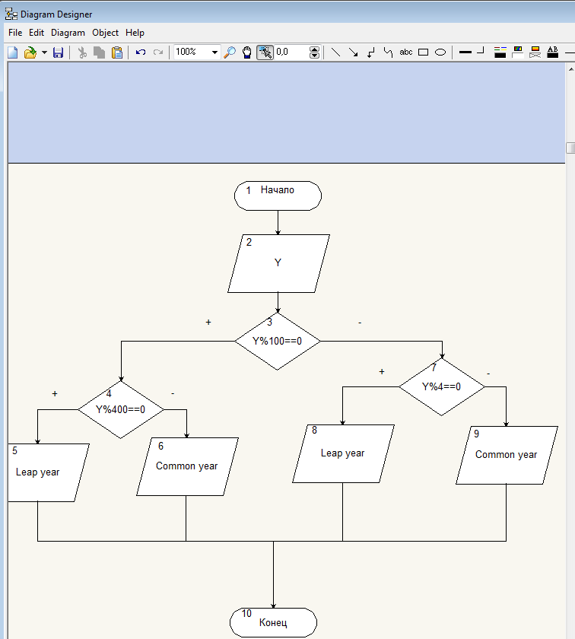

Рисунок 1 – Блок-схема