Tumor Heterogeneity in Gastrointestinal Cancer based on Multimodal Data Analysis

Dongmei Ai a*1, Yang Dua1, Hongyu Duanb1,Lulu Chena, Juan Qia, Yuduo Wanga, Yishu Wanga, Xiuqin Liua, Li C. Xiab*

aSchool of Mathematics and Physics, University of Science and Technology Beijing, Beijing, 100083, China

bDepartment of Statistics and Financial Mathematics, School of Mathematics, South China University of Technology, Guangzhou, 510641, China

**1**These authors contributed equally to this work and share first authorship

**\***

**Correspondence:**Dongmei Ai

Email Address: aidongmei@ustb.edu.cn

Li C. Xia

Email Address: lcxia@scut.edu.cn

Supplementary Material

# Supplementary Figures and Tables

## Supplementary Figures

## 

Supplementary Figure . Differences between cancer and normal tissue samples by (A) differential mRNA screening and (B) differential miRNA screening. (C) mRNA heat-map of cancer and normal samples; (D) miRNA heat map of cancer and normal samples.

Supplementary Figure . Reference chart for selecting soft thresholds for WGCNA analysis.

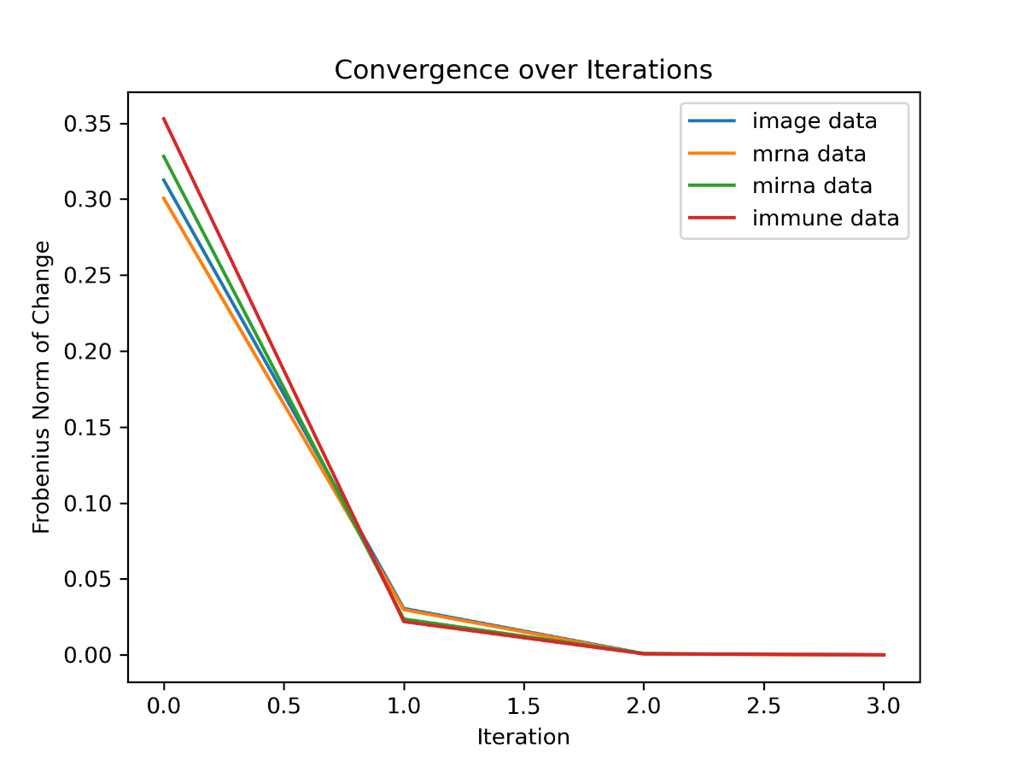

Supplementary Figure 3 Iterative process for four types of data

Supplementary Table 1 Modules obtained from WGCNA analysis and the number of genes they contain.

|  |  |  |  |  |  |
| --- | --- | --- | --- | --- | --- |
| Module | Black | Blue | Brown | Cyan | Green |
| number | 168 | 1254 | 662 | 40 | 176 |
| Module | Greenyellow | Yellow | Magenta | Midnightblue | Pink |
| number | 78 | 202 | 90 | 33 | 163 |
| Module | Purple | Red | Salmon | Tan | Turquoise |
| number | 81 | 169 | 47 | 65 | 1747 |