Supplementary Material

**Coalesced multimodal learning for the heterogeneity of gastrointestinal cancer based on transcriptome and tissue image data**

Dongmei Ai a,1*, Yang Dua,1, Hongyu Duanb,1,Lulu Chena, Juan Qi a, Yuduo Wanga, Yishu Wanga, Xiuqin Liua, Li C. Xiab,*

**\* Correspondence:**

Dongmei Ai

Email Address: [aidongmei@ustb.edu.cn](mailto:aidongmei@ustb.edu.cn) Telephone: 18910789245

Li C. Xia

Email Address: lcxia@scut.edu.cn Telephone: 18602062260

# Supplementary Tables

**Supplementary Table 1.** **Sample sizes of transcriptome data in gastric and colorectal cancer**

|  |  |  |  |  |  |  |
| --- | --- | --- | --- | --- | --- | --- |
| **Sample** | **Stomach** | | | **Colon** | | |
| raw data | mRNA | miRNA | | mRNA | | miRNA |
| 414 | 497 | | 524 | | 467 |
| intersection | 376 | | 376 | 445 | 445 | |

**Supplementary Table 2.** **Features of transcriptome data in gastric and colorectal cancer**

|  |  |  |  |  |  |  |
| --- | --- | --- | --- | --- | --- | --- |
| Transcriptome | **Stomach** | | | **Colon** | | |
| raw data | mRNA | miRNA | | mRNA | | miRNA |
| 55812 | 2652 | | 54710 | | 2652 |
| intersection | 54696 | | 2652 | 54696 | 2652 | |

**Supplementary Table 3.** **The number of genes in eight out of 15 modules**

|  |  |  |  |  |  |  |  |  |
| --- | --- | --- | --- | --- | --- | --- | --- | --- |
| Modules | black | blue | tan | cyan | green | brown | red | grey |
| Number of genes | 229 | 876 | 87 | 70 | 262 | 448 | 232 | 424 |

# Supplementary Figures

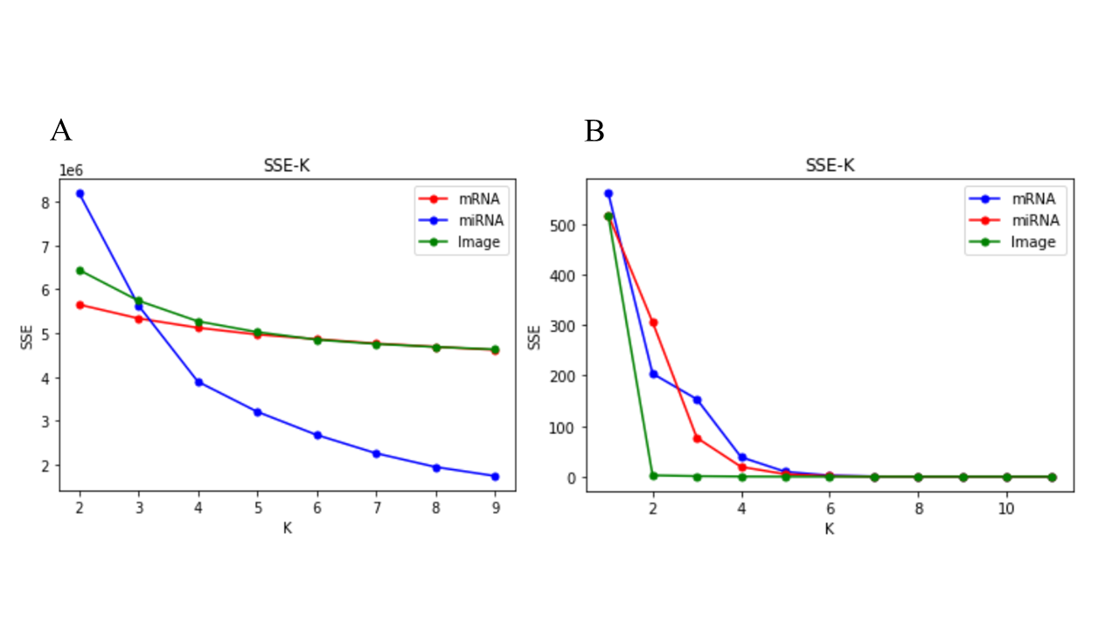

Supplementary Fig. 1 A is the SSE (sum of the squared Euclidean distances of each point to its closest centroid)-K curve for the three data views, mRNA, miRNA, and image. The SSE values for mRNA and image were scaled by 0.8, while the SSE value for miRNA was scaled by $1.5e^{-8}$ to fit into the plot. This scaling ensured the convergence of SSE values from all three perspectives into a unified plot, while preserving the cluster count. B is the Curves depicting SSE values and iteration numbers for the similarity matrices associated with the three data views: mRNA, miRNA, and image. These curves encapsulate the evolution of SSE throughout the iteration process.