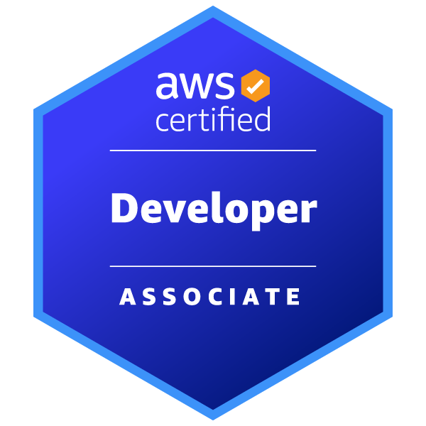
RAVI TEJA B
sudheer@cststech.com|732-401-8795 Ext:108
JAVA DEVELOPER
PROFESSIONAL SUMMARY :
- Java Developer with 5+ years of experience building scalable, secure, and event-driven applications across telecom, insurance, and banking domains.
- Strong expertise in Java 8/17, J2EE, Spring Boot, Spring MVC, Spring Security, Hibernate, and JPA for high-performance backend systems.
- Experienced in designing RESTful and GraphQL APIs, microservices architectures, and event-driven systems using Apache Kafka.
- Skilled in relational and NoSQL databases (Oracle, PostgreSQL, MongoDB) with focus on indexing, query optimization, and transactional consistency.
- Hands-on experience with Docker, Kubernetes, and AWS (EC2, S3, EKS, CloudWatch), implementing CI/CD pipelines with Jenkins and Maven/Gradle.
- Adept at Agile/Scrum collaboration, observability/monitoring using Prometheus/Grafana/OpenTelemetry, and implementing secure authentication with OAuth2/JWT/MFA.
TECHNICAL SKILLS:

- Languages & Frameworks : Java (8/11/17), J2EE, Spring Boot, Spring Cloud, Spring MVC, Spring Security, Spring Data JPA, Hibernate, GraphQL, JavaScript (ES6+), React.js, Angular, HTML5, CSS3
- Databases & Messaging : Oracle (11g+), PostgreSQL, MongoDB, Redis (Caching & Session Management), Apache Kafka, IBM MQ, RabbitMQ
- Cloud & Containers : AWS (EC2, S3, Glacier, EKS, CloudWatch), OpenShift (OCP), Docker, Kubernetes
- Testing & Quality : JUnit, Mockito, TDD, Integration Testing, SonarQube, BlackDuck
- DevOps & Tools : Git, GitHub, Bitbucket, Jenkins, GitHub Actions, Maven, Gradle, Jira, Postman, Swagger (OpenAPI), Log4j, Grafana
- Architecture & Practices : Microservices Architecture, RESTful APIs, Event-Driven Systems, Asynchronous Processing, Multithreading, OAuth2, JWT, MFA, Secure Coding Practices, CI/CD Automation, Performance Tuning, Root Cause Analysis, Agile/Scrum

PROFESSIONAL EXPERIENCE:

Client: Wells Fargo / Texas Sept 2024 – Present

Role: Java Developer
Description: Worked on secure Multi-Factor Authentication (MFA) services, building REST APIs with Spring Boot, integrating OAuth2/JWT authentication, and implementing event-driven workflows with Kafka and IBM MQ for high-volume banking applications.

Responsibilities:

- Contributed to the development and maintenance of secure authentication and transaction validation services for Multi-Factor Authentication (MFA) in high-volume banking applications, supporting large-scale customer verification in production.
- Developed RESTful APIs using Spring Boot for OTP generation and validation workflows, ensuring reliable performance during peak banking hours.
- Integrated backend services with PING Identity to enable secure session validation, privilege elevation, OAuth2/JWT-based token authentication flows.
- Implemented synchronous messaging using IBM MQ for real-time OTP delivery and monitored message queues to ensure reliability.
- Contributed to event-driven architecture using Apache Kafka, publishing authentication and transaction events for

fraud monitoring and audit systems.
- Applied multithreading and asynchronous processing using Java Concurrency utilities, optimizing API response times under high concurrency.
- Designed and optimized data access layers in Oracle DB, ensuring transactional consistency, query performance tuning, and audit logging for OTP and MFA operations.
- Implemented MongoDB for storing semi-structured authentication event logs and audit metadata, improving reporting and troubleshooting flexibility.
- Configured Spring Session with Redis for distributed session management, enabling scalable, cloud-hosted deployments.
- Applied secure coding practices including CSRF protection, input validation, encryption of sensitive data, and centralized exception handling to harden critical authentication endpoints.
- Containerized microservices using Docker and deployed to OpenShift (OCP), improving deployment consistency and environment stability.
- Practiced Test-Driven Development (TDD) using JUnit and Mockito, implementing comprehensive unit and integration testing, including negative test scenarios for OTP and MFA workflows.
- Contributed to CI/CD pipelines with automated builds, SonarQube static code analysis, and BlackDuck dependency vulnerability scanning to maintain enterprise quality standards.
- Supported production monitoring using structured logging, correlation IDs, and observability practices, performing
root cause analysis (RCA) for authentication and session-related issues.
- Collaborated in Agile/Scrum environments, participating in requirement analysis, code reviews, and
OpenAPI/Swagger documentation to deliver production-ready features.
- Performed load and performance testing for OTP validation APIs to ensure stability under high concurrency conditions.

Environment: Java 8/11, J2EE, Spring Boot, Spring MVC, Spring Security, Spring Data JPA, Hibernate, REST APIs, Oracle, MongoDB, Redis, IBM MQ, Apache Kafka, Docker, OpenShift (OCP), AWS (EC2, S3, Glacier), Git, Maven, CI/CD (GitHub Actions), SonarQube, BlackDuck, JUnit, Mockito, Agile/Scrum

Client: StateFarm Insurance/Illinois May 2023 – Aug 2024
Role: Java Developer

Description: Migrated Java 8 applications to Java 17 and developed REST/GraphQL APIs for client portfolio dashboards, integrating MongoDB, Kafka, and Spring Security, with containerized deployments on AWS EKS for high-performance, reliable financial services.

Responsibilities:
- Contributed to the migration of legacy applications from Java 8 to Java 17, refactoring deprecated APIs and improving overall code maintainability and performance.
- Developed and enhanced RESTful APIs using Spring Boot to support client portfolio dashboards, enabling access to

account balances, transaction history, and performance metrics.
- Worked on GraphQL endpoints to provide flexible data retrieval, helping reduce over-fetching for frontend dashboards.
- Modeled MongoDB datasets for portfolio and transaction data, creating optimized indexes and assisting in query tuning for efficient read/write operations.
- Implemented pagination, filtering, and aggregation pipelines to handle large financial datasets efficiently.
- Assisted in Apache Kafka integration by developing producers and consumers for portfolio updates, transaction events, and market data.
- Assisted in implementing idempotent message processing and error-handling strategies to ensure reliable event consumption.
- Supported the development of secure authentication and authorization using Spring Security, OAuth2, and JWT to protect sensitive client data.
- Contributed to audit logging for portfolio changes and user activity, helping meet internal compliance standards.
- Participated in CI/CD processes using Jenkins, containerized services with Docker, and deployed to AWS EKS
environments.
- Assisted in monitoring applications with AWS CloudWatch and structured logs to improve troubleshooting and

system observability.
- Supported database query optimization and helped reduce API response times by analyzing execution plans and tuning indexes.
- Wrote unit and integration tests using JUnit and Mockito to improve code reliability and maintainability.
- Actively participated in Agile/Scrum ceremonies, collaborating with backend and frontend teams to deliver prioritized features.
- Worked closely with frontend developers (React/Redux) to ensure smooth API integration and consistent data contracts.
Environment: Java 17, Spring Boot, Spring Security, GraphQL, MongoDB, Kafka, React.js, Redux, Docker, Kubernetes, AWS (EKS, CloudWatch), Jenkins, JUnit, Mockito, Maven, Git, Swagger

Client: T Mobile/ India Jun 2020 - Aug 2022
Role: Software Engineer
Description: Built and maintained Java Spring Boot applications with REST/GraphQL APIs, integrating Oracle and MongoDB, implementing Kafka event processing, and supporting microservices deployments on AWS with CI/CD pipelines for reliable, high-performance customer services.

Responsibilities:

- Built and maintained Java applications using Spring Boot and Spring MVC, developing controllers, services, and components with Spring annotations.
- Developed and consumed RESTful web services to enable communication between frontend dashboards and backend microservices, supporting customer account management, payment processing, and mobile plan modules.
- Worked with Oracle 11g using Hibernate to map Java objects to tables, wrote SQL/HQL queries, and assisted in optimizing database access for performance improvements.
- Contributed to DAO layers to abstract database access and promote code reusability.
- Created documents and indexes in MongoDB for storing flexible customer and service data, improving query performance for faster retrieval.
- Assisted in implementing Apache Kafka producers and consumers to process asynchronous events such as payment confirmations, service notifications, and system updates.
- Wrote unit tests using JUnit and Mockito to validate modules and ensure code reliability.
- Built projects and managed dependencies using Maven, running automated tests as part of development.
- Logged application events and errors using Log4j to support debugging and system monitoring.
- Assisted with deployment of microservices to AWS EC2 instances and monitored basic application metrics using

CloudWatch.
- Participated in CI/CD pipelines using Jenkins to automate builds, tests, and deployments.
- Worked in an Agile/Scrum team, participating in daily stand-ups, sprint planning, and code reviews.
- Collaborated with business analysts, QA, and frontend teams to implement features and resolve defects efficiently.
- Monitored application performance and assisted in investigating memory- and thread-related issues.
- Gained exposure to GraphQL endpoints and integration with frontend frameworks like Angular and React.
- Assisted in containerizing development and testing environments using Docker.
- Learned basic distributed tracing and monitoring concepts using logs and dashboards to improve visibility into microservices.

Environment: Java 8, Spring Boot, Spring MVC, Hibernate, Oracle 11g, MongoDB, REST APIs, Kafka, Maven, JUnit, Mockito, Log4j, Git, Jenkins, Docker, AWS (EC2, CloudWatch), Agile/Scrum

EDUCATION & CERTIFICATIONS:
Masters - Computer Science - Illinois Institute of Technology
Bachelors – Bachelor of Technology in Computer Science - Sikkim Manipal Institute of Technology AWS Certified Developer – Associate

