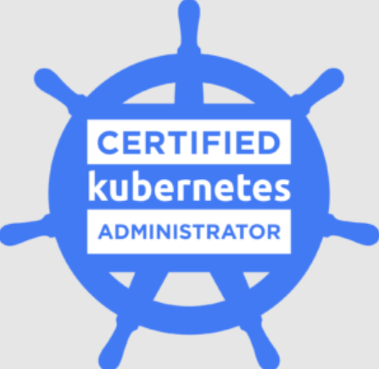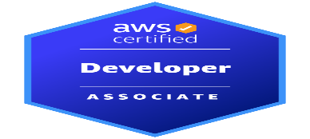

BHARGAV VANKAYALAPATI bhargavdev0ps0407@gmail.com
Sr. DevOps Engineer (469-801-9038)
linkedin
--------------------------------------------------------------------------------------------------------------------------------------------
Professional Summary:
- 9+ years of experience in the IT industry as DevOps Engineer. Experience includes Implementation, Deployment, and configuration of Cloud Infrastructure, Application Integration, and Offering Platform as a service.
- Experience in working with Git, Jenkins, Azure, OpenStack, AWS, Kubernetes, and Docker tools.
- Designed and deployed custom Kubernetes clusters using Heat templates and Helm charts, ensuring near zero downtime across on-premises and AWS , Azure environments for over 200 microservices.
- Proficient in designing and configuring Grafana dashboards that visualize key application performance indicators (KPIs) for real-time monitoring and proactive troubleshooting for applications on Kubernetes.
- Designed and deployed a scalable Hub-and-Spoke network architecture using Bicep templates to centralize security, governance, and interconnectivity across multiple Azure workloads.
- Implemented Azure Virtual Network (VNet) Peering in Bicep to establish secure and low-latency connectivity between Hub and Spoke VNets across different environments (Dev, Test, Staging, Prod).
- Secured Kubernetes and cloud environments with tailored policies, ensuring compliance with industry standards and reducing unauthorized access.
- Deployed, managed, and monitored applications across multiple environments (Dev, Test, Staging, Prod) using Argo CD, ensuring consistency and reliability in deployment pipeline.
- Leveraged Istio’s telemetry data with monitoring tools like Prometheus, Grafana, and Jaeger to gain insights into service health and performance
- Experience in integrating OpenTelemetry for unified collection of telemetry data, enabling centralized logging, tracing, and metrics across distributed applications and microservices
- Extensive experience in microservice based Application Architecture and preparing various manifest files for deployment and maintenance of Applications on Kubernetes.
Technical Skills:
- Cloud Technologies: AWS, Azure
- Azure Services: APGW, AKS, ACR, Azure functions,WAF,FD,Azure blob storage
- AWS Services: APIGW,Lambda function, EKS, AWS Step function,
- Infrastructure as code: Terraform, Ansible, Azure Biceps,Terragrunt.
- Container Technologies: Docker, Kubernetes, Helm
- CICD Tools: Jenkins, GitHub Actions, Azure Devops
- Programming Languages: Python, SQL, YAML, JSON
- Monitoring Tools: Grafana, Checkmk,Seq
Certifications:
- Certified Kubernetes Administrator (CKA)
- AWS Certified Developer Associate
Company: Ericsson Jan 2023 –Present
Role: Sr DevOps Engineer.
- Worked on Deploying and providing the IAAS and PAAS cloud platform based on platform user requirement to run applications on Openstack and Aure cloud Platforms.
- Integrated Azure Functions with Azure DevOps Pipelines to execute custom scripts, automate release approvals, and notify teams via webhooks.
- Implemented CI/CD pipelines in Azure DevOps to automate the build, testing, and deployment of Azure Functions using Azure Application Repos
- Developed Helm charts to package and version Kubernetes applications, ensuring efficient and repeatable deployments across multiple environments.
- Implemented Azure Autoscaling for virtual machine scale sets and Kubernetes clusters, optimizing resource usage and reducing costs by 30% during off-peak hours
- Streamlined continuous deployment processes by implementing GitOps principles with Argo CD, resulting in a 30% reduction in deployment lead times.
- Integrated Bicep with Azure DevOps Release Pipelines to deploy AKS clusters, ACR, Application Gateway, and other resources across multiple environments.
- Automated infrastructure updates and rollback strategies using Bicep with Azure DevOps Pipelines, ensuring safe deployments by validating changes with pre-deployment checks.
- Implemented taints, tolerations, and affinity/anti-affinity rules to ensure AI/ML workload placement aligns with hardware capabilities.
- Developed custom Kubernetes operators to automate the deployment of Api end points for various micro-services along ssl offloading on Azure cloud.
- Deployed "default-deny" Network Policies to establish a zero-trust model within Kubernetes namespaces.
- Deployed Istio across multiple AKS clusters to achieve unified traffic management and observability across distributed environments.
- Identified and resolved application performance bottlenecks by analysing liveness and readiness probe failures, improving overall system reliability.
- Designed and implemented comprehensive Grafana dashboards, enabling a 30% improvement in incident response time by consolidating logging, metrics, and tracing data for Kubernetes applications.
- Instrumented Kubernetes platform application code with OpenTelemetry methods, achieving 99.9% data accuracy for logging, tracing, and metrics for 200+ microservices
- Secured multi-tenant Kubernetes clusters by isolating workloads with namespace-specific Network Policies.
- Managed access control by creating RBAC policies based on requirement with custom roles and role bindings in k8s.
- Successfully migrated and deployed the observability platform from Seq to Grafana on Kubernetes, enhancing monitoring and visualization capabilities.
- Designed and implemented multi-stage Docker files to optimize build processes, reducing image size by 40% while maintaining application functionality
Company: ZT-Systems Jan 2021 – Dec 2022
Role: AWS DevOps Engineer.
- Leveraged GitHub Actions to integrate version-controlled Terraform code into automated workflows, reducing manual intervention and improving deployment speed and consistency.
- Led the deployment of containerized applications on AWS EKS clusters using Terraform, improving the scalability and manageability of services.
- Configured AWS Transit Gateway to establish centralized routing and efficient communication between VPCs, minimizing cross-VPC traffic complexity and enhancing network performance.
- Created modular, parameterized GitHub Actions templates that could be customized for different projects, increasing workflow efficiency, and maintaining best practices.
- Automated the provisioning and management of Hub-and-Spoke network architecture using Terraform, ensuring consistent and repeatable network configurations across multiple accounts.
Company: Charter Communications. Aug 2018 – Dec 2020
Role: Azure DevOps Engineer
Responsibilities:
- Integrated Terraform Infrastructure as Code (IaC) into Azure DevOps pipelines, automating infrastructure provisioning and management.
- Configured and developed infra pipelines to run periodically, keeping infrastructure synchronized with expected configurations and reducing configuration drift by 95%.
- Designed and implemented Azure Hub-and-Spoke architecture using terraform to centralize shared services and enforce network security and avoid cost overhead.
- Configured the hub network with centralized services like Azure Firewall, ACR, and ExpressRoute for secure and seamless connectivity.
- Reduced latency and enhanced service performance by 30% by strategically designing network peering and routing policies
- Implemented end-to-end infrastructure automation by using Terraform to provision, configure, and manage cloud resources in Azure.
- Implemented Azure Devops CI/CD pipelines for 150+ microservices on top of azure cloud for multiple environments.
Company: Nokia. Sep 2016 – Jun 2018
Role: Build and Release Engineer
- Design, implement, and maintain automated build and deployment pipelines to streamline the software development process and reduce manual errors.
- Manage version control systems (Git, SVN, TFS, GitLab) to ensure codebase integrity, enforce branching and merging strategies, and facilitate collaboration among development teams.

