Kumar  Senior Data Scientist  Saikrishna@meridiansoft.com  380-388-3683 | 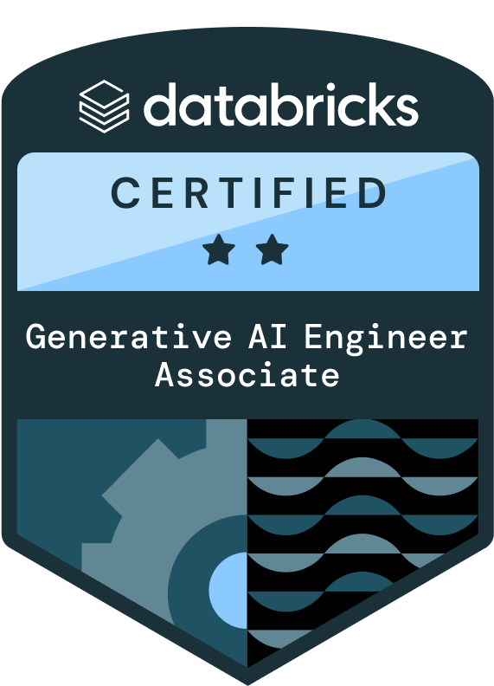 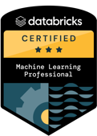 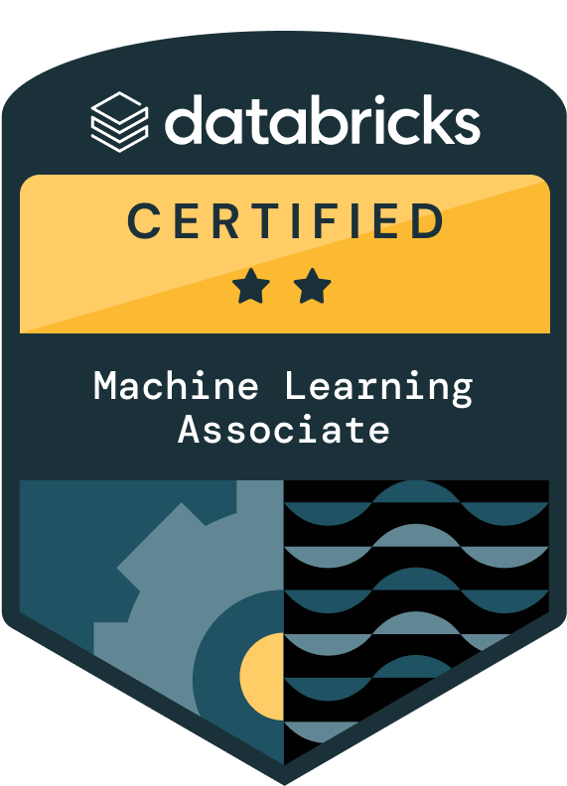
- Highly efficient Data Scientist with 11+ years of experience in Machine Learning and Deep Learning using different cloud technologies with large amounts of Structured and Unstructured data. 3X Databricks certified and adept in statistical programming languages like Python & R, Big Data technologies like Spark.
- Proficient in managing entire data science project and actively involved in all the phases of project life cycle including data acquisition, data cleaning, data engineering, feature scaling, feature engineering, machine learning modeling using a variety of algorithms like Regression Models, Time Series(ARIMA & Holt Winters), Clustering, Decision Trees, KNN, Neural Networks, SVM, Ensemble(Random Forest, Boosting), dimensionality reduction using PCA and SVD, testing and validation using regular performance metrics and AUC-ROC Plot, K- fold cross validation and data visualization.
- Experienced in Text Analytics and NLP. Developed applications using LDA, LSA and advanced text vectorizing techniques like TF-IDF, Word2Vec, Doc2Vec.
- Experienced in developing and deploying ML solutions with cloud native services like Sagemaker in AWS, Vertex AI in GCP, AzureML Studio.
- Experienced in Cloud Data Analytics and Insights services like DMS, Glue, Athena, S3, EMR, StepFunctions, Lambda, SNS, SES, EC2, Sagemaker, Quicksight, Dataproc, BigQuery, GCS, Vertex AI, Azure Databricks.
- Extensive experience in generating data visualizations using R, Python and creating dashboards using tools like RShiny, Tableau, PowerBI, Looker.
- Experienced in building Generative AI solutions including Retrieval-Augmented Generation (RAG), and enterprise-scale GPT applications for retail and CPG use cases.
- Designed and deployed Agentic AI frameworks (LangGraph, multi-agent systems) that integrate LLMs with enterprise data lakes, enabling autonomous query resolution, merchant-facing assistants, and advanced decision support.
- Skilled in operationalizing LLMs with MLOps practices, ensuring reproducibility, governance, and scalable deployment on Kubernetes and cloud-native environments.
Technical Skills
Programming: Python (Pandas, Numpy, SciPy, Seaborn, Matplotlib, Plotly, DiGraph, Scikit-learn, TensorFlow, Keras, PyTorch, statsmodels, nltk, regex, OOPS), R (RMarkdown, dplyr, glmnet, ggplot2, RODBC, RShiny, reshape2, caret), MySQL, Oracle, Shell, Unix, Hive, PySpark.
Machine Learning & Statistics: Linear, Logistic, Lasso, Ridge regression, GLM, Decision Trees, Naive Bayes, Hadoop, Support Vector Machines, Random Forest, XGBoost, LightGBM, K-nearest neighbors, K-means Clustering, Artificial, Recurrent, Convolutional Neural Networks, LSTM, Natural Language Processing, Imputation, transformation, scaling, resampling, dimensionality reduction, Principal Component Analysis, ANOVA, Hypothesis Testing, AWS SageMaker, Azure ML Studio, Big Query, GCP
Tools: LangChain, GitHub, Jupyter, PyCharm, MS Excel, Tableau, PowerBI, MySQL Workbench, Apache Oozie.
Professional Experience
PepsiCo, Dallas TX, 10/2024 – Present
Senior Data Scientist
- Developed and deployed forecasting models in Azure Databricks, achieving 95% accuracy and 25% WMAPE, using Hypothesis Testing to validate model assumptions and enabling optimized product shipments for 100+ customers.
- Implemented LightGBM, exponential smoothing, and moving averages, reducing forecast errors by 15% and improving supply chain efficiency with Hypothesis Testing to confirm statistical significance of improvements.
- Automated model deployment using Azure DevOps, reducing deployment time by 20% and ensuring seamless integration into Power BI dashboards and SAP systems.
- Built a scalable, API-driven forecasting solution processing 100K+ predictions weekly, supporting both batch and real-time inference. Streamlined ML pipeline monitoring, cutting manual intervention by 30%, ensuring continuous model performance and accuracy.
Walmart, Dallas, TX 05/2022 – 10/2024
Senior Data Scientist
- Developed Buy Quantity Optimization model using Sentence Transformer MiniLM embeddings for semantic item similarity and mathematical convolution for profit estimation, enabling sales forecasts for seasonal products with no history. Improved merchant stocking confidence reduced out-of-stock risk and drove a 20% uplift in annual sales.
- Built and deployed Club Alignment recommendation system with SVD matrix factorization, predicting item sales for 600+ clubs and 100+ departments. Generated 10 high-profit recommendations per club, boosting profitability, and delivered results via a production-ready Streamlit app for merchant adoption.
- Architected and deployed enterprise-scale LLM agent with LangGraph and GPT-4.0, processing 1B+ retail transaction records from Big Query. Integrated 15+ ML tools on Kubernetes auto-scaling infrastructure, reducing ambiguous queries by 60% and supporting secure sub-second responses for 4–6 concurrent users.
- Developed high-accuracy basket value prediction models using Gradient Boosted Trees (XGBoost, LightGBM) with advanced feature engineering and cross-validation. Achieved an R² of 0.93, improving sales forecasting accuracy and driving smarter inventory allocation across categories.
- Optimized customer retention and revenue forecasting by applying Logistic Regression with regularization alongside ensemble methods, improving retention F1-score to 87% and boosting basket value prediction accuracy by 15%, enabling targeted retention campaigns.
- Reduced inference latency by 30% by engineering a scalable ML pipeline in BigQuery and Vertex AI, supporting batch inference for tree-based models and deep learning architectures (LSTM). Enabled near real-time predictions that improved pricing, demand planning, and promotional agility.
- Led the CX Elasticities Project, applying clustering (K-means) and feature importance from boosting models to uncover behavioral drivers of customer purchasing. Insights informed targeted strategies that delivered an 18% uplift in customer buying frequency and long-term CX optimization.

Niagara Bottling, Los Angeles, CA 04/2021 – 05/2022
Data Scientist
- Reduced annual transportation costs by 30% by developing a regression-based spot market price prediction model using advanced boosting techniques, enabling optimized transportation pricing strategies and cost-efficient logistics management.
- Increased operational efficiency by 70% by leading the data engineering and optimization efforts for a supply chain planning initiative, significantly reducing manual effort and enhancing real-time decision-making.
- Designed and deployed scalable machine learning solutions, ensuring seamless integration into enterprise-wide production systems to support long-term business growth and sustainability.
Soothsayer Analytics, Detroit, MI 09/2019 - 03/2021
Data Scientist
- Prevented production loss by 60% for a leading steel manufacturer by developing a state-of-the-art time series forecasting solution using Long Short-Term Memory (LSTM) networks, enabling precise demand planning and inventory optimization.
- Reduced anomaly detection time from 4 days to 4 hours for a power generation company by designing an automated anomaly detection framework using boosting techniques, significantly improving predictive maintenance and operational efficiency.
- Enhanced fraud detection capabilities for a health insurance provider by implementing a PySpark-based predictive modeling solution, identifying duplicate claims with a 94% recall rate, saving millions in potential fraudulent payouts.
- Led end-to-end data science initiatives, ensuring the successful deployment of AI-driven solutions by employing best practices in MLOps, model interpretability, and scalable cloud-based architectures.
Quadratic Insights 01/2014 - 08/2019
Data Engineer & Data Scientist
- Enhanced fraud detection accuracy, reducing false positive rates by 45% using R's Caret package with Random Forest and XGBoost models. Built high-performance pipelines with Apache Spark and Kafka, with ggplot2 visualizations for real-time anomaly detection monitoring.
- Reduced customer churn from 10% to 5% deploying prediction models in R using Caret for XGBoost and Random Forest algorithms. Applied dplyr for feature engineering and tidyr for data preprocessing, enabling data-driven retention strategies for financial clients.
- Boosted data processing speed by 4X migrating ETL workflows from PL/SQL to R-based analysis with dplyr/tidyr alongside HIVE and PIG. Implemented Oozie workflows with RStudio integration to streamline big data transformation and automation.
- Optimized inventory allocation, improving supply chain efficiency by 15% through R-based demand forecasting models (ARIMA & Holt-Winters). Used ggplot2 for trend visualization and dplyr for data analysis, ensuring better stock management for retail clients.
- Accelerated customer response efficiency by 60% implementing NLP automation with BERT, NLTK, and SpaCy, complemented by R's text analysis capabilities. Reduced query resolution time from 5 days to 2 days with ggplot2 performance dashboards for banking clients.
- Improved targeted marketing effectiveness, increasing engagement and conversions by 22% through R-based segmentation models (K-means, DBSCAN, Hierarchical). Used Caret for model validation and ggplot2 for cluster visualization, driving personalized strategies for retail clients.
- Optimized risk assessment for healthcare claims using R's Caret package with XGBoost and Random Forest models. Streamlined validation and processing efficiency with dplyr for claims analysis and ggplot2 dashboards, ensuring accurate high-value decision-making.
Education
MTech, Artificial Intelligence
University of Hyderabad, India, 2011-2013
BTech, Information Technology
JNTUK, India, 2005-2009

