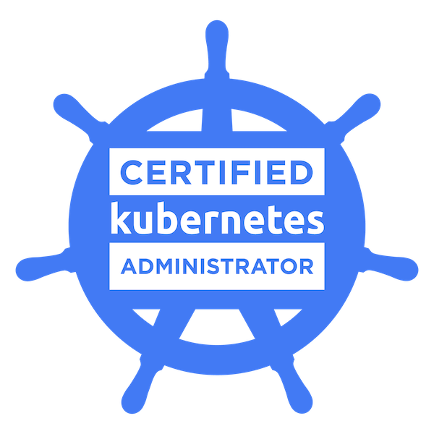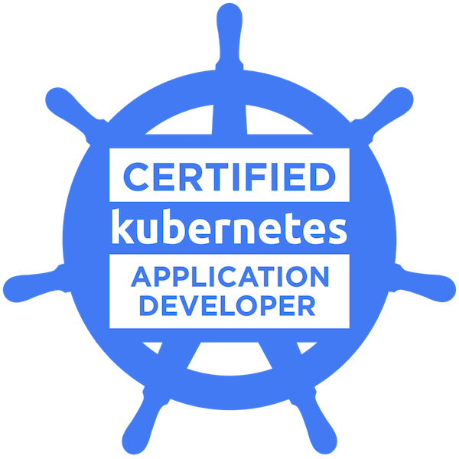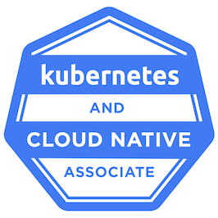

Miguel Valeriano
AWS Cloud Devops Architect/ Lead Engineer

Summary:

- 14+ years of experience in the Electronic Transaction Processing technologies, Payment aggregators and Insurance industries as Cloud Architect/DevOps Lead with a strong background in Security and Risk Mitigation.
- I’ve been involved in the design of infrastructure architectures based on AWS services, implementation of DevSecOps patterns and security compliance regulations for FINTECH companies.
- I have experience leading engineers and DevOps to turn them into self-managed teams and work according to the AGILE Framework.
- Experience in designing micro services infrastructure solutions on AWS, GCP and "On-Premise", PCI compliance and PCI Level 1 infrastructures.
- Experience implementing and managing Amazon Web Services such as: VPC, WAF, Route53, EC2, EKS, ECS, ECR, S3, RDS, IAM, SSO, Identity Management, ELB, ACM, Amazon MQ, ElastiCache, SNS, SES. Other tools I am familiar with are: Terraform, ArgoCD, NGINX, and OpenSSL.
- Experience working with containers and orchestration services: Kubernetes, Docker, ContainerD, AWS ECS, Docker Swarm, Docker Compose.
- Experience deploying production workloads with AWS EC2, Kubernetes, and RouteS3 Hosted Zones, AWS ELB, and auto scaling groups.
- Experience in management and design of integrated build pipelines using continuous integration workflows such as Jira, AWS Code Pipeline, AWS Code Build, and AWS Code Deploy.
- Design of GitOps workflows and IaC management using Git, GitHub, Kubernetes, Flux CD, AWS ECR.
- I have implemented multiple CI/CD Multi-Branch Automation Pipelines using Jenkins and Blue Ocean.
- Experience deploying Kubernetes production workload clusters using AWS EKS, GKE and "On-Premise".
- Experience in integrating CDN services and AWS infrastructures using Fastly and Cloud Front.
- Extensive experience in the design and implementation of IaC and automation processes using AWS Cloud formation templates to implement services such as: Kubernetes Cluster, AWS EC2 instances, AWS ELB, Auto Scaling Group, IAM Policies.
- Experience deploying AWS EKS Ingress controllers and NGINX Ingress controllers on Kubernetes clusters to operate with AWS Application Load Balancers.
- Implementation and management of RBAC user permissions in Kubernetes Clusters.
- Experience issuing CSR, PEM Key and SSL certificates using OpenSSL tools; Creating and managing SSL/TLS certificates using Amazon Certificate Manager. Extensive understanding of CA authority and intermediate CA certificates.
- Experience implementing and managing Observability solutions with Grafana, Prometheus, Loki, Promptail and Fluentd.
- Performed Vulnerability Tests through the Security Metrics and Tenable NESSUS tools to assess the security level of the infrastructure.
- Experience in the definition and implementation of Security Controls in AWS Cloud Infrastructures and Hardening configuration of Operating Systems (Linux, Windows).
- Experience deploying web application firewall (AWS WAF) regionally and globally to protect AWS ELB and Cloud Front distributions; also implemented OWASP Top 10 security rules and geo-restriction rules.
- Performed remediation tasks applying hardened security configuration to servers and services using CIS Security Benchmark Guides and CIS Security Controls for PCI Compliance Infrastructures.
- Expert in infrastructure design and network diagrams using Cloud Craft, Microsoft VISIO and DRAW.IO.
- Proficient working with Git, GitHub, Bitbucket.
- Experience implementing and managing Mongo DB clusters on Mongo DB Atlas Cloud Service.

Skills:

Operating Systems Debian, Red Hat, Ubuntu, Windows server 2019, Mac OS
Cloud Services AWS, GCP, Digital Ocean
Containerization/Orchestration Kubernetes, Docker, Helm, ContainerD, AWS EKS, Docker Swarm, Docker Compose, AWS AWS ECS
Scripting Languages Bash, PowerShell
Database PostgreSQL, MySQL, Mongo DB, Amazon MQ, Rabbit MQ, AWS RDS, AWS ElastiCache (Redis)
Web Servers NGINX, Apache, IIS, Fastly, OpenSSL, AWS Cloud Front
Automation AWS Cloud formation, Terraform, AWS Code Pipeline, AWS Code Build, AWS Code Deploy, Jenkins
Monitoring tools AWS Cloud Watch, DataDog, Dynatrace, Grafana, Prometheus
Version Control Tools Git, GitHub, Bit Bucket, AWS ECR, AWS Code Commit
Build Tools Maven, npm
Bug tracking tools Jira, Asana, Rally
Security SNYK, Wiz, SonarQube, WAF, OWASP Top 10, Tenable NESSUS, CIS Security, PCI
GitOps ArgoCD, Flux CD
Documentation Confluence, Cloud Craft, Microsoft Visio, DRAW.IO

Certifications:

- CKA: Certified Kubernetes Administrator
- CKAD: Certified Kubernetes Application Developer
- KCNA: Kubernetes and Cloud Native Associate
- SCRUM Fundamentals Certified

Education:

- Bachelor’s in computer science, Tecnológico National de México campus Acapulco, México.

Professional Experience:

Client: Accenture/ Travellers Apr 2023 – Till present
Role: DevOps Lead Engineer/Architect
Domain: Insurance

Responsibilities:
- I designed the application CI/CD release patterns for dev and production environments based on AWS EKS.
- Champion designated to track the DevSecOps Acceleration Strategies providing architect solutions based on AWS Cloud services and supporting engineer teams.
- I’ve worked in several initiatives for maturity and adoption of the Continuous Delivery Strategy based on Jenkins, ArgoCD, AWS EKS and Nexus across multiple teams.
- I lead a DevOps team (onshore and offshore) to provide support and solutions to Kubernetes applications deployments based on AWS EKS in multiple environments from Dev to Production.
- I lead the Support Team implementing solutions and fixing issues on multiple AWS services such as: AWS EKS, AWS VPC, AWS S3, AWS EC2, AWS Config, AWS Route53, WAF.
- I’ve led the migration from Black duck application software scan to SNYK vulnerability scan in more than 200 pipelines.
- Leading the adoption and implementation of the tagging strategy across all the Payments and Billing circle teams.
- In charge of the migration plan of Ubuntu 20.04 EC2 instances to Ubuntu 24.04 Terraform and Ansible playbooks.

Environment: AWS EKS, Kubernetes, ArgoCD, Helm, AWS EC2, AWS Route53, WAF, AWS S3, AWS Cloud Front, AWS ECS, AWS SES, AWS SNS, Docker, GitHub, SSH, NGINX, OpenSSL, SSL/TLS, AWS RDS, Maven, NPM, Terraform, Jenkins, JIRA, AWS VPC, AWS ElastiCache, DataDog, Wiz, SNYK, SonarQube, Postman.

Client: Definity First, Monterrey, MX Nov 2021 – March 2023
Role: AWS Cloud Architect/ DevOps Lead Engineer
Domain: Online Ticket Vendor(E- Commerce)

Responsibilities:
- I work as a solutions architect designing the infrastructure architecture of the new micro services platform of the Online tickets website.
- Assigned to work with one of the top online ticket vendors in the USA to design and implement the AWS infrastructure and Kubernetes services for the new ticket selling platform of Paris2024 Olympics Games.
- Leading the Cloud engineering team’s client.
- Building Continuous Integration and Continuous Delivery architectures using Github, AWS Code Build, AWS ECR, AWS EKS and Flux CD.
- Implemented Blue/Green application deployment.
- Deployed auto scaled and balanced production workloads using AWS EC2, ELB, Auto scaling groups, Route53 and SNS.
- Designed AWS Cloud Formation templates to automate infrastructure provisioning and deployment Kubernetes Clusters, Application Load Balancers, IAM Roles and Policies.
- Responsible for running vulnerability tests and vulnerability remediation tasks to have a PCI Compliance infrastructure.
- Implementation of security controls and Hardened settings in NGINX, IIS, Apache, Linux, Windows.
- I’ve implemented the current GitOps workflow to automate the deployment of containerized applications into the Kubernetes Clusters.
- Implementing a VPN solution to allow the users to connect to the AWS EC2 and RDS resources in a private and secure way.
- Created the AWS Organization to manage the multiple AWS accounts of the client I’m assigned to and I implemented the AWS SSO services to allow the management of those accounts using one single user credential.
- Creation of documentation handbooks and infrastructure diagrams.

Environment: AWS EC2, AWS Route53, AWS EKS, WAF, OWASP Top 10, Kubernetes, AWS S3, AWS CloudFront, AWS ECS, AWS SES, AWS SNS, Docker, GitHub, Bit Bucket, SSH, NGINX, OpenSSL, SSL/TLS, AWS RDS, Maven, NPM, Terraform, Flux CD, ArgoCD, AWS Code Build, AWS Code Deploy, AWS Code Pipeline, JIRA, AWS VPC, VPN, AWS SSO, AWS Organizations.

Client: Stellatech Mexico, Mexico Oct 2019 – Nov 2021
Role: Cloud Architect/DevOps Lead
Domain: Payment Aggregator/Finance TECH
Responsibilities:

- Responsible for designing and building the micro services infrastructure for the new online payment aggregator product using Amazon Web Services.
- Implement the FINTECH regulations act through the adoption of a new culture of security awareness, secure application development, implementation of security services such as WAF and security scans on applications, artifacts and code review, and protection of customer information.
- Leader of the DevOps area at Stellatech, in charge of the infrastructure design, the implementation of the security services and the management of the Cloud services on AWS and Digital Ocean.
- Implementing the CI/CD Multi-branch pipelines to build and deploy micro services to EC2 instances and Kubernetes using Jenkins, AWS EKS, Bitbucket and Docker.
- Implemented Blue/Green application deployment.
- Implemented Observability architecture solution to allow service monitoring using Grafana, Prometheus, Loki and Promptail.
- Responsible for running vulnerability tests and vulnerability remediation tasks using Tenable NESSUS to have a PCI Compliance infrastructure.
- Implementation of security controls and Hardened settings in NGINX, IIS, Apache, Linux.
- Responsible to implement Mongo DB Atlas Cloud Service Cluster and AWS RDS Databases.
- Related to multiple AWS solutions using EC2, S3, RDS, EBS, Cloud Front, Certificate Manager, Elastic Load Balancer, Auto scaling groups, Cloud Watch. Rabbit MQ and Amazon MQ.
- Automated the Jboss components like managed servers, data sources, mail resource, Jdbc, jms and tested.
- Automated the apache installation and its components using puppet.
- Used GIT version control to push the modules to GitHub.
- Good in Ruby and Bash shell scripting for writing up scripts for matrix collection of various applications and automation of day-to-day activity.

Environment: AWS, Digital Ocean, Maven, NPM, NGINX, Jenkins, GitHub, Rabbit MQ, Docker, Kubernetes, WAF, OWASP Top 10.
Client: Diestel, Mexico Feb 2010 – Oct 2019
Role: Operations Manager (System/ Infrastructure Engineering)/Architect
Domain: Payment Processor

Responsibilities:
- I am responsible for maintaining the processing of electronic payment transactions. Electronic services that are provided to more than 30,000 points of sale throughout the country on different commercial brands.
- Responsible for coordinating the tier 2 and tier 3 support department, Engineering, Databases and Contact Center for the troubleshooting of service failures.
- SysAdmin tasks to manage the On-Premise Servers applications and failure resolutions.
- Responsible for designing and providing infrastructure solutions to improve the company’s operation.
- Author of the migration plan to move the applications from the On-Premise Infrastructure to Amazon Web Services.
- Troubleshooting Server down, identified the server location inside the AWS account and validated the System Status Check and Instance Status Check
- Analyzed and resolved diagnostic problems on Operating System AIX, Solaris and Linux RHEL 6/7 Operating System and administered SUN Cluster and HACMP.
- Reengineered the company's infrastructure, optimized system performance, installed upgrades/patches, and established system monitoring on Unix servers.
- Acted as an escalation contact for troubleshooting advanced Unix infrastructure / Financial services Modules issues; Consistently earned 100% issue-resolution scores by providing excellent service to internal and external customers.

Environment: AWS, Windows, Linux, VMware, IIS, SSH, NGINX,

