Nibedita Panda
Technical Project/Product and Operations Manager at General Electric – Oracle ERP Database | SCM Functional | ServiceNow

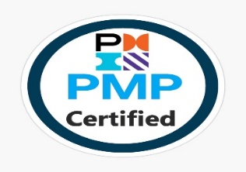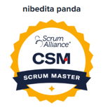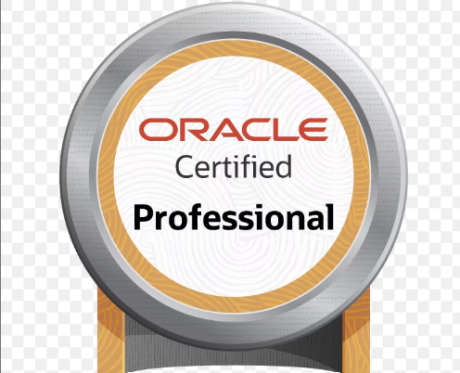

Professional Summary
Results-driven Product and Project Management professional with over 18 years of hands-on experience in both technical and leadership roles. Proven expertise in managing end-to-end Oracle ERP operations—including Database, Fusion SCM Functional, and Infrastructure support—for the APAC region. Adept at Business Analysis, Training & Communications, and IT Service Management (Incident/Change/Problem) using ServiceNow. Skilled in vendor and stakeholder management, with a strong track record of resolving complex business challenges and driving high-performance outcomes.

Technical Skills

Oracle ERP Database: Patching, Cloning, Implementation, Installation, Upgradation
Performance Tuning: SQL/Pl-SQL Tuning, AWR/ADDM/ASH Reports Analysis, OEM
Fusion SCM : User/Role/Job/Duty Management, Product management, Order Management, Costing, Inventory Management, Procurement
Web/Mobile Focus: Homepage Optimization, Global Navigation, Foundational UI, Mobile Dashboards
Project Management: Agile, SDLC, Release management, Scrum, Jira
Product Management: Product Lifecycle Management, Roadmap Planning and Prioritization, Backlog Grooming
ServiceNow: ITIL, ITSM, CMDB

CERTIFICATIONS
CSM, PMP, OCP

Professional Experience


August 2015 – July 2024
Sr Technical Product Manager for ERP Systems
Job responsibilities: -
- Boosted platform ROI by 20% through continuous iteration on ServiceNow solutions and introducing self-service portals that reduced manual workloads.
- Facilitated cross-functional collaboration by forming and leading an Agile team comprising ERP functional consultants, DBAs, developers, testers, and business analysts.
- Built and led a global support model for Oracle Fusion SCM operations, aligning regional support teams (APAC) for 24/7 critical coverage.
- Led day-to-day operational support of Oracle Fusion SCM modules (Inventory, Procurement, Order Management, Product Hub), ensuring business continuity and adherence to SLAs.
- Delivered training and functional SOPs for end users across sourcing, inventory, and order fulfillment functions to drive adoption and reduce errors.
- Leveraged Slack for cross-functional team communication and real-time engineering issue resolution, reducing response times by 25%.
- Created executive dashboards and product reports in Excel and PowerPoint to track product roadmap progress, velocity, and stakeholder KPIs, improving transparency and decision-making.
- Oversaw user provisioning, role mapping, and access audits for SCM modules, ensuring compliance with security and governance policies.
- Led the resolution of critical P1/P2 issues, closely tracking Oracle Service Requests (SRs) to manage root cause analysis, bug fixes, and major system issues.
- Using ITIL process tracking of incidents, problems, and changes using the ServiceNow tool, ensuring timely resolution and continuous improvement.
- Implemented a structured Change Advisory Board (CAB) process, reducing unauthorized changes by 90% and improving deployment success rates
- Facilitated real-time war rooms for major incidents, ensuring clear communication and quick triage across IT, business, and vendor teams.
- Led the upgrade of Oracle EBS from 11.5.10.2 to 12.2.4 using Agile methodologies, ensuring a seamless transition with minimal disruption and enhanced system performance.
- Applied an incremental development and testing strategy by breaking down the ERP upgrade into multiple sprints, prioritizing critical functionalities such as financial modules, procurement, and HRMS for phased implementation.
- Ensured robust testing and validation by conducting iterative performance tuning, load testing, and performance validation after each upgrade in lower environments, optimizing system stability and efficiency.
- Provided smooth operational support post-go-live, ensuring system stability and user satisfaction.
- Led planning, scheduling, tracking, and monitoring of resource allocation, issue resolution, and risk management to ensure seamless project execution.
- Created executive dashboards and product reports in PowerPoint and Excel to track velocity, defect density, delivery times, and quality metrics.
- Maintained the quality and integrity of all project documentation using tools like BOX and MyWorkshop, ensuring compliance and structured data management.
- Served as the Lead Manager for vendor transition activities, successfully overseeing four vendor transitions in the past nine years with an 85% success rate.
- Collaborated with distributed teams using Slack, reducing missed hand-offs and improving alignment.
- Utilized Slack for real-time communication, reducing engineering response times
- Monitored and reported on engineering KPIs across Jira and Confluence, ensuring data-driven decisions for prioritization and delivery.
- Defined and implemented homepage, global navigation, and foundational UI components to improve reusability, accessibility, and performance across web and mobile platforms
Maintained validation data in the ALM tool for external audits, ensuring FDA compliance for validated and GxP environments during major releases, including the R12 upgrade and two Exadata migrations.
- Updated and routed validated DDS and DSDS documents in MyWorkshop to reflect changes in database architecture, server infrastructure, or operational standards.
- Managed and maintained the overall ERP operations repository on BOX, ensuring all documentation remains up to date and aligned with operational processes.



August 2014 - June 2015
ERP Project Manager
- Job responsibilities: -
- Managed multiple stakeholders and technical teams in the installation, implementation, and integration of Oracle GoldenGate between Oracle EBS and FUSION APPS servers for PwC SDC's internal database.
- Managed end-to-end project delivery and post-operational support in collaboration with architects and technical teams to implement new environments and successfully upgrade Oracle EBS from 11.5.10.2 on Solaris Server 9 to 12.2.4 on Solaris Server 10.
- Executed the project using Agile methodology with Scrum, ensuring iterative development, continuous feedback, and efficient risk mitigation.
- Managed the database upgrade from 10.2.0.2 to 12.1.3 via 11.2.0.3 for clients including Southern Co. and Fujitsu. Collaborated with DevOps teams to enhance Oracle ERP deployment processes, integrating Continuous Integration/Continuous Deployment (CI/CD) pipelines for automated testing, faster releases, and improved system stability.
- design and engineering teams on mobile product development improving usability and feature adoption
- Used Slack and Excel-based trackers to bridge communication across distributed teams and vendors, reducing missed hand-offs by 30%.
- Designed mobile-enabled dashboards for stakeholders to monitor ERP project health and SLA compliance on-the-go, improving leadership visibility and decision speed.
- Monitored engineering KPIs (sprint velocity, defect density, feature throughput) across Jira and ServiceNow, ensuring data-driven prioritization and continuous delivery improvements.
- Analyzed project scope and developed comprehensive documentation, ensuring clarity on requirements and deliverables.
- Maintained a centralized knowledge repository to streamline information sharing and support ongoing project needs.
- Led knowledge transition initiatives for new resources, equipping them with the expertise and training necessary to efficiently take on new assignments.


December 2008 - August 2014
TECHNICAL ANALYST – ERP DATABASE SUPPORT
Company: Arrow Electronics
Job responsibilities: -
- Implemented Oracle on new Linux servers and migrated the database from 9i to 10g, 10g to 11g, and 11g to 12c using agile methodologies across various industries, including manufacturing, supply chain, and sales.
- Provided 24/7 production support for Arrow's databases and EBS environment.
- Executed manual code migration and implemented OBIEE, BI Publisher, and APEX systems for improved monitoring and streamlined reporting.
- Built web-based dashboards (OBIEE, BI Publisher, APEX) for real-time reporting and monitoring, enabling product teams and business stakeholders to track adoption, incidents, and delivery timelines.
- Managed overall operations of Oracle's EBS applications from 11i to R12.1 in coordination with vendors such as Datavail and Infosys.
- Analyzed project scope to create essential documentation, developed and maintained a knowledge repository, and facilitated knowledge transfer to new resources, ensuring they were prepared for new assignments.
- Oversaw monitoring, backup, recovery processes, and scheduled reports and blackouts on OEM.
- Coordinated with technical architects to propose and design technical and process solutions that aligned with business needs and objectives.


April 2007 - Nov 2008
ORACLE ERP DATABASE ADMINISTRATOR
Company: Wipro Technologies
Clients: Emerson Motors and Cisco
Job responsibilities: -

- Database Monitoring
- Backup, recovery processes, and scheduled reports and blackouts on OEM and cron job
- Troubleshooting day to day issues.
- SQL performance tuning through ADDM and AWR reports.
- Database Patching and cloning as part of Weekend database maintenance

Awards
•
- Star Performer of the Quarter – Recognized for exceptional stakeholder management during Oracle Fusion implementation at GE. Top Incident solver at Arrow Electronics and PwC
- Client Appreciation Certificate – For the best operational support at PWC
- Leadership Excellence Award – For transitioning and mentoring new vendors at GE
- Spot Award – Resolving maximum P1/P2 incidents as part of post Go-live support at GE
- Best Performer – Successful Implementation and upgradation of Oracle ERP Database and Infra at PwC.

Education
•
Bachelor of Technology — BPUT, Odisha Jun 2005

Languages
•
English (Fluent), Hindi (Fluent), Odia (Fluent)

I do hereby confirm that the information given above is true to the best of my knowledge and belief.

(Nibedita Panda)

