PRADEEP KUMAR YADAMAKANTI 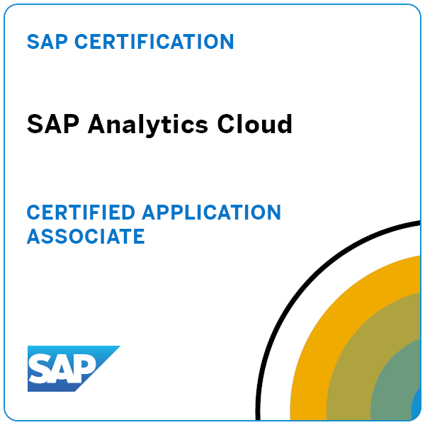
Email: pradeepkumar.sapsac@gmail.com
Phone: 7323222051
LinkedIn URL: www.linkedin.com/in/pradeep-kumar-yadamakanti-05050515
Professional Summary
- Having 14+ Years of Experience as SAP BW/SAP BW4HANA/ HANA/SAP EPM/SAC consultant, involved in Implementation, Upgradation and Support Projects.
- Implemented Five full life cycle implementations for different modules (FI/CO, SD, MM and PM) in SAP, involved in all phases like Gap analysis, Blue-printing, design Functional and Technical specification, development, performance tuning, integration and UAT, documentation, code and peer code reviews, training and troubleshooting.
- Designed and implemented SAP BW, SAP BW on Native HANA and standalone SAP HANA data models using ADSO, ODP/ODQ, Open ODS View, and Composite Providers, SDI, SDA, CDS Views and AMDP Scripts.
- Strong Analytical architecture on HANA (Calculation Views and Strong SQL statement on Procedure) and understanding the client’s current gap and needs.
- Experience on HANA Optimized Info Cubes, HANA Optimized DSO's, Transient, Composite, Hybrid Providers, Publishing HANA Model in SAP BW, Import SAP NetWeaver BW Model to HANA.
- Experience in migrating the Standard DSO & Info Cube to HANA Optimized DSO and Cubes. Experience in Importing BW models Info Cube, DSO in HANA as Analytical view.
- Worked on implementing and supporting SAP Analytics Cloud (SAC) solutions for business planning, reporting and analytics.
- Experience in SAC Excel Add-in reporting
- Integrated SAP BW/4HANA with SAP Analytics Cloud (SAC), creating interactive dashboards and reports for executive decision-making.
- Created and maintained SAP CDS Views for efficient data retrieval and reporting.
- Strong Analytical using ASAP methodologies with Administration workbench Data Modeling.
- Experience in working with Agile Methodology, Waterfall methodologies and Hybrid models.
- Having excellent problem-solving skills, with good Analytical, Decision-making and team building skills.
- Gained significant experience in direct client facing, trouble shooting and Client Management abilities.
- Strong BW technical capabilities along with the ability to independently function with global clients and in globally distributed teams.
- Conducting weekly meetings to discuss projects, ticket status and other open points.
- Worked on Business Objects, Tableau Dash boards and Power BI, AFO.

EMPOYMENT HISTORY
- Working as SAP BW4HANA / SAC Lead with Bank of America from Dec 2013 to April 2025.
- Worked as SAP BW/BI Consultant with IBM from July 2010 to Dec 2013
- Worked as SAP BW/SAP Testing with HP from Mar 2008 to June 2010

Technical & Functional Skills:
- SAP Skills: SAP BW on HANA, BW/4HANA, SAP Analytics for cloud, SAP Data sphere
- Data Warehousing & Modeling: BW Data Modeling, Data Extraction, BW Queries, BEX Reporting, Data Loading
- Testing: Unit, Integration, UAT, Regression, Load, and Performance
- Programming Languages: ABAP, SQL, Python
- Reporting/Analytics: Microsoft Excel, Power BI, Tableau, SAC (SAP Analytics Cloud), SAP BEx Analyzer, SAP EPM
- ETL Tools: Talend, Informatica
- Databases: S/4 HANA, ECC, SQL, Oracle DB
- Cloud Computing: AWS, Azure, Google Cloud
- Version Control & Collaboration: Git, Jira
- Project Management: Agile (Scrum, Kanban), Jira
- Stakeholder Communication & Collaboration
- Functional and Technical Documentation & System Design
- Business Analysis & Requirements Gathering
- Software Development Life Cycle (SDLC)
- SAP Certified SAP BW, SAP BW4HANA, SAP Analytics for Cloud Consultant
Work Experience:
Organization : Bank OF America
Period : Dec 2013 to till date
Environment : SAP BW/SAP BW4HANA/ SAC/SAP EPM Consultant
- Created ADSOs, Composite Providers and Open Hub Destinations to transfer data to third parties.
- Created many EPM report templates for users according to the business requirement.
- Worked on BW4/HANA Conversion from BW 7.5.
- Monitoring the data loads on daily basis and fixing issue if any failures in BW system.
- Working on the Incidents such as Process chain issues, report issues and environment issues.
- Involved in Pre and Post Upgradation activities in Production and Non-Production systems
- Involved in workshops for requirement gathering and freezing the requirement
- Working on the Enhancements on HANA Calculation Views, ADSO’s and Composite Providers.
- Implementing SAP BW HANA specific modelling like Info objects, ADSO, open ODS view, Compositors, Transformations, DTP and BW query in BW4HANA according to requirement.
- Worked on HANA Enterprise Modelling including Attribute Views, Analytical Views.
- Worked on Data Modeling, Data Provisioning, Reporting, ADSO, Operational Data Provisioning using BW EXTRACTORS and CDS views.
- Working on creation of reports in Embedded Analytics
- Involved in migration of reports from DEV environment to PRD Environment in EA
- Gathered and analyzed business requirements to design SAC models and stories
- Created Dashboard stories in SAC using Canvas and Responsive pages
- Integrated SAC with SAP BW, HANA or S/4HANA for real time analytics
- Experience on creation of private, public dimensions in SAC and loading of Master data
- Worked on different data sources like Flat file and File source
- Worked on SAC Planning scenarios like Data Distribution, Allocation and Version management.
- Involved in UAT by fixing the defects raised and maintaining route cause analysis thus deploying defect free code to PROD.
- Supported UAT during business users testing.
- Created Data action and Multi actions to automate the process
- Experience on configuration of Data locking methods
- Created Calendar tasks for approval process
- Transported SAC Objects from Dev to QA tenant using content networking and file import
- Worked on the creation of import jobs and scheduling the report
- Experience in SAC Excel Add-in reporting
- Created teams, Users and assigned roles to access stories model, and dimensions
- Involved in Show and Tell sessions to explain the capabilities of SAC
- Involved in End-user Training and user manual preparation for End users

Organization : IBM
Period : July 2010 to Dec 2013
Environment : SAP BW/BI, SAP BEX, SAP ECC

- Spearheaded the end-to-end implementation lifecycle of SAP BI/BW, orchestrating seamless data modeling and extraction processes to meet project objectives with precision and efficiency.
- Designed and meticulously maintained a diverse array of crucial components including Info Cubes, DSOs, Multi Providers, and Info Objects, ensuring data integrity and optimizing analytical capabilities.
- Innovatively crafted SAP BEx queries incorporating advanced features such as variables, CKF, RKF, and more, empowering users with unparalleled flexibility and insight into complex datasets.
- Implemented and fine-tuned process chains to streamline and optimize data loading procedures, enhancing system throughput and performance.
- Managed intricate data extraction tasks from SAP, APO, and Oracle systems, ensuring seamless integration and data consistency across disparate sources.
- Conducted comprehensive performance tuning exercises for SAP BW, systematically identifying and addressing inefficiencies to improve overall system efficiency and responsiveness.
- Leveraged the advanced capabilities of SAP BEx Analyzer and SAP BusinessObjects to deliver sophisticated, actionable insights through advanced reporting and analytics.
- Proactively addressed data mismatches and user enhancement requests, swiftly resolving issues to maintain data integrity and user satisfaction.
- Monitored data loads meticulously, promptly identifying and resolving production issues to minimize downtime and ensure uninterrupted data availability.
- Developed intricate ABAP routines to enhance data sources, leveraging advanced programming techniques to optimize data extraction and transformation processes.
- Collaborated closely with business users to gather requirements and deliver tailored solutions, fostering a culture of collaboration and alignment between IT and business objectives.
- Achieved significant enhancements in reporting performance and data accuracy through continuous optimization efforts, driving tangible business value and empowering informed decision-making.

Organization : HP
Period : March 2008 to June 2010
Environment : SAP BW/BI, SAP BEX, SAP ECC

- Involved in support activities data loads, data validations, process chain maintenance.
- Worked extensively on administration workbench (RSA1).
- Involved in identifying version upgrade changes in existing objects to previous version.
- Involved in taking the object design back-ups compared them after BI 7.0 upgrade.
- Set up procedure for extracting R/3 data for Customers, Sales Order, Delivery, Shipping, Billing Document in Sales and Distribution using LO-Cockpit.
- Worked extensively on Development, Acceptance and Production Environments.
- Creating Various Bex queries as per requirement and then using them for designing Universes and reports.
- Prepared reports by using master details, cross-tabs, slice and dice and drill mode as per the requirement of the end-user
- Experience in Gathering client specific requirements for projects, development, testing and deployment
- Involved in developing different type of objects Data source, Transformations, Info Source, Basic cube, DSO, Multi provider, Info set, DTP of type Standard, Direct Access, Error DTP and Info packages.
- Configured the use of filters, restricted key figure, calculated key figure, variables, structures, conditions, exceptions, and drill-down functionality as per client’s requirement. Creating Process chains for both master data & Transaction data.
- Involved in Managing of Info Cubes, which involves Info Cube Content, Performance issues like Line Item Dimension, Partitioning, Compression of Info Cube and Rolling up the data to the Aggregates.
- Good Understanding of design based on Layered Scalable Architecture (LSA).
- Transported developed objects from development box to quality box and production.
- Created ODS, Cubes and Multi providers to load the transactional data according to the BW star schema documents and data flow diagrams.

