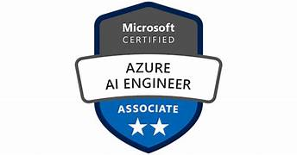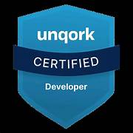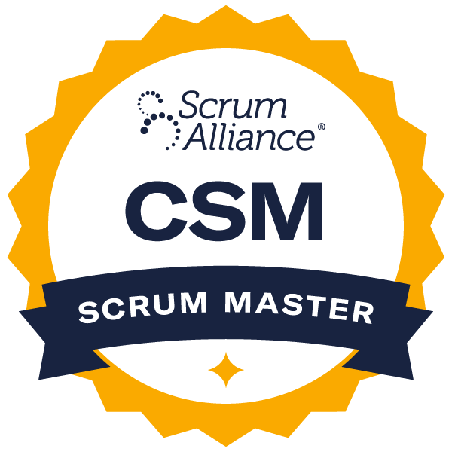

Priya Rajni

Reach me on: priyarajni005@gmail.com , (224) 742-0171

AI & Automation QA Engineer

PROFESSIONAL SUMMARY:
Senior AI & Automation QA Engineer with 10+ years of experience delivering intelligent quality engineering solutions across insurance, reinsurance, and enterprise technology platforms. Specialized in validating and optimizing LLM-driven applications, Retrieval-Augmented Generation (RAG) systems, NLP models, and AI-powered automation platforms to ensure accuracy, reliability, security, and regulatory compliance in production environments.
Extensive experience designing AI testing strategies, LLM evaluation frameworks, prompt regression testing, hallucination detection, adversarial prompt testing, and semantic retrieval validation pipelines to measure model performance and response quality. Hands-on expertise building scalable AI validation and automation solutions using Python, FastAPI, LangChain, OpenAI APIs, Hugging Face Transformers, and vector databases including Pinecone.
Proven ability to integrate traditional QA automation (Selenium, API testing, CI/CD pipelines) with modern AI validation techniques, model monitoring, and observability tools such as LangSmith and MLflow to ensure continuous model reliability and performance. Experienced in deploying and validating AI systems on AWS and Azure cloud platforms using containerized microservices and CI/CD automation.
Microsoft Certified Azure AI Engineer Associate (AI-102) with strong expertise in bridging ML engineering, development, and QA teams to deliver scalable, production-ready AI solutions with measurable improvements in quality, operational efficiency, and compliance.

TECHNICAL SKILLS

Generative AI & LLM Technologies
Retrieval-Augmented Generation (RAG), Prompt Engineering, Prompt Optimization, LangChain, LangGraph, AI Agents, Multi-Agent Workflows, Tool-Calling Agents, OpenAI APIs, Azure OpenAI, Hugging Face Transformers, Embeddings, Semantic Search, LLM Orchestration, Context Engineering

Vector Databases & Semantic Retrieval
Pinecone, FAISS, Chroma, Vector Indexing, Similarity Search, Metadata Filtering, Hybrid Retrieval (Semantic + Keyword), Embedding Optimization, Retrieval Ranking

AI Testing & LLM Evaluation
LLM Evaluation Frameworks, Prompt Regression Testing, RAG Evaluation Pipelines, Response Scoring, Hallucination Detection Testing, Ground Truth Validation, Response Consistency Testing, A/B Prompt Testing, Adversarial Prompt Testing, Semantic Similarity Evaluation, Human-in-the-Loop Validation

Responsible AI & Model Governance
Bias Detection, Fairness Testing, AI Compliance Validation, Responsible AI Frameworks, Explainable AI (SHAP), Model Transparency, AI Audit & Risk Validation, Data Privacy Validation, Ethical AI Validation

Machine Learning & NLP
Text Classification, Named Entity Recognition (NER), Entity Extraction, Document Intelligence, Transformer Models, Hugging Face, Scikit-learn, TensorFlow, PyTorch, Feature Engineering, Model Training & Evaluation

Backend Development & Automation
Python, FastAPI, REST API Development, Microservices Architecture, Intelligent Document Processing, Workflow Automation, Data Processing with Pandas, API Integration

Testing & Automation Tools
Selenium WebDriver, PyTest, API Testing, Postman, Test Automation Framework Design, Automated Regression Testing, Test Data Generation, Integration Testing, Functional Testing

Cloud Platforms & DevOps
AWS (S3, EC2, Lambda, SageMaker), Azure AI Services, Docker, Kubernetes (basic), CI/CD Pipelines, GitHub Actions, Jenkins, Infrastructure Automation

AI Observability & Monitoring
LangSmith, MLflow, Model Monitoring, Prompt Performance Tracking, Token Usage Monitoring, LLM Latency Monitoring, Logging & Observability, Model Drift Detection

Data Engineering & Analytics
SQL, ETL Pipelines, Apache Airflow, Data Modeling, Data Validation, Data Quality Monitoring, Batch & Incremental Data Processing, Analytics Dataset Preparation

ROLE ALIGNMENT
• AI & Automation QA Engineer
• Generative AI Quality Engineer
• LLM Evaluation Engineer
• AI Model Validation Engineer
• Responsible AI Engineer
• AI Testing Engineer (LLM / NLP Systems)
• AI Quality Assurance Engineer
• Retrieval-Augmented Generation (RAG) Validation Engineer
• Machine Learning QA Engineer
• AI Automation Test Engineer

PROFESSIONAL EXPERIENCE:
Client Name: Cooperators – Amy Wang Insurance & Investment Inc.
Generative AI Engineer / Automation
Feb 2023 – Present | Remote (Chicago, IL)

Project: Enterprise Insurance AI Assistant & Underwriting Automation Platform
Designed and implemented a production-grade AI platform to assist underwriting teams with intelligent document retrieval, policy analysis, compliance validation, and workflow automation using LLMs and vector search systems.

Responsibilities:
- Designed and deployed a production-ready Retrieval-Augmented Generation (RAG) assistant improving underwriting document retrieval accuracy by 40% and reducing manual policy review time by 35%.
- Built scalable vector search pipelines using Pinecone with embedding generation and metadata filtering.
- Engineered advanced prompt engineering strategies to reduce hallucinations and improve LLM grounding.
- Integrated automated LLM validation tests into CI/CD pipelines ensuring continuous model quality verification.
- Built automated regression testing pipelines for prompt updates and model upgrades.
- Implemented hybrid retrieval (semantic + keyword search) to enhance response accuracy.
- Built automated document ingestion pipelines for PDFs, structured files, and policy repositories.
- Conducted prompt injection and jailbreak testing to ensure LLM security and safe output generation.
- Implemented data leakage validation checks preventing exposure of sensitive policy information.
- Defined AI performance metrics including retrieval precision, recall, groundedness score, and response consistency.
- Monitored LLM latency, token usage, and response quality metrics to optimize production performance.
- Performed adversarial prompt testing to evaluate robustness of LLM responses.
- Developed LLM-powered automation tools for policy summarization, compliance checks, and customer communication drafting.
- Designed evaluation frameworks to measure retrieval relevance and LLM response quality.
- Integrated AI services using FastAPI-based REST APIs.
- Deployed containerized microservices on AWS (EC2, Lambda, S3).
- Implemented monitoring, logging, and error-handling mechanisms for production reliability.
- Optimized token usage and inference cost through caching and embedding reuse strategies.
- Collaborated with underwriting and compliance stakeholders to ensure regulatory alignment.

Environment: Python, FastAPI, LangChain, LangGraph, OpenAI APIs, Azure OpenAI, Hugging Face Transformers, Retrieval-Augmented Generation (RAG), Prompt Engineering, Pinecone Vector Database, Semantic Search, Embeddings, Hybrid Retrieval, AI Agents, LLM Evaluation Frameworks, Prompt Regression Testing, Adversarial Prompt Testing, Hallucination Detection, LangSmith, MLflow, Docker, AWS (EC2, Lambda, S3), REST APIs, CI/CD (GitHub Actions, Jenkins), Kubernetes (basic), Microservices Architecture, Logging & Monitoring, Token Usage Monitoring.

Client: Munich Re
Machine Learning Engineer / Automation
Dec 2021 – Jan 2023 | Remote (Toronto, Canada)

Project: Reinsurance Contract Intelligence & Claims Automation System
Developed NLP-driven contract intelligence systems to automate claims categorization, risk analysis, and contract clause extraction.

Responsibilities:
- Built transformer-based NLP models for contract analysis.
- Developed entity extraction models for exclusions, liabilities, and risk clauses.
- Implemented text classification pipelines using Hugging Face Transformers.
- Designed ML model validation frameworks to evaluate contract classification and clause extraction accuracy using precision, recall, and F1 metrics.
- Built evaluation datasets and ground truth validation pipelines to continuously measure NLP model performance.
- Designed ML model validation frameworks to evaluate contract classification and clause extraction accuracy using precision, recall, and F1 metrics.
- Built ground truth datasets and evaluation pipelines to measure NLP model performance and reliability.
- Implemented model monitoring pipelines to detect prediction drift and performance degradation in production systems.
- Developed automated data quality validation checks ensuring integrity of contract datasets used for training and inference.
- Performed API testing and integration validation for deployed ML services integrated with enterprise claims systems.
- Developed automated data quality validation checks to ensure consistency and accuracy of contract data used for model training.
- Applied Explainable AI techniques (SHAP) to interpret model predictions and validate decision transparency for regulatory compliance.
- Performed API validation and integration testing for deployed ML services to ensure reliable communication with enterprise applications.
- Optimized NLP model inference pipelines reducing processing time for contract analysis workflows.
- Designed predictive risk scoring models for underwriting decision support.
- Built scalable document parsing pipelines (rule-based + ML hybrid).
- Automated feature engineering and preprocessing workflows.
- Deployed ML models as Dockerized microservices.
- Implemented model monitoring pipelines to track prediction drift and performance degradation across production claims datasets.
- Implemented model monitoring and retraining pipelines.
- Applied Explainable AI (SHAP-based interpretation) for model transparency.
- Integrated ML services into enterprise platforms via REST APIs.
- Reduced manual review cycles through semi-automated contract processing systems.

Environment: Python, Hugging Face Transformers, NLP, Text Classification, Named Entity Recognition (NER), Entity Extraction, Scikit-learn, TensorFlow, PyTorch, SHAP (Explainable AI), Feature Engineering, Model Training & Evaluation, MLflow, REST APIs, Docker, Microservices Architecture, Data Validation Pipelines, Model Monitoring, Prediction Drift Detection, SQL, Pandas, CI/CD Pipelines, API Testing (Postman), Integration Testing.

Client: i2soft Technologies Pvt Ltd
Data Engineer / Automation
Jun 2016 – Apr 2020 | Bengaluru, India

Project: Enterprise Data Platform for Analytics & ML Enablement
Built scalable data engineering pipelines supporting analytics, reporting, and machine learning workflows.

Responsibilities:
- Designed end-to-end ETL pipelines supporting ML workloads.
- Developed Python-based data transformation and validation scripts.
- Implemented Apache Airflow DAGs for workflow orchestration.
- Built batch and incremental ingestion processes for structured and semi-structured data.
- Designed analytics-ready data models.
- Automated data quality validation and anomaly detection.
- Improved pipeline reliability through logging, monitoring, and retry mechanisms.
- Optimized SQL queries for large-scale dataset processing.
- Delivered feature-engineered datasets for ML model training.
- Implemented data governance and validation controls.

Environment: Python, SQL, Pandas, Apache Airflow, ETL Pipelines, Data Modeling, Data Validation, Batch Processing, Incremental Data Processing, Workflow Automation, Analytics Dataset Preparation, Data Quality Monitoring, Logging & Monitoring, Linux, Git.

Client: DXC Technology
Test Engineer
Oct 2011 – Feb 2015 | Bengaluru, India

Project: Insurance Application QA Automation & Integration Testing
Supported enterprise insurance systems through test automation frameworks and API validation processes.

Responsibilities:
- Developed Selenium WebDriver automation frameworks.
- Built reusable test automation libraries.
- Performed API testing and integration testing.
- Integrated automated test suites into CI pipelines.
- Reduced manual regression cycles through automation.
- Created automated test data generation scripts.
- Improved defect tracking and root cause reporting.
- Enhanced test coverage and release quality through automation initiatives.

Environment: Selenium WebDriver, Java/Python, Test Automation Frameworks, API Testing, Postman, Functional Testing, Integration Testing, Regression Testing, Test Data Management, Jenkins, CI Pipelines, Agile (Scrum), Defect Tracking (JIRA), Test Case Management.

CERTIFICATIONS
- Microsoft Certified: Azure AI Engineer Associate (AI-102) – Microsoft
- Unqork Agile Framework Certification – Unqork
- Certified ScrumMaster (CSM) – Scrum Alliance

