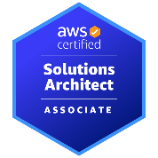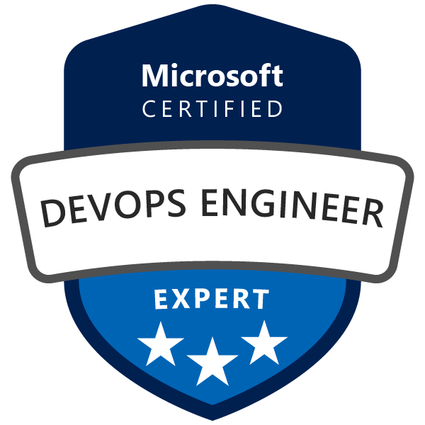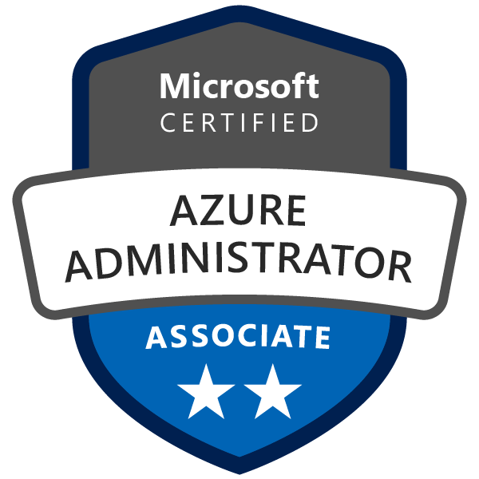
Ravi Chandra Prasad Thota

Email: t.ravichandraprasad@gmail.com
Linked In: www.linkedin.com/in/ravichandraprasadthota Phone: +1(469) 951-0405

Professional Summary:

- Around 16+ years of experience in the IT industry with expertise in development, release management, cloud computing (Azure & AWS), DevOps practices, and CI/CD pipeline implementation.
- Proven experience in migrating on-premises infrastructure to cloud environments using tools like Terraform, CloudFormation, and ARM templates.
- Proficient in build and configuration management tools such as Azure DevOps, Jenkins, GitHub Actions, and Chef.
- Strong knowledge of Azure services across IaaS, PaaS, and SaaS models, and AWS services including EC2, S3, EBS, VPC, AMI, Lambda, SSM, ELB, and Auto Scaling.
- Hands-on experience in containerization using Docker and orchestration with Kubernetes. Skilled in designing and maintaining custom Helm charts and automating deployments for consistent environment configurations.
- Experienced in source control, branching strategies, and version management using GitHub, GitLab, Bitbucket, and SVN.
- Built custom Docker images using Dockerfiles to run Jenkins, Tomcat, and MySQL services in Docker Swarm clusters for multiple environments.
- Expert in infrastructure as code using Terraform; developed reusable modules and managed state using remote backends like AWS S3 and DynamoDB.
- Automated infrastructure provisioning and implemented best practices for consistent cloud deployments.
- Implemented security best practices in CI/CD pipelines using tools like GitHub & Azure DevOps Advanced Security, CodeQL, Checkov, and TFsec. Conducted DAST and SAST scans and performed penetration testing to secure applications.
- Utilized Groovy to write Jenkins pipelines for automating CI/CD workflows. Configured and managed Linux/Unix servers to ensure high application availability and optimal performance.
- Extensive experience with monitoring tools such as ELK, Splunk, Prometheus, Grafana, Dynatrace, Pingdom, Nagios, and New Relic to track system metrics, diagnose issues, and optimize application performance.
- Experienced in managing performance, updates, patches, and backups for secure, reliable systems. Proficient with Atlassian tools like Jira and Confluence for project tracking and team collaboration. Managed project documentation using SharePoint and tracked quality using HP Quality Center.
- Skilled in driving process improvements, streamlining service requests, and enhancing communication across delivery teams. Ensured timely resolution of incidents and effective execution of change requests within defined SLAs.

Technical Skills

Cloud | AWS, GCP and AZURE
CI/ CD | Azure Devops, Jenkins, Github Actions & Digital.ai(xlr)
Containerization | Docker,Kubernetes, AKS, EKS,GKE
Version Control Tools | GIT, GitHub, BitBucket, GitLab, Subversion (SVN), TFS
Programming Languages | Core Java, Python, Groovy
Web/App Server | IIS, Tomcat, Apache
Bug Tracking Tools | Atlassian(JIRA)
Monitoring Tools | ELK, New Relic, Splunk, Pingdom, Grafana, Prometheus, Datadog
Operating Systems | Windows, MacOs, Linux

Professional Experience

Project-8:
Organization : Maxotech Solutions LLC.,
Client : Master card
Time Period : March 2024 to Present
Project Scope : Devops & Release Engineer
Role : Lead Devops Engineer
Environment : Chef Habitant, Chef Infra, Digital.ai(xlr), Jenkins, Splunk, Linux, Dynatrace, Groovy, Venafi, Bitbucket
Responsibilities:
- Implemented and managed IaC using Chef Infra and Chef Habitat to automate deployment and configuration across multiple environments.
- Automated server patching with Chef Infra, ensuring systems remain secure, compliant, and up-to-date.
- Ran and managed containerized applications using Chef Habitat for consistent builds across dev, staging, and production environments.
- Designed and maintained CI/CD pipelines using Jenkins, Digital.ai Release (XLR), and Groovy scripts for automated build, test, and deployment processes.
- Integrated automated testing tools into pipelines to enforce quality gates and reduce deployment errors.
- Automated release workflows using Digital.ai Release, reducing manual interventions and improving release velocity.
- Applied security best practices by managing SSL/TLS certificates using Venafi, ensuring secure system communication.
- Automated security audits and compliance checks using Venafi and Splunk, aligning with enterprise security standards.
- Enforced secure coding practices and implemented proactive monitoring for policy compliance.
- Configured and utilized Dynatrace and Splunk for real-time performance monitoring, log analysis, and root cause identification.
- Monitored system incidents and ensured minimal downtime by responding quickly to alerts and anomalies.
- Managed source code repositories, branching strategies, and code integration workflows using Bitbucket to support collaborative development.
- Wrote and maintained Groovy scripts to automate repetitive tasks and streamline CI/CD and operational workflows.
- Performed Linux system administration including server provisioning, patch management, and troubleshooting.
- Implemented disaster recovery and backup strategies to maintain data integrity and availability.
- Worked closely with development, QA, and operations teams to align CI/CD goals and ensure smooth delivery cycles.
- Maintained process documentation, configuration records, and workflow diagrams to facilitate knowledge sharing and onboarding
Project-7:
Organization : Coupa Software India Pvt Ltd.,
Client : Google
Time Period : Feb 2021 to Jan 2024
Project Scope : Devops Engineer
Role : Lead Devops Engineer
Environment : Azure DevOps, VMs, VNet, MS SQL, Git, ARM, PowerShell, YAML, SonarQube, AKS, EKS, Terraform

Responsibilities:
- Managed and implemented Continuous Integration (CI) and Continuous Delivery (CD) pipelines using Azure DevOps, Jenkins, GitLab CI, and Google Cloud Build, ensuring smooth automation of build, test, and deployment workflows.
- Deployed and optimized three-tier .NET web applications to Azure using services such as Azure Repos, Test Plans, App Service, Blob Storage, and Application Insights for telemetry and monitoring.
- Implemented cloud architectures on Google Cloud Platform (GCP), ensuring performance, cost-efficiency, and high availability.
- Managed GCP resources including Compute Engine, Cloud SQL, Cloud Storage, BigQuery, Cloud Functions, and Pub/Sub, optimizing usage and permissions through IAM policies and service accounts.
- Implemented and maintained CI/CD pipelines using Google Cloud Build and Cloud Source Repositories for automated application updates and rollouts.
- Configured Google Cloud Monitoring and Logging (Stackdriver) for real-time visibility into resource utilization and app performance.
- Provisioned and managed GCP services using Terraform, including:
  - BigQuery: Automated dataset, table creation, and access control policies.
  - Pub/Sub: Created topics and subscriptions with fine-grained IAM bindings.
  - Cloud Run: Deployed and updated stateless containerized services with autoscaling and HTTPS by default.
- Developed reusable Terraform modules and managed state securely using remote backends.
- Worked with Docker and private container registries (Artifactory, Docker Hub) to build and deploy custom images.
- Used Jenkins with EC2 agents to automate builds and deployments from GitHub repositories.
- Implemented Maven/ANT builds and automated WAR/JAR packaging, pushing artifacts to Nexus for downstream release processes.
- Automated infrastructure and deployment tasks, including environment setup, patching, and configuration consistency.
- Set up monitoring and alerting using Prometheus, Grafana, and Google Cloud Monitoring for proactive issue detection.
- Supported and onboarded dev teams for CI/CD adoption using Jenkins, GitHub, Nexus, and Artifactory.
- Managed data pipelines and caching layers with SSRS, OLAP, SSIS, SSAS, and Redis Cache Server.
- Troubleshot issues across infrastructure, applications, and services; conducted root cause analysis (RCA) and provided corrective actions.
Project-6:
Organization : Coupa Software India Pvt Ltd.,
Client : PWC
Time Period : Feb 2019 to Feb 2021
Project Scope : Devops Engineer
Role : Sr. Devops Engineer
Environment : AWS, MS SQL, MY Sql, Git, ARM, PowerShell, YAML, SonarQube, Windows 2012, Docker, Kubernetes (GKE), AKS, EKS, Terraform, .NET
Responsibilities:
- Automated CI/CD pipelines using Azure DevOps, enabling seamless build, test, and deployment workflows across Dev, QA, Staging, and Production environments.
- Created and managed build and release definitions using Azure Pipelines, working with Microsoft-hosted agents to streamline deployments.
- Implemented nightly builds, NuGet auto releases, and integrated PR-based test coverage reports to maintain continuous integration hygiene.
- Designed branching and merging strategies using Git in Azure Repos to support parallel development and release cycles.
- Managed configuration across multiple production and non-production environments, ensuring consistency using ARM templates and Terraform scripts for infrastructure provisioning.
- Built and pushed Docker images to Azure Container Registry (ACR) and AWS Elastic Container Registry (ECR) as part of CI/CD workflows.
- Deployed and managed Azure Virtual Machines using Azure Portal, ARM templates, and PowerShell scripting for automated infrastructure provisioning.
- Integrated security scanning tools like SonarQube and Checkmarx into CI/CD pipelines to enable shift-left security and catch vulnerabilities early in the SDLC.
- Applied RBAC (Role-Based Access Control) and Least Privilege Access principles in Azure and AWS to restrict unauthorized access and enhance cloud security posture.
- Implemented data encryption at rest and in transit using Azure Key Vault and AWS KMS to secure sensitive information.
- Configured monitoring and observability using tools such as Prometheus, Grafana, New Relic, AWS CloudWatch, and Datadog, enabling real-time performance tracking and proactive alerting.
- Developed Dynatrace dashboards and collaborated with development teams to troubleshoot and resolve application performance issues.
- Performed routine system maintenance, including patching, updates, and backups, to ensure system availability, security, and compliance.
- Responded to and resolved incidents and service requests within defined SLAs by analyzing logs, troubleshooting issues, and coordinating with development and operations teams.
- Participated in post-incident reviews and implemented corrective actions to prevent future occurrences.
- Drove process improvements by enhancing service request workflows and improving communication across delivery teams.
- Maintained up-to-date process documentation, infrastructure configurations, and operational workflows for streamlined onboarding and knowledge sharing

Project-5:
Organization : Launchship Technology Solutions India Pvt Ltd.,
Client : APS
Time Period : Nov 2015 to Feb 2019
Project Scope : Devops Engineer
Role : Senior software Engineer
Environment : Azure DevOps, VMs, VNet, MS SQL, Git, ARM, PowerShell, YAML, SonarQube

Responsibilities:
- Worked in a collaborative DevOps environment to streamline and enforce security best practices across AWS and Azure cloud environments, driving remediation of compliance gaps.
- Developed and automated infrastructure provisioning and remediation processes using PowerShell scripts and JSON templates, ensuring secure, repeatable deployments across multiple regions.
- Created, validated, and reviewed infrastructure and automation solutions using PowerShell in AWS and Azure, minimizing manual intervention and ensuring consistency.
- Implemented automated deployment pipelines using Azure DevOps, enabling smooth deployment of services to Dev, QA, Staging, and Production environments.
- Investigated and resolved issues in build and release pipelines, ensuring minimal disruption to delivery cycles and improving pipeline reliability.
- Utilized SonarQube for Static Application Security Testing (SAST) and code quality checks, integrated into CI/CD pipelines to identify vulnerabilities and enforce coding standards early in the lifecycle.
- Leveraged AppDynamics to gain real-time application performance insights and assist with root cause analysis and optimization at the code level.
- Acted as Build and Release Engineer, managing deployment workflows using AWS and Azure DevOps pipelines for production and non-production environments.
- Scheduled, coordinated, and executed production releases, including:
- Defining rollout plans and backout strategies
- Communicating release status to stakeholders
- Tracking milestones and managing release risks
- Chairing release calls and overseeing deployment execution
- Oversaw the quality and consistency of automated build plans, ensuring adherence to standards for seamless delivery across all environments.
- Worked closely with Capacity Management and Quota Management teams to align infrastructure availability with deployment requirements.
- Created cloud resources (e.g., EC2, S3, App Services, Storage Accounts) using automation while ensuring zero-impact on existing infrastructure during incremental deployments.
- Maintained thorough documentation of AppDynamics configurations, alert thresholds, and deployment practices, promoting knowledge sharing across DevOps and engineering teams.
- Ensured compliance with change management processes and maintained operational readiness for all releases.
Project-4:
Organization : Launchship Technology Pvt Ltd.,
Client : Thermofisher
Time Period : Sept 2014 to Oct 2015
Project Scope : Development (xChange)
Role : Senior Software Developer
Environment : Phonegap/Cordova 1.6, JavaScript, AngularJs, HTML, CSS

Responsibilities:
- Studied and understood client’s business and technical requirements for mobile solutions.
- Participated in project scoping meetings and provided inputs for technical feasibility, effort estimation, and timeline planning.
- Collaborated with software architects and technical leads to define mobile architecture and flow.
- Integrated RESTful APIs and third-party services (Firebase, Google Maps, etc.) for dynamic data communication.
- Implemented local data storage using Room, SharedPreferences, and SQLite.
- Worked closely with testers to fix bugs during QA and UAT cycles.
- Collaborated with UI/UX designers to implement pixel-perfect screens as per mockups and design specs.
- Participated in Agile ceremonies including daily stand-ups, sprint planning, and retrospectives.
- Used JIRA and Confluence for task tracking, sprint reporting, and knowledge sharing.
- Created and managed feature branches, submitted pull requests, and performed peer code reviews to maintain code quality.
- Followed secure coding practices and handled sensitive data with proper encryption and permission management.
- Optimized app performance by reducing memory leaks, improving rendering time, and minimizing battery usage.
- Published applications to the Google Play Store, managed app signing, release tracks (internal, beta, production), and handled crash reports post-deployment.
- Collected and analyzed user feedback to prioritize features and enhancements in subsequent releases.
- Proposed and implemented reusable components and design patterns to accelerate development cycles.
- Mentored junior developers and conducted knowledge sharing sessions within the mobile team.
Project-3:
Organization : Launchship Technology Pvt Ltd.,
Client : Discover
Time Period : April 2012 to Aug 2014
Project Scope : Development (SmartTrack)
Role : Senior Software Developer
Environment : Android, Java, Gingerbread, Android 2.3.3 (Gingerbread), Minimum API Level: 10

Responsibilities:
- Studying and analyzing client requirements and functional specifications.
- Participating in technical discussions with software architects and leads to define app architecture and design.
- Providing estimations and relevant inputs for project planning and effort evaluation.
- Integrating third-party APIs, SDKs (e.g., Google Maps, Firebase, Retrofit, Room DB) to enhance app functionality.
- Implementing Android app components such as Activities, Fragments, Services, Broadcast Receivers, and Content Providers.
- Ensuring application compatibility across different Android versions and screen sizes.
- Writing and executing unit tests and instrumentation tests to validate code quality.
- Collaborating with QA engineers to support integration and user acceptance testing (UAT).
- Working closely with UI/UX designers to translate designs and wireframes into high-quality Android UI.
- Collaborating with back-end developers for API integration and data synchronization.
- Communicating effectively with team members, leads, and stakeholders to share progress, issues, and ideas.
- Participating in daily stand-ups, sprint planning, and retrospectives as part of Agile/Scrum teams.
- Participating in code reviews, pull requests, and branching strategies.
- Implementing secure coding practices, data encryption, and proper permissions handling.
- Optimizing application performance, memory usage, and battery consumption.
- Publishing Android applications to Google Play Store, managing releases, beta testing, and versioning.
- Maintaining and updating applications post-launch to fix bugs, add features, and improve performance.
- Supporting backward compatibility and device-specific issues.
- Keeping up with the latest Android trends, libraries, and tools to enhance development efficiency.
- Contributing to continuous improvement initiatives within the team.
- Suggesting innovative features and user experience enhancements
Project-2:
Organization : Fortitude Technologies Pvt Ltd.,
Client : Mappstr.com
Time Period : Jan 2011 to March 2012
Project Scope : Development (Mappstr)
Role : Software Developer
Environment : Android, Java, Gingerbread, Android 2.3.3 (Gingerbread), Minimum API Level: 8

Responsibilities:
- Studying and analyzing client requirements and functional specifications.
- Providing estimations and relevant inputs for project planning and effort evaluation.
- Ensuring application compatibility across different Android versions and screen sizes.
- Communicating effectively with team members, leads, and stakeholders to share progress, issues, and ideas.
- Publishing Android applications to Google Play Store, managing releases, beta testing, and versioning.
- Supporting backward compatibility and device-specific issues.
- Keeping up with the latest Android trends, libraries, and tools to enhance development efficiency.
- Contributing to continuous improvement initiatives within the team.
Project-1:
Organization : Fortitude Technologies Pvt Ltd.,
Client : Fortitude Technologies Pvt Ltd.,
Time Period : Aug 2009 to Jan 2011
Project Scope : Development (Offertunes)
Role : Senior Software Developer
Environment : Android, Java, Gingerbread, Android 2.3.3 (Gingerbread), Minimum API Level: 8

Responsibilities:
- Studying and analyzing client requirements and functional specifications.
- Participating in technical discussions with software architects and leads to define app architecture and design.
- Providing estimations and relevant inputs for project planning and effort evaluation.
- Implementing Android app components such as Activities, Fragments, Services, Broadcast Receivers, and Content Providers.
- Ensuring application compatibility across different Android versions and screen sizes.
- Writing and executing unit tests and instrumentation tests to validate code quality.
- Collaborating with QA engineers to support integration and user acceptance testing (UAT).
- Communicating effectively with team members, leads, and stakeholders to share progress, issues, and ideas.
- Publishing Android applications to Google Play Store, managing releases, beta testing, and versioning.
- Keeping up with the latest Android trends, libraries, and tools to enhance development efficiency.
- Contributing to continuous improvement initiatives within the team.

Certifications:
- Microsoft Certified: Azure DevOps Engineer Expert
- Microsoft Certified: Azure Administrator Associate
- AWS Certified: Solutions Architect- Associate

Educational Qualification:
Graduated in B. Tech (CSIT), Kottam College of Engineering, (Under JNTUH) In the year of 2009, from JNTU University.

