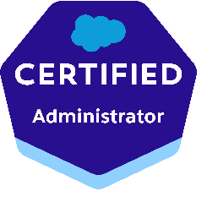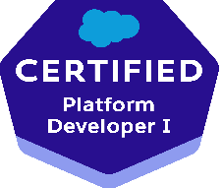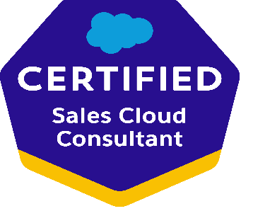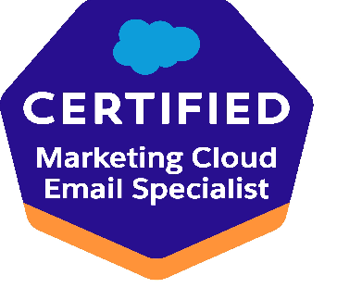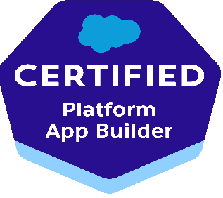
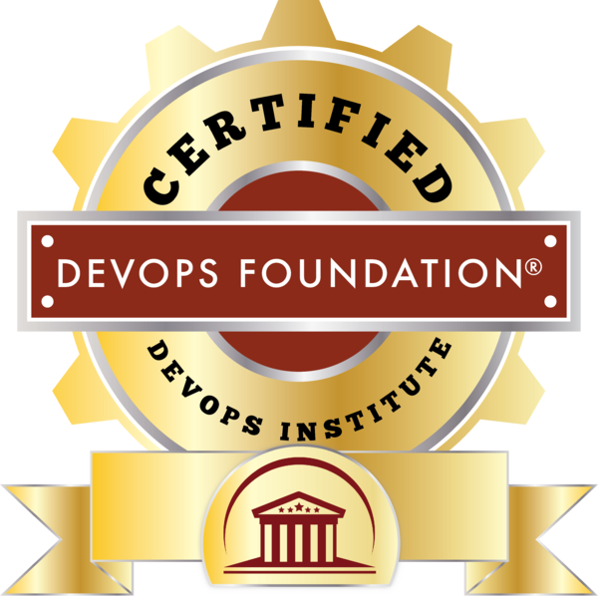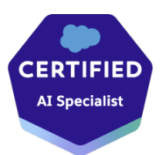
Naresh Kumar Sreeramoju
nareshk6758@gmail.com 720-640-5633

Experienced Sr Salesforce Developer With over 14 years of software experience, I have honed my expertise in developing innovative solutions and leading successful projects from conception to implementation. Around 10 years extensively worked on Salesforce CRM module.

Certifications:

Salesforce CRM Certified Administrator and Force.com developer.
Salesforce CRM Certified Platform Developer 1
Salesforce CRM Certified Marketing Cloud Email Specialist.
Salesforce CRM Certified platform App builder.
Salesforce CRM Certified Sales cloud consultant.
Salesforce CRM AI Associate.
Salesforce CRM AI Specialist.
Certified Devops foundation from people Cert Devops Institute.

Objective:

Experienced Sr Salesforce Developer/Tech Lead with over 10 years in crafting and optimizing Salesforce solutions to meet diverse business requirements. Skilled in translating complex needs into scalable, efficient designs, leveraging deep expertise in Salesforce platform capabilities. Highly skilled at deploying Agile practices to optimize processes & spearheading all.
aspects of Salesforce like systems integration, 3rd party applications, AppExchange, etc.

Salesforce Experience Summary:

- Extensively worked on Salesforce experience/Community Cloud, salesforce marketing cloud and Salesforce Sales Cloud, Salesforce Service Cloud, Salesforce Health Cloud.
- Expertise in Force.com Apex Classes, Apex triggers, Designing Visualforce Pages, Components and Controllers considering the Governor Limits.
- Salesforce.com Certified Force.com Developer (PD1), Salesforce.com Certified Force.com Administrator (ADM 201).
- Exposure on Web Services which can help us to integrate Salesforce.com with Third Party applications.
- Skilled in customizing standard objects, develop Custom objects, Page-Layouts, and Record-types, Relationships, Permission Sets, Validation Rules, Platform Encryption, Workflows and Process Builder.
- Involved with Migration between Environments using Changesets.
- Worked with SFDX and Lightning Design System Framework.
- Migrated data to salesforce using Data Loader.
- Scheduled jobs in Salesforce to automate routine tasks and processes at specified times, enhancing efficiency and productivity. By scheduling jobs, organizations can ensure timely data updates, email notifications, and other essential operations without manual intervention.
- Experience working with Force.com IDE in design and development of Custom Application for Complex Business Processes.
- Experience in using Copado for deploying the code from sandbox to production.
- Copado enabled a faster, error-free releases with continuous integration and delivery (CI/CD) technologies.
- Knowledge in java and extensively worked in java script.

Key Skill Set:
- Release Management • Salesforce Administration & Integration • Agile Practices • Technical Leadership | • SFDC
- Programming & Scripting • Development & Testing • Documentation & Reporting • Process Optimization | • Software &
- Application Development • Salesforce Configuration • Salesforce Support • Training | • Solutions Development

Technical Skill Set:

- Apex, Triggers, Apex Data Loader, SOAP & REST, Visual Studio, Validation rules, Flows, LWC, SOQL, SOQL, Data Loader, Workbench, Visual studio code, Apex Data Loaer| Tools/Languages: HTML, CSS, AmpScript, JQuery, C, C++, Siebel IDE. | Database: Oracle 9i/10g/11g, MySQL, PostgreSQL

Experience:

- Working as a Salesforce Technical lead for Horizon BCBS, New Jersey 4th Jan 2020 to till date.
- Worked as Salesforce Consultant for IBM India Private Ltd, Hyderabad from 8th July 2014 to 3rd Jan 2020.
- Worked as a Siebel Consultant for L&T Infotech Ltd, Mumbai from May 30th, 2011 to 4th July 2014.
- Worked as Associate Consultant in Sam com Technologies pvt Ltd from Oct 2010 to May 27th 2011.

Educational Summary:
- Master of computer Applications from JNT University with Honors.
- Bachelor of Computer Sciences from Kakatiya University with honors.

Project Synopsis:

Project 5 Salesforce Technical Lead/Salesforce Developer– Horizon BCBS New Jersey., USA
Client: Horizon BCBS New Jersey., USA
Domain: Health care.

Duration : July 2014 – Till Date
Platform : salesforce CRM , Experience Cloud and Sales and Marketing, Marketing cloud, Sales cloud, Health cloud and Service Cloud.

The Project objective is to improve the efficiency and customer experience with the new enrollment renewal of small groups process. This initiative will help small group brokers to communicate with customers more efficiently. This solution will eliminate a significant amount of paper handling, save paper cost and reduce the volume of calls and storage that will incur on Horizon. This will result in a more streamlined process for storage and tracking of documents and reduce turnaround time which will lead to higher broker satisfaction.

Role and Responsibilities

• Involved in group for requirement gathering throughout the planning and implementation.
• I extensively utilized Jira ticketing system and Confluence to streamline project management and collaboration processes. Leveraging Jira, I effectively tracked tasks, managed workflows, and ensured project milestones were met on time.
• I utilized Confluence to create comprehensive documentation, foster team collaboration, and centralize project knowledge for easy access and reference. My proficiency with these tools enhanced team productivity and facilitated seamless project execution.
• Created Data Validation rules and Formulas as per business requirement.
Developed and maintained integrations between Salesforce and other applications via SOAP and REST-based web services.
• Designed and developed various webpages in LWC for capturing requirements and developed Classes, and Apex Triggers for various functional needs in the broker portal application.
• Integrate Salesforce API’s with several third-party applications, such as Web access management system, APIGEE, and NMS (Mainframes) and OPTUM.
Extensively worked on Data migration from legacy system which was built on java into salesforce system.
• streamlined batch processes utilizing Salesforce Batch and Queue Jobs to manage extensive data volumes, enhancing system performance and maximizing resource efficiency.
Created triggers to update the status of the enrollments, conversions once they are processed successfully from UI.
• Extensively worked with salesforce lightning experience and built in LWC framework.
Created Dashboard using Tableau CRM for different applications for monitoring on Outbound and inbound call status reports.
• Implemented OIDC login from WAM system to salesforce using custom authentication provider for single sign-on.
- Deployed customizations from Sandbox to other environments using changesets.
• Customization of Chatter on Clinical portal using Lightning Web Components
and standard Chatter display to Portal users.
• SSO enables portal users via Auth Provider functionality and restricts the
functionality access based on their login role.
• Worked with end-to-end Service cloud Implementation like Case Management.
• Worked as a developer for Case team and Service Cloud case management operations.
• Involved in Customizing Knowledge and Case team and some of the case management operation as per the requirement.
Worked with other architects, business analysts, developers and product owners in the design and development of technical solutions.
• Led all Salesforce aspects like data migration/quality, systems integration, 3rd party applications & AppExchange products.
• Directed Salesforce administration to take ownership of technical delivery & escalate roadblocks to relevant stakeholders.
• Developed and maintained integrations between Salesforce and other applications via SOAP and REST-based web services.
• Played a key technical role in evaluating new CRM technologies/add-ons and strategized their implementation into SF.
• Configure Health Cloud to manage and organize patient records, ensuring data accuracy and privacy compliance.
• Manage patient consent and authorization for data sharing, ensuring compliance with regulatory requirements.
• Design and manage integrations between Health Cloud and external systems using Boomi, ensuring seamless data flow across platforms.
• Utilize Conga Composer to automate the generation of patient documents, such as care plans and discharge summaries, directly from Health Cloud.
• Integrate Conga with Health Cloud for efficient document creation, storage, and management, streamlining administrative tasks.
• Leverage Patient Connects advanced scheduling features to manage patient appointments and reduce no-show rates.
• Implement Patient Connect to streamline the patient onboarding process, ensuring a smooth transition into the healthcare system.
• Use Patient Connect to facilitate collaboration among care teams, ensuring that all members are aligned on patient care plans.
• Leverage Marketing Cloud's email and SMS capabilities to send timely health updates, medication reminders, and care plan adjustments to patients.
As part of production support, we resolved the tickets created by broker in case they experience any errors or issues while navigating the application.
• Aligned development activities with best practices & built future integration points between SF & custom applications.
• Performed pre- and post-maintenance tasks for a stable environment during Salesforce maintenance/updates.

Project 4 : Salesforce Developer - Salesforce Marketing cloud

Client: Horizon BCBS New Jersey., USA

Description: Horizon Blue Cross Blue Shield of New Jersey, headquartered in Newark, New Jersey is the only licensed Blue Cross and Blue Shield Association plan in New Jersey, providing health insurance coverage to over 3.2 million people throughout all of North, Central, and South Jersey. Horizon BCBSNJ salesforce Project is designed to improve Sales & Service processes and deploy globally consistent system. Facilitates the Horizon BCBSNJ business by providing various CRM solutions using Siebel technology. Salesforce CRM is used by Horizon Customer Service Reps how handle the calls, emails, fax etc., from the members and providers of Horizon BCBS.

Role & Responsibilities:

- Typically involved designing, implementing, and optimizing email marketing campaigns using Salesforce Marketing Cloud (exact target).
- Worked on Email Studio, Journey Builder, Content Builder, Automation Studio, Contact Management, Subscriber loading and user management.
- Worked on user management, like setting up the users to access the business units.
- Daily interacting with business users and understanding the requirement of regular campaigns and target the users by sending the automated emails.
- Worked on Automations workflows where business can drop the file in mft path where SFMC will pick the file from the location and process it.
- Worked on multiple business units like horizon and braven health care applications.
- Scheduling the email jobs every day based on the business requirements to target the campaign.
- Worked on data extensions, Email templates, scheduling emails, file transfer Automation.
- proficiency in HTML and CSS for email template customization. Written amp scripts as per the business need.
- Worked on marketing cloud API’s. External system to invokes marketing cloud APIs to trigger send emails.
- Worked on generating the reports for business users to understand the market by based on the delivery rate, Open rate etc.
- Worked on setting up the sender profiles, Delivery profiles with in SFMC.

Project 3 L&T Infotech Pvt Ltd

Client: Freescale Semiconductors , Inc. Phoenix USA
CRM Phase 2 upgrade 2013project objective is to facilitate the implementation of enhancements/feature post up gradation of application from Siebel 7.7.2.12 to Siebel 8.1.1.7 enhancement includes in this release are service request UI and few functional changes to improve the user experience with service requests screens views, TBUI implementation to provide the user to deal with the opportunity data easily with the number of tasks using simple steps, Front end margin business process changes to benefit more to the distributor by making process more transparent and improve the lead management process also.

Client : Freescale (Phoenix US)
Duration : Jan 2013 – July 2014
Platform : Siebel call center 8.1.1.7

Role & Responsibilities:

- Provided the high- and low-level analysis and technical design for the lead life cycle process by analyzing the business requirement.
- Regular interaction with the clients and BA for clear understanding the requirement before implementing.
- Involved in creating the assignment rules to assign primary based on the various sales stage status when a new lead is created.
- Created new policies and workflows to send mails to the primary and distributors by using the customized templates when the action is required from user end.
- Created the customized html communication templates.
- Automation of Expiration/Closure of leads when the end date is completed by using the repeating component request batch process.
- Prepared test cases, test cases results and regression test cases for all the customer requests.
- Supported on the implementation after the go live.
- Worked in supporting the application in post migration activities like fixing the bug immediately if anything went wrong after go live.
- Modified email notification functionality on creation and assignment of leads.
- Scheduled those to remove the end dated positions from leads automatically
- Added the different custom buttons like “forward lead” and “close” the lead as per client requirements.

Achievements: Appreciated “Bravo “best performance in the project.

Project 2 : L&T Infotech Pvt Ltd

Client: Freescale semiconductors, Inc.
CRM Upgrade 2012
Project Objective is to facilitate the Version upgrade of the application from Siebel 7.7.2.12 to Siebel 8.1.1.7. This project would move all the current Siebel application (i.e. Siebel 7.7.2.12) functionality into Siebel 8.1.1.7 version. It will enable users to directly benefit from the User Interface improvements provided by the latest version from Siebel/Oracle. Some of the other key enhancements being evaluated by Freescale are mentioned below.

Team size : 09
Duration : June 2011 – Dec 2012
Platform : Siebel call center 8.1.1.7

Role & Responsibilities:

- Running Upgrade Utility to merge 7.7.2.12 custom Repository with 8.1.1.7 Repository.
- Verifying UI and compare all Repository objects with 7.7.2.12.
- Analyzing the Application upgrade Object/Attributes List log.
- Analyzing the root cause of the problems/issues and Planning for Bug Fix of 8.1.1.7 Gaps based on analysis of Application upgrade Attribute/Object List log.
- Analyzing New Features of 8.1.1.7 and mapping with user requirements.
- Worked on entities like Opportunity, contact, Audit Trail.
- Worked on different areas like Configuration, Scripting, Business Services, Workflows, Smart Script and Admin related tasks (like Extracting Database, installing client & Tools, ODBC connection string settings, Generate Triggers and Monitoring Components)
- Worked on workflows to send mail notifications, to trigger the Business services and to do different Siebel Operations like Create, Update, Query the records.
- Written Business Services to create or modify the Records and to create an email messages to send the details from CRM.
- Worked on F9 functionality, configuring communication Templates and communication Drivers & Profiles.
- Written shell scripts to automate the daily interface to capture the exact errors and sends a mail alert to the team.
- Created workflow to close and auto closes the leads based on the client requirements.
- Monitoring all scheduled lead assignment jobs at sever level.
- Add new custom code and modified the code at applet of auto assignment button.

In Production Support:

- Worked for 24X7 L2/L3 productions support to handle the tickets based on their severity and fixing them instantly and some are time permits.
- Worked on configuration and non-configuration customer requests in production support, interacting with BA’s every week to deliver the requirements on time and got the huge satisfaction from the clients.

Achievements: Appreciated with “Star Award “for the best performance in fixing the bugs in upgrade project.

Project 1 Samcomm Technologies,Bangalore

Client: egovernance application Implementation for an apex Body, Governing Technical Education Sector in India
Worked on building an egovernance solution for a Central government of India. The business requirement is to streamline the New College application and approval processes and create a one window facility for the applicant to register their users (Colleges) and to provide a unified view of all relevant information for each College (i.e. the courses available, approved students intake, staff available, faculty, and other infrastructure for colleges)

The whole business process was mapped to the Siebel entities like Cases, Accounts, Activities, Service Requests, and Contacts to name the few. The ‘gaps’ were bridged using various alternatives i.e. configuration, scripting. The whole business process included multiple automation features like automated mailing to the concerned group of people and generation of PDF documents at various mile stones.

Team size : 8
Duration : Oct 2010 – May 2011
Platform : Siebel ePublicSector 8.1.1, Siebel Partner portal 8.1.1

Role & Responsibilities:
- Help functional consultants / Business Analysts during initial requirement gathering sessions
- Ongoing interacting with key business users to clarify and validate requirements
- Perform detailed technical analysis and write technical approach and design documents
- Configuration of UI, Business, Data layer entities using Siebel tools
- Prepared Application Admin screens for Administration using configuration.
- Created Custom tables, Custom business components wherever necessary.
- Written test Cases for our project.
- Created IO for generating the BIP reports for our project.
- Worked on Siebel Data Quality for filtering the duplicate records to improve the performance of the Application.
- Written client side business services using on Outbound Communication Manager to send mails to the users for Eligible deals based on their status.
Involved in migration process from one environment to another environment and knowledge on up gradation development from version 7.8 to 8.1.

