-Krishna
+1 469-202-0129
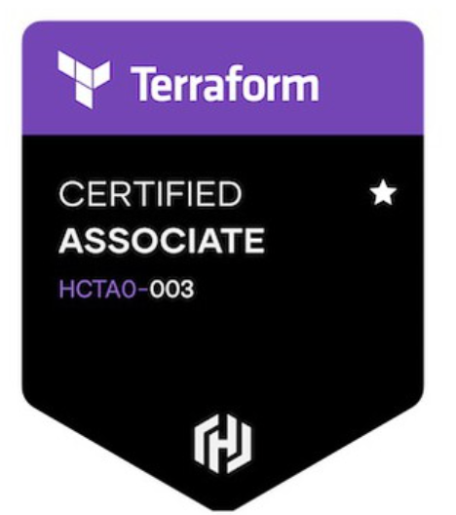
sre.devops.engineer.prasad@gmail.com

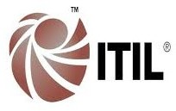
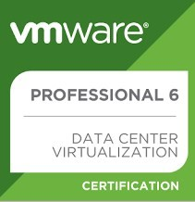
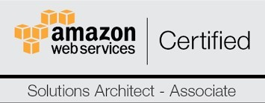
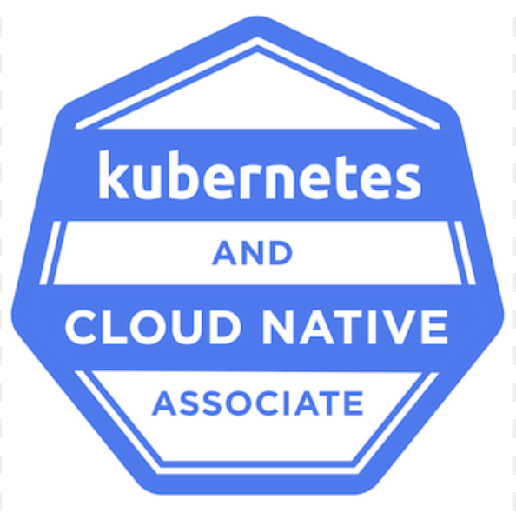
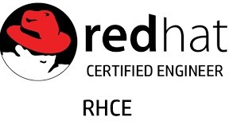

PROFESSIONAL SUMMARY:

- 15 years of experience as SRE- DevSecOps Engineer on handling major Development Projects on R&D Environment and providing Level 3 Support for Production Environment. I had coordinated with various Teams for Projects, starting from Engineering, Design, Plan, Implementation, Project Delivery and Maintenance. I had provided extended support to critical production environments which are more reliable that uses the latest technologies both in Hardware and Software
- As a site reliability engineer (SRE) have experience in creating a baseline for monitoring the applications.
- Experience in DevOps practices and tools for automating, build, packaging, code deployments
- Experience in integrating SonarQube software quality measurement tool to analyze source code, measuring quality and providing reports for your projects
- Experience in performance tests automation using JMETER, POSTMAN collection runner tools
- Experience in configuration management using Ansible and Salt, Capistrano.
- Experience in building Kubernetes multi-master cluster using Kubespray, Ansible playbooks using Ansible Tower, AWX
- Experience in managed Kubernetes cloud services like AKS, GKE, EKS.
- Experience in migrating tomcat on premises application to Openshift (OCP, AKS, GKE).
- Experience in Kubernetes deployments using Helm and Tiller.
- Implemented Continuous Integration and Continuous deployment using JIRA, GIT, Subversion (SVN), Jenkins, Maven/Make, IBM Tivoli configuration tool
- Experience in Docker Containers on LINUX platform by writing new Docker file and Docker Compose asper product requirement and deploying micro services for applications
- Experience in automating routine process using Bash and Python scripts
- Automated monitoring task to fetch F5 Load balancer configurations for PCI applications using Python script
- Experience in deploying and managing 2/3 tier applications with Apache, tomcat, HA-Proxy, MySQL, keep-alive, Redis and Nginx
- Experience in monitoring and creating alerts using Zabbix, site scope, cloud watch and new relic
- Configured playbooks for Apache using Ansible Tower, nginx, MySQL, Server Hardening, keep-alive, crontab, disk partition, certificate management and User Administration that has reduced 78% of repeated task in Ansible
- Experience in handling ec2, S3 bucket, security policy, load balancer, VPC, VPN, AMI, and snapshot in AWS cloud
- Experience in configuring KMS on Azure, GCP
- Provision infrastructure using terraform and automated deployments using ansible.
- Hands on experience in amazon ec2, s3, Rackspace cloud and Bare metal servers
- Advanced knowledge in configuring, tuning, and troubleshooting Linux Networks
- Configured Cisco ASA firewalls maintained Zimbra mail servers, open dap 389 LDAP, Centrify DC.
- Experience in configuring Splunk dashboards for monitoring.
EDUCATION:
- Bachelor’s Degree in Computer Science & Engineering, Anna University, Chennai, Tamilnadu.

CERTIFICATIONS:
- Kubernetes and cloud native associate certified ID: LF-1kjqdsbc4z
- Hashicorp certified terraform associate 003
- Microsoft Azure certified fundamentals: Microsoft certification ID: 996907963
- RHCE (Red Hat Certified Engineer) @ EL5 Certificate No: 805010179753226
- AWS Certified Solution Architect Certificate: AWS-ASA-35015.
- VMWARE Certified Professional 6 – DCV (Candidate ID: VMW-01972984F-00621894)
- ITIL Foundation Certification in IT Service Management Certificate number: GR750306983S

TECHNICAL SKILLS:

Operating Systems
RHEL 5, 6.x & 7.x, CentOS 5.x/6.x/7.x, Ubuntu 12.04,14.04,16.04, Windows servers
Hardware
HP C7000 Blade Systems, HP ProLiant DL 380/360 series G7/G8/G9 Models, Dell Servers (various models)
Automation/Build Tools
Jenkins, Maven, Docker, Docker Compose, Ansible, kubeadm, kubectl, Gitlab, Red hat Satellite server
Cloud
AWS - EC2, S3, ELB, Lambda, IAM, MFA, VPC, Azure, GCP, AKS, EKS, GKE, Terraform
CDN
Akamai, Torbit
Network tools:
F5, Netscalar, Sonic firewall, Cisco firewall.
Other Skills
VMware ESX/ESXi 5.x/6, Vcenter, vSphere, KVM, Xen, Apache, nginx, Powershell,LDAP, NIS, Zimbra, Bash/Python scripting, AWS cli, MySQL. REST, OLEDB, SSRS, Active Directory, Copilot AI.
Monitoring/Log Analysis
Zabbix, Nagios, ELK, File beat, Log stash, Splunk, Trip wire, Grafana, new relic, Cloud watch
PROFESSIONAL EXPERIENCE:

Infylogy Corp

Client: Fidelity Investments (FIS) , UPS June 2023 to Till Date
Role: Devops, SRE

- Develop and deploy code in Azure Kubernetes service (AKS ) with built in azure pipelines.
- Configure CI,CD using argoCD for automated deployments in AKS.
- Configure containers with secure scanning tools aquasec, anchore
- Migrating applications from on-premise tomcat to OCP4 and AKS, GKE.
- Monitors development activities to detect faults or inefficiencies in the processes currently in Dynatrace and Grafana.
- Experience in creating GCE and adding to the GKE node pool.
- Configured kms services in Google cloud for on premises and GKE
- Builds and manage API using Google apigee
- Manage SSL certs using Google certificate manager.
- Configure and maintain application code in Azure TFS with branching strategies.
- Maintain access to user using Azure, GKE using RBAC.
- Provide infrastructure and application support for production environments.
- Experience in creating infrastructure and services in Google cloud, Azure platforms.
- Experience in configuring Open Deploy application and upgrade software.
- Support netscalar network tool, firewall upgrade activities
- Automate routine activities using AnsibleTower and AWX playbooks.
- Provision cloud infrastructure resources using terraform, config-connectors, SDK
- Automate deployment activities using Microsoft AZURE Devops / TFS.
- Manage JFrog artifactory for development teams.
- Deploy applications in open shift container platform (OCP)
- Upgrade open shift Kubernetes to the latest versions.
- Work with and assist team implementing HashiCorp Vault services
- Assist application teams with onboarding digital secrets to HashiCorp vault.
- Manage external secrets securely using hashicorp vault.
- Experience in configuring KMS in azure.
- Migrating Active Directory accounts from legacy and configuring OLEDB, SM to new environment.
- Configure ifs and deployment pipelines in azure devops(ADO).
- Develops & drives incident management processes, playbooks, and stakeholder communication mechanisms.Migrate tomcat applications to open shift and Kubernetes for .NET applications.
- Continuous integration and deployments using Harness for the on premises environments
- Migrating user accounts from legacy to Gen3 Active Directory.
- Migrating users and configure SSRS using OLEDB, Service managers.
- Managing secrets using Cyberark Safe, policies.
- Configured Dynatrace with SLI to monitor application metrics. Created Dashboards in dynatrace with synthetic monitoring.
- Installed plugins and configured cloud and on premises infrastructure in dynatrace for monitoring.
- Used Dynatrace for monitoring and troubleshooting the defect path to resume the application services.
- Configured users and service accounts in Gen3 active directory and IDP.
- Developed and implemented a system monitoring and alerting tool that reduced system downtime and improved system availability..
- Collaborated with cross-functional teams to design and implement a new system architecture and infrastructure, resulting in a good percentage of increase in system performance and a reduction in operational costs.
- Experience in automation deployments for applications in Redhat Linux based environments
- Develop code using copilot AI for the cloud deployments.
- Experience In writing YAML scripts for kubernetes deployments in AKS, GKE, OCP.
- Experience with the incident manage process that lead improvement for system stability.
- Drives root cause analysis (RCA) & risk management processes.
- Experience in configuring file beat for log shippers.
- Experience using Grok filtering in logstash for multiple defined patterns for the data received.
- Experience in configuring ELK to store the messages and visualize in kibana.
- Design and implement cloud-based solutions using AWS services
- Monitor and optimize AWS cloud infrastructure performance using cloud watch and AWS SDK CLI for the regular backup tasks in glacier.
- Configure and maintain AWS services such as EC2, S3, VPC, Glacier, Route 53, SQS, SNS services.
- Automated CI,CD for zero touch deployments and integration of security tools for quality code analysis, testing.
- Configure EC2 snapshots to build AMI images for tomcat applications.
- Provision aws infrastructure resources using Terraform
- Integrated Sonarqube for static code analysis and code quality
- Patch servers listed in AWS security hub and update certificates using AWS Cert manager.
- Configure vault using AWS KMS services for the automated unseal.

Environment: AWS, AWX, Ansible Tower, Azure, JFrog, Dynatrace, harness, OpsView, AKS, Openshift, Terraform, GCP, OCP4, GKE, Grafana, Vault, registry, Monitoring. Performance metrics, optimization.

Infosys April’ 22 – Mar’23
Client: Vanguard(Connecticut)
Role: SRE Lead consultant (Devops)

- Experience in configuring microservice applications on Kubernetes.
- Enhanced system stability by designing and deploying an automated anomaly detection system, which preemptively identified and resolved 90% of potential disruptions.
- Participated in on-call rotations, playing a key role in post-mortem analysis and consistently applying learnings to prevent future occurrences of similar issues.
- Coordinate with CAB (change advisory board) for any infrastructure changes in production.
- Experience in configuring CI/CD pipelines using harness and Jenkins.
- Design and implement cloud-based solutions using AWS services.
- Configure AWS pipeline for ECS managed services using code commit, ECR.
- Experience in configuring SonarQube for quality code.
- Experience in configuring Github with branching strategy
- Monitored Applications and configured Metrics using Cloud watch, Prometheus, Elasticsearch, Kibana
- Worked on AWS automation using Terraform on Infrastructure as code (IAC).
- Setup administration and visualization dashboards in Grafana and Kibana.
- Automated setting up server infrastructure for the DevOps services, using Ansible, shell and YAML scripts
- Managed Kubernetes charts using Helm and tuned Helm charts for applications to deploy in EKS cluster.

Environment:,Azure, AWS, AWX, Ansible, JIRA, JFrog,nexus, sonarqube, Kibana, AKS, Terraform, Grafana, Vault, Docker, Privateregistry,System Monitoring and Alerting, performance metrics and analysis.

Chip Inc (Continental hub for info processing) Oct’ 21 – April’ 22
Client:: HHS OIG, Mcaffee (Maryland, California)
Role: SRE - Devsecops Lead

- Active participant in scrum meetings, reporting the progress and maintain effective communication with each team member and manager.
- Worked with strong team of architectures, backend developers to gather function and non-functional requirements.
- Disaster Recovery Planning and Implementation with SRCR team.
- Deploy and monitor scalable infrastructure on Amazon web services (AWS) & configuration management.
- • Configured & deployed applications on AWS for a multitude of applications utilizing the AWS stack, cloud formation.
- Working knowledge of several types of configuration management tools like Ansible.
- Driving CI/CD pipeline using jenkins and Ansible for docker image building and deployment.
- Experienced in configuring Nessus (Tenable) for Vulnerability Scan.
- Experience in configuring Redis cluster with sentinel for Spring Boot applications.
- Experience in configuring applications on Kubernetes (GKS), Docker Swarm
- Experience in automating deployment tasks using Ansible playbooks.
- Experience in configuring cache content, GTM CPS, TLS on Akamai CDN.
- Experience in configuring applications with Rootless Docker swarm.
- Configured and Managed open source REGISTRY (artifactory) for Kubernetes environment
- Experience in building the CI/CD pipeline for Kubernetes using ArgoCD.

Environment: Ansible, Docker, Kubernetes, AWS, Terraform

Walmart May ’18 – Sep ‘21
Role: Senior Security Engineer (Devsecops)

Walmart is an American multinational retail corporation that operates a chain of hypermarkets (also called supercenters), discount department stores.As a Devops security engineer, I was supporting security and personalization team migrating applications to public cloud and Kubernetes platform.

- Worked on CI/CD tools for Automating, building, packaging, deploying, and releasing of code from one environment to another environment
- Configured HSM, software appliance for encryption and decryption services
- Configured KMS with Appvault, Voltage Security services
- Implemented Kubernetes and Docker multi master setup using KUBESPRAY
- Deployed applications using helm charts and Tiller
- Configured Anchore for secure scanning of images & containers
- Migrated vms and cloud applications to bare metals in PCI
- Automated routine tasks using Ansible playbooks using AWX and Ansible Tower
- Configured GTM and CPS, TLS on Akamai CDN
- Configured SLB, MTD on Torbit
- Configured monitoring tools, Grafana Dashboards for PCI, HIPAA applications in DMZ.
- Configured log shipping tools (File Beat, Log stash) to parse logs from Elastic search (ELK) and send events to Splunk
- Configured scripts to fetch weak configurations from cloud using azure cli, Google Cloud (GCP-SDK), for cloud check projects
- Configured Data pipeline using Apache Kafka and HDFS.

Environment: Azure Cloud, Concord, Kubernetes, Vault, Jenkins, GitHub, SonarQube, Ansible, VMware,Voltage,Venafi, Brinqa, BareMetal servers, HSM.

Accenture Oct ’15 – May ’18
Client: SAP labs
Role: Senior Devops Engineer
SAP develops enterprise software to manage business operations and customer relations. I was working in mobile team as devops engineer, supporting applications and SAP customers in Success factors.

- Experience in managing JIRA tickets assigned to our queue and maintaining SLA
- Experience in handling multi-tier applications in LAMP stack
- Experience in managing instance in AWS and virtual servers in VMware
- Experience in monitoring server/application and finding performance bottleneck
- Automated routine process using bash & python scripts
- Experience in creating/deploying/ patching/configuring server infrastructure using Capistrano, Jenkins for Ruby on rails project
- Experience in source code management (GIT) for weekly deployments
- Track record for consistently meeting goals and delivering a high level of job performance
- Experience in configuring and maintaining SPLUNK dashboards for monitoring
- Worked on migration from normal setup to DOCKER containers with HA proxy and microservices

Environment: AWS Cloud, Jenkins, GitHub. Ruby, Capistrano, Ansible, VMware.

Wipro Technologies Jan ’14 – Oct ’15
Client: CITI bank, Cardinal health insurance
Role: Devops Engineer

- Develops enterprise software to manage business operations and customer relations.
- Worked on high priority and low priority incidents assigned to our queue
- Worked on change tasks assigned to me
- Tasks include building fresh servers and complete post installation configurations using Tivoli Provisioning Manager
- Involved in Creating new file systems, increasing, and decreasing LVM volumes as per request
- Detecting and configuring Lunns from OS side and configure multipathing
- Perform storage migration using LVM
- Creating plans for patching activity and apply latest patches on Linux, Windows servers with TPM
- Installing packages on required locations as per request
- Experience in handling Configuration Management tool CF Engine
- Handling high severity issues and closing the tickets within the SLA

Environment: AWS Cloud, Tivoli provisioning manager (TPM), Jenkins, GitHub, Ruby, Ansible, VMware.

Global Analytics Jun ’12 – Jan ’14
Client: Zebit, LendingStream.
Role: Senior System Administrator,

Global analytics is one of the leading analytics companies, supports lending stream and zebit financial companies. I was working as a production support engineer to the lending stream development team (production support).

- Managing and Administrating Linux Servers in Colo and production environment
- Creating and managing instances in AWS Cloud environment
- Co-ordinating with developers, testers in bringing latest code online without any issues
- Install and troubleshooting Linux, Apache, PHP, Python, MySQL
- Install and Configure Directory Server for Centralized Authentications and Replications
- Installi and Configure the SVN for users
- Configuring Firewall using iptables and cisco firewalls
- Installing and Configuring NFS server
- Writing Shell Script for automating the processes
- Monitoring the Servers and maintaining the uptime
- Root cause analysis of repeated problems, Crash dump analysis
- Apache Web server configuration
- Taking regular backups using incremental and differential backup methods
- Managing and Administrating MySQL servers and databases
- Securing and hardening the Linux servers
- Installing and configuring tomcat for load balancing
- Managing and Administrating Logical Volume Group
- Troubleshooting with remote access controllers like DELL DRAC, IPMI

Environment: AWS, Zabbix, Mysql, SVN, 389, HP proliant Blade servers.

Assistanz India private limited Jul ’11 – Jun ’12
Client: Mycpadmin, Channel
Role: Technical Support Engineer

- Managing and Administrating Linux Servers in Web Hosting Environment.
- Constantly interact with the client and understand their needs and make sure everything is done according to their satisfaction.
- Configuring and Tweaking web server (Apache, Nginx), Database server (MySQL).
- Involved in monitoring the performance and troubleshooting bottlenecks of Memory, CPU, I/O Devices and Network using ipconfig, ps, vmstat, iostat, netstat, uptime, lost and sar commands
- Co-ordinate with Data Centre regarding Server Reboot OS Reload and hardware related issue
- Identify the file system errors and performing file system consistency check using FSCK.
- Identify and fix the kernel panic errors
- Monitoring the reliability of the hard drive and predict hard drive failures using smartly
- Rebuilding the corrupted RPM Database
- Configuring and managing the NFS, Samba server
- SSH public key authentication and secure password less login
- Troubleshooting day-to-day server related issues and problems
- As a Team Member of support desk, responsible for providing timely and accurate 24X7 supports

Environment: Cpanel, Apache, nginx, Mysql.

BPM Solutions Nov ’09 – Jun ‘11
Role: System Engineer

- Installing and configuring Linux Servers. (Kickstart, LVM, hardware/software Raid)
- Configured DNS and changed the Name servers in Domain Control Panel
- Worked in trouble tickets for web hosting industry using the WHM, cPanel
- Installing PHP Applications like (joomla, WordPress, Drupal) on Linux servers

Environment: Bare metals, LVM, RAID, Cpanel.

